Science Findings

Conservation Genetics of Brook Trout (Salvelinus fontinalis):
Developing a Roadmap to Identify and Restore Native Populations

By
Dr. Tim King
U.S. Geological Survey, Biological Resources Division, Leetown Science Center, Kearneysville, West Virginia 25430

Technical Editors
Nathaniel Gillespie, Trout Unlimited
Jack E. Williams, Trout Unlimited

“Wild species must have available a pool of genetic diversity if they are to survive environmental pressures exceeding the limits of developmental plasticity. If this is not the case, extinction would appear inevitable.”
--O.H. Frankel (1983)

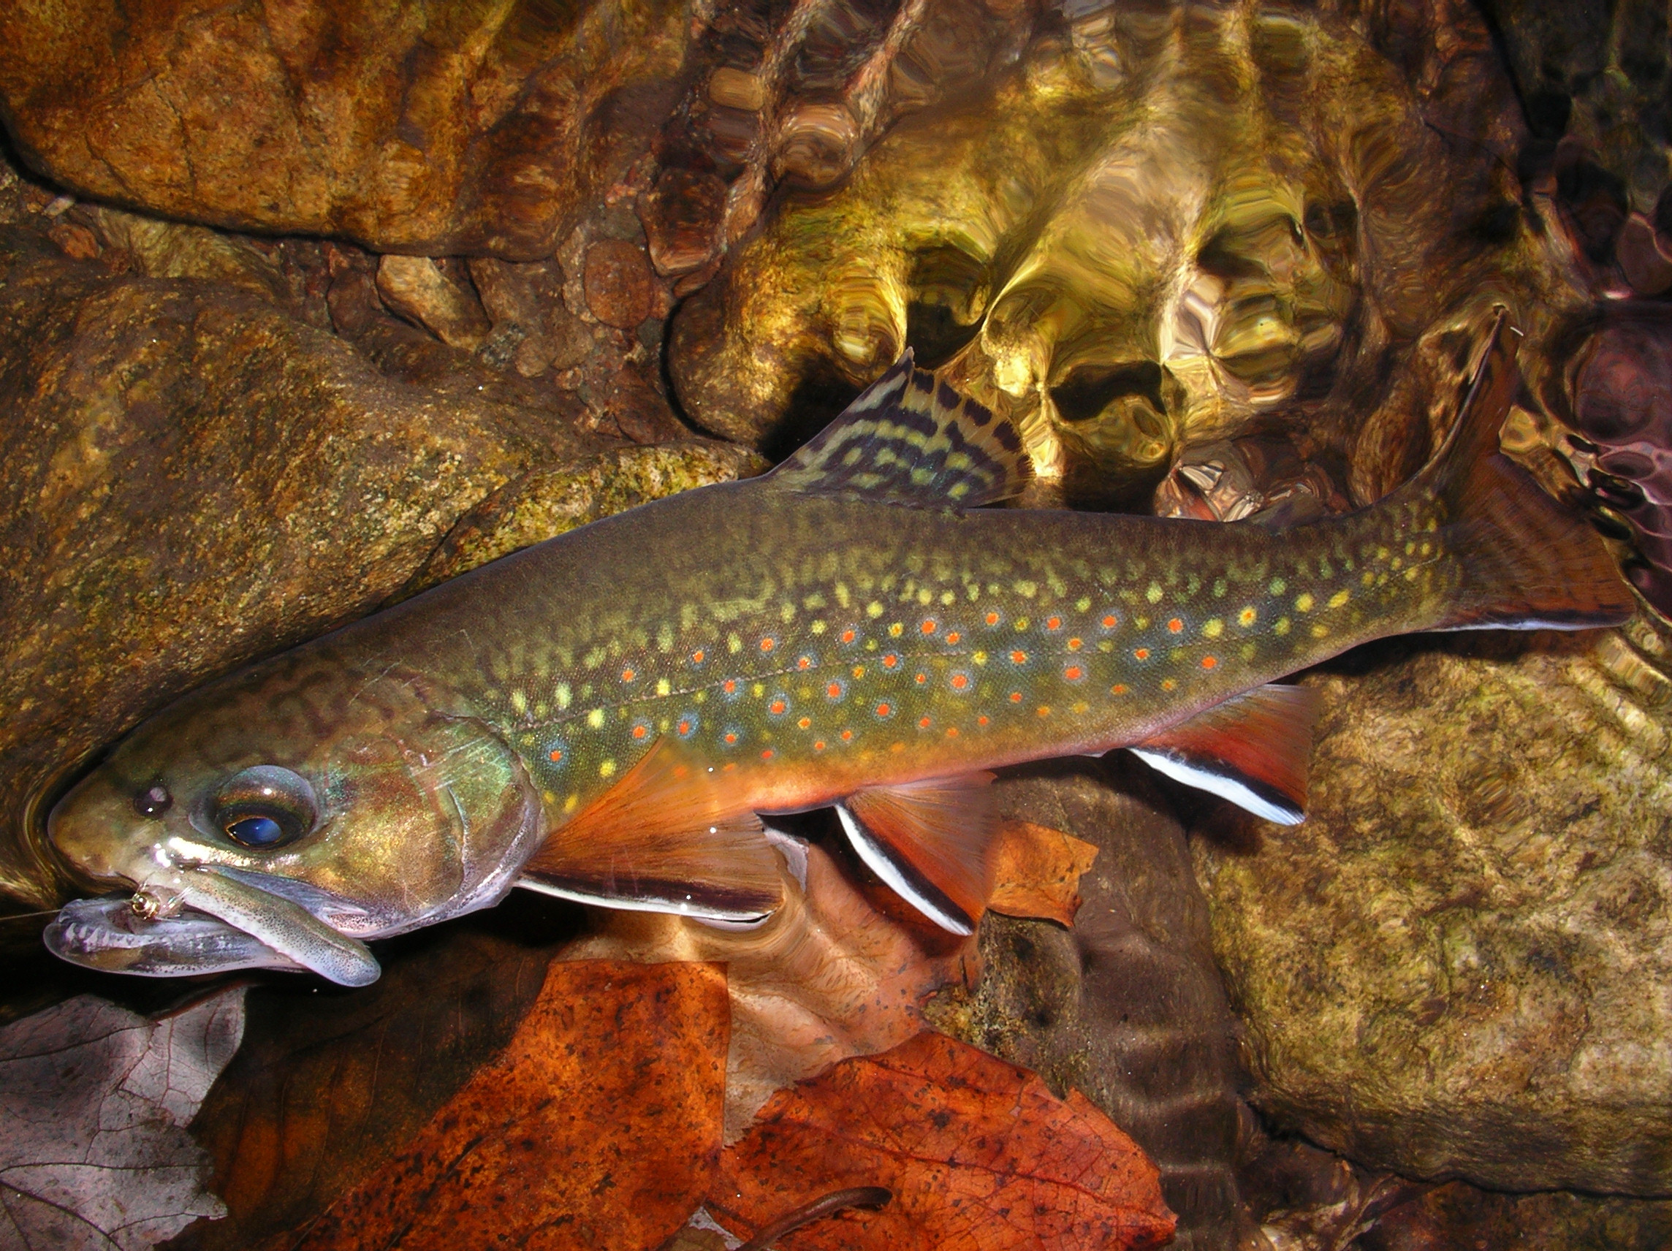
Credit: VA Trout Unlimited
In Summary
This paper reports on recent advances in our understanding of genetics of brook trout (Salvelinus fintinalis) populations. Results of research conducted by Tim King and colleagues at the U.S. Geological Survey’s Leetown Science Center show microsatellite DNA variation among 125 collection sites in the brook trout’s native range in the United States and Canada. Microsatellite DNA analysis allows examination of a much finer genetic structure than was previously possible.

Brook trout are native to the United States from Maine to northern Georgia and west to Iowa and Minnesota. Unfortunately, their conservation status has decreased in recent decades as a result of land conversion, water pollution, and the introduction of non-native trout species that may prey upon or compete with native brook trout. With an increasing emphasis on restoration of brook trout populations, it is important to understand the genetic diversity of remaining populations. Information on the pattern of genetic divergence among local populations can help determine when to protect remaining populations, when or when not to stock fish, and whether to connect subpopulations or isolate them.

Research has shown a high level of genetic diversity among brook trout across the region with differences among nearly all populations examined. Stream populations that are very close geographically may be very different genetically. Diversity is especially high in the mid-Atlantic region but somewhat lower in some coastal populations. Exceptions to high diversity were observed in some isolated southern Appalachian populations. Genetic differences can exist among streams within the same watershed, but patterns of genetic similarity or clumping among populations within larger river basins are clear.

Recommendations to managers include the need for great caution before moving brook trout between river drainages, and the recommendation that supplemental stocking should proceed conservatively and be based on local broodstock collections. Remaining genetic diversity should be protected wherever possible. Microsatellite DNA can provide an important tool in managing broodstock to maximize genetic diversity or to evaluate hatchery programs, and in determining the basic unit of management.

Introduction
According to Professor E.O. Wilson at Harvard University, current extinction rates are at the highest levels known to science. In addition to the loss of entire species, populations and the genetic diversity they contain – the building blocks of species – are rapidly disappearing. Genetic variation constitutes the most fundamental component of species diversity. When a species loses genetic diversity, its ability to adapt to changing environmental conditions is diminished. Furthermore, diversity provides the ability for populations to adapt to local conditions. In short, genetic diversity must be preserved for short and long-term survival of species.

Fortunately, new tools recently have been developed to help identify how local populations relate to the evolution and persistence of a species. Molecular genetics has recently gained status in contemporary conservation biology for its ability to identify fine-scale population structure, determine the degree of reproductive isolation among populations, and identify the appropriate population and watershed unit of management. As a more comprehensive understanding of local genetic structure becomes available, it will be possible to develop a conservation roadmap for evaluating population and watershed conservation priorities.

Greater genetic diversity provides:
- a greater ability of a population to deal with future environmental uncertainty,
such as climate change
- more adaptation to local conditions
- greater protection against parasites and diseases that periodically afflict a population

Brook trout, Salvelinus fontinalis, are the only trout native to much of the eastern U.S. This char occurs in lakes, ponds, streams and rivers from Minnesota north to Saskatchewan and Quebec, east to Newfoundland and Maine, and south along the Appalachian Mountains to northern Georgia and South Carolina. The numbers of wild brook trout populations in the U.S. have been dramatically reduced as a result of water quality and habitat degradation from agriculture, urbanization, road-building, logging, dams, abandoned mine drainage, acid rain and competition from non-native fish. As a result of declining numbers, the management and restoration of wild brook trout populations are important issues throughout their native range. The traditional method of addressing the decline of native populations has largely been hatchery supplementation. The increased use of hatchery-reared brook trout for supplemental stocking in almost every region has potential negative impacts to the overall health of brook trout populations, underscoring the need to understand the genetic composition of both wild and captive populations.

Surveys of genetic variation among brook trout populations have focused on (1) nuclear DNA variation in the form of protein differences or polymorphisms (allozymes) and (2) DNA sequence variation in the rapidly evolving, maternally-inherited mitochondrial (mtDNA). Allozyme and mtDNA techniques have identified significant, genetic differentiation on a regional scale among brook trout, such as the existence of a distinct southern strain of brook trout; however, neither technique is precise enough to allow fine-scale resolution of local sub-population or metapopulation structure.

Microsatellite DNA Analysis and Multi-locus Genotypes
Recent studies have shown that neutral genetic markers like those based on microsatellite DNA variation offer the highest resolution of population structure of any technique brought to bear on fish species. In recent years, these markers have supplanted allozymes as the genetic markers of choice for many management and biological problems including genetic stock identification, parentage assignment, forensics, and genome mapping. Microsatellite DNA segments (also called a variable number of tandem repeats or VNTRs) are short pieces of DNA in a tandemly repeated sequence such as CACACA…CA that tend to occur in non-coding DNA. Microsatellite DNA is an ideal tool to investigate the degree of relatedness among populations exhibiting small effective population sizes because of the hyper-polymorphism (i.e., large number of alternate sized DNA fragments) observed. Due to the relatively high mutation rate, microsatellite DNA markers have been remarkably successful at identifying recently diverged lineages. Although the reason for their occurrence is unknown, microsatellites are recognized as the most useful class of genetic marker available because they can be surveyed at various sites, or loci, from a minimally-invasive tissue sample. The resulting multilocus genotypes are a DNA fingerprint that can correctly separate fish into related populations, families, or individuals depending on the level of resolution desired.

The U.S. Geological Survey’s Leetown Science Center in Kearneysville, West Virginia has developed a suite of 13 microsatellite markers and applied this technique to over 7,000 brook trout from 125 separate collection sites as of April 2006. Sample collections range from Quebec and Newfoundland to the Great Smoky Mountain National Park and from eastern Maryland to eastern Iowa, with the majority centered in the mid-Atlantic region (Figure 1).

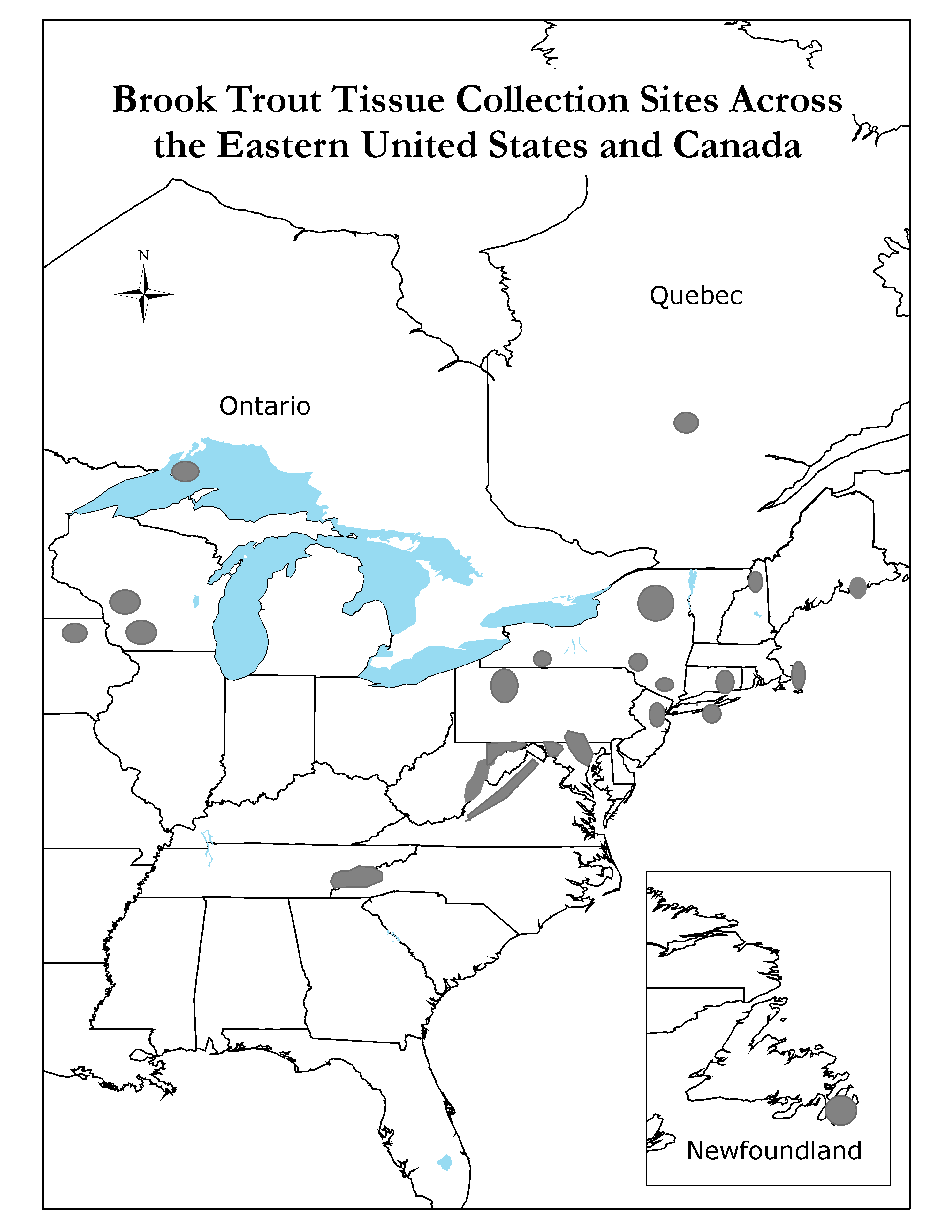
Figure 1: Gray areas showing collection sites for brook trout analyzed by U.S. Geological Survey - Biological Resources Division’s Leetown Science Center as of April 2006.

Scientific Findings
The research has shown genetic differences at scales ranging from local streams to river basins, including differences among regions, major drainages, watersheds, streams, and specific locations within streams. Specific findings include:

- There is enormous genetic diversity (247 alleles at 13 loci) among brook trout within the United States and Canada, with much of the diversity represented in the mid-Atlantic region. Coastal northern populations exhibited lower levels of diversity (numbers of alleles) and lower heterozygosity (possessing two alternate alleles for a given gene). This difference is believed to be because northern-most populations were “founded” relatively recently by fish returning to freshwater streams and lakes following glacial retreat roughly 12,000 years ago. Mid-Atlantic and southeastern populations have survived continually in their specific watersheds for a much longer time, possibly several million years.

- The genetic diversity found in brook trout at microsatellite DNA loci reflects large-scale population structure resulting from biogeographical processes. Microsatellite DNA analysis demonstrates that despite undergoing one or more bottlenecks, brook trout inhabiting most streams retain the genetic differentiation that has evolved over millions of generations. For example, in Great Smoky Mountain National Park, brook trout sampled from the three major river drainages in the park cluster into three highly distinct genetic groups, suggesting that the patterns observed have not resulted solely from random processes (Figure 2). Planned research aims to determine the adaptive significance of the observed differentiation.

-2
-1
0
1
2
Dimension-1
-2
-1
0
1
2
Dimension-2
SMC
SCU
SCL
SCM
STC
HC
LB
GC
IC
BU
FC
CC
Pigeon/French Broad
Little Tennessee
Little River
Multidimensional Scaling Plot
1 - D_{chord}
Figure 2: Multidimensional scaling diagram comparing brook trout collections sampled from three drainages in Great Smoky Mountains National Park: a) Pigeon/French Broad rivers (CC, Cosby Creek; GC, Greenbrier Creek; IC, Indian Camp Creek; LB, Lost Bottoms Creek); b) Little Tennessee River (BU, Bunches Creek; FC, Flat Creek; HC, Huggins Creek; STC, Steeltrap Creek); and c) Little River (SMC, Sam’s Creek; SCU, SCM, SCL; upper, middle, and lower Silers Creek (respectively). This figure depicts 1-genetic distance (chord distance) as a measure of the similarity between collections.

- Stream populations that are very close geographically may be very different genetically because geographic separation of the drainages has isolated them (reproductively) for millions of years. For example, in western Maryland, two brook trout populations in streams separated by a ridge and only a few kilometers drain into the Potomac (Atlantic slope) and Ohio (interior) River watersheds, respectively. These two populations are as genetically differentiated as Atlantic salmon from Europe and North America.

- Certain populations in the southern Appalachians have extremely low levels of genetic diversity at microsatellite DNA loci. Research has found that these populations exhibit lower levels of genetic diversity than those recorded in famous studies analyzing cheetah and manatee populations where populations are severely inbred or founded by a limited number of individuals. These brook trout populations are isolated due to a series of natural and manmade bottlenecks including waterfalls, degraded water quality, and the presence of non-native competitors (e.g., rainbow trout and brown trout).

- Stocking has left a definite imprint on some of the studied populations. Microsatellite techniques have demonstrated that fish introduced from a major drainage, a stream, or even a particular hatchery can be discerned. In some cases, translocated fish have successfully mated and imported (introgressed) their genes into native populations (Figure 3).

Maximum Likelihood Assignment by Brook – Acadia National Park
Brook | Sample Size | Marshall Brook | Lurvey Brook | Hunters Brook | Stanley Brook | Jordan Stream | Hadlock Brook | Classification Rate
Marshall Brook | 56 | 56 |  |  |  |  |  | 100.0%
Lurvey Brook | 55 | 1 | 44 | 2 |  | 2 | 6 | 88.0%
Hunters Brook | 55 |  |  | 53 | 1 | 1 |  | 96.4%
Stanley Brook | 55 |  |  |  | 55 |  |  | 100.0%
Jordan Stream | 50 |  |  |  |  | 50 |  | 100.0%
Hadlock Brook | 41 |  | 8 |  |  |  | 33 | 80.5%
93.3% of brook trout were correctly assigned to collection
Figure 3: Matrix showing the number of fish correctly “assigned” to six individual brooks in Acadia National Park from maximum-likelihood assignment tests utilizing microsatellite DNA variation. The highlighted Lurvey and Hadlock brooks have been stocked in the past with fish from the same hatchery. They have higher rates of “misassignment,” where individual fish from Hadlock Brook show genetic structure similar to those in Lurvey Brook and vice versa. This “misassignment” shows how stocked fish homogenize populations and cause a loss of distinct genetic structuring. The other 4 brooks have not been stocked, and the fish are 96.4% to 100% distinct to that specific brook.

- This tremendous genetic diversity of brook trout is likely attributable to both meaningful adaptation and to random processes. Some southern Appalachian brook trout stocked into northern brook trout streams appear to have become established, while some northern fish stocked into southern Appalachian trout waters have persisted. Other reestablishment efforts have failed. The explanation for this disparity may lie in currently unidentified, adaptive traits.

Microsatellite DNA analysis offers the finest level of resolution (i.e., individual fish) and therefore provides information for a range of management options. Potential uses include:
- Identify genetic stocks: high levels of allelic diversity in brook trout allow the delineation of fine-scale population structure, estimation of gene exchange rates, and quantification of effective population sizes.
- Analyze biogeographic/phylogeographic relationships: among 125 brook trout collections included in the U.S. Geological Survey study, large genetic differences have been demonstrated within and between populations in streams draining to the Atlantic Ocean and those in streams draining to the Mississippi, with southern Appalachian trout appearing to be the most distinct.
- Complement mark–recapture studies: unique multilocus genotypes can serve as markers to determine survival, growth, movement patterns, and kinship/parentage.

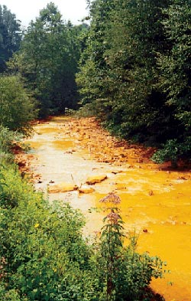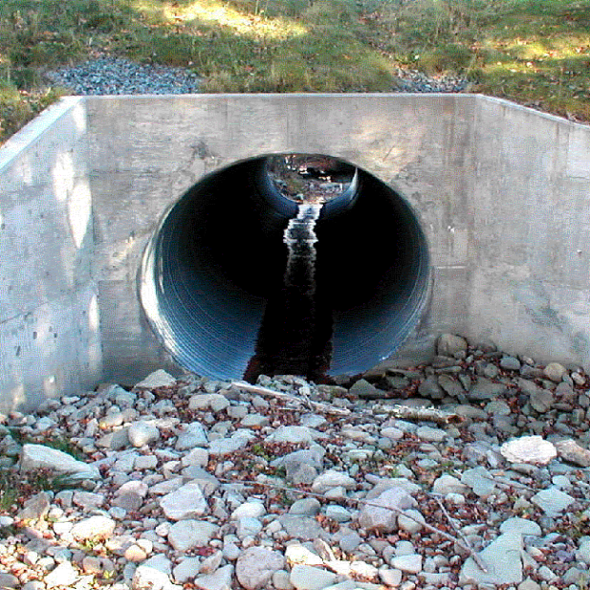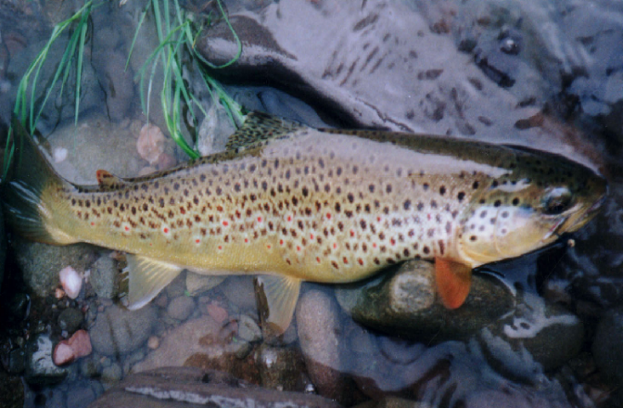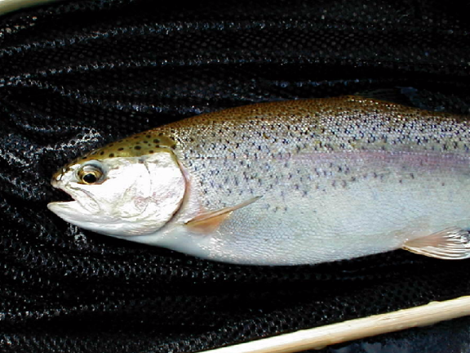
Figure 4: The need to micromanage our watersheds and protect isolated populations of brook trout results from the many human impacts that have fragmented, compressed and extirpated native brook trout populations in the United States and Canada. Abandoned mine drainage, impassable culverts and establishment of non-native fish species like brown trout and rainbow trout (pictured above) have created barriers. These barriers to movement prevent gene flow as well as prohibit recolonization of headwater habitats after vulnerable populations are lost to drought or severe flooding.

- Informed captive breeding management: unique multilocus genotypes allow estimation of genetic relatedness (e.g. proportion of shared alleles) among all potential breeding pairs and establishment of thresholds below which mating should be avoided (i.e., minimize the likelihood of inbreeding depression).
- Assess stocking programs: tracking certain genes or markers can help evaluate the effectiveness of brook trout augmentation programs. Gene marking will not only allow managers to measure the overall success of a supplementation effort, but can measure the effectiveness of various breeding and introduction methodologies. Gene marking can also monitor the genetic effects on wild populations as supplementation proceeds over time.
- Identify the basic unit of management: existing genetic variation can help biologists determine if management should be based on local stream, drainage, or regional scales.

Recommendations for Management
- Local management – Until more evidence is collected regarding the adaptive significance of the high levels of genetic divergence observed range-wide for brook trout, management should be focused on local populations. Current research suggests that brook trout should not be transferred between river drainages, and that supplemental stocking should proceed conservatively by collecting broodstock or fish for transplanting from adjacent or local populations.
- Stocking strategy – supplemental and restorative stocking has its place in fisheries management. U.S. Geological Survey brook trout research has demonstrated, however, the consequences of past stocking efforts that make careful planning a necessity.
- Captive broodstock management – microsatellite analysis can ensure matings that minimize inbreeding and maximize genetic diversity. Microsatellite DNA variation has been instrumental in captive breeding management in Atlantic salmon, Key Largo Wood rats, and many other at-risk species. For example, Shenandoah National Park is in the process of surveying genetic variation among all their brook trout streams because brook trout have been reduced to headwater streams due to dams, non-native species and declines in downstream water quality. Managers from this park may consider a captive-breeding program to restore depressed and isolated populations.
- Hatchery evaluation – microsatellite analysis can be used as a hatchery product evaluation tool to assess if a stocking program is meeting its objectives and if it is inadvertently impacting resident wild populations.
- Ecological Research – now that collection locality can be recorded with GPS technology, the geographic and genetic distances between/among individuals can be compared to determine the role that landscape factors impart upon population structure. This level of resolution has ushered in a new sub-discipline of conservation genetics called “landscape genetics.” The combination of contemporary molecular genetic techniques with robust algorithms developed by the GIS community is allowing a redefinition of the concept of a “population.”

How You Can Play a Role
Now more than ever, fisheries managers can help contribute to ground-breaking genetics research by supplying tissue samples of various populations in their regions to a central clearinghouse. The range-wide study being conducted by the U.S. Geological Survey is in need of collections from wild (unstocked) brook trout populations inhabiting ponds, streams, and brooks. Your assistance is needed in identifying populations and facilitating minimally invasive tissue sampling from these populations. This work should be coordinated with the local state fish and wildlife agency. For information about sending fin clip/tissue samples from your region for analysis, contact: Dr. Tim King, U.S. Geological Survey, Biological Resources Division, Leetown Science Center, Aquatic Ecology Branch, Kearneysville, WV 25430; phone: (304) 724-4450; email: tlking@usgs.gov.

