1. (15 pts) Standards: In order to design a system, one must take into consideration key industrial standards as recommended by the IEEE Computer Society. Write 3-9 facts on the following standards which you feel critical:

(1a) IEEE 1471
- “IEEE Recommended practice for architectural description of software-intensive systems”
- Defines the system
- System inhabits the environment and might interact with other systems in the same environment and system is influenced by environment and other systems in the environment
- System has several stakeholders and helps them to fulfill the mission
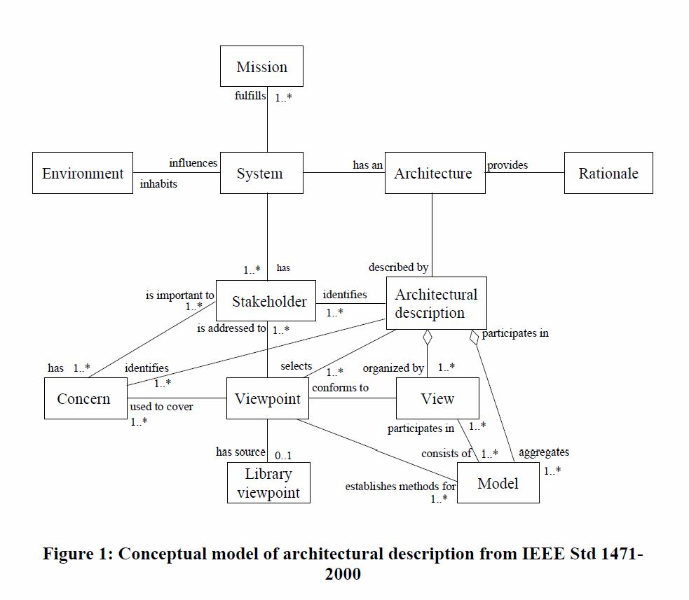
- explains about viewpoint and view, but do not prescribe any particular viewpoint, such as: view can have just one viewpoint and “viewpoints are not system specific, unlike stakeholders and views” and viewpoint descriptions can be reused
(IEEE1471 Summary)

(1b) IEEE 830
- “IEEE required practice for software requirements specifications”
- Suggests the structure for requirements documents: introduction, general description, specific requirements, appendices, and index (p137)
- The structure of documents helps stakeholders to organize their needs, and engineers to understand stakeholders needs
- Its written in plain English

2. (15 pts) Tools: In order to design and build a system, certain tools are needed. As we approach design towards implementation, tool usage (the programming and programming support environments) becomes very company-specific. Furthermore, in the age of web-based software development, advanced tools are emerging. For each tool below describe the purpose of the tool in a software engineering application. Select two from the four below and provide example usage on the selected tools.

(2a) CmapTools

I was introduced to this tool in this class. It is excellent tool to organize your research in one place and keep track of your thinking process and connect all part of your research that are interconnected already and even discover new interconnectivities since you have ability to see all of it visually displayed in front of your eyes all in one place.

(2b) Acclaro DFSS

Also introduced in this class and looking forward to use it. So fare I know it helps with transforming user requirements with capturing voice of customer (VOC) and transforming it to customer needs (CN) and using axiomatic design achieve FR-DP decompose of functional requirements FR and design parameters (DP). All that, and focus on quality with quality tools such as QFD – Quality Function Deployment, FMEA – Failure Mode Effect Analysis, and TRIZ – Theory of Inventive Problem Solving.
VOC -> CN -> FR -> DP-> PV

(2c) Visio

MS Visio is versatile tool for drawing all kind of charts. The interesting part for us in this class is its support for UML – Unified Modeling Language, the same you can find under software and databases>UML model diagram.

(2d) MS Project

One more tool from Microsoft. I hope most PM – Project managers love it. It helps PM to control WBS- work breakdown structure schedule the work unites and to assign needed resources to work units. After all work units have been planed and all interdependences entered PM is able to see critical path of the project and how the critical path will affect the project duration.
(2e) Basecamp

Web based Project management tool for diversified projects that need web support, teem collaboration…

3. (15 pts) Architecture: After the requirements phase, system architecture is needed. In addition, early detection of any problems provides major cost and time saving. While architecting a system, certain risk mitigation techniques should be used. Among these techniques are the ones listed below. Explain each one briefly. Select two and describe ways you can utilize these two selected tools to reduce risk, provide examples where needed:

(3a) DSM – Dependency Structure Matrix

It is part of Acclaro DFSS. For example it is visual presentation FR and DP and their dependences marked with ‘X’.

(3b) FMEA – Failure Model and Effects Analysis

It is also part of Acclaro DFSS. For example it is used to analyze DPs possible risks analyze the causes of it, assign the risk severity number. After all risks have been listed it will shows one with highest severity. Then team needs to develop plan how deal with those with highest severity with plan of action. FMEA is particular for critical systems.

(3c) FTA – Fault Tree Analysis

It is used to help with risk decomposition. The risk is at the root and the branches are causes of the risk and are connected to the root with Boolean logic. FTA is also particular to critical systems.

(3d) QFD – Quality Function Deployment

It is also part of Acclaro DFSS. It helps with transition of VOC and CN to FR and DP having focus on customer needs and making sure that all customer needs are met with quality product. It practices six sigma approaches.

(3e) TRF – Technology Risk Factor

It can be part of DSM and help with comparing proposed technologies to new system and their risk that might rise. MIT & NASA uses it.

4. (15 pts) Detail Design: In order to design a system based on the architecture, unified modeling language (UML) usage has gained popularity.
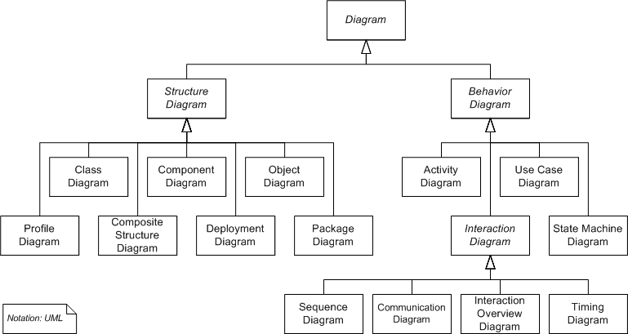
4a) Refer to the figure above and define state machine diagram in detail,

State machine diagram shows how individual object change its state in response to events. State machine models are dynamic models.

4b) Give an example of a use case diagram and explain your diagram.

Use-case diagram is a scenario-based technique for requirements elicitation. It identifies the type of interaction and the actors involved. It is a collection of scenarios of system use. A use-case describes how a system looks to its user (viewpoint)

5. (10pts) Career Relevance: Select a chapter of interest and describe how that applies to your career interest in Software Engineering.

Chapter 16 User Interface Design

6. (10 pts) Essay question: Write a short essay on pros and cons of object oriented design. You should use the relevant chapters among the ones which you are assigned to read. Usage of any other resources is welcome.

Chapter 14

7. (10 pts) Main idea: This semester our emphasis is on design. Describe the main idea of Chapter 15 and Chapter 16 of your [Sommerville] textbook (Just one paragraph each). For each main idea, provide a relevant diagram from textbook and bulleted list of ways (3-5 bullets) how this knowledge would impact your project.

Chapter 15 – Real-time Software Design
The chapter is

Chapter 16 – User Interface Design
The chapter is

8. (10 pts) Methodology. A recommended methodology to use for design is introduced this semester. Describe COMET approach. What is it and how can you utilize it?

COMET – Concurrent Object Modeling and architectural design mEThod. UML is language whereas COMET is a recommended methodology that uses UML to design advanced systems that are synchronized and distributed. The basic phases of COMET are: Requirement modeling, Analysis modeling, Design modeling, Incremental software construction, Incremental software design, and System testing.

