Occupation of Calais 1347
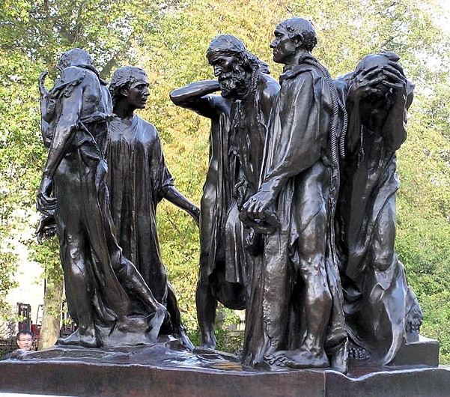
After the Battle of Crécy Edward III lead his army to Calais and began its occupation which would last eleven months. Philip VI tried to stop this occupation but failed. The major of Calais offered Edward capitulation and he accepted but only on condition that the 6 most important burghers would offer their lives. Only with the help of queen Philippa of Hainault (Edward’s wife) did these 6 burghers save their lives. This event is the topic of Rodin’s famous sculpture The burghers of Calais.
Calais became the most important military base and was part of England until 1558.

