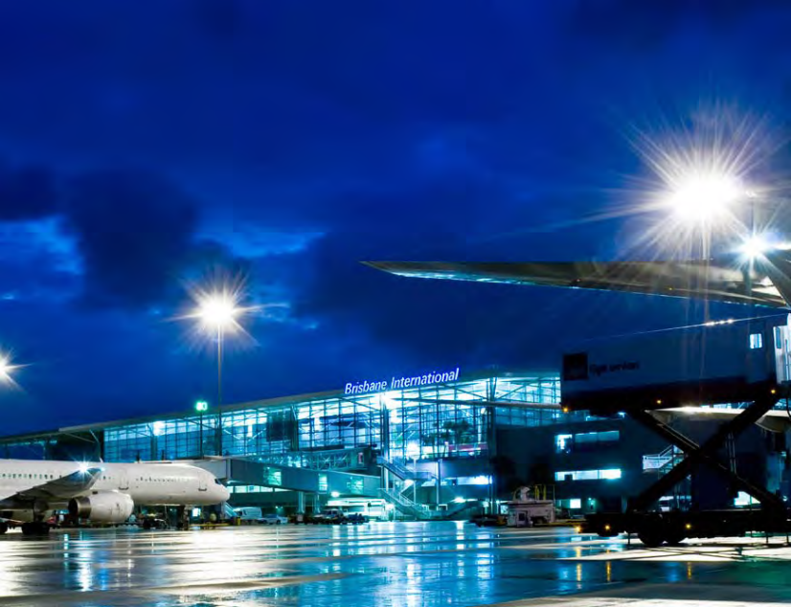

AUSTRALIA TRADECOAST
Partnership Due Diligence
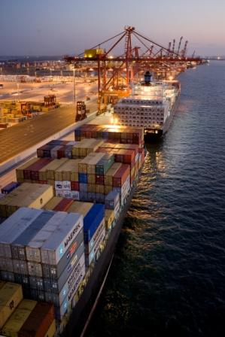

Table of Contents
A Brief Look at Brisbane 3
Brisbane employment 3
Brisbane Airport 3
Port of Brisbane 3
Australia TradeCoast 3
ATC Precinct Map 3
Population Growth 3
Public Transport Challenges for the Australia TradeCoast 3
Predicted employment needs for the BAC over the next ten years include 3
Education and Training 3
Pathways from school to employment at the BAC 3
Community Groups 3
Brisbane North 3
Brisbane South 3
Business and Industry 3

Table of Figures
Figure 1 2026 Population Growth 3
Figure 2 Employment Growth 2001 to 2026 (OUM, 2005) 3
Figure 3 Employment Growth by Suburb 3
Figure 4 2009 Year 9 NAPLAN Data 3
Figure 5 Main Destinations of Year 12 Completers, Brisbane, 2009 3

Table of Tables
Table 1Employment and Growth Scenarios 3
Table 2 School NAPLAN Performance 3
Table 3 Pathways from School to Employment at ATC 3

A Brief Look at Brisbane
Brisbane, the capital of Queensland and Australia’s third largest city, is the growth powerhouse of the Australian economy, outstripping all other major national centres. Now with the largest population growth for any Australian capital city, Brisbane is experiencing a fundamental shift in its business landscape. Recognised as Australia’s most liveable city, Brisbane has a well deserved reputation as Australia’s safest, cleanest and greenest capital city. The south-east corner is truly the State's - and indeed one of the nation's - multicultural hubs and the pattern of overseas-born migrants flocking to the south-east corner is in no doubt due to the enviable lifestyle and robust economy. The City is spread over 2,116 square km (817 square miles), and with some 1.84 million residents Brisbane is home to more than one third of Queensland’s entire population, and around 570,000 businesses. Brisbane facts
Brisbane is the largest of Australia’s six capital cities by geographic area and the third largest municipality in the world, spread over 2,116 square km (4,600 sq km’s).
Brisbane has the largest population growth (no.) by LGA for any Australian capital city.
Brisbane local government area (LGA) is the first LGA in Australia to pass the population milestone of one million, reaching 1,010,000 people in June 2007.
Brisbane City Council (BCC) is the largest city council in the Asia Pacific, managing a budget of over $1.6 billion, with managed assets in excess of $16 billion. BCC administers the entire metropolitan area of Brisbane and is the most powerful, and politically influential, local authority in Australia.
Median age of residents is 35 years old and more than 25% of residents were born overseas.
1.84 million residents, equal to one third of Queensland’s entire population, and around 570,000 businesses.
21.7% of Brisbane’s population were born overseas, with the highest numbers being from the UK, New Zealand, South Africa, Vietnam and Scotland.
Brisbane has averaged economic growth of more than 4.5% for the last 20 years.
Brisbane is the closest major Australian capital to the Asia Pacific region.
Of the OECD countries, Brisbane was the 32nd fastest growing region between 2001 and 2006

Brisbane employment
By 2026, Brisbane’s workforce is projected to increase by 55%, from 550,000 to 850,000.
Employment in Brisbane is forecast to grow much faster than population, with 1.05 million expected by 2026 (that is a 55.11% growth).
Inner city and Australia TradeCoast will account for 2/3 of employment growth in Brisbane.
Top five industries with largest employment growth: property and business, government, education, health and community, cultural and recreational.
Top five occupations with largest employment growth: professionals, managers and administrators, associate professionals, intermediate clerical sales, intermediate production transport workers.

Brisbane Airport
Brisbane Airport Corporation (BAC) received the award for best water management in the world at the 2008 International Water Association (IWA) Awards in Vienna.
Winner of the prestigious IATA Eagle award for World’s Best Privatised Airport 2005
Brisbane Airport is the nation’s best-performing capital city airport for arrivals and departures.
Brisbane Airport has the second highest number of international arrivals into Australia (behind Sydney).
Domestic and international airports are located 15 minutes from the CBD, connected by Airtrain – a dedicated rail link and the only one of its kind in Australia.
Brisbane’s Airtrain has recorded a 17% increase in passengers in 2008, a record of 1.64 million passengers used the train from the CBD to the airport.
Brisbane airport traffic is set to double by 2025 (39 million traffic movements by 2025), making Brisbane Airport Australia’s second largest.
4.1 million passengers passed through Brisbane Airport in 2007 / 08 – a new record for a financial year, and 2.5% growth compared to the previous financial year.
$2.2 billion new runway now under construction
$4.8 billion Brisbane’s Airport Link project is Australia’s largest PPP and one of the largest road infrastructure projects
Jobs at the Airport are forecast to grow stronger than the national average, with an anticipated workforce of around 42,500 by 2023.
BAC will spend $3.3B in infrastructure in the next ten years
- New roads
- New runways
- New terminals (27 new check-in counters)
- Development of aviation related precinct
- New retail and hospitality outlets

Port of Brisbane
One of only seven ports in the world with deep-water access
Room to expand - 230ha reclamation to be largest in Australia
Most cost-effective commercial port facility in Australia
Total trade to more than double to 60 million tonnes over next 20 years
http://www.docstoc.com/docs/28011087/A-Brief-Look-at-Brisbane/
The following is reproduced from http://m.bing.com.au/reference/semhtml/Port_of_Brisbane
Port of Brisbane is the shipping port of Brisbane, on the east coast of Australia. It is located in the lower reaches of the Brisbane River on reclaimed land that was once called Fisherman's Island at the mouth of the river. It currently is the third busiest port in Australia and the nation's fastest growing container port. It includes the main shipping channel across the Moreton Bay which extends 90 km north to Mooloolaba and is dredged to maintain a depth fourteen metres at the lowest tide.
Queensland's next two largest ports are the Port of Gladstone and the Port of Townsville.
According to the former Queensland Department of Primary Industries the Port of Brisbane was the most likely entry point of the South American fire ant to Australia.^{[1]}

Facilities
The port is managed by the Port of Brisbane Corporation (PBC) and facilitates more than 2,600 ships each year. The Port of Brisbane has nine deep-water container berths and three deep-water bulk berths as well as 17 bulk and general cargo berths. In total the port transports more than 28 million tonnes of cargo each year. [1]
There are two cruise ship wharves for Brisbane, with differing facilities. Portside Wharf was completed in 2006 and is an international standard facility for cruise liners, offering restaurants, coffee shops, gift shops, and more. However, due to the height restrictions of the Gateway Bridge, the larger ocean going cruise liners must dock further down the river at the more industrial standard Pinkenba Wharf. Pinkenba Wharf is managed by the Port of Brisbane authority.
The port accommodates a visitors centre and in 2005 a shorebird roost was constructed. The bird roost is the largest site built specifically for migratory shorebirds on the east coast of Australia.

Transport links
The Port of Brisbane Motorway is a short road linking the Gateway Motorway to the Port of Brisbane.
In 1980 a narrow gauge (1067 millimetres) railway line was opened between the port and a junction near Lindum on the Cleveland line. This was converted to dual 1435/1067 mm gauge in 1997 under the Keating Government's One Nation program.^{[2][3]}

Expansion
The Port of Brisbane is currently under a large upgrade and extension spending AUS $50 million on infrastructure and a further AUS $100 million on equipment including over 25 automated straddle carriers owned by Patrick Corporation.
In January 2008, Port of Brisbane Corporation signed an agreement with Brisbane Container Terminals, a wholly owned subsidiary of Hutchison Port Holdings, subsidiary of Hutchison Whampoa, which Hutchison will operate berths 11 and 12 for 42 years.^{[4]}

See also
Brisbane portal
- Australia TradeCoast
- List of deep water ports
- Transport in Brisbane

References
- ↑ "Queensland faces possibly worst ever introduced pest". The 7.30 Report. 2001-03-05. http://www.abc.net.au/7.30/stories/s255089.htm. Retrieved 2008-04-28.
- ↑ Philip Laird (page 191). "Australia's gauge muddle and prospects". Back on Track: Rethinking Transport Policy in Australia and New Zealand. UNSW Press. http://books.google.com.au/books?id=CRT45DlRXCQC&pg=PA191&dq=%22back+on+track%22+fisherman+island&client=firefox-a&sig=ACfU3U3zG2t6LFUgiaIhg2jNmRZtMyC97Q. Retrieved 2008-08-16.
- ↑ "A Critique of the Dual Gauge Link to the Port of Brisbane.". www.rag.org.au. http://www.rag.org.au/frag/fragbook.htm. Retrieved 2008-03-30.
- ↑ "HPH to invest A$200 million in port of Brisbane". Hutchison Whampoa. 2008-01-29. http://www.hutchison-whampoa.com/upload_docs/2008/01/Ports/1981/1981_eng.htm. Retrieved 2010-03-24.

Australia TradeCoast
More than 8,000 hectares
Direct links to national road network
Over the last 5 years: $1 billion in infrastructure development; over 100 new industrial developments; 50% of industrial take-up in Brisbane.
In 2006/07, the value of international exports (including both manufactured goods and commodities) through ATC grew from $4.8b in 1995/96 to $11.3b, representing an annual growth rate of 8.1%.
Manufactured goods exported from ATC (excluding commodities) was $1.16b in 1995/96 and $4.8b in 2006/07, representing an average annual growth rate of 8.39%.

ATC Precinct Map
Discover the benefits of locating in the Asia-Pacific’s premier trade and business precinct – Australia TradeCoast.
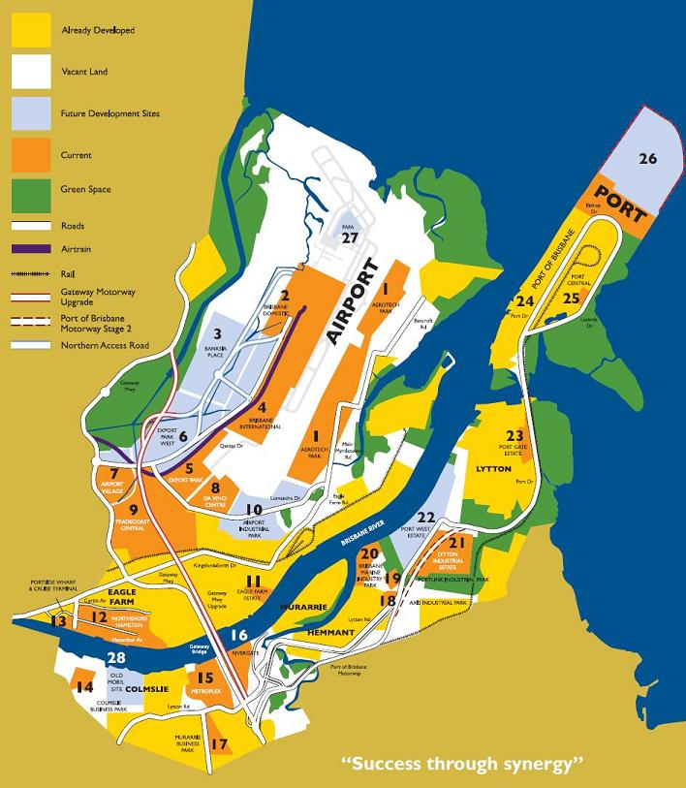

- 1. Aerotech Park
Aerotech Park consists of approximately 200ha and is fast becoming Asia Pacific's aircraft maintenance hub. The primary focus for this precinct is for Aviation Maintenance and associated Aviation Support industries.
- 2. Brisbane Domestic
The Brisbane Domestic precinct’s primary focus is the facilitation of domestic passengers. Virgin Blue and Qantas operate the majority of the Domestic Terminal with the balance available for other domestic carriers. The Airtrain connects from the Domestic Terminal to Brisbane City and the Gold Coast. Future development in this locality may include Commercial Office buildings, retail, hotel and additional carparking.
- 3. Banksia Place
Banksia Place consists of approximately 190ha and is located between the Domestic and International Terminal Buildings. The objective of this precinct is to create an attractive highway/boulevard orientated business park along both Airport Drive and the proposed Northern Access Link connecting to the Gateway Motorway duplication. It is envisaged that this precinct will cater for such diverse uses as car rental depots, centralised staff car parking, commercial offices and logistic operations.
- 4. Brisbane International
Brisbane International is the premier precinct within Brisbane Airport. It is connected to Brisbane City and the Gold Coast by regular Airtrain services. The precinct incorporates the International Terminal Building as well as the historic Kingsford Smith Memorial. Future uses in this locality will include premium commercial offices, associated retail, secure long-term parking, logistics facilities and hotels.
- 5. Export Park
Export Park consists of approximately 90ha. This precinct is ideally located to facilitate air cargo operations and has been designed as a corporate office park catering for the individual functions associated with Cargo Terminal Operators, Freight Forwarders and Warehouse Distribution networks. A final release of land is due in 2008, being Stage III.
- 6. Export Park West
Export Park West is located on the northern side of Airport Drive and consists of approximately 77ha. The Gateway deviation will dissect this precinct providing a northern interchange connection to both the Domestic and International Terminal Buildings. Future uses for this precinct include Freight Forwarding, Warehouse and Distribution plus support industries. Development of this Precinct is scheduled to commence once the Gateway deviation has occurred in this locality.
- 7. Airport Village
Airport Village is the commercial hub for the Australia TradeCoast locality. Upon full development it will be an integrated commercial, business, retail and leisure community. Uses will include Commercial Offices, Hotel(s), Child Care and Health and Well Being Centres, Supermarket, Factory Outlet Centre, Bulk Goods, Luxury Car Showrooms, Service and Speciality Retail, plus a Golf Course.
- 8. Da Vinci Centre
The Da Vinci Centre consists of 44ha and has been master planned to cater for both logistics and aviation/aeronautical education uses. The logistics development will focus around the aircraft apron previously utilised for the ex-International Terminal Building. The Education campus is strongly supported by the State Government and currently consists of Flight Simulators, Cabin Crew Training and Aircraft Maintenance Training facilities.
- 9. TradeCoast Central
TradeCoast Central, located on the old Brisbane Airport Site adjacent to the Gateway Motorway, is a joint venture between the Brisbane City Council and TradeCoast Central Pty Ltd. Once fully developed, it will include approximately 120ha of a Master planned industrial community and corporate office park. The Master Plan provides for an industrial community which will include a large distribution and manufacturing precinct, retail and community facilities, extensive public open spaces including restored heritage sites, walkways and bikeways, and a campus style office park overlooking the proposed Brisbane Airport Corporation golf course.
- 10. Airport Industrial Park
Airport Industrial Park is a future industrial precinct planned for warehousing, light industrial and logistics uses. This precinct will be an important addition to Brisbane’s northside industrial area and will provide support for airport activities.
- 11. Eagle Farm Estate
A prime riverfront address developed by the Port of Brisbane, it offers variable lot sizes for corporate headquarters, commercial offices, industrial warehousing and service outlets. Close to the airport and port, Gateway Motorway and the CBD, facilities are designed and constructed to users requirements, with the option to purchase on completion. Industries currently operating include aviation, freight forwarding and manufacturing.
- 12. Northshore Hamilton
In recognition of the opportunity created by the relocation of port activities to Fisherman Islands, the Port of Brisbane Corporation (PBC) is progressing the Northshore Hamilton urban renewal project. Located between Portside Wharf and Cruise Terminal and the Royal Queensland Golf Club, Northshore is Brisbane’s largest urban renewal project comprising 80ha of old port and industrial land (including 63ha of PBC owned land), with two kilometres of Brisbane River frontage just six kilometres from the CBD. Northshore Hamilton will be a high-quality, sustainable and environmentally responsible urban environment, which supports a healthy and diverse community with access to a variety of housing types, community/commercial facilities, open space and the Brisbane River. Over the next 20 years Northshore Hamilton will ultimately become home to a community of around 10,000 people. Land is to be progressively sold to developers through a competitive tender process.
- 13. Portside Wharf and Cruise Terminal
The $750 million Portside Wharf development is a mixed use residential and retail precinct located on the riverfront at Hamilton, approximately 5km from Brisbane’s CBD. The project, which also incorporates the Brisbane Cruise Terminal, is the beginning of the city’s largest urban renewal project, Hamilton Northshore. Stage 1 of the precinct is now complete incorporating three residential buildings a retail plaza and the International Cruise Terminal.
- 14. Colmslie Business Park
This is Australia TradeCoast’s most inner city precinct, offering variable lot sizes for industrial warehouses, cold stores, transport operators, offices and service outlets. All facilities are purpose built to users requirements.
- 15. Metroplex on Gateway
The 62ha estate in Murrarie is the most significant private sector development within Australia TradeCoast. Development commenced in 1998 and is now almost complete. All developments in the estate have to comply with architectural and landscaping codes resulting in a high quality business park. Amenities include a restaurant, childcare centre and a free shuttle bus service linking to local transit centres. Tenants include an impressive list of international companies. The final precinct, Queensport Quays, is primarily for commercial offices and offers expansive riverfront views.
- 16. Rivergate
This development located next to the Gateway Bridge at Murarrie has set new standards for integrated marine and industry precincts. It combines a working shipyard with commercial and light industrial space in a secure environment. At the centre of the precinct is Rivergate’s purpose built marina with 105 berths, 12,000sqm of hardstand and a variety of refit and maintenance sheds serviced by two travelifts capable of lifting 300 tonnes. Planning is proceeding for a 200-boat dry stacker as well as a retail and commercial precinct.
- 17. Murarrie Business Park
Opposite Metroplex on Lytton Road, the 7ha estate is fully developed. Nestlé is the highest profile tenant, with most of the estate comprising small office/warehouse buildings occupied by groups such as Videopro, CDS Gourmet Foods and Dynamic Headwear.
- 18. Axis Industrial Park
Axis Industrial Estate is a 15 Lot, 10ha industrial estate managed by Falcon Property Group. Six of the 15 allotments have been sold, the remainder will be developed on a speculative and design and construct basis for tenants. A three tenancy, 11,500m² building will be completed at the entrance to the estate in April 2009, 35% of which has been pre-committed to Kitchen Connection. The estate can accommodate warehousing requirements from 3,000m² to 10,000m².
- 19. Portlink Industrial Park
Portlink in Hemmant is an 8.3ha, 19-lot industrial sub-division off Lytton Road being developed by Pradella Developments Pty Ltd. The estate comprises two stages, with stage one (13 lots) launched in 2004. Lot sizes range in size from 2,500m² to 2ha.
- 20. Brisbane Marine Industry Park (BMIP)
Located on the Brisbane River at Hemmant on approximately 40ha (100acres) of strategic industrial land, BMIP has progressed to a stage where more than 30 businesses are engaged in manufacturing or servicing the marine industry. These businesses are supported by infrastructure which includes shiplifting and hardstand capacity, boat sheds, workshops and a marina with 190 additional berths under construction. The Brisbane Marine Industry Park has also recently acquired a 600 tonne travel lift – the largest of its kind in the Southern Hemisphere, which has doubled its shiplifting capacity. Major tenants include Viking Industries Ltd subsidiary companies, Furniture Manufacturing Company of Australia and Marine Applications together with local boat builders and refit specialists such as Brava Marine, Aluminium Boats Australia, New Wave Catamarans, Classic Motor Yachts and Smart Marine Services. BMIP is also devoted to marine industrial use, focusing on marine warehousing and service supply. The master plan includes establishing an extractive industries precinct to accommodate businesses such as Boral Hanson and Rinker.
- 21. Lytton Industrial Estate
The Property Services Group of the Department of Infrastructure has released 28 fully serviced freehold sites ranging in size from 4000m² to 8ha within the Lytton Industrial Estate. The Estate is located on the doorstep of the Port of Brisbane and has easy access to the Port of Brisbane and Gateway Motorways.
- 22. Port West Estate
Port West Estate comprises approximately 80ha of vacant strategic port land located along the riverfront at Lytton, approximately 7kms from the Port of Brisbane. Future development of the site is anticipated to provide a range of general and low impact industries, warehouse and cargo distribution activities and motor vehicle storage and processing facilities. The Port of Brisbane Corporation retains ownership of all land at the Port of Brisbane (including Port Central), Port Gate and Port West, and provides tenure by way of leases to port clients.
- 23. Port Gate Estate
Port Gate Estate provides for port operational activities as well as commercial enterprises and support services. Existing development includes tug and dredge bases, barge operations, emergency services and port security and operations base. The Port is currently developing 9ha of land for development of warehousing for transport and freight forwarding related development. Future development will include freight forwarding and customs broking warehouses, vehicle service depots and transport related servicing facilities. The Port of Brisbane Corporation retains ownership of all land at the Port of Brisbane (including Port Central), Port Gate and Port West, and provides tenure by way of leases to port clients.
- 24. Port of Brisbane
There are only very limited areas of land currently available at the Port of Brisbane for further development of port related industries, as most of the available land has been taken up by existing operators or already committed to new clients. This land obviously has unrivalled access to the port itself. However, it also has efficient road and rail links to the port’s hinterland via the Port of Brisbane Motorway (road) and a dedicated rail terminal, the Brisbane Multimodal Terminal. Ultimately, there will be significant additional areas (to the north of Bishop Drive) coming on-stream, but the development of most of this land is some way off. The Port of Brisbane Corporation retains ownership of all land at the Port of Brisbane (including Port Central), Port Gate and Port West, and provides tenure by way of leases to port clients.
- 25. Port Central
Port Central provides a unique commercial opportunity in a master planned community in the centre of the Port. A sense of community will be fostered throughout the Port Central precinct. Port Central will be the only port based development of its kind and will feature an office park, a retail precinct (with shops, food outlets, supermarket) and convention and meeting facilities. The Port of Brisbane Corporation retains ownership of all land at the Port of Brisbane (including Port Central), Port Gate and Port West, and provides tenure by way of leases to port clients.
- 26. Future Port Expansion
In August 2005, the Port of Brisbane Corporation completed a 4.6km seawall to enable the reclamation of additional land for port-related purposes at Fisherman Islands. This 230ha area will be progressively developed as demand dictates, to ensure that wharves and supporting infrastructure can be developed to meet future growth, not only for stevedoring operations, but also potentially for associated integrated logistics activities, such as container parks and warehousing.
- 27. FAFA
The Future Aviation Facilities Area (FAFA) will be strategically located adjoining the taxiway systems to runways 01R/19L and 14/32. FAFA is a future aviation precinct planned for high quality, long-term major aeronautical facilities.
- 28. Old Mobile Site
Trinity Limited has recently acquired the Mobil site on the riverfront at Morningside. This will be a prime example of a 27ha parcel earmarked for a large scale staged commercial/industrial area. It is expected to be staged over 10 years.
Taken from: http://www.australiatradecoast.com.au/aboutus/precinct_map

Australia TradeCoast is an economic development area of Brisbane, the state capital of Queensland, Australia.
The concept of branding and promoting the empty space around Brisbane's port and airport, following many years of Government reports and soul-searching on what might be done with the "Brisbane Gateway Ports Area", was first proposed to then Queensland Premier Peter Beattie by a 3PR marketing consultant who had developed Amsterdam Airport Area for Amsterdam's Schiphol Airport.
Beattie took up the idea with enthusiasm and so a partnership was formed between the Queensland Government, Brisbane City Council, Brisbane Airport and the Port of Brisbane to drive the project forward. The brand and organisational details were announced at a press conference at Brisbane Airport in May 1999.
Once defined, Australia TradeCoast covered over 80 km² of prime industrial land. It is now home to over 7,000 businesses, saw more than 100 new industrial developments in the last five years, and $1 billion in infrastructure development in the same period.[
http://en.wikipedia.org/wiki/Australia_TradeCoast
The Australia TradeCoast area incorporates the Brisbane Airport and Port of Brisbane, along with a number of warehousing, manufacturing and retail facilities. By 2026 the area is forecast to be Brisbane’s second largest employment area after the Brisbane CBD, with employment growing from 40,000 jobs in 2001 to between 64,000 and 104,000 jobs by 2026.

In comparision to the CBD, employment will be spread out over a much larger geographic area, making it more difficult to service with a broad coverage of frequent public transport services.

Population Growth

Population growth forecasts have been based on the population projections in the South East Queensland Regional Plan. There is not high population growth in the area as most the land is allocated for commercial or industrial use.

Figure 1 illustrates projected population growth in the study area as outlined in the South East Queensland Regional Plan.

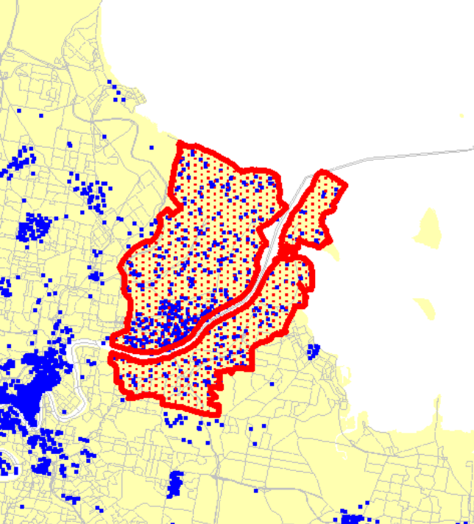
Population Growth
2006 – 2026
1 Dot = 100 person growth
Figure 1 2026 Population Growth

Public Transport Challenges for the Australia TradeCoast
The Australia TradeCoast covers a large geographic area and employment is dispersed throughout this area. Also, the type of industries in the area means individual lot sizes are large, which can present challenges for pedestrian access to public transport.

There are currently very few direct bus services to the Australia TradeCoast, with most existing services compromising route directness and travel time to provide greater coverage within the area.

Table 1 details the employment projections for each of the scenarios and Figure 2 illustrates the spatial distribution of employment growth in the study area under the PPOD Scenario.

Table 1Employment and Growth Scenarios

Year | 2006 | 2011 | 2016 | 2021 | 2026
ATC | 53,418 | 66,713 | 80,008 | 93,303 | 103,939
PPOD | 35,135 | 42,329 | 49,522 | 56,7169 | 63,909

http://download.translink.com.au/rti/100401_D103305_publictransportstudy.pdf
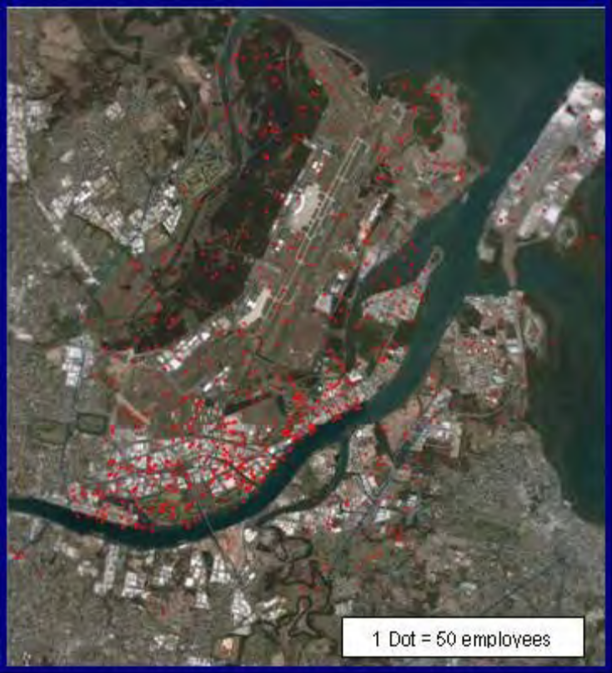
Figure 2 Employment Growth 2001 to 2026 (OUM, 2005)
Employment in the Australia TradeCoast is dispersed across a large geographic area. The type of employment means there are large lot sizes which may limit the “effective” pedestrian catchment areas. Also, current public transport infrastructure is not focused on the areas where employment is located.
While the airport rail link provides a frequent and reliable service to the domestic and international terminals, there are currently no high quality, frequent services to other employment areas such as Eagle Farm, Murarrie, Hemmant and Colmslie. The Cleveland rail line does pass through the southern Australia TradeCoast, however it is not within walking distance of key employment areas.

Further challenges are presented by the ample supply of free parking throughout the area, meaning public transport needs to effectively be inexpensive, frequent, fast and reliable to compete with the car.

Figure 3: Suburbs contributing 80% of employment growth in Brisbane LGA 2001-2026
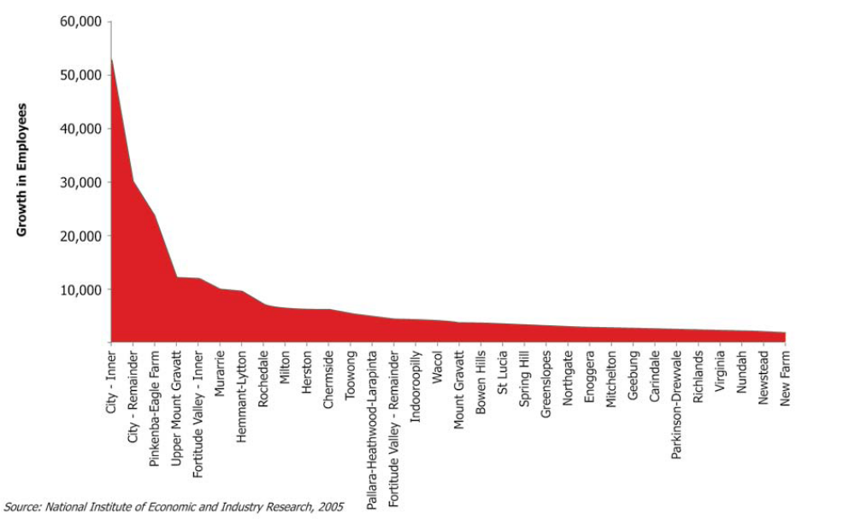
Figure 3 Employment Growth by Suburb
http://www.brisbane.qld.gov.au/bccwr/plans_and_strategies/documents/20061019_economicdevelopmentplan_full.pdf

Predicted employment needs for the BAC over the next ten years include

New terminal requirements
- Check in staff for new terminals
- Aircraft controllers and I.T. maintenance staff
- Baggage handlers/ground handlers
- Carousel maintenance
- Freight handling facilities & admin staff
- Security, Customs & Quarantine areas
- Jet fuel storage & handling staff
- Bus drivers

New runway & road building employees
Include such positions as;
- project managers
- surveyors, graphic artists (Drafting)
- heavy machinery drivers
- Diesel maintenance mechanics
- I.T. support
- workforce managers
- Concreting workers
New retail & hospitality requirements
- Lounge facility: (wait staff, short order chef, meet & greet staff, Cleaning & maintenance staff)
- Retail outlets: 30 new retail outlets (Unallotted as yet)
New aviation related opportunities
- Export Park; 17 Industrial lots
- Airport freight centre: 5 offices
- Da Vinci: 3 warehouses and offices

Clearly, the future employment opportunities available to school leavers who live in suburban areas accessible to the BAC by public transport are enormous.
To facilitate the transition however, the correct pathways must be identified and provided by the TAFE and tertiary sectors of education and training in Brisbane west, north and south. Currently, the following pathways
1) Exist and are accessible to the students in our region within the post secondary sector,
11) Are reasonably well known to students, parents and members of the education community generally, and
111) constitute a large percentage of the employment opportunities available to school leavers.
These courses are currently being provided by employment & training providers as stand alone courses, and most can be embedded in VETis courses while students are still attending schools.

Education and Training
Table 2 School NAPLAN Performance
 | Reading | Writing | Spelling | Grammar | Numeracy | % Retained
Brisbane North 2009
Albany Creek SHS | 572 | 564 | 568 | 565 | 577 | 82
Aspley SHS | 565 | 552 | 563 | 556 | 568 | 86
Aviation High | 585 | 565 | 585 | 593 | 594 | 113
Bracken Ridge SHS | 557 | 546 | 555 | 557 | 563 | 64
Craigslea SHS | 581 | 558 | 582 | 593 | 595 | 86
Earnshaw State College | 557 | 571 | 573 | 566 | 572 | 65
Everton SHS | 545 | 516 | 546 | 540 | 550 | 83
Ferny Grove SHS | 584 | 570 | 575 | 587 | 597 | 87
Kedron SHS | 582 | 571 | 582 | 581 | 595 | 90
Mitchelton SHS | 533 | 503 | 532 | 525 | 546 | 84
Sandgate District SHS | 556 | 548 | 562 | 556 | 567
Wavell SHS
Australian Average | 580.5 | 568.9 | 576.3 | 573.5 | 589.1 | State 77
Brisbane South 2008
Alexander Hills SHS | 565 | 565 | 571 | 563 | 566 | 70
Balmoral SHS | 517 | 472 | 494 | 490 | 519 | 116
Calamvale Community College | 554 | 557 | 568 | 551 | 550 | 80
Cavendish Rd SHS | 583 | 564 | 580 | 577 | 581 | 89
Capalaba State College | 549 | 532 | 550 | 540 | 549 | 55
Cleveland District SHS | 573 | 563 | 574 | 572 | 580 | 80
Coorpooroo Secondary College | 528 | 518 | 529 | 536 | 542 | 84
Holland Park SHS | 582 | 556 | 582 | 592 | 586 | 84
MacGregor SHS | 571 | 568 | 583 | 585 | 606 | 99
Mansfield SHS | 600 | 581 | 600 | 603 | 616 | 82
Mt Gravatt SHS | 584 | 578 | 575 | 577 | 590 | 103
Nyanda SHS
Rochedale SHS | 556 | 543 | 559 | 536 | 558 | 81
Runcorn SHS | 563 | 552 | 574 | 566 | 571 | 72
Stretton State College | 562 | 562 | 585 | 556 | 555
Sunnybank SHS | 531 | 497 | 529 | 563 | 543 | 79
Victoria Point SHS | 549 | 548 | 553 | 546 | 554 | 69
Wellington Point SHS | 561 | 564 | 571 | 571 | 570 | 71
Whites Hill SHS | 551 | 569 | 566 | 562 | 552 | 69
Wynnum SHS | 550 | 541 | 561 | 550 | 564
Brisbane Bayside State College (Wynnum Nth SHS) | 548 | 534 | 547 | 546 | 551
Yeronga SHS | 514 | 499 | 502 | 506 | 533
State Average | 568 | 555 | 567.8 | 563.2 | 570.7 | 70
http://www.brisbanecitylife.com.au/bcl/school/state.htm
http://www.qsa.qld.edu.au/downloads/publications/qsa_stats_naplan_09_outcomes.pdf

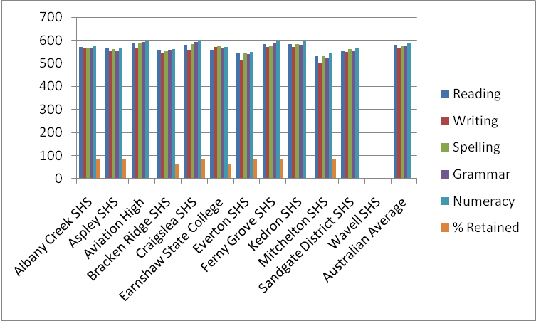
Figure 4 2009 Year 9 NAPLAN Data
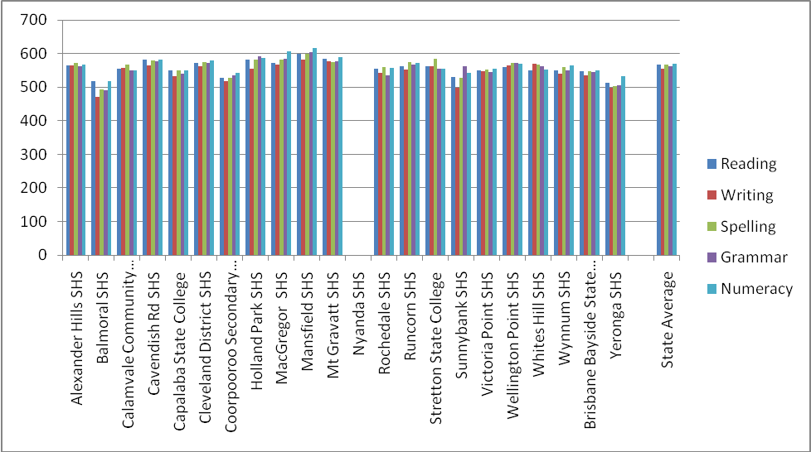
Figure 4: 2008 Year 9 NAPLAN Data

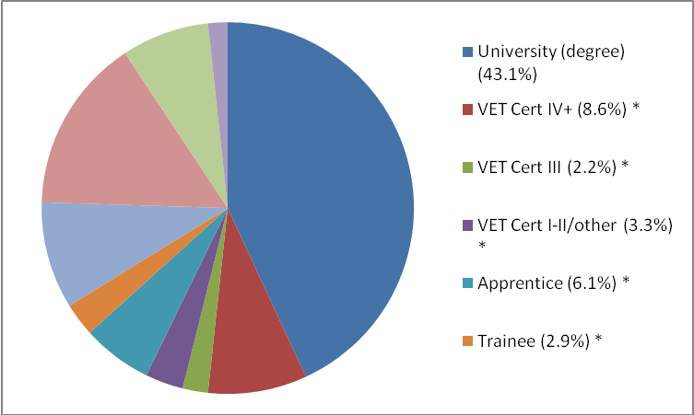
Figure 5 Main Destinations of Year 12 Completers, Brisbane, 2009

Pathways from school to employment at the BAC
This paper has identified the following tertiary providers in the Brisbane north, inner city and south as being the primary providers of the studies required.
Shortfalls in service delivery have been identified and are colour coded on the following table.
Table 3 Pathways from School to Employment at ATC
Year 11&12 | Instit. & Qualif. | Further study, Qualification. | Career path BAC |  | Year 11&12 | Instit. & Qualif. | Further study Q. | Career path BAC
Build/Constr | Southbank  Diploma  Skillstech  Cert III Construction | QUT  Batchelor Engineer | Building /  Construction |  | Human resources | Met Sth  Cert III Bus  Southb | Diploma HR  Diploma HR | Human resources
Business | Met Sth Cert III Bus  Southb  BRidge Cert III Bus | QUT  Batchelor of business  Diploma/Bachelor | Any of the many business streams present at BAC |  | Info Technology | Met Sth  Cert III  Southb  BRidge | Cert IV  Diploma of I.T  Diploma of I.T | All computer based applications
Boat Building | GoldCoast TAFE  Cert III Marine Craft Construction | Apprenticeship  UQ  Bachelor of Naval Archetecture |  |  | Interior design | Creative skills council  Cert IV Int. design | Diploma of Interior technology | Business start up function & refurbishment
Children services | Met Sth  Cert IV,  Southb  BRidge Cert III Ch services | Diploma Ch/care  Diploma Ch/care | There are 2 child care centres, one existing, one planned |  | Machinery ticketing | Met Sth  Southb  BRidge | Cannot find a current provider | Earth moving & site preparation
Cleaning | Met Sth  Cert III Asset. Man |  | One provider only, another at Mt Gravatt |  | Pest management | Met Sth  Cert III |  | Termite reports and structure reports based on insect penetration
Food Processing | Met Sth  RSA only  Southb  Baking only |  | This area may be under resourced in the future |  | Retail | Met Sth  Cert II & III  Southb  Cert II Baking  RSA  B. Ridge  Cert III | Cert IV  Cert IV | All streams of retail requirements
Graphic design | Met Sth  Southb  Dip GD for yr 11&12 | QUT  Batchelor fine arts  Diploma Gr. Design | This area may be under resourced in the future |  | Sales/Market | Met Sth  Business cert III  Southb  Business cert III  B.Ridge | Cert IV marketing  Diploma of marketing | All streams of sales and marketing requirements
Hospitality | Met Sth  Cert III  Southb  Cert III  Bridge  Cert III | All three have Diploma of events and Diploma of hospitality | This area is well resourced |  | Travel/ Tourism | Met Sth  Cert III Events  Southb  Cert III business  BridgeC3 | Diploma of Tourism/Events
Hairdressing | Met Sth  Cert II & III  Southb  Cert III | Diploma  Cert IV | This area is well resourced, but not in far north |  | Warehouse logistics | Met Sth  CertIII Trans & logistics  Southb  Bridge | Cert IV In Transport & logistics  No course in North | Warehouse and road transport logistics.  This area is a potential large growth area
Horticulture | Met Sth  Cert II & III | Cert IV and Diploma  (Landscape) | Bris north appears under resourced

Community Groups

Brisbane North
In the Brisbane North Region, an exploration of community groups reveals some 100+ with objects related to either the welfare /well being of families and community members or specific subject based recreational activities http://www.ourbrisbane.com/suburbs/north/community-groups
Many remain as unincorporated bodies that lack the formal governance arrangement and financial management systems that underpin successful partnership sustainability. Some are core nodal connectors to community groups . These larger organisations link to community groups they auspice, business enterprises who formally partner with the node and Government Departments who deliver programs with and through the "the network of networks" centred around the node
Specifically, the Chermside office of TSFPB is within fifty metres of
- Kedron Wavell RSL – (The club industry who both employ people ,link to sporting groups through Shaw Sports and provide community support and is a member of Clubs Queensland http://www.clubsqld.com.au/ who represent a significant community resource )
- Chermside Library – (The Nationally recognised contribution of BCC to community engagement and the current challenges faced by libraries for new roles in learning as individuals increasingly take charge of their personal learning programs .( Links to the Local Government Association of QLD who provide support for community development www.lgaq.asn.au )
- Chermside Pool ( BCC linkages to the strong northside network of sporting groups In the wider community
- Lang Park Police-Citizens Youth Club www.langparkpcyc.com/ -
- Volunteering Queensland www.volqld.org.au/
- Zillmere PCYC www.zillmerepcyc.org/ -
- Self Help Queensland www.selfhelpqld.org.au/

Brisbane South
From the an Environmental Scan the following groups were identified as the community groups most relevant to the education and transitions outcomes of young people, including activities the group is undertaking.
- A range of non-government organisations operate to assist youth and are generally grouped in the following categories careers, drugs and alcohols, finding work, heath (sexuality, suicide). Specific community organisations present in the region are:
- Boys Town (Youth Connections and Get Set for Work);
- BABI (Youth Support Coordinators & Get Set for Work);
- National organisations (Mission Australia, Red Cross);
- Horizon Foundation (Disability);
- Bayside Disability Services (Disability);
- Youth Support Coordinators funded by Qld Dept of Communities;
- Redlands Employment & Placement Services;
- Industry and community based organisations such as local Chambers of Commerce, Lions and Rotary (Business Links & Community projects);
- LCPs still operational - SCIPS, RWTG Inc, South West Carer Connect.
- The Smith Family have a strong presence in the Brisbane South East and Redland City region with one Learning for Life (LfL) worker delivering the Learning for Life suite of programs in community.

Business and Industry
Australia TradeCoast Business Directory
http://www.australiatradecoast.com.au/business/browse_directory/l
Active Hire
Active Hire is a Queensland owned equipment hire company, supplying both general and specialised equipment to all market segments. Active Hire has three branches strategically positioned at Hemmant, Rocklea and Hendra to promptly service your needs.
Name: Nigel Delve
Address: 1289 Lytton Road,HEMMANT QLD 4174
Email: ndelve@activehire.com.au
Phone: 07 3277 8566
Fax: 07 3274 1489
Mobile: 0403 368 095
Active Selection
As a recruitment agency our strategy is to keep in close contact with our clients temporary staff and candidates. We aim to maintain the personalised service of a small organisation and still achieve the strength of a multi-national company.
Name: Terry Blake
Address: 217 Logan Road ,Buranda QLD 4102
Email: tbl@ttas.com.au
Phone: 07 3217 3027
Fax: 07 3217 3488
Mobile: 0422 405 099
Adagold Aviation
Adagold is the leader in air charter in Australia. Adagold specialises in air charter for both passengers and frieght, both domestically and internationally. Adagold select the most suitable aircraft with the right specifications at the most economical costings.
Name: Stuart Lee
Address: Casuarina Street,Brisbane Airport QLD 4009
Email: brisbaneops@adagold.com
Phone: 07 3860 4777
Fax: 07 3860 5955
Mobile: 0438 759 601
Adecco
Recruitment agency servicing the following areas: Freight Manufacturing Transport & logistics Clerical & administration
Name: Patrick Ryan
Address: PO Box 112, Morningside QLD 4170
Email: patrick.ryan@adecco.com.au
Phone: 07 3009 4300
Fax: 07 3009 4399
AGS World Transport Pty Ltd
AGS is a leader in international, wholesale freight forwarding and cargo consolidation. AGS has offices in Brisbane, Sydney, Melbourne, Adelaide and Fremantle in addition to a web of worldwide agents.
Name: Andrew English
Address: 3/106 Fison Avenue West, EAGLE FARM QLD 4009
Email: ace@agsworld.com
Phone: 07 3632 4300
Fax: 07 3632 4333
Mobile: 0413 753 221
ANZ Corporate Banking
ANZ corporate banking is responsible for providing leading finacial services solutions to private family companies and ASX listed companies.
Name: Ben Barrett
Address: 3/324 Queen Street, Brisbane QLD 4000
Email: barrett3@anz.com
Phone: 07 32283059
Fax: 07 3228 3979
Mobile: 0412 261 751
Aristopet Pty Ltd
Australia's leading manufacturer of pet care and veterinary products, Aristopet pride themselves on the quality of their products and export to many countries including China. Aristopet distribute nationally through direct sales and distributors.
Name: Dianne Nelson
Address: PO Box 2, Fortitude Valley QLD 4009
Email: diane@aristopet.com.au
Phone: 07 3630 2166
Fax: 07 3630 2177
Mobile: 0417 357 616
Australian Presentation Systems (QLD)
Audio visual specialist dealing with quality products providing audio visual solutions for businesses that require projectors and accessories for boardrooms, training rooms etc. We provide total installation and connectivity. Other products include, plasmas, LCD Screens, audio systems and electronic whiteboards.
Name: Jane Timmins
Address: 4/7 Miller Street, MURARRIE QLD 4172
Email: jane@apsqld.com
Phone: 07 3890 5900
Fax: 07 3890 5700
Mobile: 0413 629 696
Bartons Bayside
Bartons Bayside was established over 60 years ago and has grown in this time to be Queensland's largest privately owned Holden dealer. We sell and service both Holden as well as used cars. We currently operate dealerships at 4 different locations.
Name: Mark Beitz
Address: PO Box 105,Wynnum QLD 4178
Email: markb@bartons.com.au
Phone: 3396 7777
Fax: 3393 3595
Mobile: 0417 755037
Bendix Business Furniture
Name: Peter Stephens
Address: PO Box 1212, EAGLE FARM QLD 4009
Email: peter@bendixqld.com.au
Phone: 07 3268 7700
Fax: 07 3268 7929
Mobile: 0413 758 956
BP Refinery
Refinery
Name: Kathy Hirschfeld
Address: PO Box 4,Pinkenba QLD 4053
Email: carmel.taylor@bp.com
Phone: 07 3243 7333
Fax: 07 3243 7301
Mobile: 0411 740 069
Brisbane North Institute of TAFE
Our tailor-made corporate training programs help businesses become globally competitive Brisbane North Institute of TAFE is a recognised leader in developing and delivering innovative training that connects people to the jobs of the future and gives more choice in learning pace, place and pathway. Our purpose Brisbane North Institute of TAFE delivers quality customer focussed vocational education and training to students and corporate clients across Brisbane’s central and northern districts using a variety of flexible and blended delivery options. In addition, students Queensland and Australia-wide are provided with access to off-campus training via the TAFE Open Learning delivery mode. We specialise in developing and delivering quality training that prepares the workforce for the jobs of the future. We lead the development and delivery of programs that give people the choice and flexibility to learn at their own pace at home, online, on the job, or on campus. We work with community, industry and employers to develop and deliver innovative training programs that equip people for jobs in emerging industries. .
Name: Jenny Salonen
Address: Locked Bag 3, Eagle Farm BC, Eagle Farm QLD 4009
Email: jenny.salonen@detal.qld.gov.au
Phone: 32599239
Fax: 32599273
Mobile: 0437024196
Bulk Cargo Services Pty Ltd
Dry bulk storage. Grab Hire. Hopper Hire. Cargo Superintendence, Gypsum sales.
Name: David Alexander
Address: PO Box 80
PINKENBA QLD 4008
Email: David.Alexander@bulkcargo.com.au
Phone: 07 3621 1777
Fax: 07 3621 1788
Mobile: 0402 411 999
buzz print
Buzz Print is a dynamic and flexible full service print business situated in the expanding Gateway Corridor of Brisbane. The business offers a borad range of pre-print (design, copywriting, logo/company image development), print (offset large print jobs - order/docket books, business card/letterhead, brochures and more flexible digital printing - training manuals, plans, short run business cards etc) and print finishing options (binding, laminating) as well as a number of complimentary products and services (banners, banner stands, signage (hard and soft)). The business has operated successfully for over 10 years focusing on delivering value for money print solutions and five star services to both local and interstate clients. Some of Buzz Print's clients include Royal Wolf, Boeing, APA Group (Origin Energy) Robin's Kitchen Brambles and FBAA.
Name: Justin Ward
Address: 4/944 Nudgee Road
Northgate QLD 4013
Email: justin@buzzprint.com.au
Phone: 07 3267 6666
Fax: 07 3267 3366
Mobile: 0408 885517
Caltex Refineries (Qld) Pty Ltd
Processing of crude oil to petroleum products
Name: Liam Tobin
Address: PO Box 40, WYNNUM QLD 4178
Email: latobin@caltex.com.au
Phone: 07 3362 7101
Fax: 07 3362 7972
Mobile: 0412 599 215
Cavcorp
Cavcorp is a leading diversified property development and construction company active in investment, development and construction. Cavcorp’s vast experience in the property and construction industry allows for the reliable delivery of quality commercial and residential developments. Australian owned and operated, Cavcorp continues to expand as one of Queenslands boutique property groups. A leader in its field, Cavcorp is committed to the provision of exceptional service, outstanding residential and commercial developments, and sound investment opportunities.
Name: James Richards
Address: 34 Helen St, Newstead QLD 4006
Email: james@cavcorpqld.com.au
Phone: 3257 1188
Fax: 3257 0655
Mobile: 0447 487 008
Coachtrans Australia
Coachtrans provide passenger airport transfers between Gold Coast/Brisbane, accommodation and hotels to Brisbane International and Domestic airports. Contracted to Queensland Transport Department and Brisbane Airport Corporation to operate these services.
Name: Cosimo Sita
Address: PO Box 300, Biggera Waters QLD 4226
Email: cos@coachtrans.com.au
Phone: 07 5500 8999
Fax: 07 5500 8937
Conics (Brisbane) Pty Ltd
Conics is a leading development consultancy focused on urban growth and infrastructure. We help our clients, both public and private, meet the challenges of urban growth and infrastructure delivery through a unique combination of services – Design, Planning, Surveying and Economics + Advisory We add value through an integrated approach to development. We collaborate, combining the expertise and technical skills of our diverse professionals for a holistic project perspective. Through industry leadership, we seek to achieve strong commercial outcomes for our clients that impact positively on the social, economic and environmental fabric of our communities
Name: Michael Mason
Address: 743 Ann Street, Fortitude Valley QLD 4006
Email: amba.sharpe@conics.com.au
Phone: 07 3237 8899
Fax: 07 3237 8833
DHL Global Forwarding
Name: Robert Kasch
Address: PO Box 406, Brisbane Airport QLD 4007
Email: robert.kasch@dhl.com
Phone: 07 3637 7100
Fax: 07 3637 7222
Finlease (Australia) Pty Ltd
We can offer a tailored finance package without tying up your valuable working capital or property: Commercial Hire Purchase, Finance Lease, Operating & Lease Back, Vendor Supplier Finance; Equipment Rental; Factoring & Debt Restructuring
Name: Phil Horton
Address: PO Box 611, COOPAROO QLD 4151
Email: qldsales@finlease.com.au
Phone: 07 3324 2655
Fax: 07 3324 2655
Frequentis Australasia Pty Ltd
Frequentis provides: Safety Critical Communications and Information Management Systems for Airports, Air Traffic Control, Defence, Police, Fire, Ambuland, Security, Ports and Coast Guard, Maritime Safey, Rail Transport
Name: Allan McDonagh
Address: 4b / 12 Navigator Place, Hendra QLD 4011
Email: allan.mcdonagh@frequentis.com
Phone: 07 3630 0888
Fax: 07 3630 1955
Mobile: 0419 003910
G. James Australia Pty Ltd
The G.James Group of Companies is involved in manufacture, fabrication, processing and installation of a diverse range of products and is Australia's leading integrated glass & aluminium manufacturer and contractor.
Name: Lewis Saragossi
Address: PO Box 1376, EAGLE FARM QLD 4009
Email: lewis_saragossi@gjames.com.au
Phone: 07 3877 2333
Fax: 07 3877 2893
Geon Australia Pty Ltd
GEON is the largest sheet fed printing company in QLD and we offer our clients high quality and innovative print and mail solutions, supported by highly experienced personnel and industry leading technology.
Name: Debbie Luttgens
Address: 675 Macarthur Avenue Central , EAGLE FARM QLD 4009
Email: debbie.luttgens@geongroup.com
Phone: 07 3637 9639
Fax: 07 3637 9680

Mobile: 0411 693 703
Halmac Services (Qld) Pty Ltd
Halmac is an Electrical Engineering, Contracting including Data & Communications, Service and Maintenance Company. Electrical Engineering includes Switchboards, PLC, SCADA and Telemetry Systems. Electrical Contracting includes large industrial projects, abattoirs, food and beverage process lines, water and wastewater treatment plants, hazardous areas and petroleum projects and commercial projects. Service activities include programmed and break down maintenance, welder and specialist equipment repair, 24 hours 7 days all year.
Name: Brad Robertson
Address: 30 Palmer Place, MURRARIE QLD 4172
Email: Brad@halmacservicesqld.com.au
Phone: 07 3249 9500
Fax: 07 3249 9599
Mobile: 0427 008 162
Health For Industry
Health for Industry provides occupational health services across Australia to help prevent, treat and manage workplace injuries and illness. We also provide specialist medical and allied health services to improve overall workplace health. Delivering benefits for employers Health for Industry delivers significant benefits to employers, through: safer workplaces injury treatment to minimise lost time improved return to work outcomes lower insurance premiums. We have a medical clinic at Brisbane Airport with another 6 located in industrial areas throughout QLD
Name: Thea Lynch
Address: GPO Box 9821, Brisbane City QLD 4001
Email: thea.lynch@hfi.com.au
Phone: 07 3307 9473
Fax: 07 3307 9453
Heavy Maintenance Group
Heavy Maintenance Group is a new mining services provider. HMG is based in Brisbane and initially comprises three recently acquired operating businesses: Hardchrome, Westhill Engineering and ABC Heavy Engineering.
Name: John Bromfield
Address: PO Box 386, Hamilton QLD 4007
Email: john.bromfield@heavymaintenance.com.au
Phone: 07 3866 7070
Fax: 07 3866 7072
Hunter Transport Industries
Freight and courier business, including warehousing and taxi trucks, with company owned premises Sydney, Melbourne and Brisbane and servicing all of Australia.
Name: Les Bihari
Address: 97 Bancroft Street, PINKENBA QLD 4008
Email: lesb@hunterexpress.com.au
Phone: 07 36227700
Fax: 07 3860 4838
Mobile: 0411 523 076
idec solutions pty ltd
idec solutions specialises in the design and construction of steel framed buildings.
Name: Glenn Gibson
Address: PO Box 100 , Cannon Hill QLD 4170
Email: glenn.gibson@idec.com.au
Phone: 07 3908 9600
Fax: 07 3908 9699
Mobile: 0423 770 452
Incitec Pivot Ltd
Leading agriculture and chemical fertiliser plant which has operations from its phosphate plant in FNQ to the heart of all farm sellers in Eastern and Southern Australia.
Name: Damian Ziebarth
Address: PO Box 140, MORNINGSIDE QLD 4170
Email: michelle.hudson@incitecpivot.com.au
Phone: 07 3867 9616
Fax: 07 3867 9577
ITT Communications Pty Ltd
Communication is everything. Business Telephone systms for 14 years. Best breed of equipment and suppliers: Panasonic, ShoreTel and Telstra. We are your neighbour.
Name: Hamish Haggitt
Address: PO Box 7, Bulimba QLD 4171
Email: hamish.haggitt@ittcoms.com.au
Phone: 07 382 382 22
Fax: 07 382 38211
Mobile: 0411 550 210
Kagan Logistics
Warehousing, transport and distribution. Modern fleet of container trucks picking up from the wharf and delivery to our warehouse fo unpack and storage or direct to clients. Large warehouse services and distribution of warehoused goods.
Name: Peter Thompson
Address: PO Box 552, Wynnum QLD 4178
Email: peter.thompson@kagan.com.au
Phone: 07 3348 3755
Fax: 07 3396 0177
Mobile: 0409 430 610
King & Co Property Consultants
South East Queensland's premiere specialist in the sale or leasing of industrial or commerical property as well as property management, much of it with the Australia TradeCoast region.
Name: David Knapp
Address: PO Box 1046 , Coorparoo DC QLD 4151
Email: d.knapp@kingco.com.au
Phone: 07 3844 3222
Fax: 07 3844 9888
Mobile: 0421 571 140
Kingsfeld (QLD) Pty Ltd
Bulk haulage, excavation and civil engineering, landfill and rehabilitation consultants.
Name: Stephen Rhind
Address: PO Box 1412, Eagle Farm QLD 4009
Email: jo@kingsfeld.com.au
Phone: 07 3860 4076
Fax: 07 3860 4076
Mobile: 0418 264 003
Kwik Kopy Printing Eagle Farm
Kwik Kopy Printing Eagle Farm is a local independently owned business. With a full time graphic designer as part of our team, we can design & print anything from Corporate stationary, presentation folders, and carbonless forms through to brochures, posters and training manuals. We can print directly from digital files to high speed B&W or colour copiers and also offer a comprehensive range of finishing services.
Name: Sandy Kochelak
Address: PO Box 1019, EAGLE FARM QLD 4009
Email: print@eaglefarm.kwikkopy.com.au
Phone: 07 3268 5911
Fax: 07 3268 6413
Mobile: 0433 563 260
Lago Coldstores Pty Ltd
Cold Storage Provider of bulk freezing operations. Picking and container unpack and pack. Distribution fleet servicing South East Queensland.
Name: Ian Vayro
Address: PO Box 7116 , Hemmant QLD 4174
Email: ian.vayro@lago.com.au
Phone: 07 3390 8000
Fax: 07 3890 1068
Mobile: 0404 063102
Life Assets
Life Assets is a Financial Planning and Wealth Management Company where growing, protecting and managing your wealth is our prime objective. Life Assets specialises in creating tailored financial plans based on the unique needs, objectives and situations of our individual clients. We identify your financial needs and goals, discuss your comfort level of risk and tailor a strategy which meets both your financial goals and abilities. We can offer expert advice on protecting your income, workplace employee solutions, superannuation and retirement planning and wealth creation.
Name: Paul Stephenson
Address: PO Box 809, Hamilton QLD 4007
Email: garth@lifeassets.com.au
Phone: 07 3868 3200
Fax: 07 3868 4977
MDRN Solicitors
Solicitors with offices in Capalaba and Cleveland , 4 partners , 40 staff. Property Conveyancing; Planning and Enviroment Law ; Business Law ; Wills and Estates; Litigation. Corporate Law ; Leasing.
Name: Jon McCarthy
Address: PO Box 122, Capalaba QLD 4157
Email: jonm@mdrn.com.au
Phone: 07 3245 5100
Fax: 07 3390 3006
Mobile: 0413 620 094
Moreton Hire
National suppliers and market leaders with 40 years experience in the exhibition and event infrastructure market servicing over 300 major industry and public events and exhibitions last year.
Name: Michael Coulton
Address: 31 Paringa Road , MURRARIE QLD 4172
Email: michael.coulton@moreton.net.au
Phone: 07 3307 4444
Fax: 07 3307 4449
Optone Pty Ltd t/as Rizzi Cold Storage
Name: Walter Lago
Address: PO Box 7115, Hemmant QLD 4174
Email: info@rizzi.net.au
Phone: 0738904100
Fax: 0738904027
Mobile: 0416073909
Process Systems Pty Ltd
Process Systems manufacture and distribute control valves for air, fluid, vacuum, chemical and steam. Soleinoid valves, actuated ball and butterfly valves, (penumatic and electric) in various materials including brass, stainless steel and plastic. Ancillary range of fittings and tubing etc.
Name: Ross Griffiths
Address: PO Box 2070, Wellington Pt QLD 4160
Email: sales@processsystems.com.au
Phone: 3890 3122
Fax: 3890 3133
Mobile: 0412 742 662
Raine & Horne Commercial
Raine & Horne Commercial Southside has 2 offices. Head Office located at Rocklea and the Port Office at Murarrie.
Name: Nick Comino
Address: PO Box 504, ARCHERFIELD QLD 4106
Email: nick@rnhcommercial.com.au
Phone: 07 3899 4700
Fax: 07 3899 4088
Mobile: 0412 151 492
Raine & Horne Queensland
Head Real Estate fanchisor with 105 offices located throughout Queensland.
Name: Stephen Sharry
Address: Level 1, 545 Queen Street , Brisbane QLD 4000
Email: ssharry@rhq.com.au
Phone: 07 3031 0333
Fax: 07 3221 8671
Mobile: 0423 439 999
Red Spot Rentals
Red Spot Car Rentals is the largest independent car rental company in Australia. We offer new cars at competitive rates, including our unique all-inclusive Drive-Away rate. With rental desks inside the terminal building or operating from conveniently located offices close to the airport, Red Spot is the alternative to the multinationals.
Name: Stuart Ratcliffe
Address: PO Box 886, Mascot QLD 1460
Email: sratcliffe@redspotrentals.com.au
Phone: 1300 668810
Fax: 02 9690 1435
Rentokil Fumigation & Quarantine Services
Fumigation of imported and exported goods, from general freight to perishables. Inspection of goods for export. Head treatment for import and export goods.
Name: Shaun Miley
Address: 335 Fison Avenue East, Eagle Farm QLD 4009
Email: smiley@rentokilinitial.com.au
Phone: 07 3630 0800
Fax: 07 38684097
Mobile: 0412 389 626
Rohrig
Commercial construction, project management and development
Name: Glenn Rohrig
Address: PO Box 1413, EAGLE FARM QLD 4009
Email: glennr@rohrig.com.au
Phone: 07 3868 3880
Fax: 07 3868 3690
Mobile: 0419 763 203
Schenker Australia Pty Ltd
DB Schenker is one of the world's leading providers of integrated logistics services. We provide support to trade and industry in the global exchange of goods. DB Schenker is part of DB Mobility Logistics, the transportation and logistics division of Deutsche Bahn AG.
Name: Michael Price
Address: PO Box 350 , Albion QLD 4010
Email: michael.price@schenker.com
Phone: 07 3622 7500
Fax: 07 3860 5304
Skelton Sherborne
Worldwide logistics management of oversized and heavy cargo. Freight forwarding, customs consultancy, quarantine clearance, bonded storage and heavy haulage.
Name: Jillian Kingsford Smith
Address: PO Box 7148, Hemmant QLD 4174
Email: jillian@skeltonsherborne.com
Phone: 07 3348 7810
Fax: 07
Mobile: 0424191392
Skyclean
Skyclean is committed to being the leading provider of aviation support services. We specialise in Aircraft Detailing (internal and external clean), tarmac and ramp safety, passenger logistic services, loading of inflight catering, potable water servicing, full toilet servicing.
Name: Phil Lennox
Address: 53 Raceview Avenue , HENDRA 0 4011
Email: skyclean@bigpond.net.au
Phone: 07 3860 5441
Fax: 07 3860 5424
Mobile: 0418 150 984
Stylers Body Works Pty Ltd
Stylers is a business smash repairs in the Brisbane metro area. We provide quality workmanship by qualified tradesmen. Our success is built on customer referral and quality workmanship.
Name: Loris Puglia
Address: PO Box 8, Virginia QLD 4014
Email: loris@stylers.com.au
Phone: 07 32668838
Fax: 07 32668839
Mobile: 0418876947
Suncorp
Provision of commercial finance for construction, property investment & business purposes. Virginia office incorporates all areas of north & east Brisbane including Hamilton, Eagle Farm, Pinkenba, Murarrie etc. The branch at Hamilton provides a full banking service including branch, business and investment services. I currently manage several clients within the precinct. As opposed to being based in the region, my role is to visit with clients/prospects at their premises and within the local branch network (which includes Hamilton). I have been assigned by Suncorp to manage the TradeCoast region in relation to commercial prospects.
Name: Shane Miller
Address: 94 Robinson Road East, Virginia QLD 4014
Email: shane.miller@suncorp.com.au
Phone: 3632 9330
Fax: 3865 6270
Mobile: 0409 268 958
Svitzer
Adsteam Harbour is the ship assist division of Adsteam Marine and provides world standard maritime services, including towage, lines and moorings, crew transfers and bunkering. Adsteam Harbour operates in all major container ports in Australia.
Name: Chris Barnes
Address: 20 Howard Smith Drive, WHYTE ISLAND QLD 4178
Email: christopher.barnes@svitzer.com
Phone: 07 3895 1022
Fax: 07 3895 1024
Mobile: 07 3895 1024
Travelex
Travelex specialise in the payment and receipt of international funds for importers and exporters. We offer a range of products and solutions to simplify the payment process and manage foreign currency exposure. We are based in Sydney, Brisbane, Melbourne, Perth and Adelaide. We are a global company.
Name: John Holden
Address: Head Office, Level 12, Margaret Street
Sydney NSW 2000
Email: John.Holden@travelex.com
Phone: 02 8585 7000
Fax: 02 8585 7591
Mobile: 0410 005 470
Tzaneros Group
Developing and maintaining a facility at Portgate precinct for freight forwarders, custom brokers, exporters and importers.
Name: Steven Tzaneros
Address: PO Box 530, Wynnum QLD 4178
Email: steven@tzanerosenterprises.com.au
Phone: 07 38955750
Fax: 07 38955788
Mobile: 0419 227 037
Valves Online
Internet portal and distributor for control valves and related equipment.
Name: Ryan Griffiths
Address: PO Box 2070 , WELLINGTON POINT QLD 4160
Email: thegs@bigpond.net.au
Phone: 3890 3122
Fax: 3890 3133
Wallace International
Wallace International provides Importers and Exporters with the complete logistic services through the entire supply chain.In addition to being a Licensed Customs Broker, the company is a member of the Customs Broker and Forwarders Council of Australia (Inc), The Australian Institute of Export and has IATA accreditation.
Name: Brendan Gardiner
Address: PO Box 678 , BULIMBA QLD 4171
Email: brendan.gardiner@wallaceintl.com.au
Phone: 07 32127 333
Fax: 07 3399 6722
Mobile: 0417 762 446
Wilson Parking
Wilson provides services in car park management, car park equipment and security. Wilso has offices across Australia and South East Asia. Wilson works closely with BAC to manage on-site airport parking.
Name: Wylliam Young
Address: PO Box 90, Brisbane QLD 4000
Email: wyoung@wilsongroup.com.au
Phone: 07 3233 0709
Fax: 07 3233 0777
Wilson Security
Wilson Security provides a professional highly coordinated management approach in the delivery of security, retail loss prevention, traffic management, major event security and event management
Name: Bill Harding
Address: Level 28 AMP Place, 10 Eagle Street, Brisbane QLD 4000
Email: bharding@wilsonsecurity.com.au
Phone: 07 32330703
Fax: 07 32299100
Mobile: 0423024180

One of the points of differentiation between the BAC Precincts and POB Precincts is the level of retail activity.

BAC precincts existing retail outlets and accommodation providers:
The Village markets
- Novotel: Reservations, business admin, baggage handlers, hospitality staff, retail staff, cleaners.
- Woolworths
- Dan Murphy
- R M Williams
- Coffee Club
- Chemists
- Flight Centre
- Clancy James (Butcher)
- Tadpoles and other ELC.
- Hairdressers
- Tavern
- Beauty shop
- Fashion and footwear stores
Existing Domestic terminal retail and hospitality providers
- Eagle Boys
- Merlo Coffee
- Food court
- Food on 2
- Food on 2 Express
- Velluto Expresso Bar
- Luggage sales
- Ripcurl
- Newsagent
- Visitor information centre

Existing international terminal retail & hospitality providers:
- Internet kiosk
- Luggage protection shop
- Mobile phone store
- Car rentals
- Airline lounge
- 17 other retail outlets
- 11 food outlets

