LEARNING TO WRITE NEED STATEMENTS

The story I heard
Everybody in their own tent, doing their own thing

The picture that came into my head
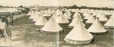

The need I wrote in our summary
Enable people who provide programs for our kids to work more effectively together, working collaboratively to reach shared goals and working in a complimentary way so as to minimize replicating programs.

The results we might aim at
Strengthen the partnerships already established and improve communications between community and service providers, and between all service providers themselves.

High quality partnerships are established that link key stakeholders together with shared commitment, goals and outcomes to improve young people’s education and transition outcomes.

The story I heard
There are too many people at the table. Most of them can’t make decisions. Some have the solutions and want to make decisions for us!

The picture that came into my head
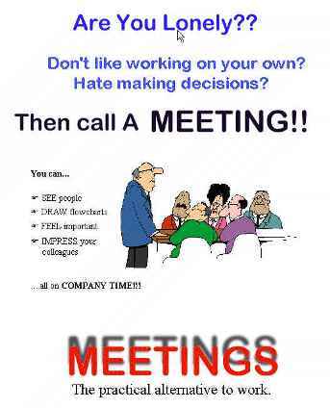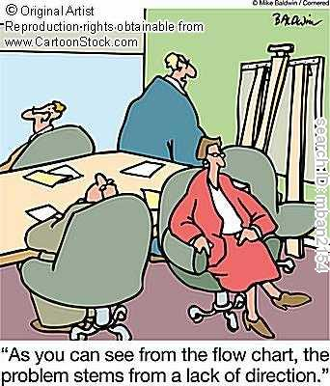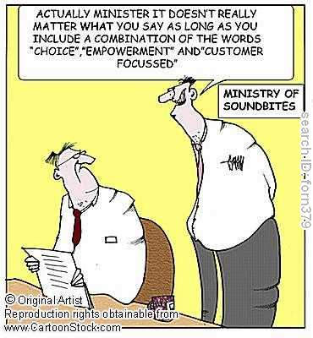

The need I wrote in our summary
Focus on things that matter for kids.

The results we might aim at
Value everyone’s information; decide together; do what we say

Aboriginal people must lead and drive the agenda for change – not the non-Aboriginal bureaucrats. Community ownership and control of initiatives guarantee cultural identity is acknowledged and valued and will lead to true sustainable partnerships being formed.

The story I heard
Parents aren’t home, nobody there for the kids and if they are home they don’t know what to do to help their kids. Programs to inform parents and help them manage young people are not working.

The picture that came into my head
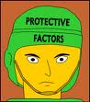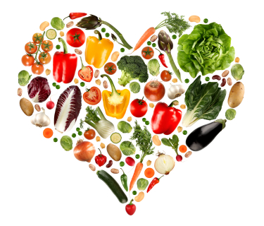

The need I wrote in our summary
Provide easy access to practical information for parents in language they can understand and apply.

The results we might aim at
Parents play a more active role, and are equipped with practical tools that allow them to be engaged in their kids lives. Young adults have access to transition information when they need it in a form they can use.

