Table of Contents
Part One Introduction to Evaluation
- Evaluation’s Basic Purpose, Uses, and Conceptual Distinctions
  - Brief definition
  - Informal v. formal
  - Distinguishing betw. Evaluation’s purpose and evaluators role
  - Some basic types of evaluation
  - Evaluation’s Importance and its limitations

- Origins and Current Trends in Modern Program Evaluation
The history and influence of evaluation in society
Recent trends influencing program evaluation

Part Two Alternative Approaches to Program Evaluation
Part Three Practical Guidelines for Planning Evaluations
Part Four Practical Guidelines for Conducting and Using Evaluations
Part Five Emerging and Future Settings for Program Evaluations

Chapter 1 Evaluation’s Basic Purpose, Uses, & Conceptual Distinctions

Scriven (1967) defined evaluation as judging the worth or merit of something. More broadly, evaluation is the identification, clarification, and application of defensible criteria to determine an evaluation object’s value (worth or merit) in relation to those criteria (p. 5).

An important role of evaluation is to help stakeholders articulate their criteria and to stimulate dialogue about them. Evaluation uses inquiry and judgment methods, including (1) determining standards for judging quality and deciding whether those standards should be relative or absolute, (2) collecting relevant information, an (3) applying the standards to determine values, quality, utility, effectiveness, or significance.

Pgs. 6 & 7 difference between research and evaluation: purpose, who sets the agenda, generalizability of results, criteria, and preparation.

Informal v. formal form a continuum. Informal eval can result in faulty or wise judgments, characterized by an absence of breadth and depth because of a lack of systematic procedures and formally collected evidence.

Evaluation has an ultimate impact on society. Mark, Henry, and Julnes (1999) four different purposes of evaluation: assessment of merit or worth, oversight and compliance, program and organizational improvement, and knowledge development.

Formative and Summative Evaluation
- Formative if the primary purpose is to provide information for program improvement.

- Two important factors that influence the usefulness of formative are control and timing.

- Summative are concerned with providing information to serve decisions or assist in making judgments about program adoptions, continuation or expansion. Scriven (1991) evaluation done for, or by, any observers or decision makers who need valuative conclusions for any other reasons besides development (pg. 20). Some orgs focus too much of summative evaluation.

- Summative must attend to time of budgetary and legislative decisions (pg. 19).

- Summative evaluation may be largely or entirely process evaluation. (Scriven, 1996 pg. 152)

Robert Stake (cited by Scriven, 1991, p. 19) when the cook tastes the soup, that’s formative evaluation, when the guest tastes it, that’s summative evaluation.

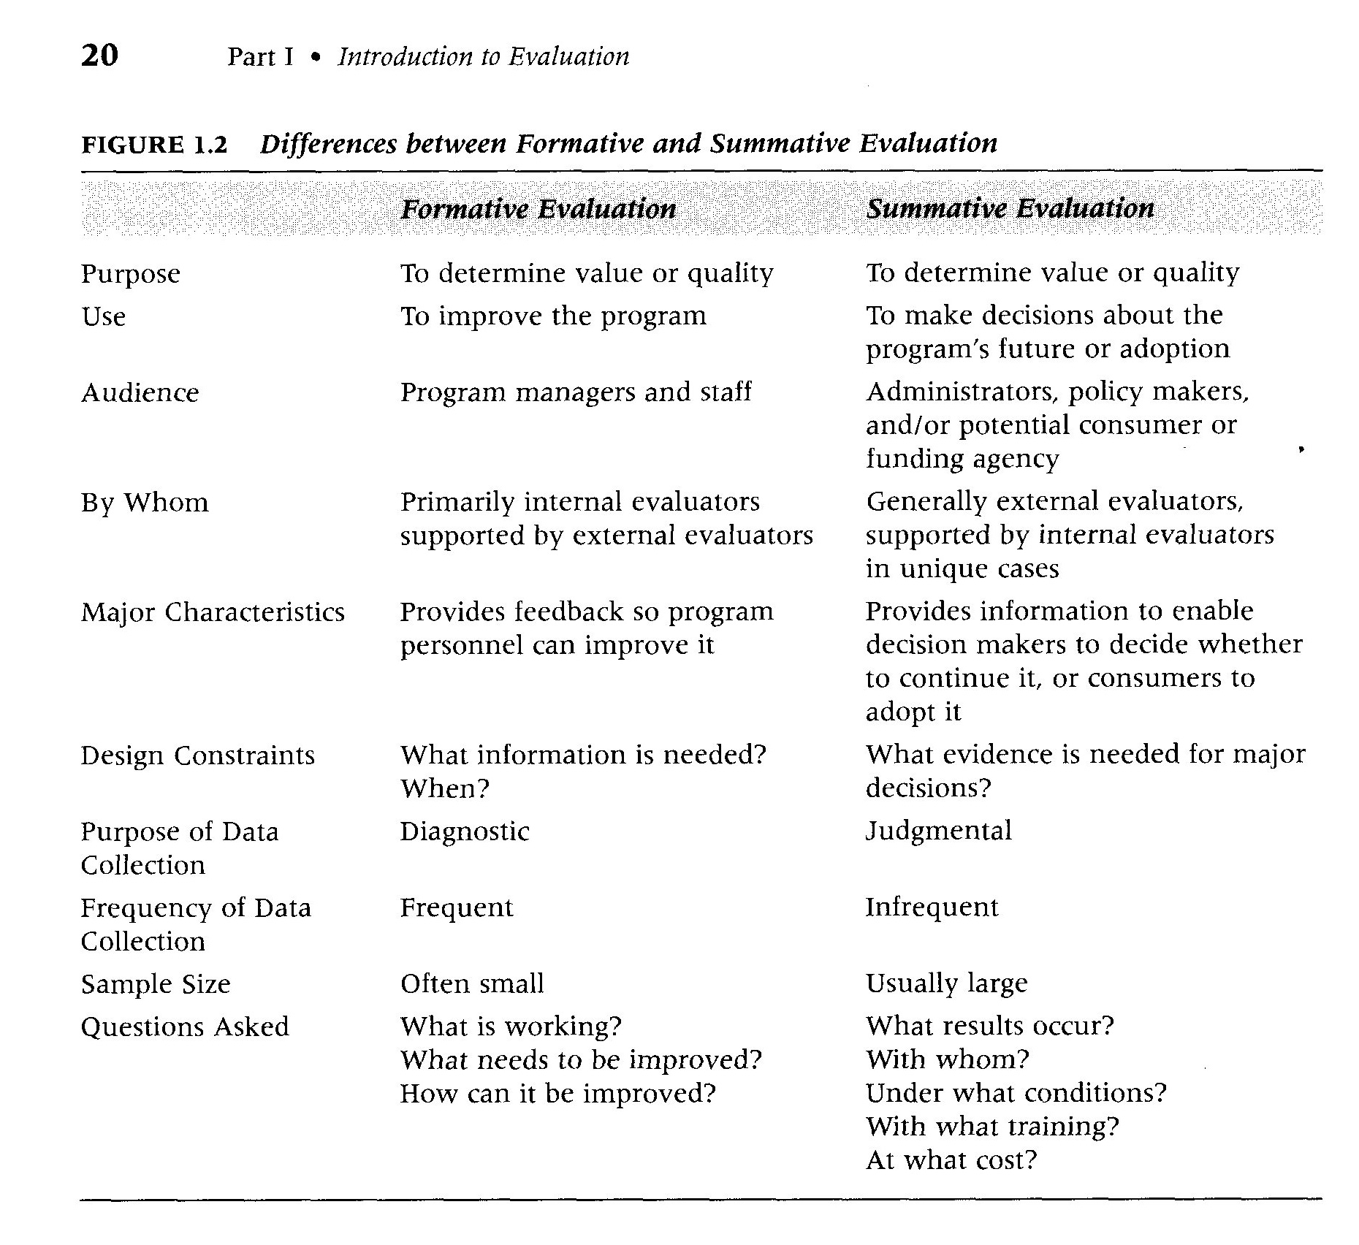
Audience for summative and formative evaluation is very different. Generally, the people delivering the program is formative and the potential consumers, policy makers are summative.

Needs Assessment, Process, and Outcome Evaluations

The distinctions between formative and summative evaluation are concerned primarily with the kinds of decisions or judgments to be made with the evaluation results.

Needs assessment questions are concerned with establishing (a) whether a problem or need exists and describing that problem, and (b) making recommendations for ways to reduce the problem, i.e., the potential effectiveness of various interventions.
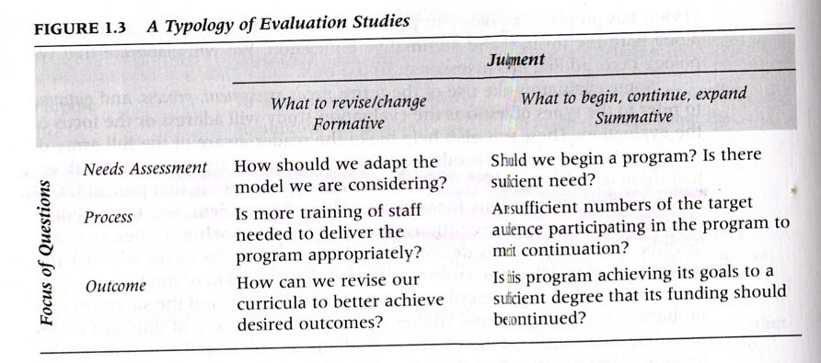
Process, or monitoring studies, typically describe how the program is delivered. Such studies may focus on whether the program is being delivered according to some delineated plan or model or may be more open-minded.

Outcome studies are concerned with describing, exploring, or determining changes that occur in program recipients, secondary audiences or communities as a result of the program.

The formative and summative distinction comes first, then, to help focus our attention on the judgment to be made or the action to be taken.

Internal and External evaluations

Strengths of external evaluations lie in their distance from the program and the evaluator’s expertise. Summative evals are probably most often (and probably best) conducted by external evaluators.
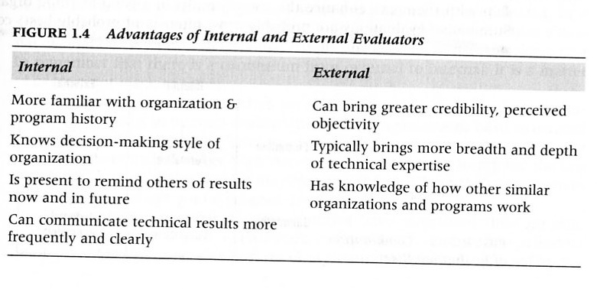
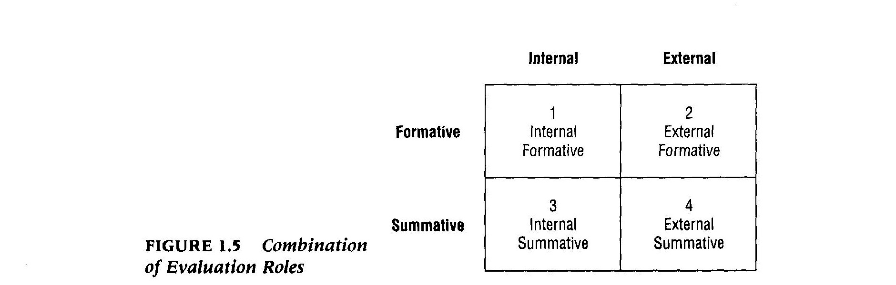Evaluation’s importance and limitations

Scriven: evaluation on pragmatic, ethical, social and business, and intellectual terms.

Chapter 2 Origins and Current Trends in Modern Program Evaluation

Early Forms of Formal Evaluation
- As early as 2000 B.C., Chinese officials conducted civil service exams

Program Evaluation: 1800-1940
- Efforts in accreditation of universities (late 1800’s), medical schools (Flexner, 1900s)
- City management of slum conditions in urban areas
- Educators regarded measurement and evaluation as synonymous, with the latter usually thought of as summarizing students test performance and assigning grades.
- Tyler plants the seed for criterion-referenced testing in the Eight Year Study

Program Evaluation: 1940-1964
- Applied social research during WWII expands
- Enhancement of the Tylerian approach
- Sputnik and the National Defense Education Act (NDEA) 1958 <millions for math and science>

The Emergence of Modern Program Evaluation 1964-1972
- War on Poverty and the Great Society (President Johnson)
- The Elementary and Secondary Education Act (ESEA, 1965) federal funding for education for Title I (compensatory education) and Title III (innovative educational projects)
- No serious expertise in evaluation of these new projects/products existed
Growth of Evaluation in Other Areas
- Theoretical and methodological work emerges.
- Suchman (1967) methods
- Campbell (1969) social experimentation needed
- Campbell and Stanley (1969) quasi-experimental design
- Scriven (1967) Stake (1967) and Stufflebeam (1968) evaluation practice and theories
- Wholey (1970) political aspects of evaluation
- Weiss (1972)

Graduate Programs in Evaluation Emerge
Modern program evaluation was set by three factors: 1) burgeoning post WW II US economy; 2) dramatic growth in the role of the federal government in education and policy and; increase in the number of social science grads with interest in evaluation and policy analysis.

Evaluation Becomes a Profession: 1973-1984
- Scriven (1972) goal-free evaluation
- Stufflebeam (1971) CIPP model
- Stake (1975b) responsive evaluation
- Guba & Lincoln (1981) naturalistic evaluation
- The decline in evaluation at the federal level actually resulted in a diversification of evaluation not only in settings but in approaches.
- Formative evaluations examining programs to provide feedback for incremental change and improvement and to find the links between program actions and outcomes, becomes more prominent.

1985-Present

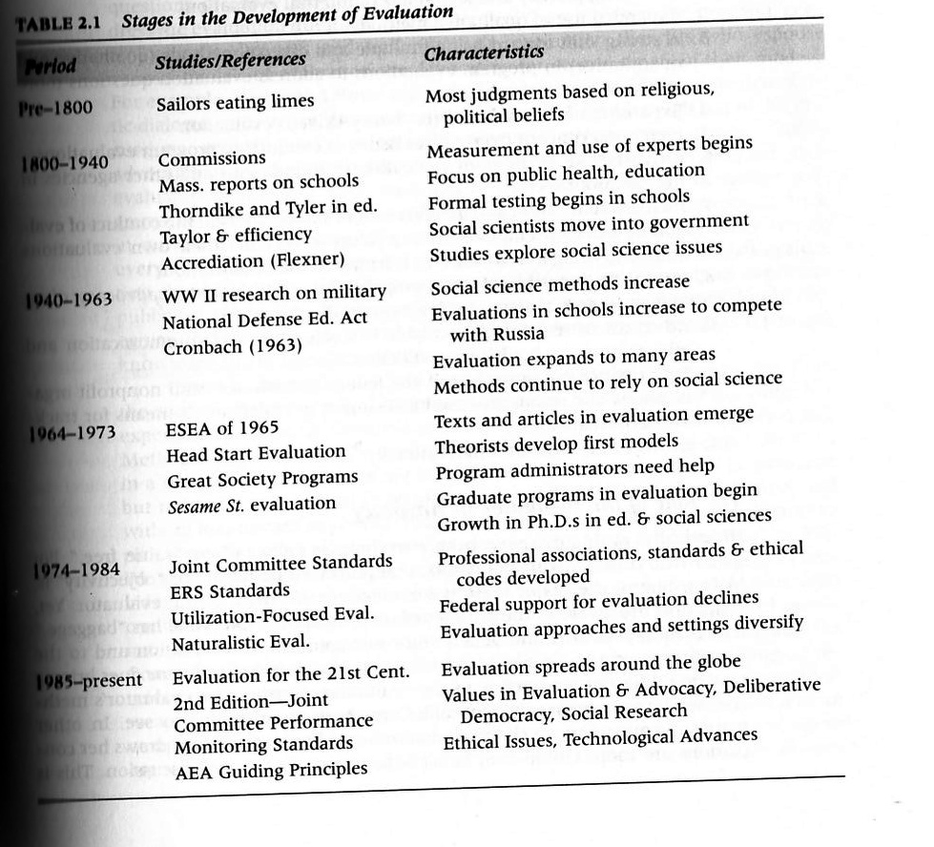
Recent Trends Influencing Program Evaluation
The Role of Evaluation in Advocacy
- Greene (1997) advocacy is an inevitable part of evaluation inquiry (p. 26). Evaluation as a force for democratizing public conversations about important public issues. Evaluators should recognize their role as advocates, to be explicit about those values, and to acknowledge their implications of those values.

Evaluators’ Use of Technological Advances and Resulting communication and
Ethical Issues

Performance Measurements and Standards-Based Education
Growth of Evaluation Internationally

Chapter 3 Alternative Views of Evaluation

Diverse Conceptions of Program Evaluations

Origins of Alternative Views of Evaluation
Baker & Niemi (1996) propose four disparate sources from which much of the thinking about evaluation has been drawn (1) experimentation, (2) measurement, (3) systemes analysis, and (4) interpretative approaches

Philosophical and Ideological Differences

Objectivist and Subjectivist Epistemology

Utilitarian v. Intuitionist-Pluralist Evaluation

The Impact of Philosophical Differences

Methodological Backgrounds and Preferences

Quantitative and Qualitative Evaluation

Disciplinary Boundaries and Evaluation Methodology

Different Metaphors of Evaluation

Responding to Different Needs

Practical Considerations

Themes Among the Variations

A Classification Schema for Evaluation Approaches

