AGENDA Workforce Futures Forum Design Group Workshop
9.30am to 11.00am, Friday 5th November

WELCOME Don Whitehouse OAM
LEAD AGENCY STRATEGIC INTENT Don Whitehouse OAM
Regional Development Australia is committed to sponsoring the collaborative design, delivery and review of a Workforce Futures Forum in early December for the South West Brisbane area.
Regional Development Australia Brisbane in its Regional Roadmap has identified Education retention and skills development as a strategic focus. Specific priority actions for 2010 include
  - Identify networks across training to leverage enhanced collaboration and knowledge sharing; and
  - Liaise with industry groups to promote involvement in training to employment pathways
Publicly available data suggest there is a gap between industry requirements and education and training provision in the South West area of Brisbane
The intended outputs of this meeting
- Shared appreciation of the potential value added of the proposed South West Brisbane Workforce Futures Forum
- Agreed data sharing protocols to inform Forum design and delivery.
- An integrated credible and user friendly evidence base to inform Forum design and delivery
Intended outcomes of the Workforce Futures Forum
- Multi level connections between ,community, industry and education/training
- Better awareness of each other’s needs and offerings,
- Potential Local Partnerships development
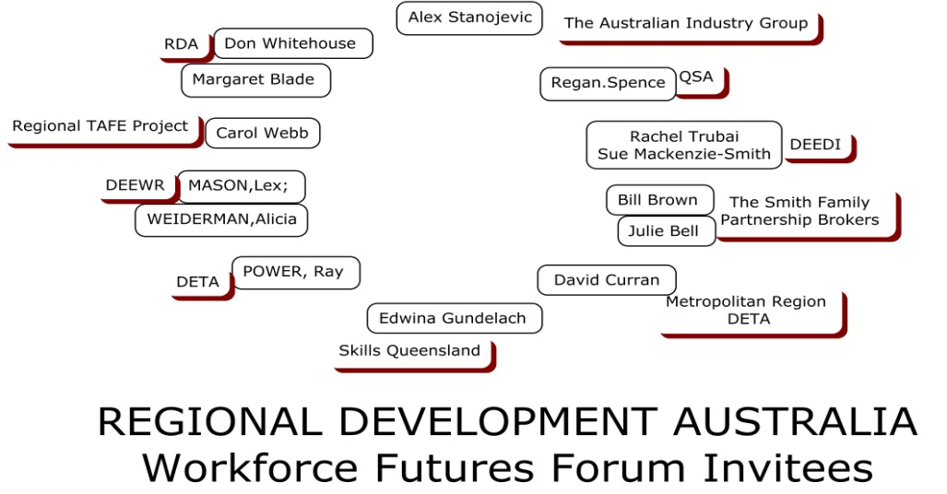
INTRODUCTIONS Bill Brown to facilitate

WORKSHOP PROCESS OVERVIEW Bill Brown
Focussing Question 1
WHAT strategic advice do you offer to strengthen the
- Focus of the South West Workforce Futures Forum
- The tangible outputs of that Forum
- The longer term outcomes of the strategic intent
To assure we provide a return on investment for your involvement.
Output 1
Shared appreciation of the potential value added of the proposed South West Brisbane Workforce Futures Forum
Focussing Question 2
WHO can we approach in your organisation to assemble the story/data/information/knowledge/wisdom on which this collaborative endeavour is premised?
- Ethics/risks considerations of information provision and public sharing?
- Authorisation of engagement Time and talent?
- Data sets you will make available?
Output 2
Agreed data sharing protocols to inform Forum design and delivery.
An integrated credible and user friendly evidence base to inform Forum design and delivery

Focussing Question 3
HOW do we move from intention to action?
WHAT I WILL CONTRIBUTE | Who/How /When

