Behaviorism-focuses on observable behavior and actual conditions that lead to behavior; deals with the relationship between stimuli and responses and among stimuli.

Learning is defined as a change in the behavior of the learner
- Stimulus response principle
- Known as associative learning
- All behavior is caused by external stimuli
- Behavior is explained without consideration of mental states
- Behavior is shaped by negative and positive reinforcements
- Punishments can be both positive (application of stimulus) and negative (withholding of stimulus) which is used to decrease the behavior
 | Variables of Concern | Theorist
Behaviorism | Stimuli | Pavlov (1849-1936)
 | Responses | Watson (1878-1958)
 | Reinforcement | Guthrie (1886-1959)
 | CS (Conditioned Stimulus) | Thorndike (1874-1949)
 | US (Unconditioned stimulus | Hull (1884-1952)  Skinner (1904-1990)

Variable | Theorist/Theory | Subject (s)
Unconditioned | Clark L. Hull (1884-1952)
Stimulus | Hypothetico-Deductive System  Neobehaviorist  S-O-R | A logical, scientific, and mathematical system that explains human learning and behavior. The relationship betw stimuli and responses
Keyword (s) | Habit strength  - Reaction potential  Drive  Goal reactions  Habit families  Intervening variable | - Measure of the potential that a stimulus has for eliciting a specific response  Hypothetical set of behavior variables
Appraisal | Made logical constructs of the learning process.

Variable | Theorist/Theory | Subject (s)
Stimuli | Ivan Petrovich Pavlov (1849-1936) | dogs
 | Classical Conditioning | Definition
 | - Learn through stimulus substitution  - Making new association(s) between event(s) in the environment | Reflexive automatic type of learning in which a stimulus requires the capacity to evolve a response that was originally evoked by another stimulus.
Keyword (s) | Tabla rosa  Reflex  Stimulus-response  Conditioned response  Unconditioned stimulus  Respondent conditioning | Learner as an empty vessel that can be filled  Unlearned stimulus-response unit; simple, non-intentional, unlearned behavior
Learning | Contiguity  Reinforcement | Simultaneous or nearly simultaneous occurrence of events  - Simultaneous  - Delayed  - Trace  - Backward pairing  Positive negative effects stimulus
Phenomena | Acquisition  Extinction and recovery  Generalization and discrimination  Higher ordering conditioning | - Formation of stimulus-response association  - Conditioned response elimination  - Similar/distinct response to related stimuli  - Pairing of CS with another stimulus but not to the new stimulus with the US
Implications | Teachers should maximize the frequency & potency of pleasant US in classroom while minimizing the negative US.
Appraisal | Laid foundation for clinical conditioning and principles of cc still applied today.

Variable | Theorist/Theory | Subject (s)
Responses | John B. Watson (1878-1958) | infants
 | Classical Conditioning/Behaviorism
Keyword (s) | Classical conditioning  - Environmentalism  Contiguity  reflexes | - Darwinian influence, tabla rosa; impact of environment on humans
Learning | Habits  Explains Pavlov’s model  Classical conditioning involving the reflexes | Complex learning requires the conditioning of stimulus-response sequences.
Phenomena | Emotional learning is also classical conditioning  Transfer | Phobias can be caused by CC  Stimulus generalization (Pavlov)
Implications | Rigid child rearing practices Behavior modification
Appraisal | Profound impact on American psychology. Pro | Oversimplification theory of emotional development. Con

Variable | Theorist/Theory | Subject (s)
Unconditioned | B.F.Skinner (1904-1990)
Stimulus | Operant Conditioning | Human behavior follows certain laws; explanation of behavior rely exclusively on observable phenomenon by using an experimental analysis of behavior.
 | Radical Behaviorist
Keyword (s) | - Operant  - Respondent  Schedules  Extinction  Shaping  Superstition  Programmed instruction  Behavior modification | - Responses emitted from the organism  - Responses elicited by a stimulus  Continuous, intermittent, superstitious, random
Learning
Implications | Classroom-large Skinner Box  Behavior management
Appraisal | Description of the effects reinforcement on responding

Variable | Theorist/Theory | Subject (s)
 | Edward L. Thorndike (1874-1949) | Cats, chickens, and humans
Conditioned Stimulus | Connectionism  Did not consider himself a behaviorist and preferred experimentation of introspection | The formation of bonds between stimulus and responses-bond that take the form of neural connections
 | Established educational psychology  Operant learning | Was able to change his theories over time
Keyword (s) | Effect  Satisfiers  Annoyers  Trial and Error | How the organism learns
Learning | Stamping In  Stamping out | Forgetting
Phenomena | Law of Exercise  Law of Effect  Law of Readiness
Implications | Practical applications of psych. Principles in teaching.
Appraisal | Introduced controlled investigations of animals and human  Consequences of behavior as determiners of what is learned and what is not. Pro  Popularized the use of test and statistical methods in education. | Based on informal observations  Talks about vague and ill-defined internal states of satisfiers/annoyers. Con

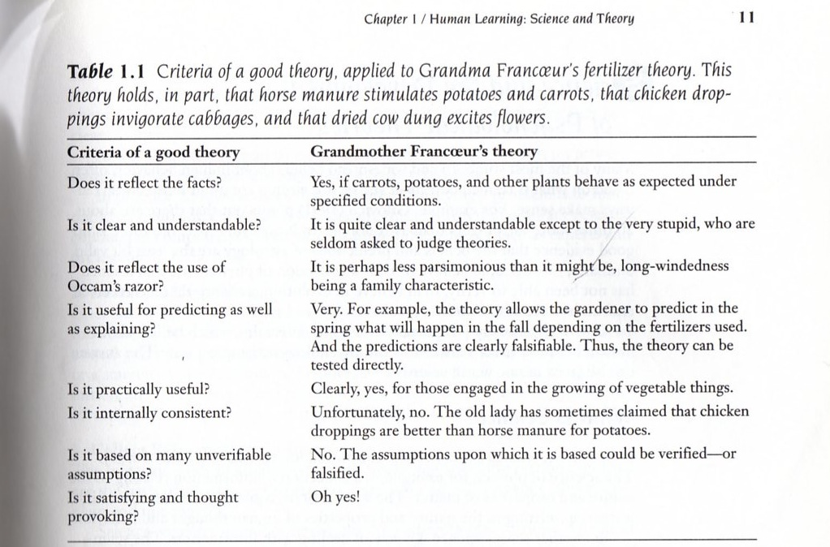

From
LeFrançois, G. (2006) Theories of Human Learning 5th Ed.

