Handout for Presentation

By Jillian French using IHMCmap
Focus Question
What are the skills, values, attitudes and practices needed for professionals in blindness and low vision education to work individually and interprofessionally with students with diverse learning needs and their families and whanau?
URL for this Cmap is:
http://cmapspublic2.ihmc.us/rid=1JRVH1819-7HYW9R-2PT/Master%20copy%20asst%202.cmap
Specialist Teacher Vision work with learners and others to develop in them an attitude that children who are blind or have low vision are more than their disability. With adaptive supports they can participate, contribute, learn and achieve and take their place in society. As a Specialist Teacher Vision you need to listen, build trusting and reciprocal relationships, have empathy, be creative and adaptive, patient, supportive, practical, and good at collaborating.

Key Points

Values & Principles
- Relationships
- Early Intervention
- Mainstreaming.
- Respect for the challenges that learners face and overcome.
- Collaborative practice.
- Positive view of the learner’s abilities
- Equity and access

Culturally Appropriate Practices
Te Whare Tapa Wha Model
Te Reo and Tikanga
The child is Maori first and part of the Whanau second and Kapo third
Tuakana and Teina Relationships

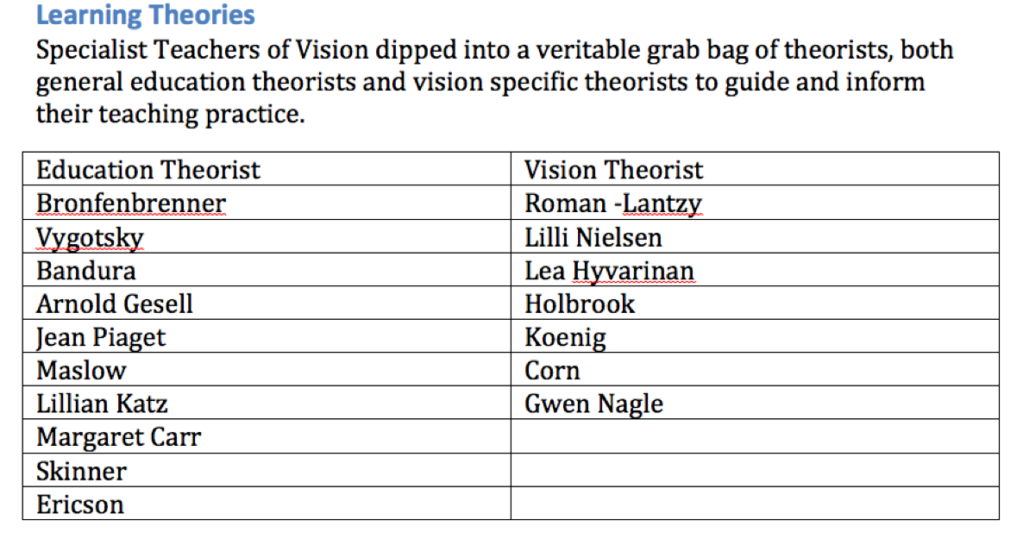

Inclusive Education,
Is underpinned by legislation but is implemented in the classrooms. The Team working with the learner all need to share and model inclusive practices with each other. (eg please don’t wave goodbye to a child who is blind).

Human Development
Understanding of human developments guides assessment and informs ideas of ‘What next’ for learners whose development does not match usual milestones.

Inter professional Practice
E Raka te Mauī, e raka te katau.
A community can use all the skills of it's people.
A Specialist Teacher Vision works with parents, caregivers, teachers, and specialists to help the learner who is blind or has low vision to learn and develop (Ministry of Education 2009)

Evidence Based Interventions
Evidence Based Practice focused more on using observable information about individual children to inform goal setting. There is not a large body of quantitative and qualitative research available to draw from due to the highly individual nature of many of the children’s eye condition and health condition. For some children they may be the only child in New Zealand with the condition. This small population means that it is essential that Specialist Teachers Vision begin to write and share their information globally.

Assessment Theories & Practices
Assessments:
- Influence placement
- A range of tools
- Uses adapted tests.
- In natural environments
- Normative testing? What is the make up of the ‘norm’
- Functional Vision Assessment
- Learning Media assessment, Braille or Print?
- Orientation & Mobility Assessment
Lead to
Adaptations
Which are
Accommodations: “changes to the way a child learns or is instructed that do not change what is being taught or what is being measured” (Ferrell 2011) eg print material transcribed into braille.
Modifications: “changes to what the child is expected to learn that do not affect either the level of instruction or what is being measured by a particular test” (Ferrell 2011) eg omitting a visual task from a test.
Tools: Aids, devices and materials that assist the child who is blind or has low vision to achieve in regular classroom activity eg assistive technology.
Hands on Experiences: eg if reading the Velveteen Rabbit the child needs to first experience playing with a real rabbit to understand what a rabbit is.
Concrete Objects: No… not made of concrete, but tangible. If there is a model pictured in a book provide or build together a real model.
Accessing adaptive technology is part one of success, part two is working with others to ensure that it is used to provide access to learning.

Resource
A newly written book that I am sure will become the new “Bible” for working with children who are blind or have low vision is:
Ferrell, K.A. (2011) Reach out and Teach: Helping your child who is visually impaired learn and grow 2nd Edition AFB Press New York

