Academic Measurement and Achievement Mentor
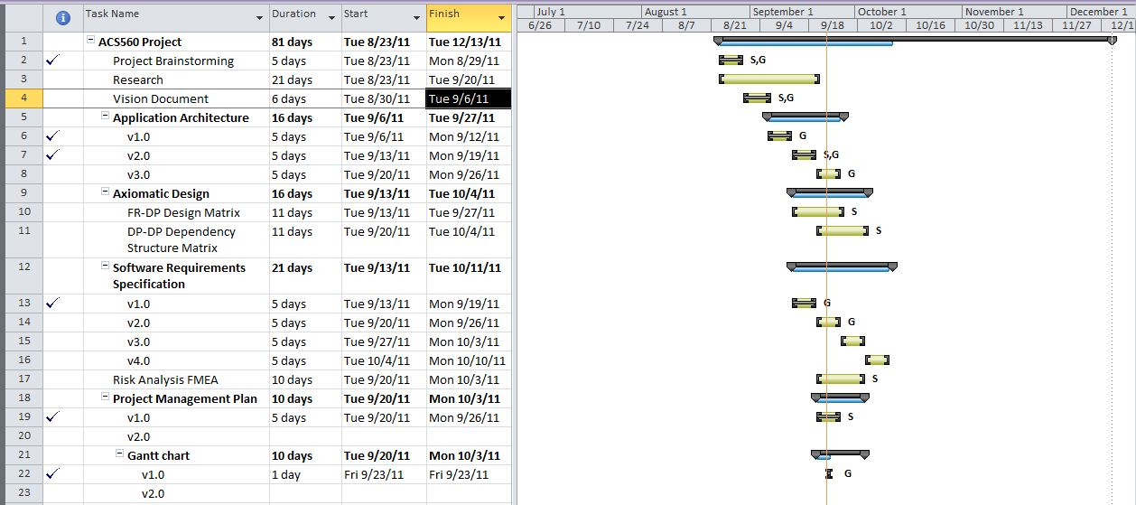
Gantt Chart v1.0

