Body Systems

What is a human body system?
A system of human body means a collective functional unit made by several organs in which the organs work in complete coordination with one another. Organs cannot work alone because there are certain needs of every organ that need to be fulfilled and the organ itself cannot fulfill those needs. So all organs of human body need the support of other organs to perform their functions and in this way an organ system is formed.
Example of dependance of organs of a system on one another:
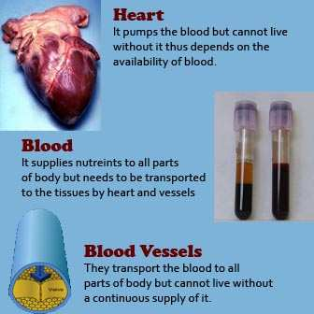

Systems of the Human Body:
Human body is made of ten different systems. All the systems require support and coordination of other systems to form a living and healthy human body. If any one of these systems is damaged, human body will become unstable and this lack of stability will ultimately lead to death. The instability caused by damage of one system cannot be stabilized by other systems because functions of one system cannot be performed by other systems. Knowledge of human body systems is very important for a medical professional because it is the base of all medical sciences and clinical practices. Although, generally, the structural aspects of human body systems are studied in anatomy and the functional aspects are studied in physiology but it is very important to have a coordination between the two subjects because knowledge of structure is incomplete without the knowledge of function and the knowledge of function is incomplete without the knowledge of structure.

A brief introduction to all the systems of human body is given in the table below. For details of a system, please go to its section by clicking on the link to that system’s section.
Name: | Components | Role
Skeletal System  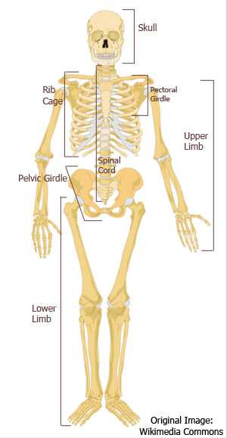 | Bones, Associated cartilages, Joints | Strength, Support, Shape, Protection, Leverage, Cell Production
Muscular System  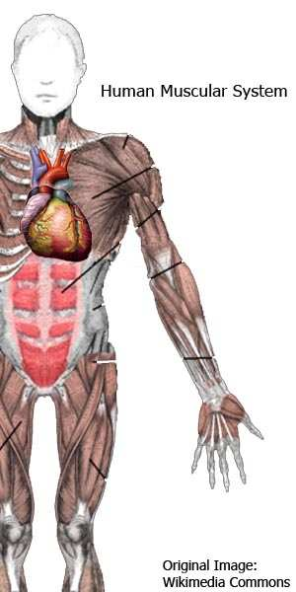 | Muscles (Skeletal Muscles, Smooth mucles, Cardiac Muscles) | Motor power for movements of body parts.
Nervous System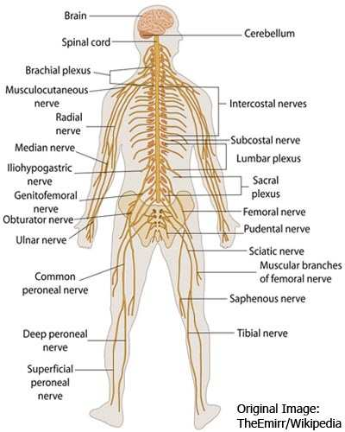 | Brain, Spinal Cord, Nerves, Nerve Endings | Control and Coordination of all body functions (Nervous coordination)
Respiratory System  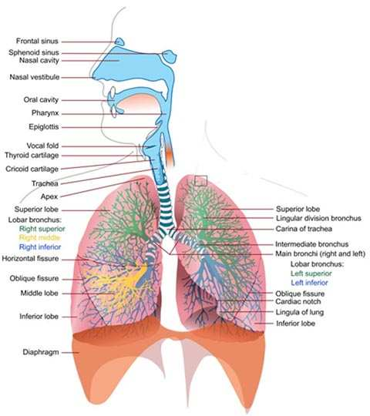 | Lungs, Nose, Trachea, Bronchi, Bronchioles, Alveolar sacs, Alveoli | Gaseou exchange
Cardiovascular System  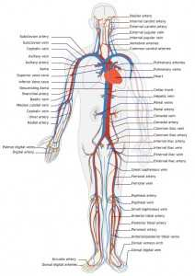 | Heart, Blood vessels (Arteries, Veins and Capillaries), Blood | Flow of blood (and nutrients) throughout body
Lymphatic System  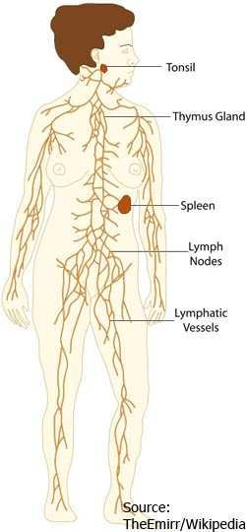 | Lymph vessels, Central lymphoid tissue, Peripheral Lymphoid Organs, Lymphocytes | Drainage and Protection
Endocrine System  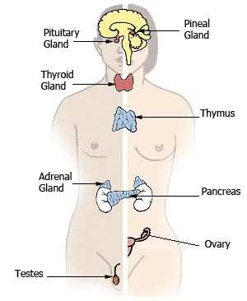 | Endocrine glands (Pituitary gland, Thyroid gland, Parathyroid glands, Adrenal glands, Pancreas (endocrine part), Testes (endocrine part), Ovary (endocrine part), Liver (endocrine part)) | Regulation of body functions (Chemical coordination)
Digestive System  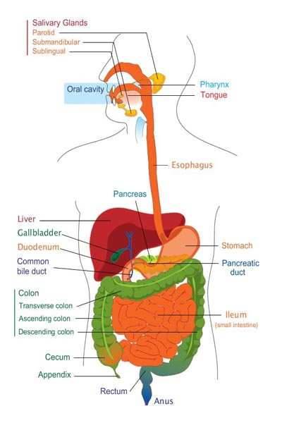 | Alimentary Canal (Oral Cavity, Esophagus, Stomach, Small Intestine, Large Intestine, Anus), Liver, Pancreas, Salivary glands, Teeth, Tongue | Digestion and absorption of food
Urinary System  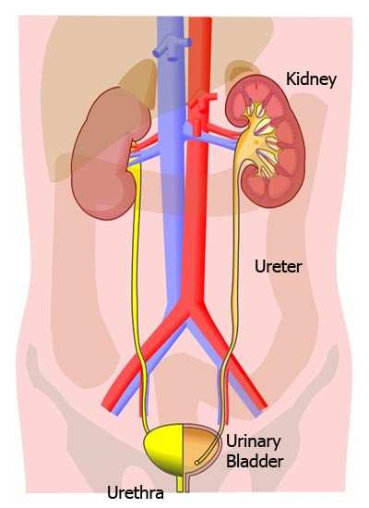 | Kidneys, Ureters, Urinary bladder, Urethra | Regulation of body’s internal environment, and production and excretion of urine
Male Reproductive System  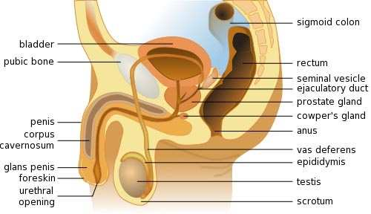 | Penis, Testes | Formation of sperms and semen, and fertilizing the female
Female Reproductive System  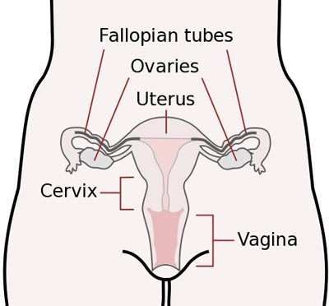 | Uterus, Ovaries, Vulva, Labia, Clitoris | Formation of eggs and bearing the fetus during development
MAN ANATOMY: http://www.mananatomy.com/body-systems

