Matthew Rasler
9/26/2011
CS 360
SWEBOK Knowledge Area 2- Software Design
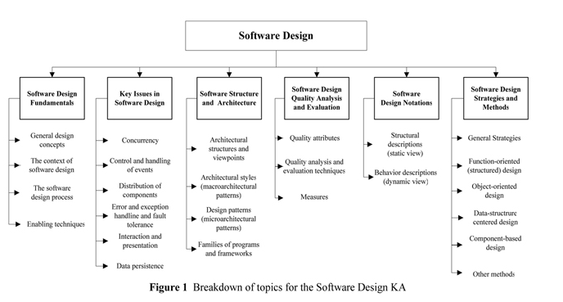
SWEBOK defines the Software Design knowledge area as the subject dedicated towards describing the software architecture in such a way that it can be developed, by breaking down the components of the architecture into components that describes there interconnectivity and the interfaces between these components.
This process includes the subset of knowledge required to design the system architecture. Also encapsulated by this knowledge area is the process of determining which design methodology is best suited for the system; Function-Oriented Design, Object-Oriented Design, Data-Structure-Centered-Design, and so on.
Key issues that a Software Designer must consider are concurrency, control and handling of events, distribution of components, error handling, presentation, and data persistence.
How this applies to our project:
We have used varies architecture types in designing our project, including UML, application architecture, and systems architecture. We have expressed our understanding of this KA by implementing these architectures and by utilizing the Axiomatic Design Process.

