Matthew Rasler
9/26/2011
CS 360
SWEBOK Knowledge Area 3-Software Construction
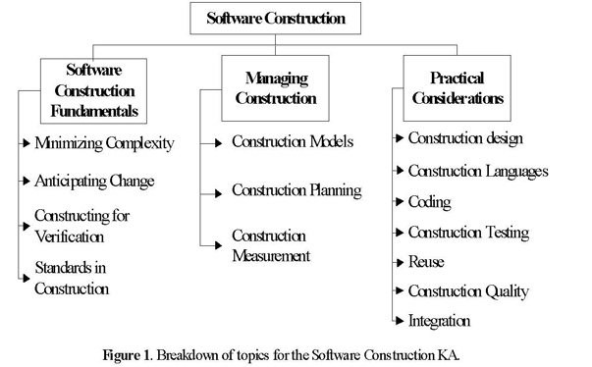
“The term software construction refers to the detailed creation of working, meaningful software through a combination of coding, verification, unit testing, integration testing, and debugging.”
Of all the KAs, the Software Construction KA is the KA that is considered most akin to the domain represented by the field of Computer Science, because of its focus on knowledge of algorithms and coding practices. The Software Construction KA is most directly linked to the Software Design and the Software Testing KAs. SWEBOK states that the use of standards in the Construction KA is paramount in that it reduces complexity, more easily allows for change, and allows for easier validation. It is of note that the Software Design and Software Testing KAs may overlap this KA as both testing and redesigning are a natural part of the cyclical lifecycle of the Software process.
How this KA applies to our project:
Numerous decisions made while designing this project considered factors encompassed by this KA, including which programming languages to choose for individual components that would allow for efficient interoperability, which languages are familiar to all the members of the group so that individual components can be constructed with verifiability and cohesion, and how to abstract large components so that each component is individually testable.

