Matthew Rasler
9/26/2011
CS 360
SWEBOK Knowledge Area 1- Software Requirements
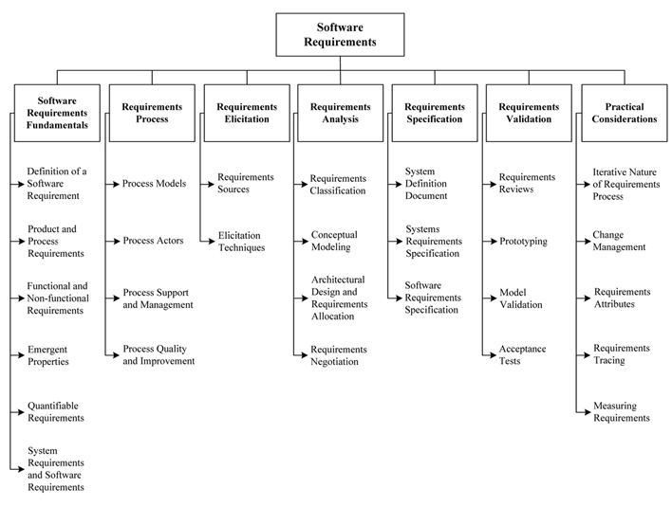
SWEBOK defines Software Requirements as those elements that must be present to accomplish the real-world problem that the software is attempting to solve. As noted in the image above, this knowledge area is subdivided into areas entitled Software Requirements Fundamentals, Requirements Process, Requirements Elicitation, Requirements Analysis, Requirements Specification, Requirements Validation, and Practical Considerations.
The area of study focuses on what requirements are by definition, how to obtain, quantify, and classify them. It also focuses on the continued management of these requirements throughout the software process, and the continued and changing relationship between them. This knowledge area stresses the importance of abstractly being aware of where the project is going and the interconnectivity of its components to mitigate unnecessary steps.
How this applies to our project:
We have displayed our understanding of this KA by formally recording the voice of the customer, deriving the cooresponding functional requirements, and creating associtated design parameters from the functional requirements. We have found through the validation process that this was a cyclical process for our group in specific, with the need to redefine functional requirements and design parameters as validation failed.

