Matthew Rasler
9/26/2011
CS 360
SWEBOK Knowledge Area 6 – Software Configuration Management
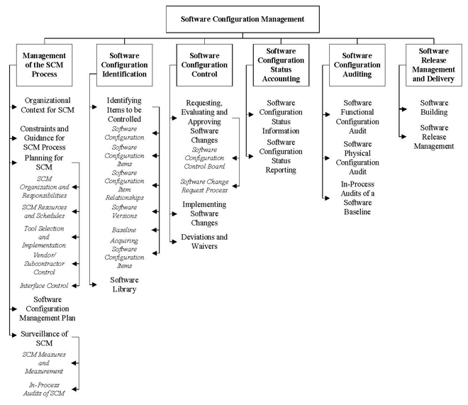
The software configurations management knowledge area contains information identifying the configuration of software at specific times throughout the software life-cycle. These identifications increase the traceability of the system, and aid in controlling changes to the configuration, or in the maintenance of the system.
The subsections of this discipline include the management of the SCM process, software configuration identification, software configuration control, software configuration auditing, and software release management and delivery.
By explicitly demarcating each revision of documents by its iterative version number, we, as a group, are adhering to the philosophy outlined in this knowledge area.

