Matthew Rasler
9/26/2011
CS 360
SWEBOK Knowledge Area 11 – Related Disciplines of Software Engineering
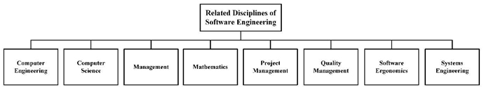
This knowledge area was created to identify disciplines that software engineering is implemented and identify in each an informative definition and a list of knowledge areas.
The related disciplines describe include computer engineering, computer science, management, mathematics, project management, quality management, software ergonomics, and systems engineering. Knowledge areas for computer engineering include HCI, Embedded Systems, Electronics, Operating Systems, Software Engineering, Digital Logic, among others.
Knowledge areas for computer science include: Algorithms, Intelligent Systems, Software Engineering, Graphics, Operating Systems, among others.
Systems Engineering is considered a multidisciplinary category.
This knowledge area applies to our project because of the many specific disciplines it utilizes, including: Embedded Systems, Operating Systems, Digital Logic, Electronics, Software Engineering, Algorithms, among others.

