Matthew Rasler
9/26/2011
CS 360
SWEBOK Knowledge Area 10 – Software Quality
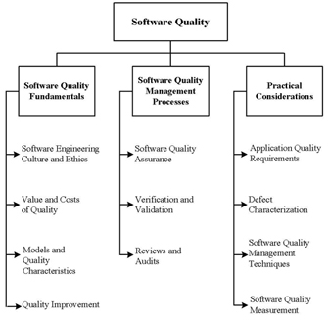
The software quality knowledge area is derived from the need to create software that conforms to user requirements and has high levels of fitness for use, and focuses on quality issues that go beyond the life cycle processes. This KA stresses the importance of ethics and culture in software quality, and differentiates the cost of quality into preventative costs, appraisal cost, internal failure cost, and external failure cost. A subfield, software quality management processes, is broken down into quality assurance process, verification process, validation process, review process, and audit process to encourage quality and find possible problems.
The iterative process of collecting and recording the voice of the customer, and deriving functional requirements from it helps assure software quality. The house of quality implemented helps assure quality of product and audits by the program manger also help insure quality of our project.

