Study Worksheet
English Department
Name:_______________________________________________2° Grade_____Date:

Uncountable Nouns (Quantifiers #1)
Because uncountable nouns in English do not have plurals
and cannot be counted in the normal way, quantifiers
are often used as a way of "measuring" them. The basic
quantifiers are some, any, a little, and a lot of, but there
are many more.
One group of quantifiers is common with food and items
found at home: the names of the containers in which the
items are sold.
Special Note:
These containers can also be used for countable nouns.
.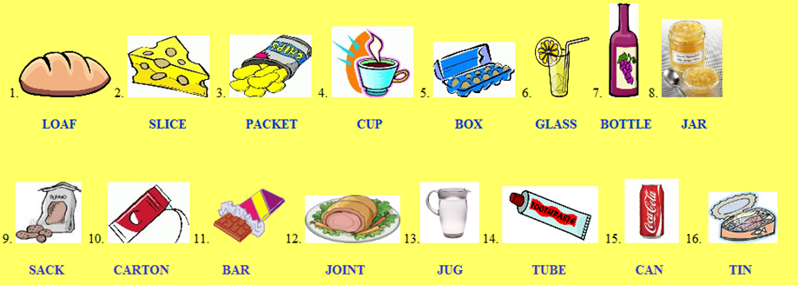
EXERCISE 1
Complete with the right containers.
1. A of bread.
2. A of chips.
3. A of jam.
4. A of wine.
5. A of potatoes.
6. A of milk.
7. A of cheese.
8. A of lemonade.
9. A of coffee.
10. A of eggs.
11. A of chocolate.
12. A of water.
13. A of meat.
14. A of toothpaste.
15. A of coke.
16. A of sardines.

EXERCISE 2
Complete with some or any.

Sue: Have you got sugar in the pantry?
Mary: No, I haven’t got .
Sue: I think I’m going to buy oranges too.
Mary: Ok. Don’t forget to buy eggs too, because
we haven’t got .

EXERCISE 3

Complete the sentences with the containers.
Mary: I am going to the supermarket.
I need a of meat. Do you need something?
Sue: Yes, please. I also need a
of bread and a
of chips for dinner.
Mary: Do you have some eggs? I could buy a
of eggs and a
of milk for breakfast…
Sue: Could you buy some
of coke too?
Mary: Sure! Goodbye.

