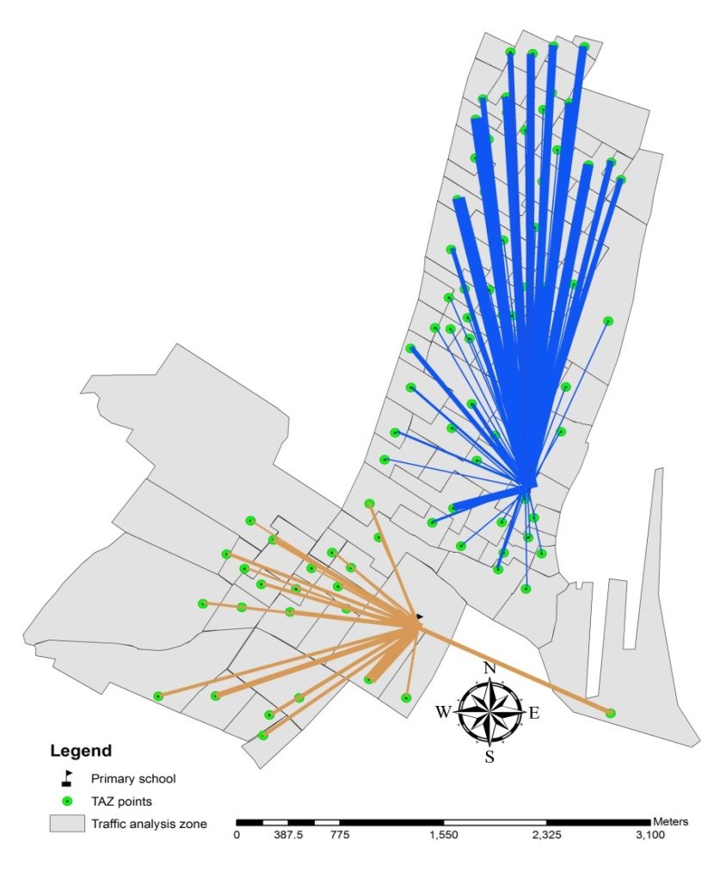

Fig. 1: Origin-destination (shelters) demand

