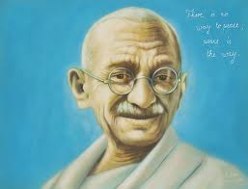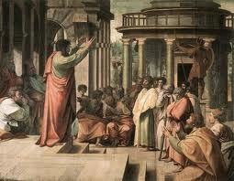

Translation program to revise the use and study of English

By:

Arauz Edsson 4-750-935

Medina Delvis 4-752-2387

March 31st 2012

Present

New Christian Civilization

Many languages interacted to create a new Christian Civilization

Around X Centuries

Christian Era

Translation program lauch

1922

The emerge of National Language

Growing of A. E.

XX century

This Translation to our time is a symbol of promoting the teaching of Hinduism.

The bhagavad Gita

Twenty century

Czech language

The kralic bible in the Czech language

St. Jerome Translated the Greek and Hebrew Bible into Latin and produced the Vulgate.

1579-1593

St. Jerome

The Hebrew Bible was created

347-419

Translation of the bible into English, French and German

New languages and cultures providing the bridge to Renaissance and modern world

Bible Translation

IX Century

1300-300 BC

Birth of Islam

The Bible

VII Century

Christian Era