PMBOK-Knowledge Area 1: Project Integration Management

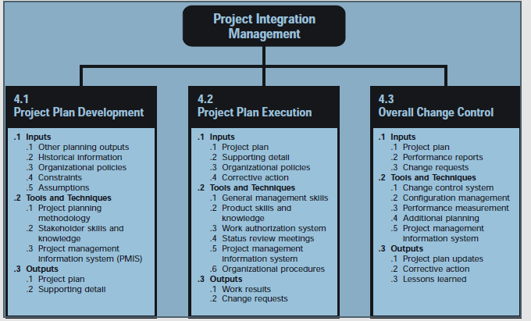
The Project Integration Management Body of Knowledge Area details information involved that help insure that the processes define the elements in the project in such a way that they are properly coordinated. This Body of Knowledge is broken up into 3 subfields: Project Plan Development, Project Plan Execution, and Overall Change Control.
The Project Plan Development area describes information dedicated to the development of the Project Plan using inputs from other processes, to create a consistent document that can be used for both overall change control and project execution.
The Project Plan Execution Knowledge Area discusses the area of Project Management devoted to the process of carrying out the project plan. This process is where the majority of the resources will be expended, in that it is where the project is actually developed. This knowledge area is broken up into three subcategories: Inputs to Project Plan Execution, Tools and Techniques for Project Plan Execution, and Outputs from Project Plan Execution (as detailed in the above image). The Inputs to the Project Plan Execution section details the contributing factors to the Project Plan Execution; listed are: the Project Plan, Supporting Detail, Organizational Policies, and Corrective Action. The Tools and Techniques for Project Plan Execution subsection details tools and techniques, of which: General Management Skills, Product Skills and Knowledge, Work authorization system, Status review meetings, the Project management information system, and organizational procedures, are listed. The Outputs from Project Plan Execution subsection details the outputs derived from the execution of the project plan, included as items are: Work Results and Change Results.

PMBOK-Knowledge Area 2: Project Scope Management
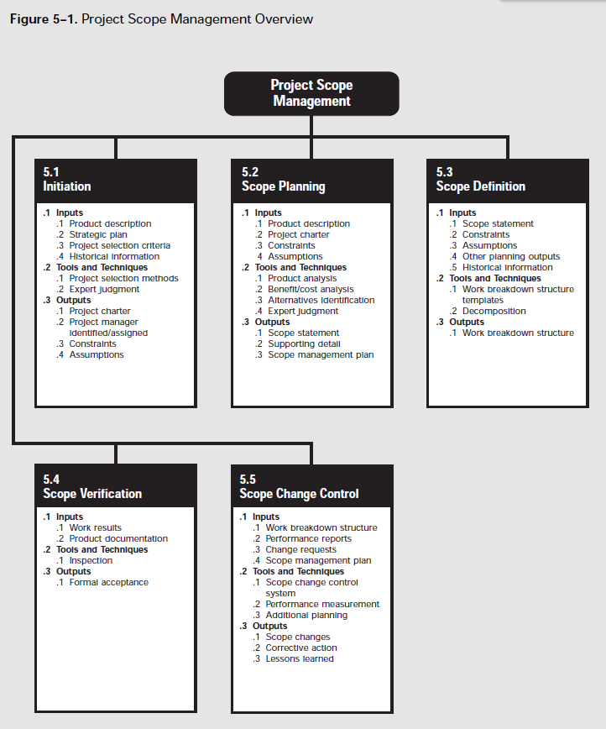
The Project Scope Management Body of Knowledge consists of information dedicated to the defining the processes and tasks required to insure that project plan will completely describe the necessary work required to successfully complete the project, without doing extra work. It involves 5 main subcategories: Initiation, Scope Planning, Scope Definition, Scope Verification, and Scope Change Control.
Initiation describes the formal or informal beginning to a new project or new phase of existing project. They are typically initialized because of: market demand, a business need, a customer request, a technological advance, or a legal requirement. The inputs to initiation include product description, strategic gain, project selection criteria, and historical information, and result in a project charter, and a project manager identified.
Scope planning and Definition involves subdividing the project into manageable tasks and development of a written statement for future project decisions.
Scope verification is the process of formally accepting the project scope by the stakeholders.

PMBOK-Knowledge Area 3: Project Time Management
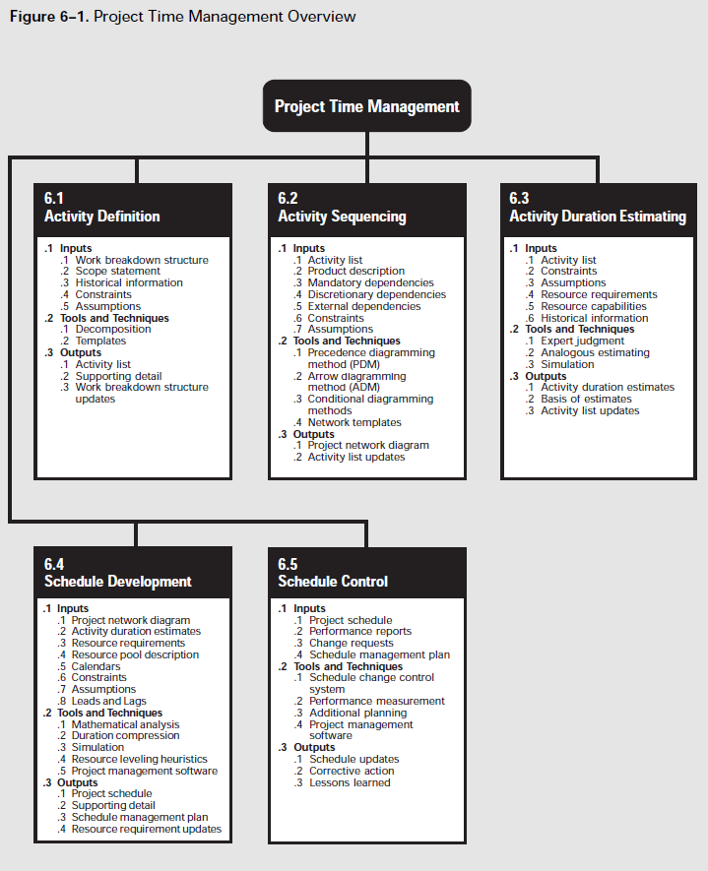
The Project Time Management Body of Knowledge Area is dedicated to the knowledge concerned with the process needed to insure timely completion of the project. The major processes in this body of knowledge include: Activity Definition, Activity Sequencing, Activity Duration Estimating, Schedule Development, and Schedule Control.
The Activity Definition process involves identifying the specific activities that must be performed to produce the various project deliverables.
The Activity Sequence process involves identifying and documenting interactivity dependencies.
The Activity Duration Estimating involves estimating the number of work periods which are needed to complete individual activities.
The Schedule Development process involves analyzing the activity sequences and activity durations to create the project schedule. In smaller projects, Activity Sequencing, Activity Duration Estimation, and this process are likely to be considered one process.
The Schedule Control process involves controlling changes to the project schedule.

PMBOK-Knowledge Area 4: Project Cost Management
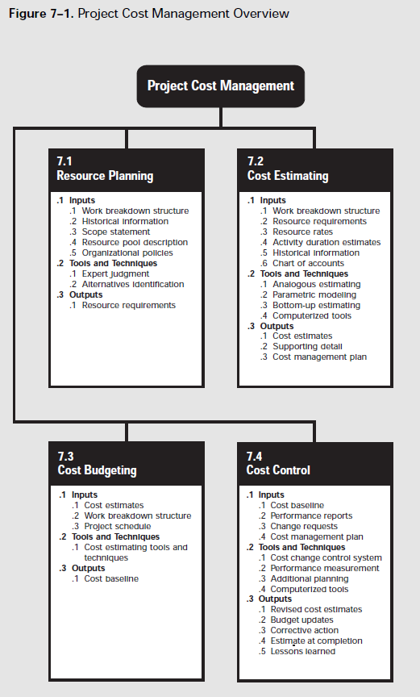
The Project Cost Management Body of Knowledge Area describes the information necessary to detail the processes required to ensure that project is completed on budget. It is divided into 4 major categories: Resource Planning, Cost Estimating, Cost Budgeting, and Cost Control.
The resource planning process includes determining what resources and what quantities of each should be used to perform specific tasks or activities. Resources include people, equipment and materials.
The cost estimating process includes developing an estimate of the costs of the resources needed to complete the project.
The cost budgeting process includes allocating the overall cost estimate to individual activities/tasks.
The cost control process includes controlling changes to the project budget as the needs arise.
Also, it is a concern of project cost management to determine the tradeoff between project decisions and the end cost of the product to the client; this is considered life-cycle costing. The differing anticipations or expectations of cost to different stakeholders should also be analyzed by project cost management.

PMBOK-Knowledge Area 5: Project Quality Management
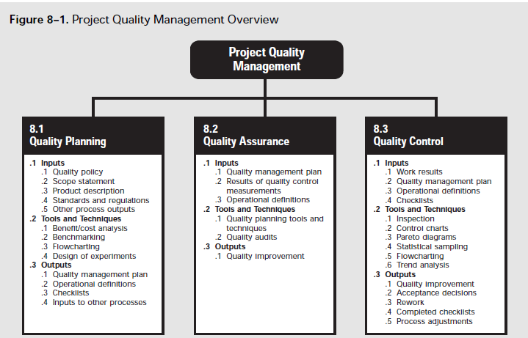
The Project Quality Management Body of Knowledge Area is concerned with the processes required to ensure that the project will satisfy the needs for which it was undertaken. It includes “all activities of the overall management function that determine the quality policy, objectives, and responsibilities and implements them by means such as quality planning, quality control, quality assurance, and quality improvement , within the quality system.” It is subdivided into 3 major categories: Quality Planning, Quality Assurance, and Quality Control.
The quality planning process identifies which standards of quality are important to the project and determines in which way to satisfy them.
The quality assurance process evaluates overall project performance to provide assurance that the project will satisfy the relevant quality standards.
The quality control process monitors the project results to determine if they comply with relevant quality standards and indentifies ways to eliminate causes of bad performance.
This area of knowledge is intended to be compliant with the ISO 9000 and 10000 series of standards, Total Quality Management, and Continuous Improvement standards.
Project quality management addresses both the management of the project as well as the product itself.

PMBOK-Knowledge Area 6: Project Human Resource Management
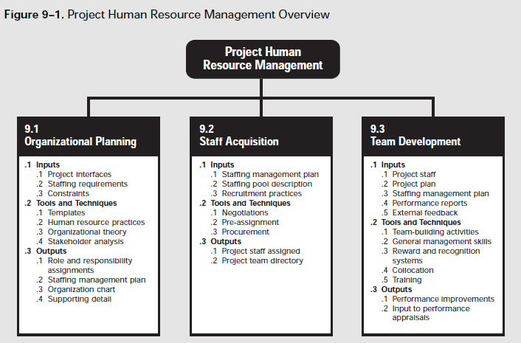
The Project Human Resource Management Knowledge Area includes the processes that determine the most effective use of the people involved in the project. These people are: the stakeholders, sponsors, customers, contributors, as well as others. This knowledge area is subdivided into the tree processes: Organizational Planning, Staff Acquisition, and Team Development.
The organization planning process involves identifying, documenting, and assigning project roles, responsibilities, and reporting relationships, which may be assigned to individuals or groups, and may be a part of the project group or not. The inputs to this process include: project interfaces, staffing requirements, and constraints. The outputs are: role and responsibility assignments, staffing management plan, and an organizational chart.
The staff acquisition process involves getting human resources needed assigned to and working on the project. The inputs to this process are: the staffing management plan, the staffing pool description, and recruitment practices. The outputs to this process include: project staff assignment and the project team directory.
The team development process includes the enhancement of the team to function as a team and the ability of the stakeholders to contribute. The inputs to this process include: project staff, the project plan, the staffing management plan, performance reports, and external feedback. The outputs include: performance improvements and an input to performance appraisals.

PMBOK-Knowledge Area 7: Project Communications Management
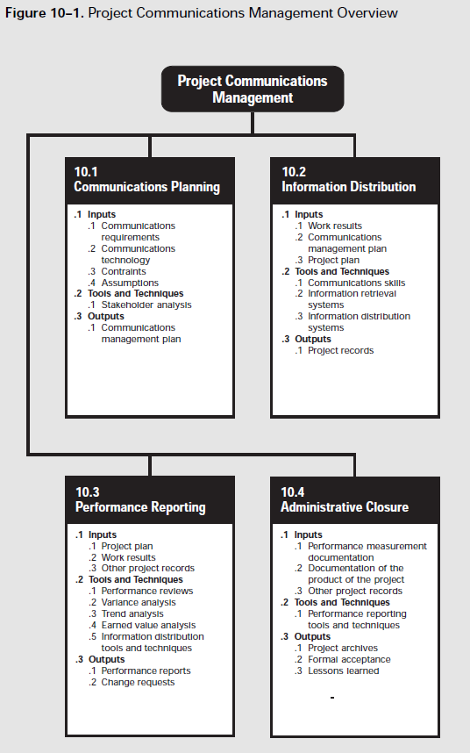
The Project Communications Management includes the processes required to ensure timely and appropriate generation, collection, dissemination, storage, and disposition of project information by providing the critical link between people, ideas, and information needed for success. This knowledge area is subdivided into 4 major processes: Communication Planning, Information Distribution, Performance Reporting, and Administrative Closure.
The Communication planning process determines the information and communication needs of the stakeholders, who needs what information, when they will need it, and how it will be given to them. The inputs to this process include: communication requirements, communications technology, constraints and assumptions. The output to this process is the communications management plan.
The information distribution process involves making the needed information available to project stakeholders with the given time constraint. The inputs to this process include: work results, a communications management plan, and a project plan. The output is the project records.
The performance reporting process involves collecting and disseminating performance information in order to provide stakeholders with information about how resources are being used to achieve project objectives. This process includes: status reporting, progress reporting, and forecasting.
The administrative closure process consists of verifying and documenting project results to formalize acceptance of the product by the sponsor after achieving its objectives.

PMBOK-Knowledge Area 8: Project Risk Management
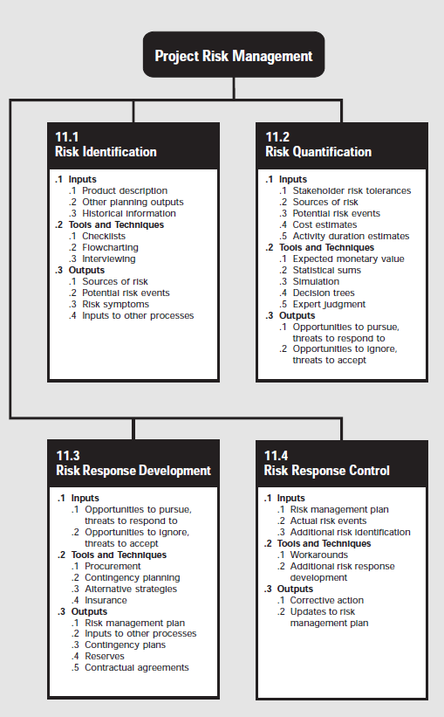
The Project Risk Management Body of Knowledge Area includes the processes concerned with identifying, analyzing, and responding to project risk, including maximizing the results of positive events and minimizing the consequences of negative ones. This knowledge area is subdivided into 4 main processes: Risk Identification, Risk Quantification, Risk Response Development, and Risk Response Control.
The risk identification process determines which risks, or the possibility of suffering harm or opportunities, are likely to affect the project and documenting characteristics of that risk. The inputs to risk identification include: the project description, other planning outputs, and historical information. The outputs are: the sources of risk, the potential risk events, risk symptoms, and inputs to other processes.
The risk quantification process involves evaluating risks and risk interactions to assess the range of possible project outcomes, being primarily concerned with deciding which risks need responses.
The risk response development process involves defining the enhancement steps for opportunities and responses for risks. The inputs to this process include both the opportunities to pursue and the treats to respond to as well as opportunities to ignore and the threats to accept.
Risk response control involves executing the risk management plan in order to respond to risk events over the course of the project.

PMBOK-Knowledge Area 9: Project Procurement Management

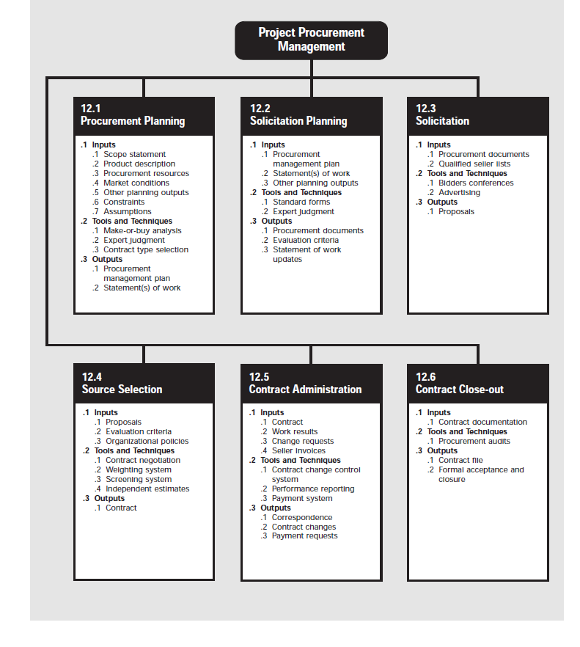
The Project Procurement Management Body of Knowledge includes the processes required to organize the procurement of acquiring goods and services outside the project’s organization. This process is comprised of 6 subfields: Procurement Planning, Solicitation Planning, Solicitation, Source Selection, Contract Administration, and Contract Close-out processes.
This body of knowledge assumes that the seller is external to the project’s organization and is discussed form the perspective of the buyer in the buyer-seller relationship.
The procurement planning process can be defined as the process of identifying which project needs can be met in the best way by introducing and funding products or services outside the project’s organization. It involves determining how, what, how much, when, and whether to procure an product, and considers the potential of subcontracts.
The solicitation planning process involves preparing the documents needed to support the procurement of products. The inputs to this process include: the procurement management plan, statements of work, and other planning outputs. The outputs are: the procurement documents, evaluation criteria, and statement of work updates.
Solicitation is the practice of obtaining bids and proposals from prospective sellers. The inputs include the procurement documents and the qualified seller lists, and the output is the proposal.
Source selection involves selecting from the solicited options and the evaluation criteria used to select that option. The inputs are the proposals, the evaluation criteria, and the organizational policies and the output is the contract.
The contract administration process involves ensuring that the seller’s performance meets the requirements set forth in the contract. It includes performance reporting to monitor the contractor cost and schedule and quality control of the contractor’s work.
The contract close-out process involves product verification and administrative close-outs. The input to this process is the contract documentation and the outputs are the contract file and the formal acceptance and closure.

