Section 5 COMMUNITY

INTENDED OUTCOMES
Community groups participating in partnerships that harness resources and build social capital to support young people to identify and achieve their goals and improve their education and transition outcomes.

EVIDENCE BASE

Strategic Conversations
5 hours of of strategic conversation with community .workers in Brisbane North Region
TSF env scan ??????

Document Analysis We take this from Wendy's analysis /How do we access that
Appendix 1 The evidence base that underpins identified trends and issues of parent engagement @ the global level
Appendix 2 The evidence base that underpins identified trends and issues of parent engagement @ the National level
Appendix 3 The evidence base that underpins identified trends and issues of parent engagement @ the State level

Appendix 4 The map
This is a Cmap image that results from using the knowledge management technology technology
We have to decide between a list as Tom has provided and some version of this
I am ten times more productive with these tools .I am not wedded to this BUT a great example of the multilayered chaotic space of community and an opportunity to show off

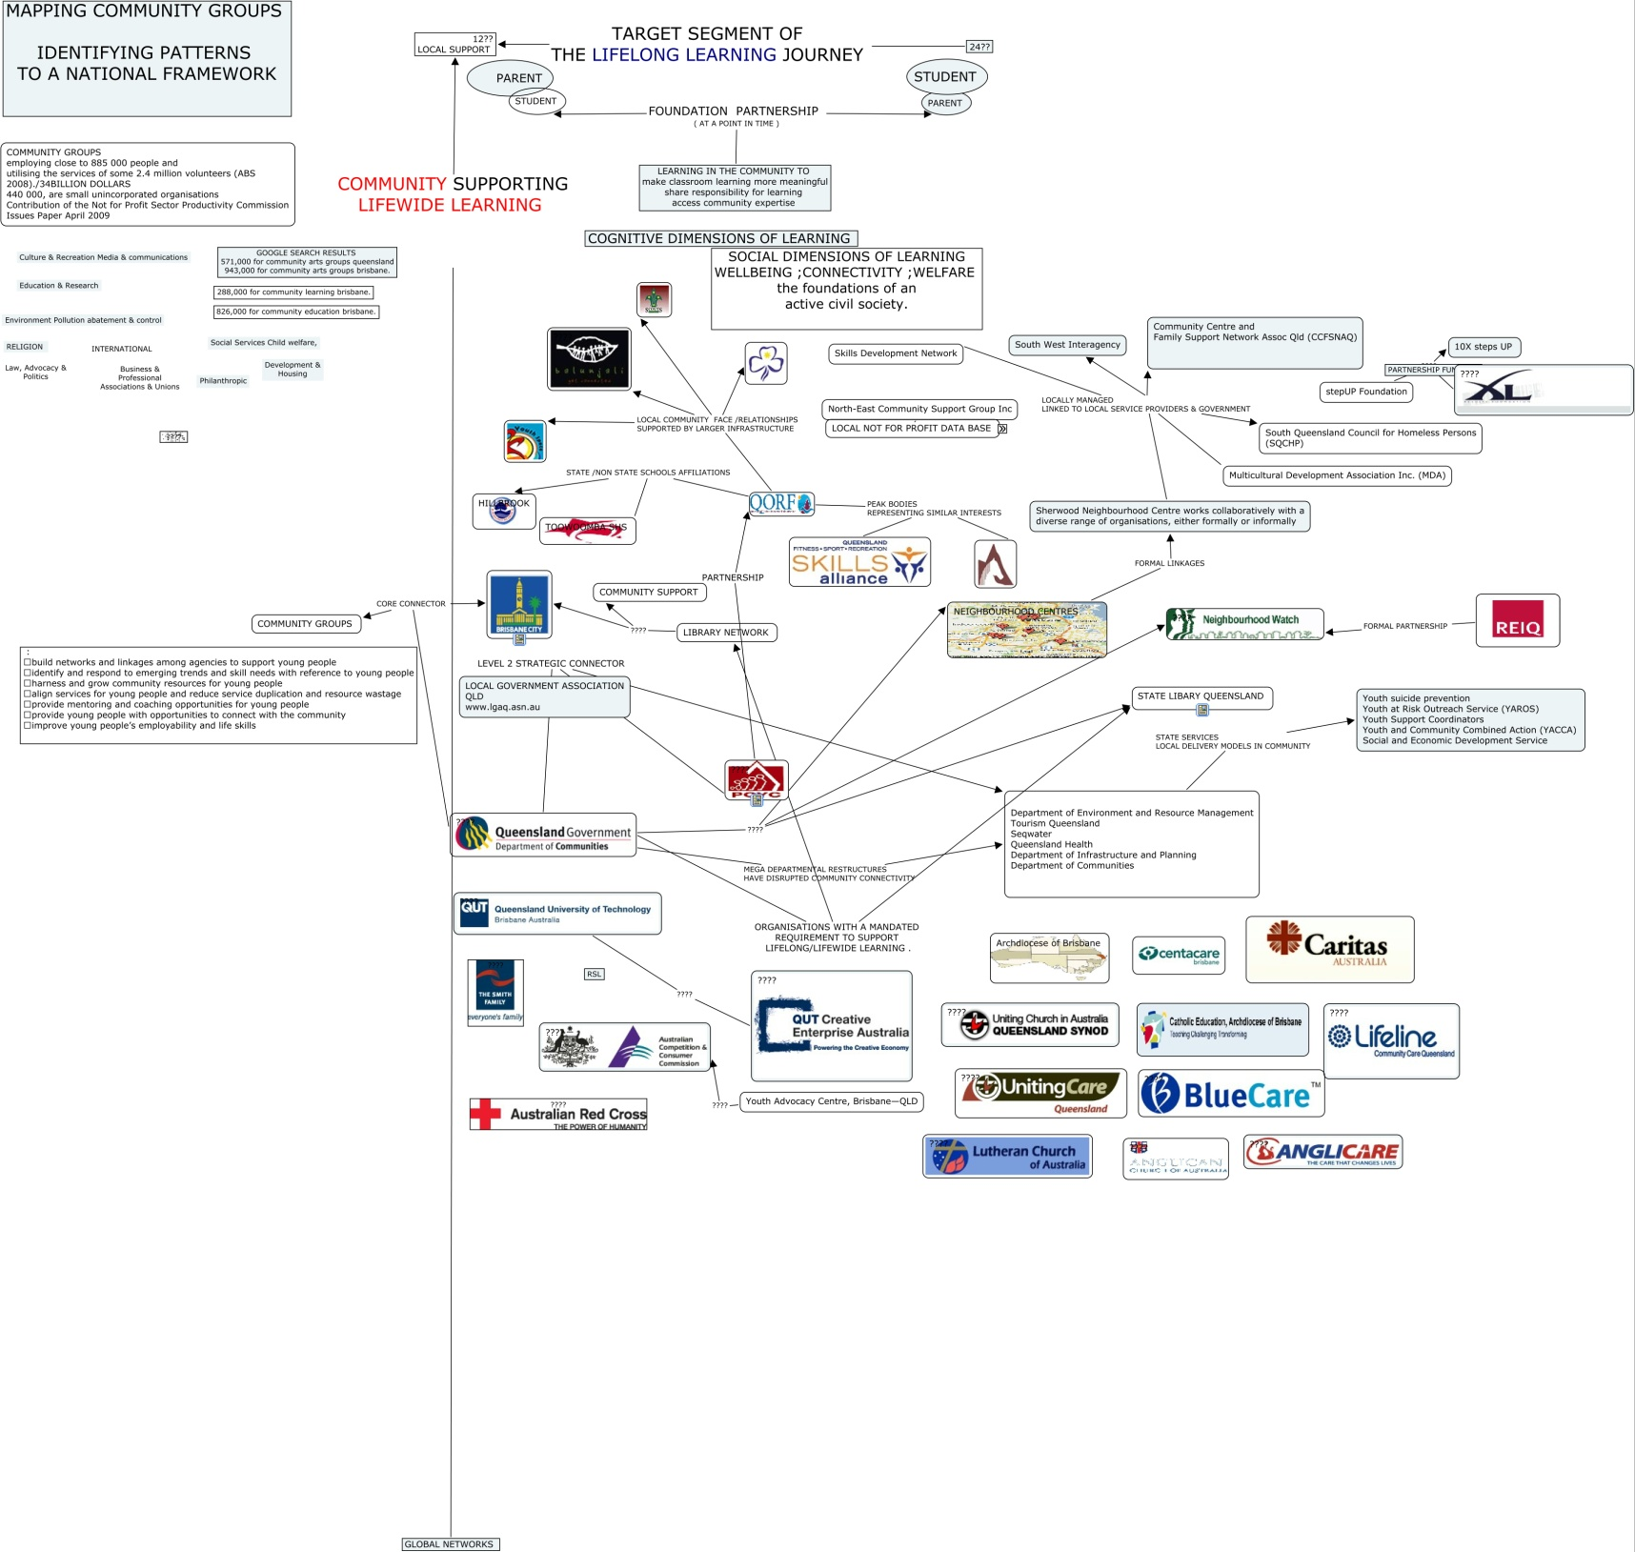

OPPORTUNITIES AVAILABLE TO TSFPB TO STRENGTHEN harness resources and build social capital to support young people to identify and achieve their goals and improve their education and transition outcomes.

PARENTS AND FAMILIES PARTICIPATING IN PARTNERSHIPS

Leverage existing TSF programs
The highly sophisticated volunteer program that attracts and retains volunteers across age cohorts and cross disciplinary expertise .

The Kedron Wavell Precinct
The Chermside office of TSFPB is within fifty metres of
- Kedron Wavell RSL – (The club industry who both employ people and provide community support )
- Chermside Library – (The Nationally recognised contribution of BCC to community engagement and the current challenges faced by libraries for new roles in learning as individuals increasingly take charge of their personal learning programs .
- Chermside Pool ( BCC linkages to the strong northside network of sporting

The Reconnect initiative and Youth Coordinator services
- Focus on cooperation to harness resources across community organisations

The PCYC Northside network
This network has the following characteristics relevant to the PB role
- High visibility in the local community
- Networks the networks of smaller independent community groups ,( scouts;guides ;aboriginal groups etc ) that appeal to the target age group
- Multiple links and formal partnerships with business
- Multiple links to State Government departments
  - Department of Environment and Resource Management
  - Tourism Queensland
  - Seqwater
  - Queensland Health
  - Department of Infrastructure and Planning
  - Department of Communities

New Farm Neighbourhood Centre
- A 19 year history of delivering services for homeless,and other social welfare programs

Emerging " Social Enterprise" models of community group operation
( need help here )

The Challenges for TSFPB delivery of parent partnerships
The National review on taxation and the not for profit sector
- The partnerships supported by business through corporate social responsibility may require renegotiation.

The sheer number of community groups
- Many unincorporated,local topic specific community groups remain hidden from this scan
- Specific data on service duplication,resource waste ,and the quality of existing partnership are not publicly available to this scan
- The Brisbane North & East region has community groups sponsored sand resourced by the full spectrum in the third sector
  - Philanthropic contributions
  - Corporate Social Responsibility contributions from business
  - Tied grants to local,state,and federal governments

