# SOFT SKILLS SUMMARY

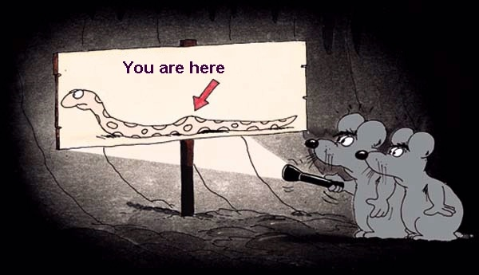

WHY ARE WE DOING THIS ?

Organisational culture provides some 20% of the organisational performance - Potentially higher @ IH

The development and sustainability of the organisational culture is a shared responsibility for BOM CEO staff and residents

The CEO IS the primary custodian of the IH culture

Dealing with the ambiguities between organisational performance ,personal characteristics & professional responsibilities is a challenge

WHAT RESULTS DO WE WANT as a result of this project ?

Personal development

Professional development related to position description and priority tasks

CEO Position Description

* Lead the delivery/implementation of the organisational culture

CEO Priority actions

* build and sustain positive interpersonal relationships between the BOM and staff
* develop strong interdependent relationships to underpin internal work practices
* establish and sustain the links to key external agencies

CEO professional capabilities required to deliver the position requirements

* appreciate the social support needs of the broad range of YOUNG ADULTS from culturally diverse backgrounds
* build fit for purpose professional support networks beyond the college for self ,staff and students
* negotiate partnerships
* operate in environments of increasing constraint AND increasing choice
* "Treat others as equal participating members, whose rights, insights, and purposes need to be engaged and creatively aligned.
* "The leader sees his / her role primarily as facilitating the development of others and the group to be more and more creatively involved in the success of the organization.
* "The leader can support, challenge and confront the group and its members.
* "The leader is now taking responsibility for authoring the vision and is about the process of enrolling others into the vision.
* "The leader catalyzes alignment by helping group members discover how the vision allows them to fulfill their own personal visions collectively.
* "Leadership is shared but not yet a true partnership
* "We engage in dialogue across differences to find understanding, accommodation, and cooperation. We can sustain differences within a broader context of respect for the multipleness of the whole. In this exchange the Palestinian discovers his / her Israeli-ness, the rich man discovers his poverty, and the woman discovers the man inside her.
* "Differences are not to be eliminated, but understood as an opposite tendency within oneself that needs to be explored and integrated. The complexity of the outer world is seen as ecology to be preserved. Conflict is seen to exist because incompleteness is taken for completeness. Discord is seen as reflecting some inner intolerance within ourselves that is manifesting in the collective.

??

????

Organisational culture health check

Consider the interdependencies between CEO accountabilities in this " soft " area and shared responsibilities for congruence of SAY & DO

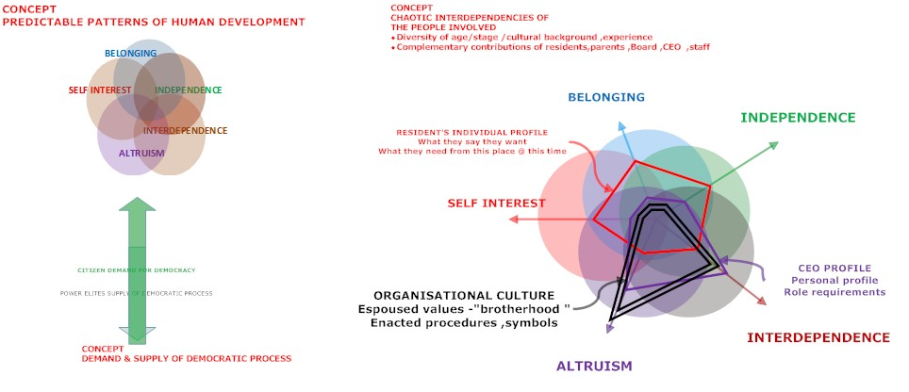

HOW might we gather credible,reliable,valid evidence to inform feedback/improvement /judgmen