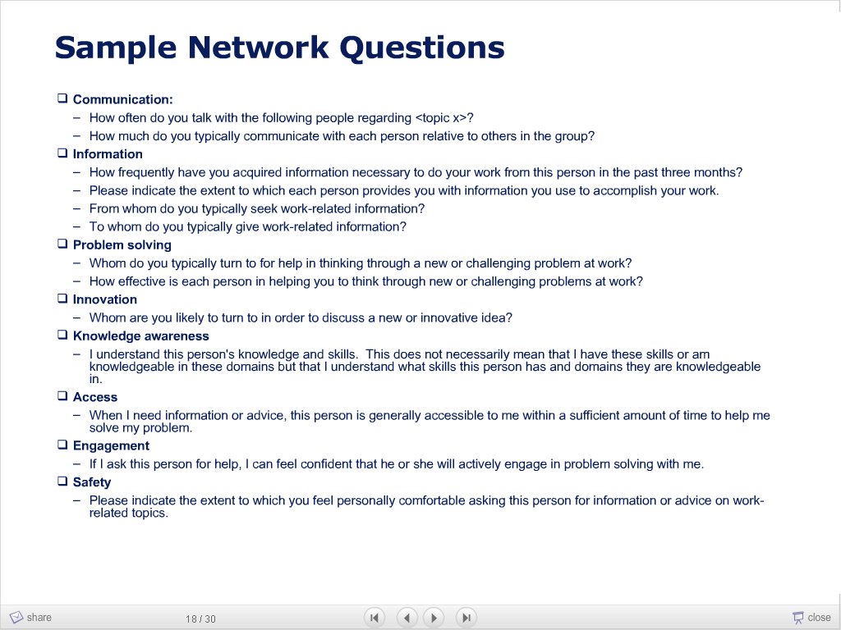http://www.rch.org.au/gatehouseproject/about/index.cfm?doc_id=176
Investing In Our Youth

The First Fully Operational Communities That Care Project in Australia

Written for Investing In Our Youth by
Colleen Carlon

Participating Organisations
Agencies South West Accommodation, Bunbury Cathedral Grammar School, Bunbury Catholic Youth Services, Bunbury City Council, Bunbury District Safer WA Committee, Bunbury Primary Health Services, Bunbury Crime Prevention, Catholic Education Office, Centre for Regional Development and Research—Edith Cowan University, Centrelink, Chamber of Commerce, Child and Adolescent Mental Health Services, Department of Community Development—Family and Children’s Services, Department of Education, Department of Indigenous Affairs, Department of Justice, Department of Sport and Recreation, Disability Services Commission, Greater Bunbury Division of General Practice, Homeswest, Job Futures, Jobs South West JPET, NEEDAC, Non Government School Psychology Service, Shire of Capel, Shire of Dardanup, Shire of Harvey, South West Aboriginal Medical Service, South West Area Consultative Committee, South West Community Drug Team, South West Development Commission, 2029 Committee, South West Population Health Unit, South West Regional College,
South West Times, Youth Outreach

“INVESTING IN OUR YOUTH” THE FIRST FULLY OPERATIONAL “COMMUNITIES THAT CARE” PROJECT IN AUSTRALIA.

INTRODUCTION
A healthy and safe community environment for all young people to develop their full potential by building strong relationships and valued participation within our communities is a vision that many would agree is worth pursuing. This is the vision that the Investing In Our Youth project is working towards in the South West region of Western Australia.

Investing In Our Youth aims to establish a community wide research and planning process to promote collaborative and strategic use of resources to assist the community to support the healthy development of children and young people. The Investing In Our Youth project uses the Communities That Care (CTC) approach. The project is based in the Shires of Harvey, Dardanup and Capel and the City of Bunbury in regional Western Australia.
Communities That Care is a community outcomes-based planning approach and service development strategy that is adopted by local communities to strengthen local policy, program and community strategies for prevention of youth problems. A research foundation of knowledge of predictors of health and behaviour problems, namely risk and protective factors, underpins the strategy. (Fiske 2000 p.1)

Investing In Our Youth was the first CTC project in Australia to attract sufficient funds to establish an Executive Officer position to facilitate the development of the project. CTC Ltd., is based at the Centre for Adolescent Health in Melbourne and CTC projects have also been established in Victorian communities.

The aim of this paper is to provide an overview of the Communities That Care approach within the context of the initiation and early development of Investing In Our Youth. The paper covers: information on the CTC approach, an outline of the initiation and early development of Investing In Our Youth and the benefits and future development of the project.

INFORMATION ON THE CTC APPROACH
The aim of the Communities That Care approach is to provide a structure to support communities to work across government and non-government sectors in a coordinated and collaborative way. This is achieved by using the CTC framework to establish a focus from which to grow common understandings and guide the development of working relationships in a community wide approach to promoting healthy youth development.

The Communities That Care approach has been developed by Professors Hawkins and Catalano of the Social Development Research Group, University of Washington, Seattle (Arthur, 2000; Developmental Research and Programs Inc 2000; Hawkins, Catalano et al. 1999; Catalano, Kosterman et al. 1996). The work of the Social Development Research Group supports the CTC approach and the processes involved in establishing operational CTC projects.
A central focus of this work is on the risk and protective factors as predictors of positive outcomes for children, the health and behaviour problems that get in the way of positive development and the effectiveness of programs in influencing these factors. (Fiske 2000 p.16)

Risk and Protective Factors
The concepts of risk and protective factors are central to the CTC approach. Risk factors are commonly viewed as something negative in a young person’s life that increases the chance of problems arising or exacerbates the existence of current problems such as low attachment to school, favourable parental attitudes to drugs and community disorganisation (Bond, Thomas, Toumbourou, Patton, & Catalano, 2000). Protective factors are something in a young person’s life that may be a support in dealing with problems in a more positive way such as opportunities for prosocial involvement in school and community (Bond et al., 2000). CTC look at protective and risk factors within four domains the community, school, family, and the individual. The research shows that the cumulative effect of the number of risk factors in a young person’s life has direct correlation to their adoption of behaviours which may be self destructive (Bond et al., 2000; Toumbourou, 2000). Such behaviours include drug use, crime, homelessness and youth alienation. The number of protective factors a young person has operating in their life can provide a buffer to the risk and can support young people to make more positive responses to their situation. The relationship between the presence of risk factors and/or the absence of protective factors and the increase in problem behaviours shows that a young people with seven or more risk factors in their environment have a much higher incidence of problem behaviours. Thus reducing the impact of 2 to 3 risk factors across the community would see a significant drop in the incidence of problem behaviours (Catalano et al., 1996; Toumbourou, 2000). Discussion and clarification of the effectiveness of the risk-focused approach have emerged throughout the last decade in the field of prevention science (Catalano & Hawkins, 1996; National Crime Prevention, 1998; Murphy, 2000; Toumbourou, 2000).

The CTC approach offers communities training, research tools and technical support to work together across the community to identify the risk and protective factors that exist in the local setting. Then to use this information to plan to boost protective factors that are depressed and to reduce risk factors that are high in the local area through the application of evidence based programs. The key focus of the CTC framework is around building capacity for community wide collaboration and promoting a prevention and early intervention approach to dealing with youth issues. Developmental Research Programs, Inc. view CTC as an “operating system”.
Communities That Care operating system provides research based tools to help communities promote the positive development of children and youth and prevent adolescent problem behaviours that get in the way of positive development, including substance abuse, delinquency, teen pregnancy, school dropout and violence. (Developmental Research and Programs Inc, 2000).

The CTC Research Framework and Phases
The CTC framework has four key aspects:
- Social Development Strategy
- Comprehensive community wide approach
- Data-based predictors
- Effective, tested programs, policies and practices
(Developmental Research and Programs Inc, 2000 p.2).

The Social Development Strategy aspires to establish clear standards specific to the community and applicable to the different developmental stages of young people. It requires communities to examine role models set by the adult community. Communities are challenged to identify and promote clear standards for healthy beliefs considered acceptable to the community within the context of cultural frameworks and macro issues that impact on the community (Catalano & Hawkins, 1996; Catalano et al., 1996).
The Social Development Strategy begins with the goal of healthy, productive behaviours of young people. In order to develop, young people must be immersed in environments that consistently enhance protective factors by communicating healthy and clear standards of behaviour. (Fiske, 2000 p.17).

The community mobilisation aspect of the approach aspires to involve all sectors of the community in researching, planning and implementing early intervention strategies and attempts to apply the benefits of community development to a model for research and planning. The database predictors for the local community are developed within a framework of common risk and protective factors and assist the community to identify and target specific factors relevant to the local context. A key CTC tool is the youth survey. The Youth Survey was adapted to the Australian context by the Centre for Adolescent Health in Melbourne. It is known as The Adolescent Health and Well Being Survey and was piloted in 1998 and run across Victoria in 1999 (Bond et al., 2000; Toumbourou 2000). Interventions are selected from evidenced-based programs reliant on evaluations to indicate effective strategies in the identified target areas (Developmental Research and Programs Inc, 2000; Fiske, 2000).

Figure 1 shows the structural diagram developed by Investing In Our Youth, to support the early development of common understandings of the CTC framework. This diagram was used by the Executive Officer to facilitate discussion, inform community and establish boundaries for the work of the project.

Figure 1 The CTC Research Framework and Phases for Investing In Our Youth October 2000.

The five phases outlined by the approach move from the notion of community readiness through to community involvement, development of a community profile, development of a plan and the implementation of the plan (Developmental Research and Programs Inc, 2000; Fiske, 2000; Toumbourou, 1999). The CTC phases facilitate a progression of the collaborative and consultative process whilst enabling communities to move through the process in a way that is relevant to the local situation. The experience of Investing In Our Youth has been that aspects of each phase move into the next with different community readiness issues emerging as the project develops (Carlon, 2002). The phases provide a reference point for different groups within the process to identify their own movement and to acknowledge the position of other groups/individuals thus facilitating an understanding and acceptance of community collaboration processes.

AN OUTLINE OF THE INITIATION AND EARLY DEVELOPMENT OF INVESTING IN OUR YOUTH

The Local Area
The Shires of Harvey, Dardanup and Capel and the City of Bunbury are situated in the Preston sub-region of the South West Region of Western Australia.
The sub-region has a steady population growth averaging 2.2 per cent per annum. More than one-third of the South West Region's population - approximately 45,000 - lives in an area known as Greater Bunbury, encompassing the city itself and the dormitory centres of Australind and Leschenault (Shire of Harvey); Eaton (Shire of Dardanup); Stratham, Dalyellyup and Gelorup (Shire of Capel). The shires of Dardanup and Harvey in particular have achieved consistently high growth rates over the last six years. (Available WWW: www.swdc.wa.gov.au)

The Preston region has a high population of children and youth with local education facilities catering for approximately 14,000 pre-primary, primary and secondary students. ABS figures 30 June 1999 show the number of children and young people up to age 20 living in the Preston region to be 23752. There is a growing concern for youth in the area. Youth alienation as defined by patterns of substance abuse, crime, violence and referrals to mental health facilities and school disaffection is consistent with the general youth pattern in Western Australia.

Initiation and Early Development of the Project
Interest in the CTC process was raised and pursued through various meetings and public forums in the Bunbury area throughout 1999 and 2000. Organisations represented in this very early development of community collaborative planning processes were the Education Department of Western Australia, the Bunbury District Safer WA Committee, Bunbury Primary Health Services, the Centre for Regional Development and Research Edith Cowan University South West Campus, South West Mental Health, Agencies for South West Accommodation, the South West Development Commission and the City of Bunbury. Documentation from this time asserts a clear commitment in the local community to advancing the process of community wide collaborative planning and an acknowledgment that existing data held by agencies did not provide a clear picture of the risk and protective factors existing in the local community (Plumb, 2000). By April 1999 a Steering Committee named “Investing In Bunbury’s Youth” was established. Throughout 1999 various seminars and public forums were hosted in Bunbury.
A commitment to proceed with CTC was reaffirmed on the basis that it provides a community development process which is clear and well structured, network support through CTC worldwide and in Australia, access to the leading research-based program in the area of community intervention to bring about community change and interest within WA Government department circles in the program. (Plumb 2000 p.5).

The Steering Committee raised funds and significant in kind support, from different sources, to carry out the coordination of research and planning from July 2000 over a three-year period. An Executive Officer was appointed to facilitate the CTC process in the City of Bunbury and the Shires of Harvey, Dardanup and Capel under the project known as Investing In Our Youth. The project was set up to operate under the incorporation of the Bunbury District Safer WA Committee and to function as a research project from the Centre for Regional Development and Research at Edith Cowan University South West Campus.

Development of the Committee Structure
The first key task of the Executive Officer was to establish a committee structure for the project and to broaden community involvement. The model adopted by Investing In Our Youth is shown in Figure 2.

Figure 2 Investing In Our Youth CTC Committee Connections

The CTC approach advocates establishing a leadership group known as the Key Leaders and a work group known as the Community Prevention Board (Developmental Research and Programs Inc, 1998).

The theoretical assumptions underpinning the model accept the importance of top-down support in order to sustain local community change processes, but also accepts that priorities and responses must be bottom-up if they are to enhance capacities for local control, engagement and well-being. The CTC program emphasises an educational – consultative role to assist communities to explore an evidence-based approach to prevention. (Toumbourou 2000 p.4).

It was felt that a Community Board directed by a Key Leaders group was not suitable to the political and social environment of Investing In Our Youth. The project sought to adapt the CTC concept of these two groups to a model more applicable to the local community. For Investing In Our Youth the Community Board acts as the decision making group for the project and the Key Leaders as a group that will work along side and provide strategic and resource support as required see Figure 2.

The Steering Committee that had directed the project to this point was made up of local service directors and departmental managers and local government representatives. The majority of these members moved into the Key Leaders Group with some also sitting also on the Community Board. The Key Leaders Group are currently identified as the individuals in the community who can impact on policy, direct resources, and/or influence public opinion. Their key role is to facilitate the process as decided by the Community Board. The role of the original Steering Committee diminished over time with the development of the Community Board and the Key Leaders Group. The decision- making role for the project was passed on from the original Steering Committee to this new body, the Community Board, as the Board gained strength in late 2000.

The Community Board provides governance of the Investing In Our Youth Communities that Care Project. It is the decision making body for the project and aspires to be representative of the diversity of the community in the greater Bunbury region. Together the Community Board and the Key Leaders Group work towards their vision for the future of the community’s children and the development of a structural process to reach this vision.

The Community Board
Expressions of interest for the Community Board were called for through community announcements in the local press and radio and through direct communication from the Executive Officer or through the Steering Committee network. At the time of writing there are 40 listed members of the Community Board, not all of these people will be active in the project, but all have indicated an intention to participate. Members have self-selected by coming to meetings and indicating interest and intention to participate. The Community Board will maintain a broad base membership thus enabling people to move in and out of the project according to their interest and/or availability.

Members are those from the community who are actively involved with young people or have an interest in creating a better future for young people. The initial event for prospective Community Board members was the CTC Community Board Orientation Session, September 2000, facilitated by David Sheval from Developmental Research and Programs Inc., Seattle. Since this time the Community Board have met on a monthly basis and new members continue to join the group as community awareness of the project grows.

Various work groups have emerged within the structure of the Community Board to take on different tasks within the project. Figure 3 shows the some of the work groups to have functioned over the time of the project.

Figure 3 Community Board Work Groups

The structure for the formation of these groups stays fluid to facilitate the emergence of different groups according to perceived need in each phase of the project. Community Board members move in and out of groups to best suit their interests, skills and availability to the project. The Community Board and the attached work groups have over time gone through a process of developing the role and structure of each group. All meetings in the project are open to all community members and observers. The core of the Community Board is known as the Community Board Executive Group.

THE BENEFITS AND FUTURE DEVELOPMENT OF THE PROJECT
The benefits of applying the CTC process in a community are varied, and would be specific to each location, however from the experience thus far of Investing In Our Youth some of the most salient benefits appear to be:

- To facilitate a youth voice in the local policy network. Investing In Our Youth has over time established a youth members groups known as “YVoiceOut!” this group meets each month to discuss issues and to explore ways in which they may be able to support themselves and other young people in the community. “YVoiceOut!” are also involved in broader project meetings to view research findings and to discuss the application of the research and planning process in the local context. Their familiarity and ongoing involvement in the project supports their authentic participation in these broader meetings.

- To produce research data outlining local issues for young people. The focus group research has been effective in taking the notion of risk and protective factors to young people and finding out about their perceptions of what does or does not support healthy development. The survey data provides a risk and protective factor profile for the local community and assists the community in identifying clear priorities for planning.

- To provide a local forum for youth issues. Investing In Our Youth holds regular meetings open to all community members and service providers to direct the work of the project. These meetings generally discuss relevant local issues as they arise and also act as a forum for the exchange of information regarding current programs and services and policy developments.

- To provide a structured framework for allocating and sourcing resources. This is particularly beneficial for those organisations that do not have a strong emphasis on or history of working with youth issues or even social and/or health services. One of the local governments participating in Investing In Our Youth was successful in gaining funds for a youth worker position on the basis of the local community action that had developed around issues for young people. Their active involvement in a local CTC project gave strength to their application and was useful in demonstrating their commitment to youth issues and their capacity to take a structured evidenced based approach to assessing needs and working with youth issues.

- To support collaboration by providing a clear framework for collaborative action. The commitment to and understanding of collaboration required as the project develops takes participants beyond networking and exchange of information. The training and consultation processes provide another avenue to move through some of the common barriers to collaboration (Carlon, 2002).

- Takes the focus off “the problem” of young people and looks not only at how young people grow and develop but how their families, schools and communities support and/or hinder that growth and development.

The CTC approach takes a long-term view to working on prevention and early intervention strategies to promote healthy youth development. “YVoiceOut!” talk about this in terms of what may have supported them more as they grew up. They look to what they can do now to help in their local community but also what is possible for the future.

The benefits of Investing In Our Youth to the Shires of Harvey, Dardanup and Capel and the City of Bunbury are at this stage largely untested. A high level of interest has been generated and maintained around the project and highlights the broad appeal of the CTC approach. The structure of the CTC research framework and five-phase plan provides a clear way forward in a collaborative planning process yet is flexible enough to accommodate a diversity of local concerns. Interest in and support for the Community Board and the Key Leaders Group has been strong with meetings well attended and a solid group forming to promote and develop the work of the project. The implementation of the CTC approach serves to highlight the differences in perspectives that exist in the local community and can be seen to be opening an avenue to an exploration of working more effectively with these differences. Investing In Our Youth demonstrates the way in which a community can adapt the CTC framework to the local environment and early indications are that the processes involved in working through the CTC phases and framework support the community in getting ready for implementing a community wide plan focused on promoting healthy youth development. The learning to come out of this project informs the broader application of CTC in an Australian setting.

Written by Colleen Carlon Executive Officer Investing In Our Youth Edith Cowan University
South West Campus Robertson Drive Bunbury Western Australia 6230 Tel: 0897807754 email: c.carlon@ecu.edu.au

BIBLIOGRAPHY

Arthur, M. W., and Blitz, C., (2000). Bridging The Gap Between Science and Practice in Drug Abuse Prevention Through Needs Assessment and Strategic Community Planning. Journal of Community Psychology. May: 241-255.

Bond, L., L. Thomas, et al. (2000). Improving the lives of young Victorians on our community: A survey of risk and protective factors. Melbourne, Centre for Adolescent Health.

Carlon, C. (2002). “Implementing Communities That Care in Regional Western Australia.” Unpublished, paper.

Catalano, R. F. and J. D. Hawkins (1996). The social development model: A of antisocial behaviour. Delinquency and crime: Current theories. J. D. Hawkins. New York, Cambridge University Press.

Catalano, R. F., R. Kosterman, et al. (1996). “Modelling the etiology of adolescent substance use: A test of the social development model.” Journal of Drug Issues 26(2): 429-455.

Developmental Research and Programs Inc., (2000). Communities That Care information pack. Seattle, Washington, Developmental Research and Programs, Inc.

Developmental Research and Programs Inc., (1998). Communities That Care Process facilitators training. Seattle, Washington, Developmental Research and Programs, Inc.

Fiske, G. (2000). Communities that care: A prevention approach to build the resilience of young people in our communities. Victoria, The Department of Human Services. 2001.

Hawkins, J. D., R. F. Catalano, et al. (1999). “Preventing adolescent health-risk behaviours by strengthening protection during childhood.” Archives of Paediatrics and Adolescent Medicine 226-243.

Plumb, A. (2000). Investing In Our Youth Process. Bunbury, Western Australia, Investing In Our Youth.

Plumb, A. (2000). Opening Address. Catalano Seminar, Bunbury, Western Australia.

Toumbourou, J. (1999). “Implementing Communities That Care in Australia: A community mobilisation approach to preventing crime.” Australian Institute of Criminology: Trends and Issues in Crime and Criminal Justice 122: 1-6.

Toumbourou, J. (2000). Will crime prevention using the Communities That Care approach be relevant in Australia. Perth, Western Australia, Australian Institute of Criminology. 2000.

Statistics provided by the South West Development Commission.
WA Child Health Survey- Institute for Child Health Research: Australian Bureau of Statistics, 1995.

