PROJECT WORKING TITLE

“CLASS GOVERNANCE – BENCHMARKING PROJECT 2008 “
ASSUMPTIONS
CLASS is in the developmental stage of its design and implementation. The CLASS governance group needs to gather story, anecdote, and data to synthesise these sources of evidence to inform the design of the next phase of CLASS evolution.

FOCUS
This paper
- Articulates CLASS enterprise logic
- Hypothesises key research questions relating to the stated intentions
- Describes a set of Principles, Protocols and Practices to design a data gathering system that can be managed within the resource base available to CLASS
- Presents set of visual dashboard images designed to summarise data and inform the CLASS governance group of some measures of impact and outcomes achieved during the year
  - Student performance profile
  - Student migration patterns
  - Resource use summaries
  - Class community resiliency
ARTICULATE CLASS ENTERPRISE LOGIC

HYPOTHESISE KEY RESEARCH QUESTIONS | DESCRIPTION OF PRINCIPLES,PROTOCOLS& PRACTICES
RESEARCH QUESTION 1  Are we adding value to our student learning ?(as measure by these tests)  RESEARCH QUESTION 2  Are we attracting and retaining students who reflect the diversity of our communities? | Principles  - Data available to governance group for decision on use /distribution  - Individual students not identified  Protocols  Each CLASS principal to annually affirm data sharing protocols and principles  Request EDS to run queries from CDW annually  - Average literacy gain year for each student cohort tracked from year 3 to year 9 i.e. year 3 in 2003 to year 5 in 2005 to year 7 in 2007 and to year 9 in 2009.  Each school principal conducts annual analysis of individual school data. Relevant trends and patterns reported to CLASS GOVERNANCE GROUP who determines specific focus investigations that impact at a cluster level.  Practices  At the annual planning forum ,synthesise trends and patterns ;affirm internal /external application of findings ( advocacy for resources ,strengthening partnership proposals ,program evaluation etc )

HYPOTHESISE KEY RESEARCH QUESTIONS | DESCRIPTION OF PRINCIPLES,PROTOCOLS& PRACTICES
RESEARCH QUESTION 3  Are CLASS schools retaining students who enrolled in Prep/year 1??  RESEARCH QUESTION 4  What are the characteristics of students who enter and exit our school system? | Principles  - Data available to governance group for decision on use /distribution  - Individual students not identified  Protocols  Each CLASS school maintains a common data base established to track exiting students at year 2/4/6/8/10  - Student number  - Postcode of residence  - Literacy performance ( 1 Top quartile ;2 middle quartiles ;3 bottom quartile )  - Destination ( a attend other CLASS school ;b attend SS ; c attend non state school in area )  BDM synthesises annually to inform planning forum  Practices  Analysis of the data is intended to generate early warning signs (early/weak signals) of changes in student populations. More importantly, what responses are required .at the cluster level (I imagine that these trends may be used to advocate for resource differentials at the district and regional levels)?

HYPOTHESISE KEY RESEARCH QUESTIONS | DESCRIPTION OF PRINCIPLES,PROTOCOLS& PRACTICES
RESEARCH QUESTION 5  Are CLASS schools managing their financial resources within system protocols?  RESEARCH QUESTION 6  Are the patterns of resource inputs and resource consumption positioning CLASS to become a sustainable enterprise? | Principles  - All financial operations comply with departmental standards  Protocols  All CLASS financial resources are managed through a single school account  All CLASS programs &projects are resourced to account for the total cost  - Transparent contributed from CLASS resources AND participating school contributions required ( people expertise , time , in kind support etc )  Program managers/project leaders report on planned VS actual resource usage  (The Ecological footprint may be a futures orientation )  Practices  The Governance group is accountable for resource management at a portfolio /program level – Program /Project managers deal with the resources allocated and are given the responsibility to “manage wisely” and reallocate within given budgets to meet emergent needs.

HYPOTHESISE KEY RESEARCH QUESTIONS | DESCRIPTION OF PRINCIPLES,PROTOCOLS& PRACTICES
RESEARCH QUESTION 7  Is CLASS building and sustaining mutually beneficial relationships internally with staff and externally with community, business and the corporation? | Principles  - Share contacts for mutual benefit  Protocols  All professional learning activities triangulate perceptions of program outcomes  Participant  Project  Leader  Participant  Supervisor  CLASS PROGRAM MANAGER SYNTHESIS  - BUILDING CAPABILITY  - STRENGTHENING SOCIAL CAPITAL  - IMPLICATIONS FOR NEXT ACTION STEPS  BUILDING CAPABILITY  - Participants rate personal capability in terms of project objectives  - Entry Self report on capability ( 1- 10)  - Activity conclusion Self report ( 1- 10)  - 12 months Self report negotiated with supervisor ( 1- 10)  - Project manager record judgments of individual participant capability at entry and exit ( 1-10)  - Supervisor of attendee negotiates 12 month review rating  - Program manager ensures final report includes Accomplishments ( based on feed back from attendees supervisors ) and Implications for next action steps written into final report  STRENGTHENING SOCIAL CAPITAL  All project managers maintain a common data base of attendance  Participants draw the social support map of people who help in relation to this topic ‘ Who are the people you seek advice from to help you ( teach literacy )  Project leaders identify patterns of connection across CLASS settings .Program managers report on implications for next actions.  Practices  This is a little “cutting edge “with potential to disturb people not used to actually delivering or following through after attendance. The capabilities required to complete the Organisational Network Analysis need to be developed.

DASHBOARD SUMMARY –STUDENT PERFORMANCE PROFILE

Yr3 2003

Yr 5
2005

Yr7
2007

Yr9 2009
CLASS TREND
QLD TREND
VALUE ADDED

DASHBOARD SUMMARY –STUDENT MIGRATION PATTERNS

VISUAL IMAGE
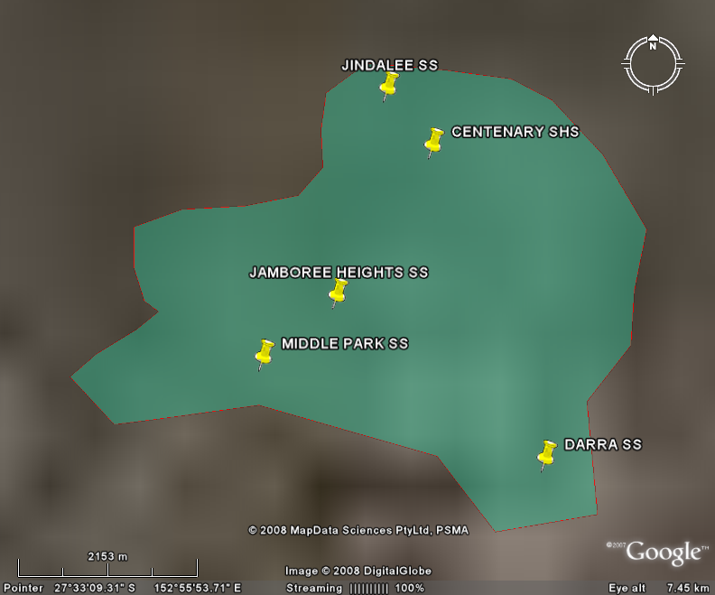

TOTAL STUDENT COHORT
Individual school
INFLOWS & OUTFLOWS

ALL CLASS PREP
ATTENDANCES
DAY 8???

ALL CLASS YEAR 2
ATTENDANCES
DAY 8 2002

ALL CLASS YEAR 4
ATTENDANCES
DAY 8 2004

ALL CLASS YEAR 6
ATTENDANCES
DAY 8 2006

ALL CLASS YEAR 8
ATTENDANCES
DAY 8 2008

CLASS MIGRATION TRENDS & PATTERNS

ALL CLASS YEAR 10/12

DASHBOARD SUMMARY – RESOURCE USE SUMMARY
VISUAL IMAGE
JAN FEB MAR APR MAY JUN JUL AUG SEP OCT NOV DEC
TIME
$

FINANCIAL

BREAKDOWNS AS REQUIRED
INCOME STREAMS

- CLASS TARGET TOTAL
- BUDGET PROJECTIONS
- ACTUALS
  - Student levies
  - EQ grants
  - Grants form outside agencies
  - Business sponsorship
  - Value of in kind contributions????

OUTGOINGS
- Program budget/actuals
- Administration costs
  - Salaries
  - Plant /equipment?

ECOLOGICAL FOOTPRINT
  - Performance of schools in terms water, energy & waste reduction to deliver “ Enough for all for ever”
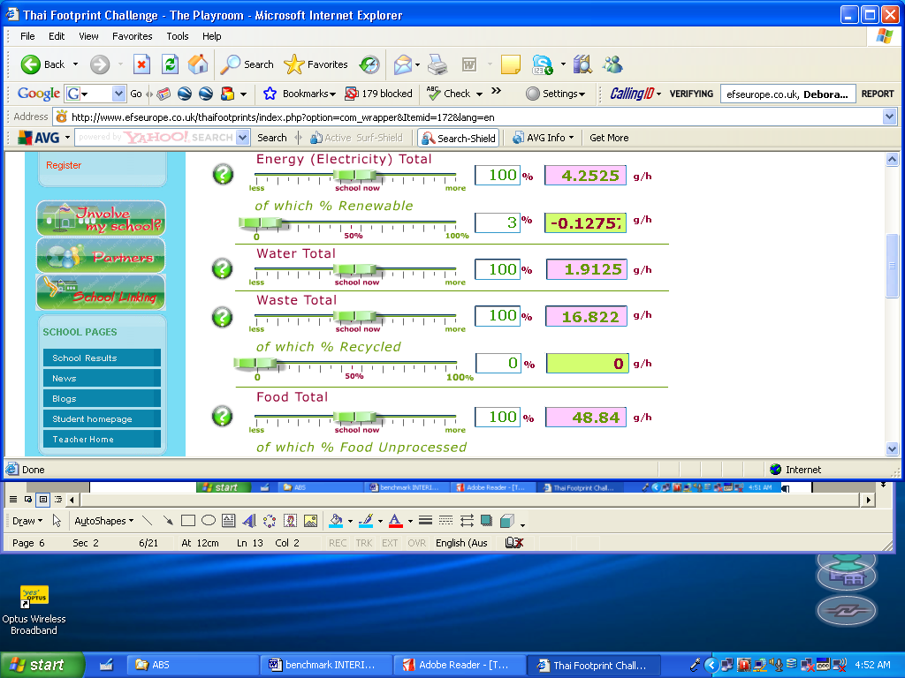




DASHBOARD SUMMARY CLASS COMMUNITY RESILIENCY

VISUAL IMAGE

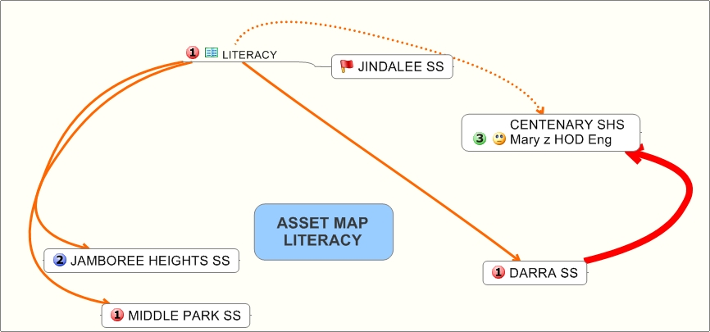

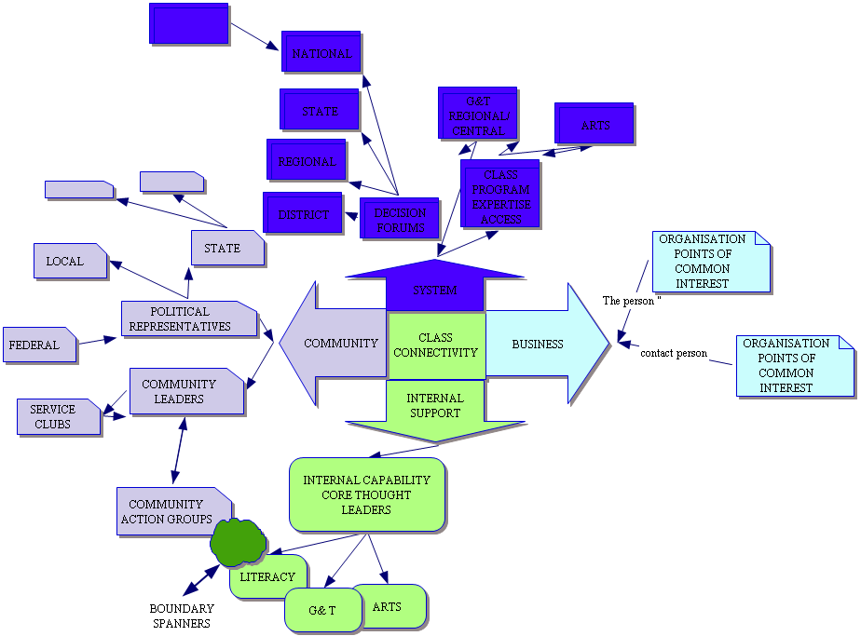
National
State
Regional
District
Arts
Decision Forums
G&T Central/ Regional
CLASS program expertise access
System

DEMOGRAPHIC ANALYSIS

WHY DO THIS? /HOW DOES IT ASSIST DECISION MAKING
- Share data across CLASS schools to provide the local area profiles for strategic planning
- Appreciate market segments to inform marketing
- Monitor the outcomes of specific programs designed for specific market segments (i.e. is the portfolio of programs that engage primary /secondary student interactions making a difference to student migration patterns??
  - Migration patterns of high performing students @year6 and year 8)

HOW CAN THIS BE SUTAINED INTERNALLY
- Data source
  - ABS every 4 years
  - Google Earth
  - Day 8 enrolment data by student number and postcode
- Capability requirements
  - Internet access
  - Search capability
- Collection and presentation protocols
  - BDM managed through identified school expertise
  - Consider Geography /G&T students unit of work on GIS applications of local area study
PHYSICAL ATTRIBUTES OF LOCAL AREA

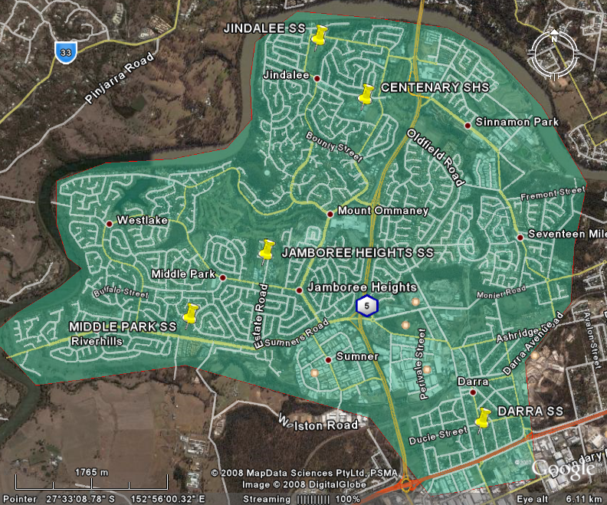
River to North & west
Centenary Highway
Ipswich Road
Ipswich Rail line

Location

Transport

Competing schools

Community assets
Available for
Educational purposes

POPULATION CHARACTERISTICS WITH AN IMPACT ON CLASS

Socio economic profile
- Median house prices
  - Middle Park
    - Sumner Park
    - River Hills
    - West Lake
  - Jindalee
    - Cinnamon Park
  - Jamboree Heights
    - Mt Omani
  - Darra
  - Seventeen Mile Rocks
- Income profile

EDUCATION BACKGROUND
Education Level | Australia | QLD | Jindalee | Jamboree Heights | Mt Omani | Middle Park | Westlake | River hills | Darra-Sumner
Year 8 or below | 9.4% | 10.0% | 4.1% | 5.6% | 4.4% | 3.4% | 2.5% | 3.1% | 14.0%
Year 10 or equivalent | 23.8% | 28.4% | 22.6% | 22.1% | 16.1% | 19.3% | 18.6% | 26.3% | 21.4%
Year 12 or equivalent | 37.7% | 37.0% | 56.7% | 52.4% | 61.2% | 59.6% | 61.5% | 53.2% | 37.6%
Did not go to school | 1.0% | 0.5% | 0.1% | 0.8% | 0.8% | 0.6% | 0.4% | 0.3% | 4.7%

 | Australia | QLD | Jindalee | Jamboree Heights | Mt Omani | Middle Park | Westlake | River hills | Darra-Sumner
Postgraduate Degree | 1.8% | 1.4% | 3.8% | 3.2% | 4.4% | 4.2% | 4.7% | 2.4% | 0.4%
Graduate Diploma and Graduate Certificate | 1.4% | 1.1% | 2.1% | 1.9% | 1.9% | 2.7% | 1.9% | 2.0% | 0.7%
Bachelor Degree | 9.7% | 8.3% | 16.1% | 13.3% | 19.7% | 17.2% | 18.2% | 14.8% | 5.9%
Advanced Diploma and Diploma | 6.0% | 5.5% | 8.3% | 8.0% | 8.9% | 8.8% | 8.5% | 7.7% | 3.8%
Certificate | 15.8% | 16.0% | 14.3% | 17.3% | 11.0% | 11.8% | 13.2% | 15.9% | 12.0%

LANGUAGE SPOKEN AT HOME

Australia |  | QLD |  | Jindalee |  | Jamboree Heights |  | Mt Omani
English | 79.1% | English | 86.8% | English | 85.5% | English | 78.6% | English | 71.4%
Italian | 1.9% | Italian | 0.7% | Mandarin | 1.7% | Vietnamese | 3.5% | Mandarin | 8.5%
Greek | 1.4% | Cantonese | 0.5% | Vietnamese | 1.2% | Cantonese | 2.7% | Cantonese | 3.6%
Cantonese | 1.2% | Mandarin | 0.4% | Cantonese | 1.0% | Arabic (including Lebanese) | 1.2% | Vietnamese | 2.5%
Arabic (including Lebanese) | 1.1% | German | 0.4% | Italian | 0.6% | Spanish | 1.0% | Japanese | 1.6%
Vietnamese | 0.9% | Vietnamese | 0.4% | Netherlander | 0.6% | Polish | 0.9% | Tamil | 0.9%

Middle Park |  | Westlake |  | River hills |  | Darra-Sumner
English | 75.2% | English | 78.3% | English | 85.5% | English | 49.5%
Cantonese | 4.2% | Cantonese | 3.2% | Vietnamese | 1.6% | Vietnamese | 26.9%
Vietnamese | 3.8% | Vietnamese | 3.2% | Mandarin | 1.2% | Polish | 2.9%
Mandarin | 3.0% | Mandarin | 2.4% | Cantonese | 1.0% | Samoan | 1.9%
Tamil | 1.6% | Hindi | 1.0% | Spanish | 0.9% | Cantonese | 1.9%
Hindi | 0.9% | Tamil | 0.9% | Italian | 0.6% | Spanish | 1.8%

