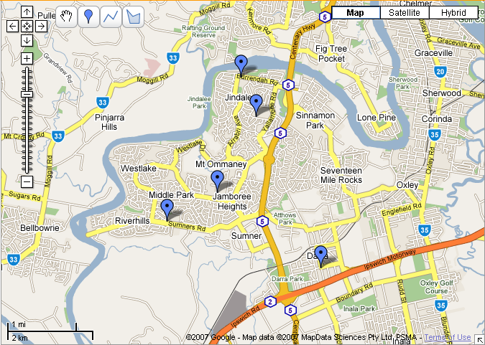Schools from top to bottom are:

Jindalee SS
Centenary SHS
Jamboree Heights SS
Middle Park SS
Darra SS

