CENTENARY ALLIANCE OF STATE SCHOOLS (CLASS) BUSINESS PLAN 2009

PERFORMANCE REVIEW 2008
CLASS established four primary outcomes to focus collaborative effort in the longer term.
- Enhanced academic, social and ecological learning outcomes for students in each school
- Stronger personal and professional relationships
- More effective and efficient application of the resources available
- A stronger voice within the education community

A program evaluation methodology accessed the professional judgement of the governance group, data collected from project delivery and current research to celebrate strengths of 2008 performance and identify gaps between strategic intent and delivery to inform program improvement in 2009.

The following synthesis is based on the available evidence.

STRENGTHS /ACCOMPLISHMENTS 2008
Impact on student learning
- Regional expertise has identified results from National benchmark tests in Years 3/5/7and 9.literacy data across the CLASS cluster. Principals have begun to analyse CLASS student performance data across schools to track “ value added “ for each student cohort and gain early indicators of required interventions and educational programming at a cluster level.(Retention of Year 7 students from top performance quartile is of specific interest)
Achievement of intended outcomes
- The four intended outcomes and culture that define CLASS identity have been affirmed as relevant, credible and feasible.
- The Governance Team has met on X occasions with 90% attendance. The “Fierce Conversation” protocol is providing a framework that is developing open honest dialogue about things that matter to the governance team.
- Of the 10 project proposed for 2008, Five? Were funded and delivered within the project design, monitoring and review protocols established by the governance team.
- Y school staff have attended CLASS sponsored professional learning opportunities/collaborative events.
- In a trial pilot application of the Standards for Teachers framework, 95% of participants in the Literacy project reported that they believe the program had strengthened professional knowledge and built sustainable professional learning communities across the participating CLASS schools.
- CLASS has generated z$ from school funds contributions and attracted the following additional resources to CLASS operation
  - G&T resources
  - Grants
  - Etc in kind
- The budget is in surplus to provide carry over start up funds for 2009 operation
- CLASS is increasingly being approached as a single entity to support regional and district initiatives.

IDENTIFIED GAPS BETWEEN STRATEGIC INTENT AND DELIVERY
Evidence based decision making (effective & efficient resource use)
Triangulation of professional judgement across schools and levels within the governance team is becoming more powerful as “fierce conversations” become the norm. – This is a necessary but insufficient approach to shared decision making.

A more comprehensive information management system to link story, data information and wisdom will enhance CLASS credibility and develop the trust on which these social systems are premised.
- The emergent systems to track “ value added “ for targeted student cohorts ; identify CLASS migration trends ,track financial performance etc need to be formalised and applied to provide credible evidence on which to
  - Inform decision making within CLASS (i.e. decisions on project delivery - G&T project 2008)
  - Attract additional resources/commitment from the business community
  - Advocate for diminishing resources within the corporate resource allocations

Developing and sustaining CLASS connectivity. (Stronger personal and professional relationships/stronger voice in education community)
There are two foci for building and sustaining CLASS connectivity
- Internal
  - Class governance team ( This is going very well BUT expect constant disruption through acting appointments etc )
  - School staff (It would appear that staff who have attended CLASS sponsored events may know about the program. Most do not! Engaging the broader group in some meaningful way is essential to sustain CLASS operation.
  - Parents/carers (Representation at the governance level has not been finalised. The role of P&C’s from each school is unclear)
- External
  - Decision forums within DET&A (Julie sits on some influential Professional development forums at the regional level. Who replaces this essential role??)
  - Business Community ( The Business Development Manager has attracted sponsorship in $ and in kind support through personal effort – There are implications for BDM outcome accountabilities )
  - Government agencies/community groups ) Integrated service delivery has been an unrealised aspirational goal
The adoption/adaption of a networked business structure may provide the Meta framework that could inform guidelines, protocols and practical actions

Building capability to sustain alliance strategy (professional relationships0
The employment conditions, roles, responsibilities of the BDM have changed through both practice and the capabilities brought to the position by the incumbent

The alignment between management at the portfolio. Program and project levels are not yet clear. The interdependent relationship across all levels needs to devolve project management to project leaders and allow the governance group to refocus on strategy

ENVRONMENTAL SCAN
The governance team analysed the contextual factors that have implications for operation in 2009

PHYSICAL ATTRIBUTES OF LOCAL AREA

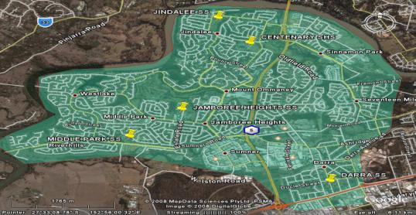

The communities for who CLASS provides educational services are bounded to the north and west by the Brisbane River while Ipswich Road provides a southern boundary. The Centenary Highway divides Jindalee, Middle Park, Jamboree Heights and Centenary from Darra.

These factors, combined with proposed rerouting of traffic around the CBD, suggest that future enrolments will be drawn from within the defined catchment. Some potential exists to attract out of catchment enrolments from the eastern fringes or commuters using the north south highway.

RELEVANT DEMOGRAPHICS
Quantitative data on the total number of school age students residing within the defined catchment and the percentage of those who choose to attend CLASS schools is currently unavailable.
The annual review of enrolments conducted by each principal indicates the following trends and patterns with implications for CLASS strategy
- The total number of students attending P-12 has remained relatively stable between 2006 - 2008
- Outflows of students from prep , Years 4, 6 and 10 are within state benchmarks for similar schools
- Approximately 80% of Centenary SHS year 8 enrolments are drawn from CLASS primary schools.
- A high proportion of CLASS students achieving literacy results below National averages choose to attend Centenary SHS. Concomitantly, a relatively low proportion of students performing in the top quartile choose to continue their education at the local high school.

CLASS schools service a broad diversity of students and parents
- More than half of adults living in the catchment area have completed year 12 or its equivalent
- The number of adults with a degree is approximately twice the national average
- Over 80 % of adults in the catchment speak English. Vietnamese ( Darra ) and Mandarin are also spoken

The CLASS communities value education and hold high expectations for the quality of educational provision. Most have access to the resources necessary to support the education program and are articulate advocates for their children. This challenge to add value to each child’s learning results in the need to support a broad range of educational programs that address academic performance (both giftedness and remediation), and social dimensions of learning ( community building and dysfunction) in a context where there is considerable choice available for most parents.

EDUCATIONAL CONTEXT
Jindalee SS, Jamboree Heights SS Centenary SHS, Darra SS and Middle Park SS are extremely proud of the high quality education each school community currently provides. However, the increasing complexity of the situation in which we work is challenging our long term effectiveness. Specifically
- Diversity of students needs requires access to a broader range of targeted educational programs than our individual resources can provide
- Increasing specialised capabilities required by staff to design, and deliver targeted educational interventions places undue pressure on individual school communities. (There are possible economies of scale to be accessed by sharing experience and expertise and building capabilities at a cluster level)
- Community assets we contribute / access from business /Government / System sources are underutilised when each school community contributes/competes individually
- A disjointed voice in regional decision making reduces our capacity to maximise use of system resources

We believe that by working together as part of the State School System, we can strengthen our effectiveness in improving the learning outcomes for all students

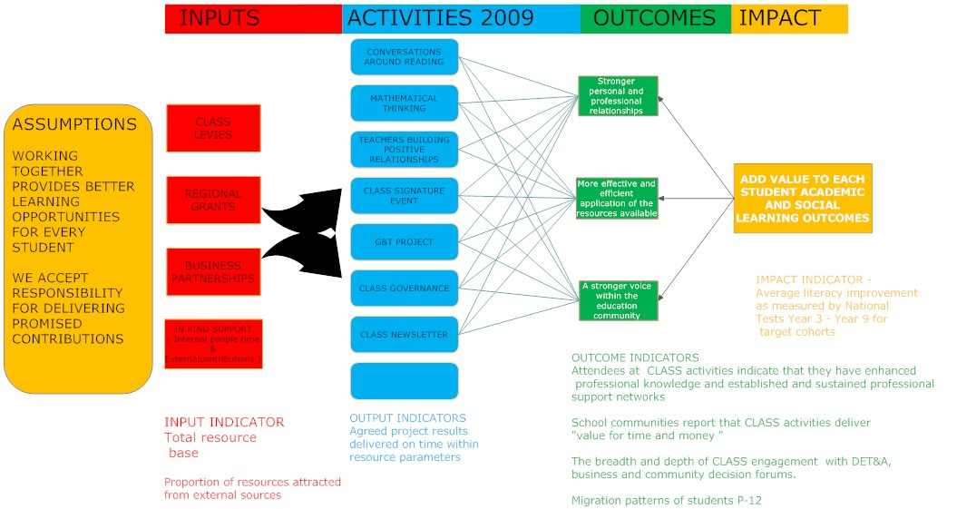
CLASS BUSINESS PROGRAM LOGIC MAP 2009

PROGRAM MANAGEMENT PRIORITIES 2009

TIMELINE | TASK | ACCOUNTABILITIES
27 NOV 08 | Write draft CLASS Business Plan 2009 | Bill Brown
 | Project Managers reconsider approved projects to accommodate review feedback | Debra McPhee Cheryl Rowe Mike Nolan  Ann Baker
 | Recommendation on future of G&T project | John Brew & Cath Porter
 | Establish process for reframing BDM role | Mike Polites
 | Identify performance gaps and provide consultancy options for 2009 | Bill Brown

