[](http://1.bp.blogspot.com/-QQhOhaS-fto/TxIFFEeSwfI/AAAAAAAAIIo/9H5XYrGo_wY/s1600/homeworkchart.jpg)

[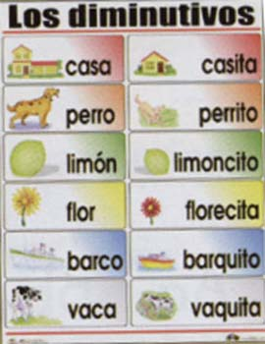](http://www.google.com.mx/url?sa=i&rct=j&q=ejercicios+de+sufijos+ita+ito&source=images&cd=&cad=rja&docid=vvTJaQbFRTE1aM&tbnid=74hJSelWdCQ6sM:&ved=0CAUQjRw&url=http%3A%2F%2Felblogdekmu.blogspot.com%2F2012%2F11%2Flas-comparaciones-aumentativos-y.html&ei=PMyiUZLpE4rO9QSTxoG4Bg&bvm=bv.47008514,d.dmQ&psig=AFQjCNFcWRkm2WwZQf4C-ZxLIUpp0-dtIQ&ust=1369709827867522)