THE LIFE CYCLE OF MARINE CARBON

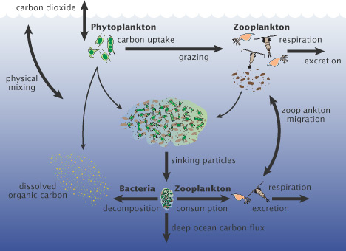

“Worldwide, this “biological carbon pump” transfers about 10 gigatonnes of carbon from the atmosphere to the deep ocean each year. Even small changes in the growth of phytoplankton may affect atmospheric carbon dioxide concentrations, which would feed back to global surface temperatures” (Earth Observatory, n.d)

Reference
Earth Observatory (n.d) The Importance of Phytoplankton. Earth Observatory. Retrieved from
http://earthobservatory.nasa.gov/Features/Phytoplankton/page2.php
.

