Practical activity: Electricity: Charged Attraction

Link(s) to Victorian Curriculum
Energy from a variety of sources can be used to generate electricity; electric circuits enable this energy to be transferred to another place and then to be transformed into another form of energy (VCSSU081).
Changes to materials can be reversible, including melting, freezing, evaporating, or irreversible, including burning and rusting (VCSSU077).
With guidance, pose questions to clarify practical problems or inform a scientific investigation, and predict what the findings of an investigation might be based on previous experiences or general rules (VCSIS082).
Compare data with predictions and use as evidence in developing explanations (VCSIS086).
Communicate ideas and processes using evidence to develop explanations of events and phenomena and to identify simple cause-and-effect relationships (VCSIS088).
Science Concepts (C) and Skills (S) addressed
C1: Creating friction along a specific surface generates electricity.
C2: Certain materials generate electricity and react similarly to magnets.
S1: To conduct an experiment and identify what materials generate static electricity.
S2: To observe and make changes to materials and make predictions as to what items react to one-another.

What did you do (use photos - diagrams)
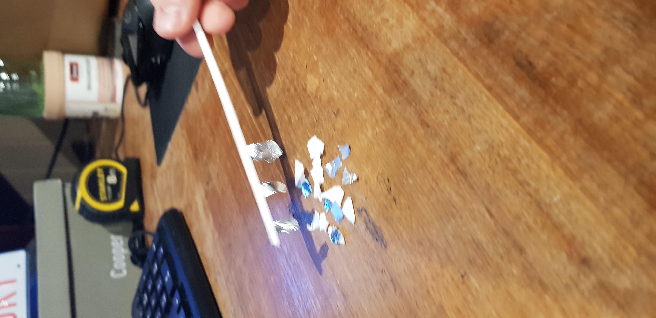
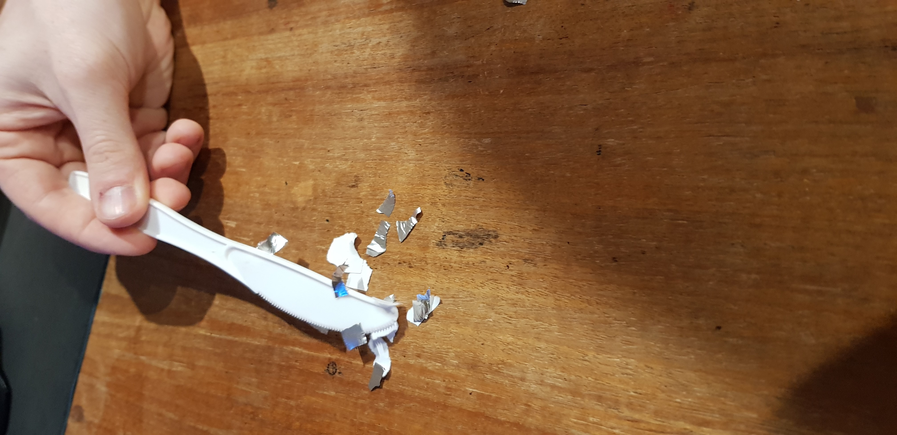
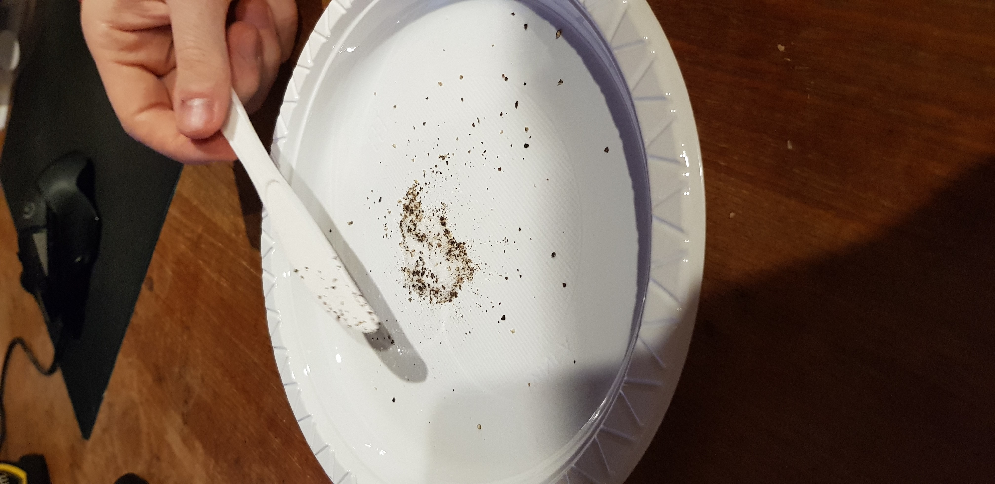
I did not have access to balloons, therefore only conducted the salt and pepper, and paper/foil experiments using a plastic knife. I realised that static electricity generates well within plastic material, and substituted the balloon for the knife, and achieved comparable results.
What did you learn about:
Science
To overcome limited available materials, I substituted key materials for others that would create similar reactions involving static electricity. This was done making predictions on my prior knowledge of components of a material and the likelihood of generating electricity. I conducted the experiments I could with the materials available, and still came to conclusions about reactions of static electricity and the effects it has on salt and pepper, foil and paper. This identified materials that can generate and hold electricity.

Teaching
This provides an opportunity for students to explore the concept of electricity and electrical current generation with everyday items. It provides first-hand, authentic learning experiences that students could conduct at home, and record their results. Also, students have an opportunity to extend themselves by experimenting using balloons/plastic utensils with other materials to observe if there is a reaction.
One way you could use this activity
I would use this activity as an active homework activity. By providing students with an example of one electrical reaction in class (the hair experiment or water), I would give them a checklist and a table to record their results and represent their findings. The checklist given to them will have the remaining experiment conducted, along with a blank space to allow students to choose a household item or material they believe will react to the electrical current in the balloon and represent their results. This would then form a class discussion once they have been completed, and students can compare their findings and represent this further.

References:
VCAA (Victorian Curriculum and Assessment Authority) (2017) Science, VCAA, Victorian Government, accessed 10 April 2021.

