# VALUES COMPONENT

VALUES

Description

It is our values that carry the life-giving energy of the inner world into the external world of family and society. Values stand between as a brokerage unit that assesses information and enables the brain to synthesize it into everyday decision-making.

Brian Hall

**The assertions that frame our understanding**

The breadth of values

**Personal Values link why we think & feel, what we say& write and how we choose to behave.**

The depth of values

**We can and do change our patterns of behaviour as we grow and develop.**

The height of values

**Differences in values and beliefs bring both strength and complexity to our work together.**

ASSERTION

The breadth of values

**Values link why we think & feel, what we say& write and how we choose to behave**

**IMAGE PATTERNS WE CREATE - Rubic Cubes of possibilities**



VALUES



BEHAVE

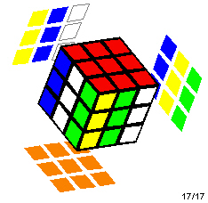

THINK & FEEL

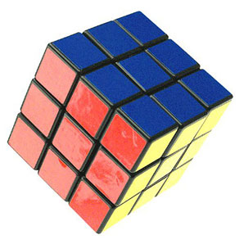

SAY & WRITE

**STORY WHEN THERE ARE GAPS BETWEEN**

* **WHAT WE BELIEVE ,**
* **WHAT WE SAY & WRITE AND**
* **HOW WE BEHAVE**

***PEOPLE LEAVE***

*“ If the corporate values say we operate through mutual respect – How come my boss yells at me in front of the staff ??*

***PEOPLE STAY BUT NO LONGER CONTRIBUTE 100%***

*“ My wife would kill me if I gave up this salary ,so I guess I’ll just have to grin and bear it here for a while.”*

***INSIDERS SHARE STORIES OF “ HOW TO REALLY GET THINGS DONE AROUND HERE*** *– “ Join the Corporate cycle group @ 6 am every Thursday – That’s where all the real decisions are made !!!!!”*

**IMPACTS ON THE BUSINESS**

**Corporate image is strengthened when customers and employers share good news stories through informal networks. Conversely!!!!!!!!**

**Staff turnover costs 8-10 times the direct salary cost for each employee**

**ASSERTION**

The depth of values

**We can and do change our patterns of behaviour as we grow and develop**

**IMAGE HUMAN DEVELOPMENT**

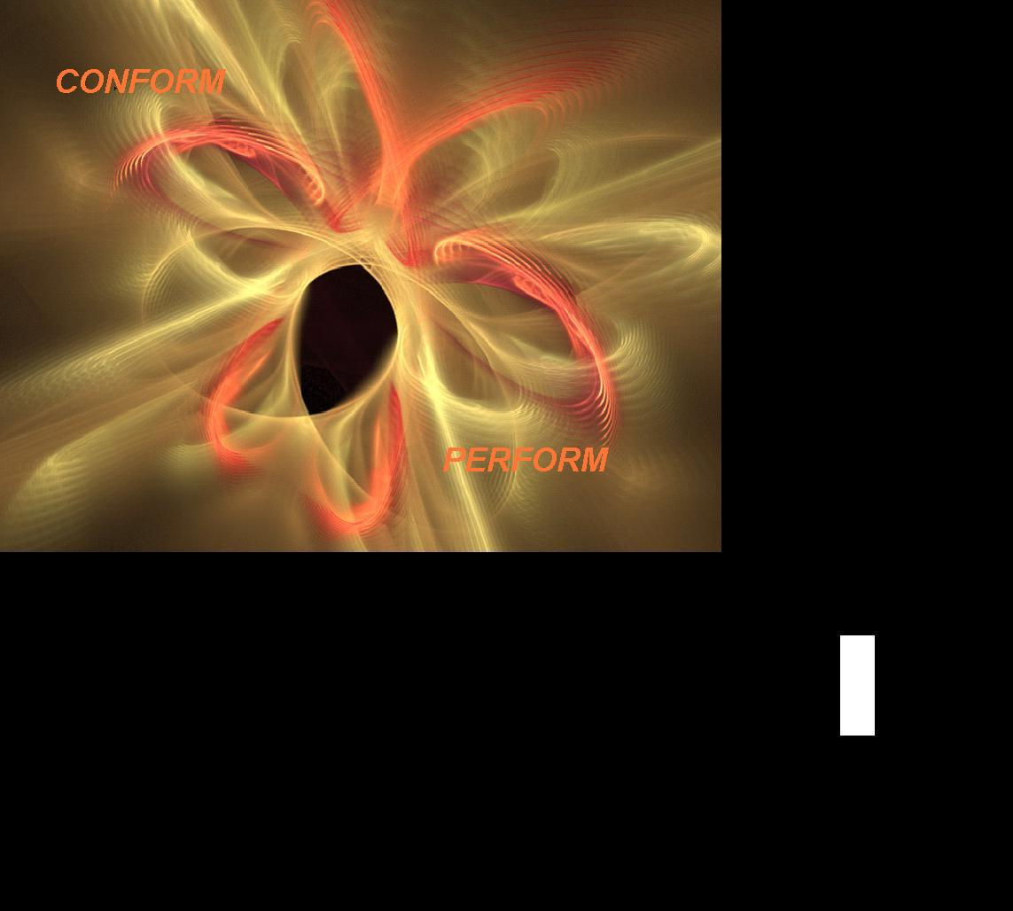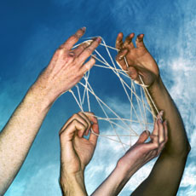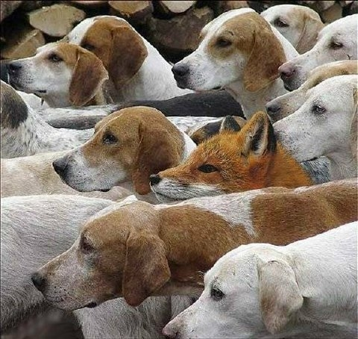

**Selfish Me (24 %?)**

**Look after Number ONE in a hostile world. Control dependent followers who become rebels or victims. Dictators Rule !!!**

**Social Me (60 %?)**

**I am my job . I am my friendships. I lead by competence orderliness and efficiency. I lead by getting people to like me. The organisation rewards loyalty and obedience and “not making waves”.**



**Independent Me (15% ?)**

**I set my own boundaries to deal with external demands I can support challenge and confront the group. The organisation is a high performing, self managed team**

**My Selfless self (1%?)**

**I take action in partnership with other like minded people to serve the “Common Good". We no longer need to pretend that we can be all things to all people**

**THE SELFLESS PART OF ME (1%?)**

**I take action in partnership with other like minded people to serve the “Common Good". We no longer need to pretend that we can be all things to all people**

**THE INDEPENDENT PART OF ME (15% ?)**

**I set my own boundaries to deal with external demands I can support challenge and confront the group. The organisation is a high performing, self managed team**

**THE SOCIAL PART OF ME (60 %?)**

**I am my job . I am my friendships. I lead by competence orderliness and efficiency. I lead by getting people to like me. The organisation rewards loyalty and obedience and “not making waves”.**

**THE SELFISH PART OF ME (24 %?)**

**I look after Number ONE in a hostile world. I Control dependent followers who become rebels or victims.**



1 EGOCENTRIC SELF 5%

3 INDEPENDENT SELF 20 % OF TOTAL

40%OF higher educated

2 SOCIALIZED SELF 14%

5 THE WISE SELF?

4 INTEGRAL SELF

1%

Transition 8%

14 % Transitioning

Transition 32 %

Constructive Styles

Affiliative Achievement;

Self Actualizing Humanistic Encouraging

Passive defensive styles of Approval; Conventional; Dependent; Avoidance

Aggressive Defensive styles Perfectionism;

Competitive, Power; Oppositional

Co ordination Collaboration

Compliance, communication

Congruent complementary contributions



**MY PROFILE**

**THE ESPOUSED VALUES PROFILE OF ST PATRICK’S COLLEGE**

**The balance has moved to the right .I assume these values are non negotiable The theory says this is ideal BUT need to appreciate that to deliver accountabilities at such a high level the hard compliance protocols need to be in place**

**THE PROFILE OF EXISTING BEHAVIOUR OF TEAM LEADERS ??**

**This is a sheer guess made up on your description of some individual team member profiles . It leads me to suggest that**

**THE INDEPENDENT PART OF ME (15% ?)**

**I set my own boundaries to deal with external demands I can support challenge and confront the group. The organisation is a high performing, self managed team**

**THE SELFLESS PART OF ME (1%?)**

**I take action in partnership with other like minded people to serve the “Common Good". We no longer need to pretend that we can be all things to all people**

**THE SOCIAL PART OF ME (60 %?)**

**I am my job . I am my friendships. I lead by competence orderliness and efficiency. I lead by getting people to like me. The organisation rewards loyalty and obedience and “not making waves”.**

**THE SELFISH PART OF ME (24 %?)**

**I look after Number ONE in a hostile world. I Control dependent followers who become rebels or victims.**

***WORLD VIEW 1***

AS I WAS AND SOMETIMES STILL AM & NEED TO BE

## WORLD VIEW 3

AS I WOULD LIKE TO BE & SOMETIMES TALK ABOUT

***WORLDVIEW 2***

AS ITRY TO BE AND SOMETIMES AM

**STORY**

**Fred was a great principal when he worked in small schools in the country and could talk to everybody every day . Now he’s in the city , he’s being pecked to death by ducks.- The 8 o’clock line up of well intentioned people who offer polite advice /want his advice /approval is a sight worth seeing !! n**

**Amazing how many times Joan has to answer the mobile phone when she’s away from the office !!!!!**

**IMPACT ON BUSINESS**

**Creativity and innovation thrive in performance cultures**

ASSERTION

The height of values

**Differences in values and beliefs bring both strength and complexity to our work together**

**Image MODEL A “ THE CEO’s HALLUCINATION”**

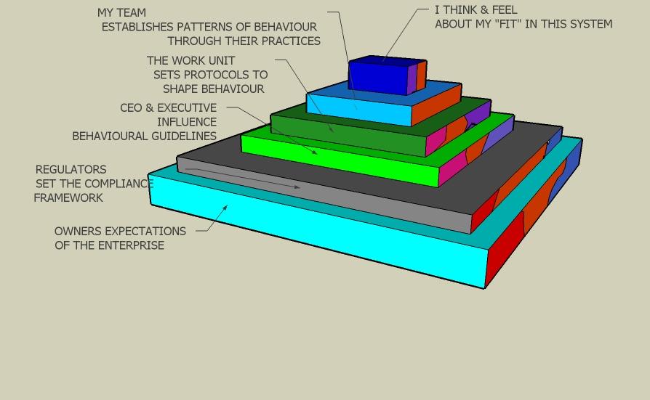

**MODEL B “ I AM THE CENTRE OF THE UNIVERSE”**

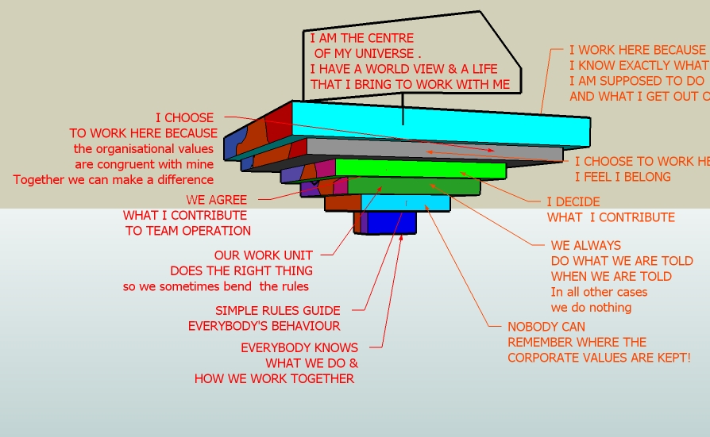

**STORY**

**We hire people with the right attitude . We can train them to acquire the technical skills necessary to deliver our business.**

**Playing a Bigger Game.**

**Stay in the corporate world but jealously guard the ability to say no when moral issues were at stake.**

**I would rather not leave the position I love, and where I’m making**

**a difference. But I need to build up enough money to retire.**

**If I put my love for the environment first, my wife would shoot me.”**

**Playing to Win.**

**Sceptical about grandiose aspirations, or altruistic ideas, especially in the workplace.**

**Put your faith in drive, intelligence, and free markets to get to the top.**

**Playing to Live.**

**Remain committed to the job, but real satisfaction comes from life outside work, especially from their families. “I have a life outside of here. You sometimes have to pretend to be a shark, to avoid having your loyalty tested.”**

**Playing for the Good Guys.**

**Actively seek out employers whose mission or culture they could believe in. This group was passionate about customers, employees, organizational transformation, or businesses that “do well by doing good.”**

**Change the people/change the people, Leave the organizations to preserve integrity. Interestingly, this often happened when organizations with the highest aspirations contradicted themselves**

**How I think about our world**

**REFLECT ON BELIEFS & ASSUMPTIONS**

**Knowing WHY???**

REFRAME PERSONAL MINDSET

Human development

**Evolving Self: Problem and Process in Human Development**

**by** [**Robert Kegan**](http://search.barnesandnoble.com/booksearch/results.asp?ATH=Robert+Kegan&z=y)

Publisher: Harvard University Press

Pub. Date: June 2006

ISBN-13: 9780674272316

**The Developmental Stages of Erik Erikson**

By [Arlene F. Harder, MA, MFT](http://www.support4change.com/us/bios/Harder.html)

<http://www.learningplaceonline.com/stages/organize/Erikson.htm>

**The Theory of Human Development: A Cross-Cultural Analysis**

Christian Welzel Ronald Inglehart

University of Bremen University of Michigan

Hans-Dieter Klingemann

Wissenschaftszentrum Berlin

2002 Center for the Study of Democracy

(University of California, Irvine)

<http://repositories.cdlib.org/cgi/viewcontent.cgi?article=1006&context=csd>

E:\Research\Bill's Personal Models and Summaries\Values

**REFOCUS ON RESPECTFUL RELATIONSHIPS TO CONTRIBUTE TO THE COMMON GOOD**

Values

**OECD WORLD VALUES SURVEY**

<http://www.worldvaluessurvey.org/statistics/WVSQuest_SplitVers_OECD_Bballot.pdf>

A Business Case for Working with Values

<http://www.valuesatwork.org/A4BusinessCaseforValues.pdf>

Organisational Values as "Attractors of Chaos”:

An Emerging Cultural Change to Manage Organisational Complexity

Dolan S.L1., Garcia S2., Diegoli S3., Auerbach A4.,

<http://www.econ.upf.edu/docs/papers/downloads/485.pdf>

Kurt Lewin's Change Theory in the Field and in the Classroom: Notes Toward a Model of Managed Learning [[1]](http://www.solonline.org/res/wp/10006.html#fn1#fn1)

Edgar H. Schein Professor of Management Emeritus MIT Sloan School of Management

<http://www.solonline.org/res/wp/10006.html>

[Images of Organization](http://www.amazon.com/Images-Organization-Gareth-Morgan/dp/1412939798/ref=sr_1_1/105-1273967-7514843?ie=UTF8&s=books&qid=1193805856&sr=1-1) by Gareth Morgan

<http://www.siliconyogi.com/andreas/it_professional/sol/complexsystems/ImagesofOrganizationbyGarethMorgan.html>

The Social Construction of Life Meaning: The 2007 North Carolina Sociological Association Presidential Address by Stephen J. McNamee     
University of North Carolina Wilmington

<http://www.ncsociology.org/sociationtoday/v52/steve.htm>

OUT THERE! -at your own risk

http://www.formlessmountain.com/collage.html

<http://www.integralinstitute.org/public/static/default.html>

OECD WORLD VALUES SURVEY

<http://www.worldvaluessurvey.org/statistics/WVSQuest_SplitVers_OECD_Bballot.pdf>

A Business Case for Working with Values

<http://www.valuesatwork.org/A4BusinessCaseforValues.pdf>

Organisational Values as "Attractors of Chaos”:

An Emerging Cultural Change to Manage Organisational Complexity

Dolan S.L1., Garcia S2., Diegoli S3., Auerbach A4.,

<http://www.econ.upf.edu/docs/papers/downloads/485.pdf>

The Omega Factor:

A Values-Based Approach for Developing Organizations and

Leadership

**Brian Hall**

<http://www.hthall.com/company/OmegaFactor4.pdf>

<http://www.hthall.com/company/company_home.html>

Evolving Self: Problem and Process in Human Development by [Robert Kegan](http://search.barnesandnoble.com/booksearch/results.asp?ATH=Robert+Kegan&z=y)

Publisher: Harvard University Press

Pub. Date: June 2006

ISBN-13: 9780674272316

Kurt Lewin's Change Theory in the Field and in the Classroom: Notes Toward a Model of Managed Learning [[1]](http://www.solonline.org/res/wp/10006.html#fn1#fn1)

Edgar H. Schein  
Professor of Management Emeritus  
MIT Sloan School of Management

<http://www.solonline.org/res/wp/10006.html>

[Images of Organization](http://www.amazon.com/Images-Organization-Gareth-Morgan/dp/1412939798/ref=sr_1_1/105-1273967-7514843?ie=UTF8&s=books&qid=1193805856&sr=1-1) by Gareth Morgan

<http://www.siliconyogi.com/andreas/it_professional/sol/complexsystems/ImagesofOrganizationbyGarethMorgan.html>

Leadership and the New ScienceDiscovering Order in a Chaotic World

Margaret J. Wheatley THIRD EDITION  
Berrett-Koehler Publishers, Inc.; 2006

The Theory of Human Development: A Cross-Cultural Analysis

Christian Welzel Ronald Inglehart

University of Bremen University of Michigan

Hans-Dieter Klingemann

Wissenschaftszentrum Berlin

2002

Center for the Study of

Democracy

(University of California, Irvine)

<http://repositories.cdlib.org/cgi/viewcontent.cgi?article=1006&context=csd>

The Developmental Stages of Erik Erikson

By [Arlene F. Harder, MA, MFT](http://www.support4change.com/us/bios/Harder.html)

<http://www.learningplaceonline.com/stages/organize/Erikson.htm>

The Social Construction of Life Meaning: The 2007 North Carolina Sociological Association Presidential Address

by

Stephen J. McNamee   
    
University of North Carolina Wilmington

<http://www.ncsociology.org/sociationtoday/v52/steve.htm>

at your own risk

http://www.formlessmountain.com/collage.html

<http://www.integralinstitute.org/public/static/default.html>