Using Concept Maps as Teaching Tools

Concept Maps as Introductions
- Advance Organizers
  - Before instruction, construct a map for the entire unit of study, making sure that all of the major themes and pervasive concepts are accounted for
    - From this large-scale map, a series of more specific maps can be drawn to show more detail, resulting in a nested set of conceptual maps for the unit
  - Create these maps in such a way that they can be presented to students (as a handout, PowerPoint slide, overhead projection, classroom poster, etc.)
  - At the beginning of the unit instruction, present and explain the large-scale map. In subsequent classes, refer back to the large-scale map as each new concept is covered. Present more specific maps in class periods where appropriate.
- Introducing a New Topic
  - Because the theory of concept mapping is based on integrating new knowledge with prior knowledge, concept maps are ideal for introducing new topics/information.
    - Using a pre-constructed map of the course up until the new topic/information (this works especially well if students are familiar with the pre-map already), introduce the new topic/idea by drawing the topic in and showing students where the proper connections to other topics are located. Also, show students where common misconceptions can occur with the new topic.
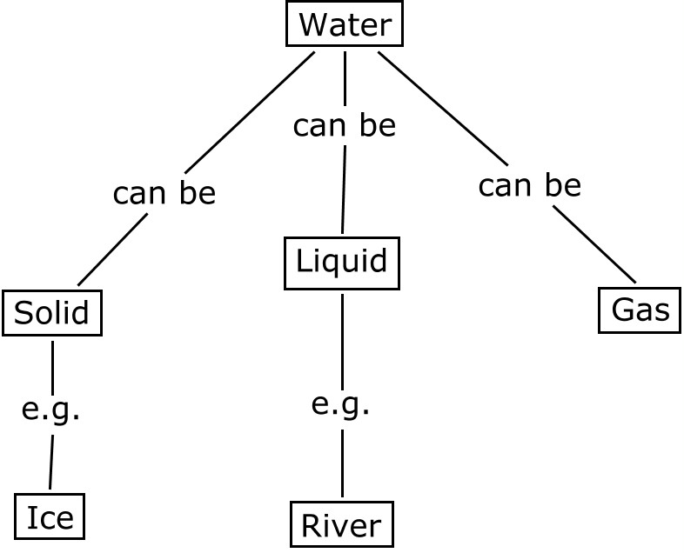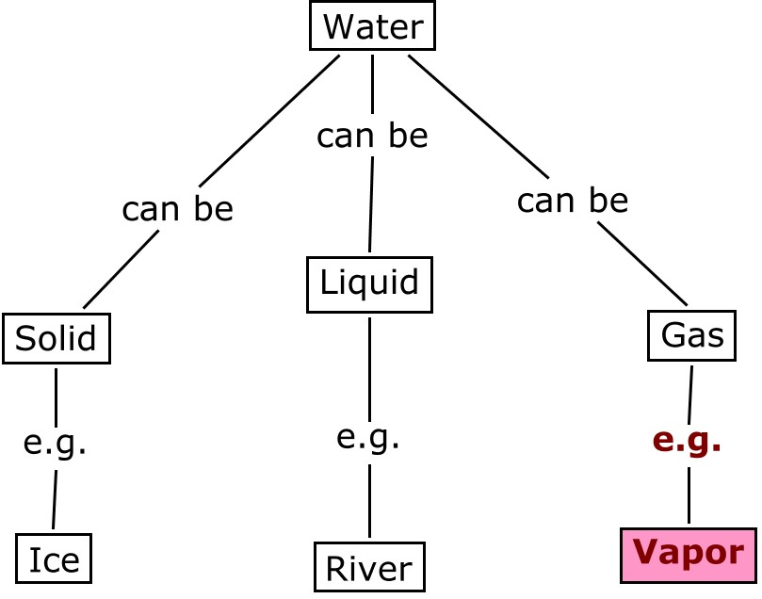

Course Maps
- Have the teacher and students construct a collective map as the course progresses. Through discussions, students should give input for this map by supplying the key ideas and connections. (Allow students to take ownership of their contributions by writing their own ideas, concepts, and connections on the map.)
  - Alternative option: students could make mini-maps of every day or every couple of days, then these mini-maps could be combined to created a comprehensive map
  - Alternative option: use the course’s discussion section as a time to create a master map of the week’s topic
Complete-the-Map Classroom Activities
      - Have students fill in the concepts
        - Give students a map with the concepts missing. You may or may not want to give students a list of concepts from which to choose

Example question: Complete this concept map by using the following concepts: additive, distributive, equivalent, equations, identity, inverses, multiplicative, opposite, properties, reciprocal, solving linear equations in x, and x - #. Fill in your own examples.

      - Have students fill in the linking words
        - Gives students a map with linking words missing. You may or may not want to give students a list of linking words from which to choose

Note: Complete-the-Map activities are especially useful for students to practice thinking about what they have just read for a class period or what they have just learned in a class period. If you would like to make a Complete-the-Map activity more robust, have students write a brief paragraph “telling the story” of the concept map that they have completed.
Concept Maps and Writing Assignments
- Adding horizontal linking lines
  - Prepare a concept map of the subject matter for students ahead of time
  - Make a copy of this map with only the concepts and the vertical linking lines to give to the students
  - Instruct students to add horizontal linking lines in the lowest level of the map, label them with a number, and then write a justification for each linkage

- Structure an essay assignment for students
  - Give students a concept map of the topic you would like them to write about. This will help them to organize their paper and ensure that every topic you want addressed is clearly identified for them
- Let students structure an essay assignment for you
  - Have students construct a concept map to accompany their writing assignment. This will help you to follow along the organization of their paper as you read it, it will help them to organize their paper as they write it, and it will make misconceptions or unclear topics immediately clear

Misconception Maps
- Display a concept map with commonly used inaccurate connections among topics or common uses of inappropriate concepts. Students can orally analyze the maps in groups to verify the use of concepts and the connections among them. Discuss such maps in the large group as well to ensure that all students understand the “wrong” version of such a map and the “correct” version of such a map.

Maps adapted from (Novak, 1998, pp. 54-55)
Map and question adapted from (Bartels, 1995)
(Cilburn, 1987)

