Assessing and Evaluating Concept Maps

Summative Assessments
These are assessments that are given periodically to determine what students do and do not know. Examples: Standardized exams, end-of-unit exams, formal essays, analysis papers, graded homework problem sets, midterms, finals, etc. These assessments are usually graded or evaluated formally in some way.

- Instead (or in addition to) essay questions on exams, try a mapping exercise. Present students with a set of concepts. Ask students to select a focus and construct a map: for example, “Below are seven concepts associated with [insert topic]. Use them to construct a concept map.”
  - The following is such a map from a college-level midterm in a Theory and Methods of Education course:

- Alternatively, you could have students create a map without a given set of concepts. This will allow you to see what students thought was most important
- You could also give students a map of what you would like to assess and have them write an essay “telling the story” of the given map
- Note that it is important that students not be asked to recall concepts or labels from a memorized map—such an exercise will not promote meaningful learning!
Formative Assessments
These assessments are an informal, but important, part of instruction. Often these assessments are thought of as “practice” or “classroom participation” assignments. These may or may not be graded or formally evaluated and can take a wide variety of forms. Instructors often use formative assessments observing students as they work, asking discussion questions to check student understanding, having students turn in reflection papers or practice problems. The purpose of these assessments is to get a sense of students’ understanding.

- Any mapping exercise can be used as a formative assessment. The following, however, work particularly well:
  - Have students map previously assigned readings
  - Have students map their small-group discussions of a given topic
  - Have students map a summary of a given set of class periods
  - Have students map topics that they don’t quite understand or would like to know more about (these maps should be addressed in small- or large-group discussions

- The following maps are a good example of how you can quickly see the difference between a student that has a basic understanding of course material and a student that has a deep understanding of the course material:

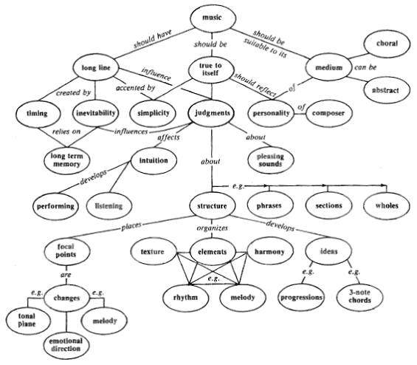

(Novak, 1998)
Maps from (Novak & Gowin, 1984)

