The Natural Communities of Virginia
Classification of Ecological Community Groups
SECOND APPROXIMATION (Version 2.2)

Rocky Bars and Shores
This group contains seasonally flooded to intermittently exposed woodland, shrub, and herbaceous vegetation of bouldery and cobbly depositional bars, or less frequently bedrock exposures, on the shores and islands of large, high-gradient streams. Communities in this group are scattered throughout the Virginia mountains and Piedmont, primarily along major rivers and their largest tributaries. Habitats are influenced by a frequent regime of powerful flood scouring, including occasional scouring by ice flows during the winter months. Substrates vary from bedrock outcrops to deeply piled cobbles and boulders, with soils consisting of fine to coarse alluvial materials deposited among the rocks.
Vegetation varies from woodlands to entirely herbaceous or sparse. Common water-willow (Justicia americana) is one of the most widespread and characteristic herbs of rocky bars and shores in Virginia, often forming extensive, nearly monospecific beds. Another well-marked herbaceous type of this group, known from bouldery banks and bars along a number of mountain streams, is dominated by twisted sedge (Carex torta). The typical overstory on wooded depositional bars consists of moderately to widely spaced, often battered or flood-trained specimens of sycamore (Platanus occidentalis), river birch (Betula nigra), and willows (primarily black willow [Salix nigra] and Carolina willow [Salix caroliniana]). Stands located on broader, bedrock floodplains that are scoured by frequent powerful floods and ice flows have more diverse overstories of green ash (Fraxinus pennsylvanica), swamp white oak (Quercus bicolor), boxelder (Acer negundo var. negundo), American elm (Ulmus americana), sycamore, river birch, and other trees. Shrubs include silky dogwood (Cornus amomum ssp. amomum and ssp. obliqua), American hornbeam (Carpinus caroliniana ssp. virginiana), and ninebark (Physocarpus opulifolius var. opulifolius).
The herbaceous flora of rocky bars and shores is highly variable and includes species common to both ephemeral fine-textured sand, gravel, or mud bars (e.g., halberd-leaf rose-mallow [Hibiscus laevis]) and somewhat more stable, bedrock habitats (e.g., big bluestem [Andropogon gerardii]). The clasping-leaved dogbane (Apocynum sibiricum) is also particularly characteristic. These communities are threatened by rampantly invasive weeds such as purple loosestrife (Lythrum salicaria) and Johnson-grass (Sorghum halepense), which are readily dispersed and established in high-energy alluvial environments.
References: Hupp (1983b), Hupp (1986), Fleming and Moorhead (1996), Lea (2000), Vanderhorst (2000).

Click on the images below to open a larger image in a separate window.
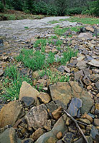 | Twisted sedge (Carex torta) colonizes the bouldery shore of Laurel Fork on Allegheny Mountain in Highland County (George Washington and Jefferson National Forests). Photo: Gary P. Fleming / © DCR Natural Heritage.
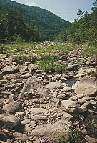 | Low sprouts of willows (Salix nigra and S. caroliniana) and clumps of switchgrass (Panicum virgatum) in the bouldery bed of the Maury River. Goshen Pass Natural Area Preserve, Rockbridge County. Photo: Gary P. Fleming / © DCR Natural Heritage.
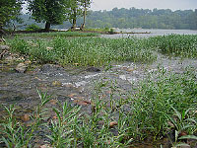 | Large beds of common water-willow (Justicia americana) on the bouldery shore of the Potomac River near Langley Island. Turkey Run Park, Fairfax County. Photo: Gary P. Fleming / © DCR Natural Heritage.
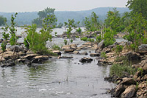 | Sparse scrub of flood-battered sycamores (Platanus occidentalis) and willows (Salix nigra) on the rocky shore of the Potomac River above Great Falls. Great Falls Park, Fairfax County. Photo: Gary P. Fleming / © DCR Natural Heritage.
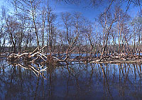 | Woodland of flood-battered river birch (Betula nigra) and sycamore (Platanus occidentalis) on Langley Island (Maryland) in the Potomac River. View from Turkey Run Park, Fairfax County. Photo © Gary P. Fleming.
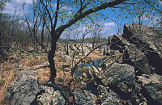 | Flood-stunted, mixed woodland on the bedrock floodplain of the Potomac River above Great Falls, Fairfax County, Virginia (Great Falls Park). Photo: Chris Ludwig / © DCR Natural Heritage.
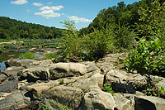 | Scrub river birch (Betula nigra) and sycamore (Platanus occidentalis) on an outcrop bar along the Rappahannock River just upstream from Fredericksburg, Spotsylvania County. Photo: Irvine Wilson / © DCR Natural Heritage.

REPRESENTATIVE COMMUNITY TYPES:
Only limited data on the composition and environmental dynamics of rocky bar and shore communities have been collected in Virginia, primarily from the Potomac Gorge west of Washington, D.C. This group has also been studied intensively along the Potomac River in adjacent Maryland and the District of Columbia by Lea (2000). The Twisted Sedge community type has not been plot-sampled but was described from field observations by Fleming and Moorhead (1996) and also observed in several localities along the James River. The Water-Willow community type has been sampled along the Potomac River and observed elsewhere, but data have not yet been analyzed. For the time being, USNVC names, as well as names that emerged in a regional analysis of more than 300 Virginia, Maryland, and D.C. floodplain plots, have been adopted below. The rarity of vegetation in this group warrants future inventory along high-gradient sections of major rivers elsewhere in Virginia. Click on any highlighted CEGL code below to view the global USNVC description provided by NatureServe Explorer.
- Carex torta Herbaceous Vegetation
Rocky Bar and Shore (Twisted Sedge Type)
USNVC: CEGL004103
Global/State Ranks: G3G4/S2?
- Justicia americana Herbaceous Vegetation
Rocky Bar and Shore (Water-Willow Type)
USNVC: CEGL004286
Global/State Ranks: G4G5/S4?
- Platanus occidentalis – Betula nigra – Salix ( caroliniana , nigra ) / Apocynum sibiricum Woodland
River-Scour Woodland (Sycamore – River Birch Type)
USNVC: ~CEGL003896
Global/State Ranks: GNR/SNR
- Platanus occidentalis – Fraxinus pennsylvanica – Acer saccharinum – Betula nigra / Eupatorium serotinum – ( Carex emoryi ) Woodland
River-Scour Woodland (Bedrock Floodplain Mixed Type)
USNVC: no equivilant
Global/State Ranks: GNR/SNR

