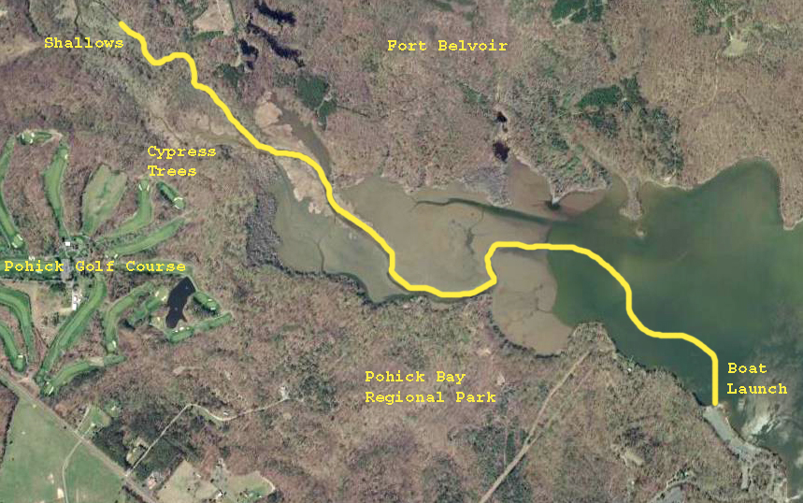

From the launch site, we will traverse the open water of the bay, taking note of wildlife such as osprey, eagles, fish, aquatic snakes, and more. Once we enter the wetlands we’ll see spadderdock (a wetland plant that grows seasonally from mud flats), redwing blackbirds, and perhaps beavers! Once through the wetlands, we will encounter the noticeable current of Pohick Creek. Look for turtles, singing warblers, kingfishers, dragonflies and all sorts of other florae and faunae!

