Images

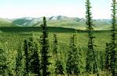
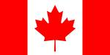

The Tundra(above) The Canadian Shield(above)

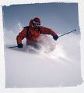

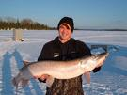
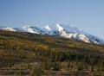

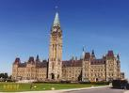

Ice Fishing(above) Skiing (above)

