Economics
The definition of economics is the science that deals with the production, distribution, and consumption of goods and services, or the material welfare of humankind.

Canada's natural recourses are petroleum and natural gas, hydroelectric power, metals and minerals, fish, forests, wildlife, abundant fresh water.

In December 1997 the unemployment rate for unemployment in Canada was 8.6%.

The total value for exports in Canada are $208.6 billion. The basic recourses and agricultural products are newsprint, wood pulp, timber, crude petroleum, machinery, natural gas, aluminum, motor vehicles and parts and telecommunications equipment.
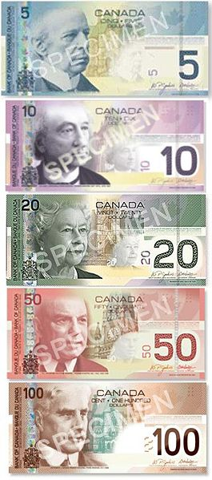
Partners for Canadian exports are US, Japan, UK, Germany, South Korea, Netherlands and China
The total value for Imports in Canada are $194.4 billion. The basic recourses and agricultural products are crude oil, chemicals, motor vehicles and parts, durable consumer goods, computers and telecommunications equipment and parts. The partners for Canadian Imports are US, Japan, UK, Germany, France, Mexico, Taiwan, South Korea.
Canada is in debt externally since 1996 $253 billion dollars.
The Canadian currency is 1 Canadian dollar=100 cents.
Economy of US effects the Economy of Canada

We Buy 25% of Canada's goods
Canada buys 85% of our goods
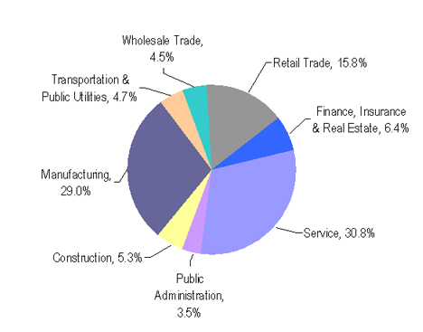

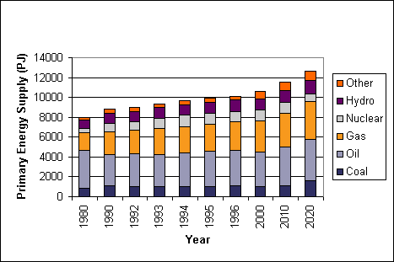

Works Cited

“The Economy of Canada.” Vancouver English Center. Vancouver English Centre. October 15, 2008. http://www.vec.ca/English/2/canada-economy.cfm

