Political Organization of Canada

- The Canadian is considered a Parliamentary Monarchy, it has a parliament, and a queen.
- Queen Elizabeth II is the Queen of Canada, and Head of State.
- She distributes the powers of judicial, legislative, and executive branches of the Canadian government.
- This is very complicated, Canada's government consists of two parts: federal, and parliament.
- There is a federal government because each province has its own local power, and each province has senates.
- Canada's Parliament consists of three components: Legislative, sovereign, and the senate.
- The person with the most power is the Prime Minister.
- House of Commons is the Parliament and it reports to the Prime Minister.
- It starts like this: The queen appoints a Governor General, then the Governor General appoints the Prime Minister, the Prime Minister is the head of the government, the Prime Minister is also the head of the House of Commons.
- The GG is Michaelle Jean, the Governor General is also the head of the Military during the time of war.
- The Prim Minister is Stephen Harper, he is the head of Parliament and the Cabinet.

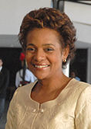
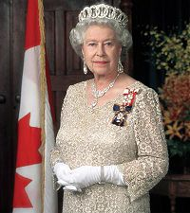
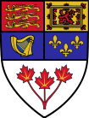


Michaelle Jean Queen Elizabeth II Stephen Harper Canadian Seal
of
Government

Works Cited

“Government of Canada.” Wikipedia. The Free Encyclopedia.
10/15/08 <http://en.wikipedia.org/wiki/Government_of_Canada>

