Many different cultures have many different ways of practicing religion and practicing death rituals. But, surprisingly or not Canada is not that different than the United States Of America. Join us on this journey to find out the simulative of Canada and and Americas death rituals and religions.

Religion:

- Cathilic, Protestant, Christain Orthadox, Christan, Muslum, Jewish, Buddhist, Hindu, Slkh.
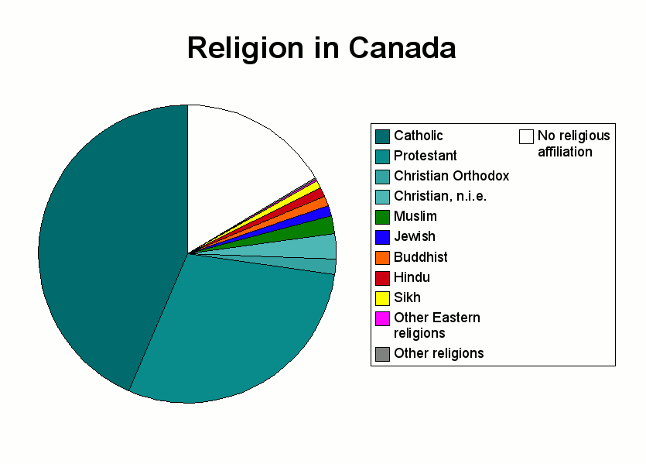
- Main Religion is Cathlic

- Same things as in America

- a lot of hate crimes in canda
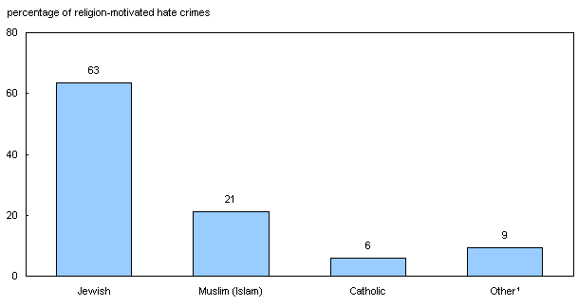
Death Rituals:
- They Burry people the same
- There is a weiwing held for 4 days
- A mass dedicated to the dead before and after there funeral.
- The have a wake then they burry the person
- before people die they have wills and they dontate body parts to sience
- you are officaly dead when your brain waves are no longer detected
- funeral homes are a service industrie
- In places like Ontario you must have a funeral director ( it cost money)
- They tumb stones, markrs, and flowers

