Canada's Place
Place consists of human and physical characteristics of a location. Canada's physical characteristics is that most of Canada's land is flat except for to the west and southeast. The west of Canada has mountains. The southeast of Canada is lowlands. Canada is 9.9 million square km. The climate is colder in Canada then in the US, because it is closer to the arctic. Some human characteristics of Canada are dams, reservoirs, highways, and national parks.

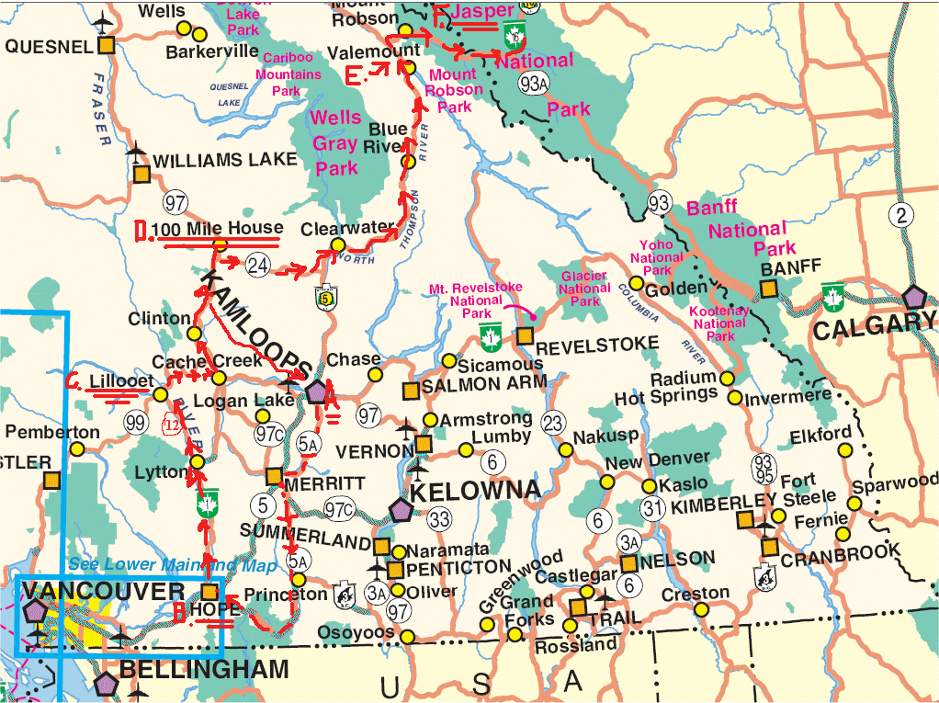
Map of Canada's highways.

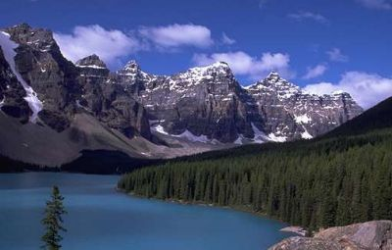
These are some mountains in Canada.

