

**PROJECT MANAGEMENT PLAN**

**ACS 567: Software Project Management**

**Spring 2009**

**Instructor: Dr. John Tanik**



**Team Members:**

► Kalyan Govindu [*kalg.email@gmail.com*](mailto:kalg.email@gmail.com)

► Deep Rauniyar [*deep.rauniyar@gmail.com*](mailto:deep.rauniyar@gmail.com)

► Tyson Maxwell [*tyson.maxwell@gmail.com*](mailto:tyson.maxwell@gmail.com)

**Report Submitted on: 7** MAY 2009

**Revision History**

**V1.1** 04/16/2009 Start structuring project plan from notes.

**V1.2** 04/17/2009 More content added

**V1.3** 04/20/2009 More content added

**V1.4** 04/22/2009 More content added

**V1.5** 04/27/2009 Restructured contents with IEEE Std. & Checked style and content

**V1.6** 05/07/2009 First publicly released version, Final report submitted for ACS567.

Table of Contents

Revision History

Table of Contents

Acronyms and Abbreviations

List of Figures and Tables

1. **Project Summary 5**
   1. Introduction. . . . . . . . . . . . . . . . . . . . . . . . . . . . . . . . . . . . . . . . . . . . . . . . . . . . . . . . . . . . . . . . . . . . 5
   2. Purpose, Scope, and Objectives. . . . . . . . . . . . . . . . . . . . . . . . . . . . . . . . . . . . . . . . . . . . . . . . . . 5
   3. Assumptions and Constraints . . . . . . . . . . . . . . . . . . . . . . . . . . . . . . . . . . . . . . . . . . . . . . . . . . . 6
   4. Project Deliverables . . . . . . . . . . . . . . . . . . . . . . . . . . . . . . . . . . . . . . . . . . . . . . . . . . . . . . . . . . . . . . 6
   5. Schedule and Budget Summary . . . . . . . . . . . . . . . . . . . . . . . . . . . . . . . . . . . . . . . . . . . . . . . . . . 6
2. **References 8**
3. **Project Organization 9**
   1. Roles and Responsibilities . . . . . . . . . . . . . . . . . . . . . . . . . . . . . . . . . . . . . . . . . . . . . . . . . . . . . . . . 9
4. **Managerial Processes 11**
   1. Start-Up Plan. . . . . . . . . . . . . . . . . . . . . . . . . . . . . . . . . . . . . . . . . . . . . . . . . . . . . . . . . . . . . . . . . . . . 11
      1. Project Estimation. . . . . . . . . . . . . . . . . . . . . . . . . . . . . . . . . . . . . . . . . . . . . . . . . . . . . . . . 11
      2. Staffing Plan. . . . . . . . . . . . . . . . . . . . . . . . . . . . . . . . . . . . . . . . . . . . . . . . . . . . . . . . . . . . . . 12
   2. Work Plan. . . . . . . . . . . . . . . . . . . . . . . . . . . . . . . . . . . . . . . . . . . . . . . . . . . . . . . . . . . . . . . . . . . . . . . 12
      1. WBS and Work Packages . . . . . . . . . . . . . . . . . . . . . . . . . . . . . . . . . . . . . . . . . . . . . . . . . 12
      2. Schedule Dependencies. . . . . . . . . . . . . . . . . . . . . . . . . . . . . . . . . . . . . . . . . . . . . . . . . . . 13
      3. Budget Allocation. . . . . . . . . . . . . . . . . . . . . . . . . . . . . . . . . . . . . . . . . . . . . . . . . . . . . . . . . 16
   3. Project Control Plan. . . . . . . . . . . . . . . . . . . . . . . . . . . . . . . . . . . . . . . . . . . . . . . . . . . . . . . . . . . . . 17
      1. Requirements. . . . . . . . . . . . . . . . . . . . . . . . . . . . . . . . . . . . . . . . . . . . . . . . . . . . . . . . . . . . 17
      2. Schedule. . . . . . . . . . . . . . . . . . . . . . . . . . . . . . . . . . . . . . . . . . . . . . . . . . . . . . . . . . . . . . . . . 17
      3. Budget. . . . . . . . . . . . . . . . . . . . . . . . . . . . . . . . . . . . . . . . . . . . . . . . . . . . . . . . . . . . . . . . . . . 18
   4. Risk Management Plan. . . . . . . . . . . . . . . . . . . . . . . . . . . . . . . . . . . . . . . . . . . . . . . . . . . . . . . . . . 19
5. **Technical Processes 21**
   1. Project Test Plan . . . . . . . . . . . . . . . . . . . . . . . . . . . . . . . . . . . . . . . . . . . . . . . . . . . . . . . . . . . . . . . 21
   2. Product Acceptance Plan. . . . . . . . . . . . . . . . . . . . . . . . . . . . . . . . . . . . . . . . . . . . . . . . . . . . . . . . . 21
   3. Web Security Plan . . . . . . . . . . . . . . . . . . . . . . . . . . . . . . . . . . . . . . . . . . . . . . . . . . . . . . . . . . . . . . . 22
6. **Supporting Processes 23**
   1. Verification and Validation . . . . . . . . . . . . . . . . . . . . . . . . . . . . . . . . . . . . . . . . . . . . . . . . . . . . . . 23
   2. Quality Assurance . . . . . . . . . . . . . . . . . . . . . . . . . . . . . . . . . . . . . . . . . . . . . . . . . . . . . . . . . . . . . . . 23

Attachment/Appendices

Acronyms and Abbreviations

ACS Applied Computer Science

ANSI American National Standards Institute

CAPTCHA Completely Automated Public Turing test to tell Computers and Humans Apart.

CPM Control Path Method

DOQ Denial of Request

EVMS Earned Value Measurement System

ISO International Organization for Standardization

OS Operating System

PERT Program Estimation and Review Technique

PMBOK Project Management Body of Knowledge

PMI Project Management Institute

PMP Project Management Plan

QA Quality Assurance

SRS System Requirement Specification

SWEBOK Software Engineering Body of Knowledge

WBS Work Breakdown Structure

List of Figures and Tables

Table 1: Budget Summary . . . . . . . . . . . . . . . . . . . . . . . . . . . . . . . . . . . . . . . . . . . . . . . . . . . . . . 7

Table 2: Schedule Dependencies . . . . . . . . . . . . . . . . . . . . . . . . . . . . . . . . . . . . . . . . . . . . . . 13-15

Table 3: Budget Details . . . . . . . . . . . . . . . . . . . . . . . . . . . . . . . . . . . . . . . . . . . . . . . . . . . . . . . . 16

Table 4: Brief summary of Risk Register . . . . . . . . . . . . . . . . . . . . . . . . . . . . . . . . . . . . . . . . 19-20

Figure 1: Shareit.com staffing plan . . . . . . . . . . . . . . . . . . . . . . . . . . . . . . . . . . . . . . . . . . . . . . . 12

Figure 2: Work Breakdown Structure (WBS) compressed view . . . . . . . . . . . . . . . . . . . . . . . . . 12

Figure 3: Web Security CAPTCHA example . . . . . . . . . . . . . . . . . . . . . . . . . . . . . . . . . . . . . . . 22

Appendix A: Detailed Work Breakdown Structure (WBS)

Appendix B: Project Gantt chart

Appendix C: Detailed Risk Register

1. **Project Summary**
   1. Introduction

The purpose of this project is to develop a web site that will promote networking among the web users allowing them to share their personal items with their friends. The site will also allow users to track their personal items, lend or borrow items they desire with their friends as well as make new friends and communicate with their current friends in an efficient manner.

* 1. Purpose, Scope, and Objectives

The purpose of this document is to introduce the reader to Web Design, ‘Shareit.com’, Project Management Plan (PMP). Software Project Management Plan will explain in detail the web development lifecycle which our group will take in order to complete the desired web site. The process and procedure implemented in the design procedure will be discussed by the team in the Project Management Plan.

All activities directly related to the purpose of the project are considered to be in scope. All activities not directly related to the purpose are considered to be out of scope. For example, the scope of the project is concerned with only initial planning of the project, and production of the web site or the coding is not within the scope of this project.

This document will cover detailed information about the management plan used for the project. The following topics are covered in the document:

* A statement of what our project is.
* The project organization.
* The project management, estimation and control procedures.
* The project managerial, technical and supporting processes.
* The activities, schedule, and budget.
* The risk management plan.
* The test plan, acceptance plan and web security plan.
* The Quality assurance and verification and validation plan.

The objective of the project is to prepare deliverables that are intended to assist in defining and planning the activities, required for the successful completion of the project. The plan includes a brief identification of major activities. PMP gives brief outline of activities involved in completion of project, project organization, quality assurance, activities, scheduling estimates, specific project deliverables, and the tasks that are necessary to develop each deliverable.

* 1. Assumptions and Constraints

The project will be planned with the following assumptions:

* It is our understanding, and therefore our assumptions that the project is completed on an academic level, and hence it provides ample flexibility in preparing some of the deliverables required for the project.
* The schedule and cost estimate is not required to be accurate, however best estimation is expected.
* The project does not require coding of any form.
* The project will not to be implemented into the production phase, however it is expected that the project deliverables will have enough supporting documents and artifacts for successful completion of the project, if required.

The project will be planned with the following constraints:

* The project deliverables should be completed as per the date specified by the instructor.
* It is desired, however not required for the team to use software in completing some of the deliverables assigned by the instructor.
* The project is supposed to follow the guidelines specified by the instructor.
* The project deliverables are required to be published in C-map.
  1. Project Deliverables

The project will be composed on the following deliverables:

* Project Management Plan (PMP)
  + Gantt Chart
  + Work Breakdown Structure (WBS)
  + Risk Register
  + Cost Estimation sheet
  + Other deliverables are per need of the project (desirable but not required)
* Software Requirements Specification (SRS)
* PowerPoint project presentation
* Project C-map

All deliverables will be placed on the project C-map and will be placed on a CD and handed to the instructor. A hardcopy of PMP will also be handed to the course instructor.

1.5 Schedule and Budget Summary

The project will be conducted in five phases:

* Phase 1: Define the project (Duration: 34 Days)
* Phase 2: Develop site structure (Duration: 33 Days)
* Phase 3: Design visual interface (Duration: 44 Days)
* Phase 4: Build and Integrate (Duration: 59 Days)
* Phase 5: Launch and beyond (Duration: 30 Days)

The total project duration is expected to be 200 Days. Since the project is defined on an academic level, rather than commercial, the expected start date and end date for the project has not been defined at this point.

The end of each phase is a milestone, where specified deliverables are expected to be completed by the design team.

* **Milestone 1 (end of phase 1):** Used cases data collected, analyzed and distributed, existing marketing and research materials collected and analyzed, audience demographic identified, audience profile created, Backend programming needs identified, Overall project goals determined, communication brief prepared, estimated budget set, estimated schedules created, project team assigned, project plan materials assembled.
* **Milestone 2 (end of phase 2):** Site content addressed and organized, site content outlined, content delivery plan created, sitemap created, site structure determined, wireframes for the page-view created, key user paths defined, HTML Protosite created, user scenarios created.
* **Milestone 3 (end of phase 3):** Site goals reviewed, concepts developed, design presented, Site feedback gathered, navigation and content confirmed, site functionality tested, graphic template created, design style guide created.
* **Milestone 4 (end of phase 4):** Project status assessed, graphic templates received from visual designer, graphics optimized, HTML templates created, light scripting implemented, individual pages built, quality assurance (QA) plan created, quality assurance conducted, bugs are prioritized and fixed, final check conducted.
* **Milestone 5 (end of phase 5):** Production style guide completed, maintenance training scheduled, search engine optimized, site launched, site security confirmed, and maintenance plan developed.

Assuming the site goes in to production phase, the total budget for the project is expected to be $410,000 (The expected budget also includes a 15% safety factor). The major cost driver for the project are employee salary (3 employees employed for 10 months), services utilized during project, materials acquired to complete the project and administrative expenses.

|  |  |  |
| --- | --- | --- |
| **Budget Summary** shareit-logo.jpg | | |
| **S No.** | **Cost Element** | **Estimated Cost** |
| 1 | Employee expenses | $ 250,000 |
| 2 | Services used | $ 30,500 |
| 3 | Materials acquired | $ 30,000 |
| 4 | Administrative expenses | $ 46,000 |
| *Safety Factor (15%)* | | *$ 53,475* |
| **COST-ESTIMATE TOTAL** | | **$ 409,975** |

Table I: Budget Summary

1. **References**

Broad requirements for this project are set by ACS 567 syllabus and lecture materials.

**Educational References**

Web Redesign: 2.0 Workflow that Works, 1st Edition, Kelly Goto and Emily Cotler. Berkeley, CA: Peachpit Press, 2004.

Real Web Project Management: Case Studies and Best Practices, 1st Edition, Thomas Shelford and Gregory Remillard. Boston: Addison Wesley Professional, 2002.

Software Engineering, 8th Edition, Ian Sommerville. Boston: Addison Wesley Professional, 2006.

A Guide to the Project Management Body of Knowledge. 3rd Edition, ANSI/PMI 99-001-2004. Newton Square, PA: Project Management Institute, 2004.

Guide to the Software Engineering Body of Knowledge. 2004 Version. IEEE Computer Society. Los Alamitos, CA. 2004.

**Advisor Reference**

* Dr. John Tanik

1. **Project Organization**

3.1 Roles and Responsibilities

► **Project Manager / Site Producer – Kal Govindu**

* + Organize the web project from start to finish.
  + Act as primary contact for the client as well as the central point of communication for the team.
  + Determine and define the web project actual needs.
  + Determine the nature of technology needed for the project.
  + Identify the schedule and budget required for completion of the project.

► **Assistant Project Manager – Deep Rauniyar**

* + Perform the ground work required to assist the decision made by the project manager.
  + Share responsibility with the project manager and takes charge of the project if the project manager is unavailable.

► **Programmer / Backend Engineer – Kal Govindu**

* + Provide the technical expertise necessary to make the site work.
  + Determine the backend needs of the project.
  + Run a parallel workflow behind the front-end site development, especially during the production phase.
  + Determine and implement the web structure required (E.g. basic JavaScript or more complex programming Perl, PHP, etc.).

► **Art Director / Visual Designer – Kal Govindu**

* + Create effective graphics while working within the limitations of the capabilities of the target audience.
  + Communicate needs of the client to the project design.
  + Provide creative vision to the web design project.

► **Production Lead / Production Designer – Tyson Maxwell**

* Perform the role of HTML production designer and facilitates HTML production and testing, while keeping an eye on scope and schedule.
* Implement final HTML layouts as well as combine design specifics and art integration into the web design.

► **Copywriter/ Content Manager – Tyson Maxwell**

* + Keep track of all web design assets (i.e., photos, media, copy, etc) and ensure that they are delivered to production in accord with the content delivery plan.
  + Help meet web-specific needs, including style and tone.
  + Work closely with the information designer.

► **Information Designer – Tyson Maxwell**

* + Translate content and business goals into functional schematics in accordance with design, structure, and usability objectives.
  + Develop the site map and structure the way content navigation is laid out on a page (in a non-design oriented manner).
  + Develop Use Cases (user task flows in scenario format).

► **Quality Assurance (QA) Lead – Deep Rauniyar**

* + Check for bugs starting right after production or engineering starts.
  + Test the website, individual applications and functional components before and after the launch.
  + Build a Test Plan and test use case and checks browser compliance, HTML, and content placement.

► **Usability Lead – Deep Rauniyar**

* + Gather firsthand information about how site visitors actually use a site and analyze what works and what doesn’t.
  + Work with the information designer on navigation and user paths and then tests the redesigned site for usability issues at the HTML Protosite phase, alongside QA, and at launch.

1. **Managerial Processes**

**4.1 Start-Up Plan**

4.1.1 Project Estimation

The effort, cost, schedule, and resources for the project were estimated using an analogous techniques using similar project as reference before PMP was written. PERT estimation techniques and team member experience were used where necessary to narrow the rough estimate.

Effort estimates are shown in the work breakdown structure in Appendix A. The breakdown of effort and estimates are based on the initial architecture of the web project, on constraints specified by the course objectives, and on research into similar projects. Milestones and tasks have been chosen to meet the project scope and objectives.

The cost of the project is limited to the cost of the employee salary (3 employees employed for 10 months), services utilized during project, materials acquired to complete the project and administrative expenses. A 15% safety factor is also included in the cost estimation to avoid the possible cost overrun into the project. The initial estimate is based on the knowledge and experience of the team members and the estimation is in accordance with a similar project with more or less same size and complexity. The team has tried to include all possible cost drivers which might contribute to the budget of the project. Detailed cost estimation is shown is the section 4.2.3 – Budget Allocation.

The schedule estimate for the project is driven by the assumption that the project would be going into to the production phase and being commercially launched after the initial planning has been completed. Once the team has listed the necessary task and activities required for the project, a simple PERT estimate model is implemented to obtain the most likely estimate of the time duration. The PERT estimate uses a weighted average of three numbers to come up with a final estimate:

PERT estimate =

Microsoft Office tools were utilized to analyze and document the schedule estimate. Detailed schedule estimate is shown in the Gantt chart attached in the Appendix B.

Resources estimation of the project includes the staff (design team member of the project) and materials required to complete the project. Considering the fact that the project planning is only performed on the academic level and not in the commercial level, detailed resource estimation is not required for the project.

4.1.2 Staffing Plan

The project team for, *‘Shareit.com’* will consist of three members: Kal Govindu, Deep Rauniyar and Tyson Maxwell. The roles and responsibilities for completing the project will be equally divided among the three team members. The team members will be performing multiple roles and responsibilities and will be extensively involved in the project planning and decision making phase.



Figure 1: Shareit.com staffing plan

**4.2 Work Plan**

4.2.1 WBS and Work Packages

Work Breakdown Structure (WBS) is used to define the scope of the project. Control Account and Work packages are illustrated by the WBS. Due to the length and abnormal width of the WBS, it is included in Appendix A. The resources and cost required to complete the individual work package is not determined at this point (due to timing constraints in completing the deliverables required by the project.). However the WBS element does include an approximate time (number of days) required to complete the individual task.

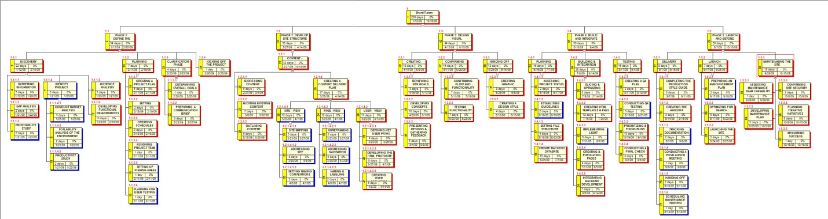

Figure 2: Work Breakdown Structure (WBS) compressed view

4.2.2 Schedule Dependencies

The schedule dependencies for the project ‘ShareIT.com’ is represented by the table below. The time duration for each task is an approximation based on a time taken by a project with similar level of size and complexity. The start date and the finish date of the project has not been defined at this point, since the project planning is required on an academic level

|  |  |  |  |  |
| --- | --- | --- | --- | --- |
| **Task ID** | **WBS Element** | **Task Name** | **Duration** | **Predecessors** |
| **1** | **1** | **shareit-logo.jpg** | **200d** |  |
| 2 | 1.1 | **PHASE 1: DEFINE THE PROJECT** | 34d | - |
| 3 | 1.1.1 | DISCOVERY PHASE | 22d | - |
| 4 | 1.1.1.1 | GATHERING INFORMATION | 7d | - |
| 5 | 1.1.1.2 | GAP ANALYSIS | 2d | 4 |
| 6 | 1.1.1.3 | PROFITABILITY STUDY | 2d | 4 |
| 7 | 1.1.1.4 | IDENTIFY PROJECT ENVIRONMENT | 3d | 4 |
| 8 | 1.1.1.4.1 | CONDUCT MARKET ANALYSIS | 3d | 4 |
| 9 | 1.1.1.4.2 | SCALABILITY ANALYSIS OF THE ENVIRONMENT | 2d | 4 |
| 10 | 1.1.1.4.3 | PRODUCTIVITY STUDY | 2d | 4 |
| 11 | 1.1.1.5 | AUDIENCE ANALYSIS | 3d | "5,4" |
| 12 | 1.1.1.6 | DEVELOPING FUNCTIONAL REQUIREMENTS | 10d | "4,5,11" |
| 13 | 1.1.2 | PLANNING PHASE | 7d | 3 |
| 14 | 1.1.2.1 | CREATING A PROJECT PLAN | 5d | 3 |
| 15 | 1.1.2.2 | SETTING BUDGET | 2d | 14 |
| 16 | 1.1.2.3 | CREATING SCHEDULES | 2d | 14 |
| 17 | 1.1.2.4 | ASSIGNING PROJECT TEAM | 1d | 3 |
| 18 | 1.1.2.5 | SETTING UP STAGING AREAS | 1d | 3 |
| 19 | 1.1.2.6 | PLANNING FOR USER TESTING | 1d | 3 |
| 20 | 1.1.3 | CLARIFICATION PHASE | 4d | 13 |
| 21 | 1.1.3.1 | DETERMINING OVERALL GOALS | 1d | 13 |
| 22 | 1.1.3.2 | PREPARING A COMMUNICATION BRIEF | 3d | 21 |
| 23 | 1.1.4 | KICKING OFF THE PROJECT | 1d | 22 |
| **Milestone 1:** Used cases data collected, analyzed and distributed, existing marketing and research materials collected and analyzed, audience demographic identified, audience profile created, Backend programming needs identified, Overall project goals determined, communication brief prepared, estimated budget set, estimated schedules created, project team assigned, project plan materials assembled. | | | | |
| 24 | 1.2 | **PHASE 2: DEVELOP SITE STRUCTURE** | 33d | 2 |
| 25 | 1.2.1 | CONTENT - VIEW | 33d | - |
| 26 | 1.2.1.1 | ADDRESSING CONTENT | 5d | - |
| 27 | 1.2.1.2 | AUDITING EXISTING CONTENT | 5d | 26 |
| 28 | 1.2.1.3 | OUTLINING CONTENT | 6d | "26,27" |
| 29 | 1.2.1.4 | CREATING A CONTENT DELIVERY PLAN | 17d | 28 |
| 30 | 1.2.1.4.1 | SITE - VIEW | 12d | - |
| 31 | 1.2.1.4.1.1 | SITE MAPPING | 5d | - |
| 32 | 1.2.1.4.1.2 | ADDRESSING SITE ORGANIZATION | 5d | 31 |
| 33 | 1.2.1.4.1.3 | SETTING NAMING CONVENTIONS | 2d | 32 |
| 34 | 1.2.1.4.2 | PAGE -VIEW | 12d | - |
| 35 | 1.2.1.4.2.1 | WIREFRAMING | 5d | - |
| 36 | 1.2.1.4.2.2 | ADDRESSING NAVIGATION | 5d | 35 |
| 37 | 1.2.1.4.2.3 | NAMING & LABELING | 2d | 36 |
| 38 | 1.2.1.4.3 | USER - VIEW | 17d | - |
| 39 | 1.2.1.4.3.1 | DEFINING KEY USER PATHS | 4d | - |
| 40 | 1.2.1.4.3.2 | DEVELOPING THE HTML PROTOSITE | 8d | 39 |
| 41 | 1.2.1.4.3.3 | CREATING USER SCENARIOS | 5d | 40 |
| **Milestone 2:** Site content addressed and organized, site content outlined, content delivery plan created, sitemap created, site structure determined, wireframes for the page-view created, key user paths defined, HTML Protosite created, user scenarios created. | | | | |
| 42 | 1.3 | **PHASE 3: DESIGN VISUAL INTERFACE** | 44d | 24 |
| 43 | 1.3.1 | CREATING | 18d | - |
| 44 | 1.3.1.1 | REVIEWING SITE GOALS | 3d | - |
| 45 | 1.3.1.2 | DEVELOPING CONCEPTS | 10d | 44 |
| 46 | 1.3.1.3 | PRESENTING DESIGNS & GATHERING FEEDBACK | 5d | 45 |
| 47 | 1.3.2 | CONFIRMING | 14d | 43 |
| 48 | 1.3.2.1 | CONFIRMING FLOW AND FUNCTIONALITY | 7d | 46 |
| 49 | 1.3.2.2 | TESTING FUNCTIONALITY | 7d | 48 |
| 50 | 1.3.3 | HANDING OFF | 12d | 47 |
| 51 | 1.3.3.1 | CREATING GRAPHIC TEMPLATES | 8d | - |
| 52 | 1.3.3.2 | CREATING A DESIGN STYLE GUIDE | 4d | 51 |
| **Milestone 3:** Site goals reviewed, concepts developed, design presented, Site feedback gathered, navigation and content confirmed, site functionality tested, graphic template created, design style guide created. | | | | |
| 53 | 1.4 | **PHASE 4: BUILD AND INTEGRATE** | 59d | 42 |
| 54 | 1.4.1 | PLANNING | 16d | - |
| 55 | 1.4.1.1 | ASSESSING PROJECT STATUS | 2d | - |
| 56 | 1.4.1.2 | ESTABLISING GUIDELINES | 2d | 55 |
| 57 | 1.4.1.3 | SETTING FILE STRUCTURE | 4d | 55 |
| 58 | 1.4.1.4 | CREATE BACKEND DATABASE | 10d | 57 |
| 59 | 1.4.2 | BUILDING & INTEGRATION | 28d | 54 |
| 60 | 1.4.2.1 | SLICING & OPTIMIZING | 5d | - |
| 61 | 1.4.2.2 | CREATING HTML TEMPLATES & PAES | 12d | 60 |
| 62 | 1.4.2.3 | IMPLEMENTING LIGHT SCRIPTING | 6d | 61 |
| 63 | 1.4.2.4 | CREATING & POPULATING PAGES | 4d | 61 |
| 64 | 1.4.2.5 | INTEGRATING BACKEND DEVELOPMENT | 7d | 63 |
| 65 | 1.4.3 | TESTING | 15d | 59 |
| 66 | 1.4.3.1 | CREATING A QA PLAN | 2d | - |
| 67 | 1.4.3.2 | CONDUCTING QA TESTING | 3d | 66 |
| 68 | 1.4.3.3 | PRIORITIZING & FIXING BUGS | 10d | 66 |
| 69 | 1.4.3.4 | CONDUCTING A FINAL CHECK | 3d | 68 |
| **Milestone 4:** Project status assessed, graphic templates received from visual designer, graphics optimized, HTML templates created, light scripting implemented, individual pages built, quality assurance (QA) plan created, quality assurance conducted, bugs are prioritized and fixed, final check conducted. | | | | |
| 70 | 1.5 | **PHASE 5: LAUNCH AND BEYOND** | 30d | 53 |
| 71 | 1.5.1 | DELIVERY | 8d | - |
| 72 | 1.5.1.1 | COMPLETING THE PRODUCTION STYLE GUIDE | 5d | - |
| 73 | 1.5.1.2 | CREATING THE HANDOFF PACKET | 3d | 72 |
| 74 | 1.5.1.3 | TRACKING DOCUMENTATION | 2d | - |
| 75 | 1.5.1.4 | CONDUCTING A POSTLAUNCH MEETING | 1d | 74 |
| 76 | 1.5.1.5 | HANDING OFF | 2d | 75 |
| 77 | 1.5.1.6 | SCHEDULING MAINTENANCE TRAINING | 1d | 76 |
| 78 | 1.5.2 | LAUNCH | 7d | 71 |
| 79 | 1.5.2.1 | PREPARING AN ANNOUNCEMENT PLAN | 2d | - |
| 80 | 1.5.2.2 | OPTIMIZING FOR SEARCH ENGINES | 5d | - |
| 81 | 1.5.2.3 | LAUNCHING THE SITE | 2d | 80 |
| 82 | 1.5.3 | MAINTENANING THE SITE | 15d | 81 |
| 83 | 1.5.3.1 | ASSESSING MAINTENANCE TEAM CAPABILITY | 1d | - |
| 84 | 1.5.3.2 | DEVELOPING MAINTENANCE PLAN | 5d | 83 |
| 85 | 1.5.3.3 | CONFIRMING SITE SECURITY | 3d | 84 |
| 86 | 1.5.3.4 | PLANNING ITERATIVE INITIATIVES | 5d | 85 |
| 87 | 1.5.3.5 | MEASURING SUCCESS | 1d | 86 |
| **Milestone 5:** Production style guide completed, maintenance training scheduled, search engine optimized, site launched, site security confirmed, maintenance plan developed. | | | | |

Table 2: Schedule Dependencies

The Gantt chart attached in Appendix B at the end of this document shows the relationships among the tasks in detail. Note that some tasks cannot begin until others are completed. This relationship is clearer in the Gantt chart.

4.2.3 Budget Allocation

The table below shows the detailed budget allocation of the project. The project is expected to cost around $357,000 which includes the salary expenses, services utilized to complete the project, additional materials that might be required during the project and administrative expenses. Several assumptions have been made as shown in the table to come up with an approximate budget for the project. A 15% safety factor is also included to cover up un-seen expenses during the project. The team has referred to a similar project with more or less same level of size and complexity to calculate the budget allocation of the project.

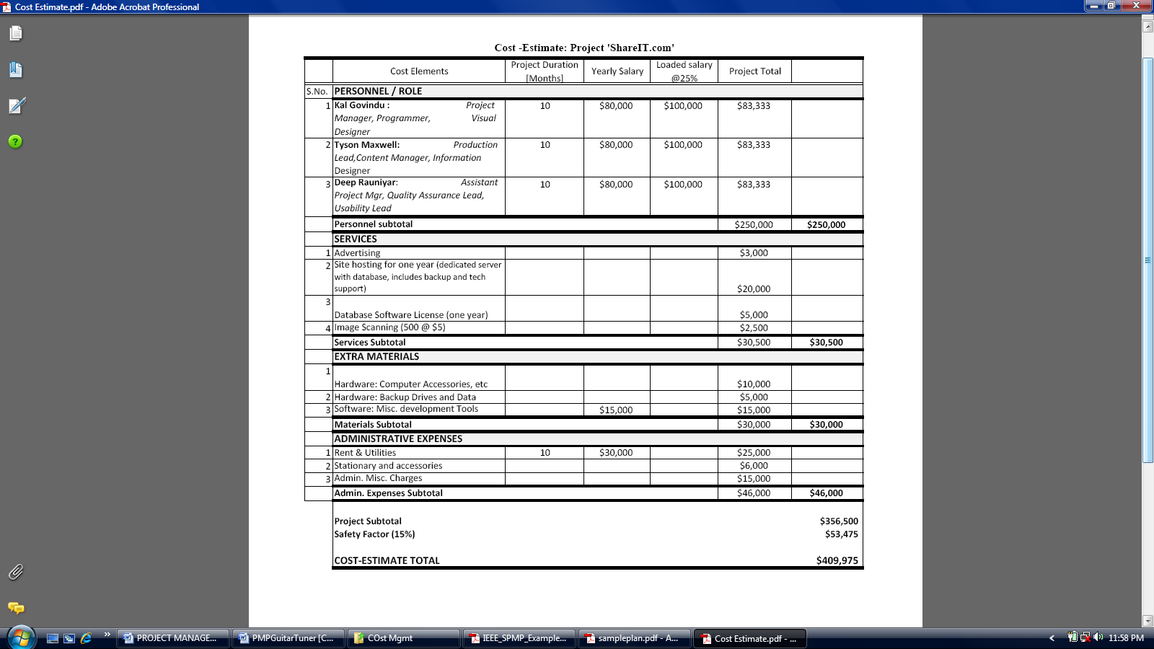

Table 3: Budget Details

**4.3 Project Control Plan**

4.3.1 Requirements

Once all the requirements have been identified analyzed and documented, the design team is expected to create a requirement control plan to manage the requirements processes and procedures to be used by the project, ‘ShareIT.com’. The Plan will define how requirements will be recorded; how requirements will be modified; and how requirements will be reconciled for final completion of the web site.

The process and procedure used in the management of the requirements will include following elements:

**Identification of Requirements:** The Project Manager will confer with the members of the department to identify the structure of the project, the desired functionality of the project, and any performance issues. The Project Manager will meet the design team to review and negotiate any changes to requirements as the project progresses. Once consent from all the team members is obtained, the change in requirement would be approved, documented and implemented.

**Recording Requirements:** The Project Manager will keep track/record of the requirements approved by the design team. The Project Manager will number and enter each requirement into a requirements tracking matrix and will keep a project requirements file containing documentation of approved requirements, and approved modifications to requirements.

**Modification of Requirements:** Major modification of specified requirements will require the consent and approval of the design team under the authority of the Project Manager. The Project Manager will also incorporate the approved requirement modification into the requirements tracking matrix, and add the modification request to the Requirements Project File. The project team will then implement the approved modification.

The design team is expected to use a Requirements Tracking Matrix (created in Microsoft Excel) and Requirements Project File to efficiently control and mange the requirements.

4.3.2 Schedule

The project will perform schedule control using the Earned Value Management System (EVMS). In addition, the Critical Path Method (CPM) will be used to control the activities most crucial to completion of the project on-schedule. A major milestone will be placed at the end of each phase and a team meeting is held, the design team is expected to complete certain deliverables as specified by the work plan 4.2.2 and approved in order to progress into the next phase. Sub-activity milestones will be developed for each activity by the assigned resources as the depth of each activity becomes known.

The following Earned Value measurements will be used to monitor schedule progress:

* Budgeted Cost of Work Scheduled (BCWS)
* Budgeted Cost of Work Performed (BCWP)
* Schedule Variance (SV)
* Schedule Performance Index (SPI)
* Estimated Time At Completion (ETAC)

All most all of the EVMS metrics specified above will be automatically calculated by Microsoft Project. The project manager and the assistant project manager will be assigned the responsibility to maintain and manage the project schedule or make necessary changes as per the need of the project.

The team is expected to identify the critical task that needs to be completed to avoid unnecessary project delays. Microsoft Office tools will be utilized to identify and track critical path. These tasks shall receive special attention with respect to completion of the project. Bi-weekly examination of the critical path will be undertaken in order to account for activities that enter and leave the critical path as real progress data is entered against the baseline project schedule (defined by the Gantt chart).

4.3.3 Budget

Considering the size and complexity of the project, an extensive budget control plan will not be required for this project. However, a cost baseline is expected to be created for the project once more details into the requirements of the project are known. Changes in cost will be measured against the baseline.

Assuming the project deliverables are completed on-time with no schedule delays, the project is not expected to accumulate additional cost. Most of the required resources such as software’s and computer hardware’s will be acquired at the beginning of the project. With a careful planning of budget allocation, as stated in section 4.2.3, the team as set aside 15% of the total development cost ($53,000) as extra reserve. If the project does somehow goes over the budget with unseen or unexpected cost, the team is expected to use the reserve fund with the consent of the project manager and assistant project manager.

**4.5 Risk Management Plan**

The Risk Management Plan attempts to identify, characterize, prioritize and document a mitigation approach relative to those risks which can be identified prior to the start of the project. The Risk Assessment (Assuming the project goes into production phase) will be continuously monitored and updated throughout the life of the project. The risk mitigation approach is based in team member’s agreement and PERT estimate is used to calculate risk likelihood and severity. The following risks and their mitigation strategy have been indentified:

|  |  |  |  |  |
| --- | --- | --- | --- | --- |
| **Risk ID #** | **Risk** | **Probability** | **Severity** | **Risk Response** |
| R1 | Organizational financial problems force reductions in the project budget. | 2.5 | 4.8 | Inform project manager. Cut / reduce unnecessary expenses. Readjust budget allocation. |
| R2 | Poor management of project changes | 3.5 | 3.5 | Have weekly team meeting to address change in project. |
| R3 | Key staff are ill at critical times in the project | 1.5 | 3.5 | Reschedule work. Possibility of working from home. |
| R4 | Site is not accessible for launch date | 2.2 | 4.5 | There is already a holding page in place for users to access. |
| R5 | Inflation of prices (raw materials/ labor) | 1.5 | 3.7 | Re-adjust budget, Request for additional funds, Find alternative resources. |
| R6 | Changes to requirements which require major design rework are proposed. | 3.0 | 4.2 | Team meeting to address the issue and if the change can be avoided. If not adjust scope, budget and schedule to fit the new requirement. Review. |
| R7 | Script errors on out-of-scope browsers | 2.6 | 3.8 | We have not tested the site in out-of-scope browsers. We estimated only 3% of site users will be using out-of-scope browsers. |
| R8 | Site Performs very slowly | 1.3 | 3.8 | We have specified a server that could perform at normal speed, with double the predicted levels of traffic |
| R9 | Loss of power | 1.5 | 4.1 | Install a back-up power source. |
| R10 | Vendors fail to deliver the required software package needed for development | 2.0 | 3.3 | Get different software from market with similar feature and function. |
| R11 | The database used in the system in inefficient. | 2.5 | 4.1 | Review performance of database and perform necessary maintenance every weekend. |
| R12 | Project fails to attract potential users. | 3.5 | 4.5 | Carry a user survey to identify user needs and expectation. Have project team meetings and discuss possible change to lure users to the site. |
| R13 | The back-end functionality coding is inefficient. | 2.0 | 3.7 | Review code for possible errors and faults. Perform expert analysis on the back-end functionality coding. |
| R14 | The project fails to attract potential customers (Advertisers). | 2.8 | 4.7 | Contact potential advertisers. Provide advertising incentive to advertisers. |
| R15 | Users misuse the web site for inappropriate activity | 3.5 | 4.2 | Review pictures and contents uploaded by the users before actually being posted on the site. Require new users to agree with terms and condition of the site. |
| R16 | Hard to term possible threats from competitors | 3.0 | 4.3 | Update site on weekly basis to meet the changing demands on web users and technology. |
| R17 | Difficulty of operation and simplicity of the web site. | 3.4 | 4.1 | Implement plan to address usability of the web site. |
| R18 | Lack of testing tool for web application. | 1.8 | 3.2 | Outsource the testing of the design to a third-party. |
| R19 | Large volume of information than expected | 3.0 | 4.0 | Devise a plan to address handling on information. Assign responsibility to a team member to systematically manage information. Hire new employee if needed. |
| R20 | Lack of aesthetics in content | 3.4 | 4.0 | Implement plan to consider human factor integration in the web-site. |
| R21 | Lack of communication between team members. | 3.2 | 3.8 | Plan to have a mandatory meeting of the team members every week. |
| R22 | Difficult in defining content and functional requirements | 3.5 | 4.4 | Consult an expert. Review requirements. |
| R23 | Lack of providing data privacy and data security | 3.5 | 4.8 | Provide multiple layer of security on the server for important data. Limit access to main server. |
| R24 | Some requirements are technically difficult to implement. | 3.3 | 4.0 | Consult an expert. Review requirements. |

Table 4: Brief summary of Risk Register

* A detailed risk register including the consequences of risk, risk triggers, residual risk and residual severity and secondary risk is attached in Appendix C (due to the size of the document).

1. **Technical Processes**

5.1 Project Test Plan

Test Plan for the project would simply define the process and procedure required in checking the web site for bugs and against the original specification outlined during the scope of the project. Web site testing for the project will consist of a dynamic verification of the behavior of the program on a finite set of test cases, suitably selected from the execution domain, against the expected behavior.

The test plan for the project will include following elements:

* Identification of fundamentals related to testing of the construction of the web design.
* Listing all faults and failure modes and possible causes of malfunction, how and where they occur, etc. Other issues such as test selection criteria, testing effectiveness and objectives for testing; testing for defect identification, theoretical and practical limitations, problems of infeasible paths, etc would also be identified and listed on the test plan.
* A standardized method for test will be identified that can reveal as much potential for failure as possible and listed in the test plan. Methods implemented would be based on the test category (if the test is related to installation, alpha and beta testing, conformance testing, functional testing, reliability achievement and evaluation, performance testing, etc.)
* Testing will be conducted on multiple stages. Alpha and Beta testing (on the actual server, assuming the project goes to production phase) will be performed. Testing level would be determined based on budget, time resources, expertise and needs of the project.
* Before moving the site to the live server, a last check is planned to be conducted on design, content, production, and functionality.

The test plans and procedures for the project will be systematically and continuously developed, and refined, as development of the project proceeds.

5.2 Product Acceptance Plan

The product acceptance plan will describe the methods of acceptance for each of the project deliverables indentified in section 4.2.1. Considering the size and complexity of the project, a detailed product acceptance plan will not be required. Acceptance of work products is ultimately achieved when approval is granted by the design team under the supervision of the project manager. The acceptance decision and details will be document as per the need of the project.

5.3 Web Security Plan

Security features of ShareIt.com will consist of following features:

1. Security questions - The user will be required to choose and answer three security questions at the time of registration. These questions will used to verify the validity of the user in any of the following scenarios.
   * User forgets password
   * User using a different computer
   * User would like to delete his or her account
2. CAPTCHA - Stands for Completely Automated Public Turing test to tell Computers and Humans Apart. This is the latest in website technology to differ DOQ (denial of request) attacks which are often carried out by computer by producing huge amounts of traffic. Some examples of CAPTCHA follow:



Figure 3: Web Security CAPTCHA example

1. Expiring Password - If the user has not used the site in over a month, their password will be expired and they will have a set a new one when they attempt login next.
2. User Categories - Items on the website can put into different categories defined by the user. After which the user will have the capability to share only some categories with other members or all. This enables users to share some items private and share other stuff, enabling more usability.
3. SSL encryption - From the point the user logs in, their session is encrypted.
4. **Supporting Processes**

6.1 Verification and Validation

Explicit verification and validation is not planned for this project because of the scope of the project and the size and complexity nature of the requirements. Formal validation and verification will be performed on the following project work products and are listed below in order of occurrence:

* Web design requirements
* Web design architecture
* Web design interface design
* Database design
* Implemented web site interface

The main verification and validation activities performed on these work products will be inspections and review by the design team.

All other work products will be informally verified and validated to some degree, but they will not receive formal verification and validation from the design team. For each verification and validation of a work product, a corresponding report will be issued and documented by the team.

6.2 Quality Assurance

The design team is expected to incorporate a quality assurance model based on the ISO 9000 quality assurance procedure. Since the project planning is performed on an academic level, the full extent of normal ISO 9000 procedure will not be required or necessary. The major quality focus area for the project would include usability, browser and OS compatibility, functionality, internal standards, performance/ load handling, content and security.

The quality assurance model/ plan will include following activities:

* Overall goals for QA including methodology (Code reviews and unit tests), schedule, and resource allocation will be summarized in QA plan.
* Plan to incorporate web usability in the design.
* Specific browsers, platforms, and operating systems being tested would be listed in the QA plan.
* Desired connection speeds being tested would be listed in the QA plan.
* Specific paths or functions that need to be tested would be indentified and listed in QA plan.
* A plan for bug tracking would be determined.
* A plan for prioritizing and fixing bugs and confirming the fixes would be determined.

Quality measurements will be carried by following activities:

* Customer satisfaction and functional correctness
* Code conformity to ISO 9000 standards.

The quality assurance activities are expected to be performed throughout the lifecycle of the project.

**Attachments/ Appendices**

**Appendix A:** Detailed Work Breakdown Structure (WBS) –Left Section View

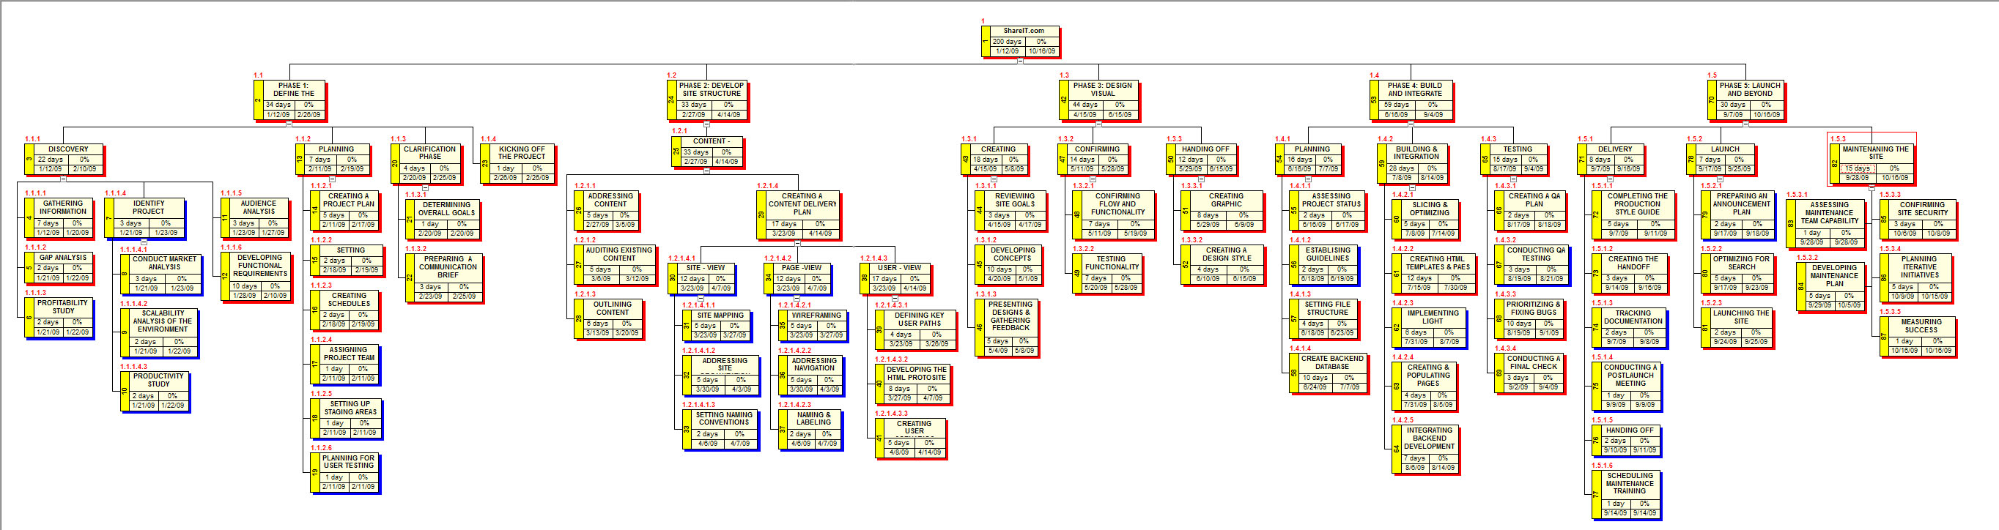

**Appendix A:** Detailed Work Breakdown Structure (WBS) –Middle Section View



**Appendix A:** Detailed Work Breakdown Structure (WBS) –Right Section View



**Appendix B**: Project Gantt chart – Schedule Phase I

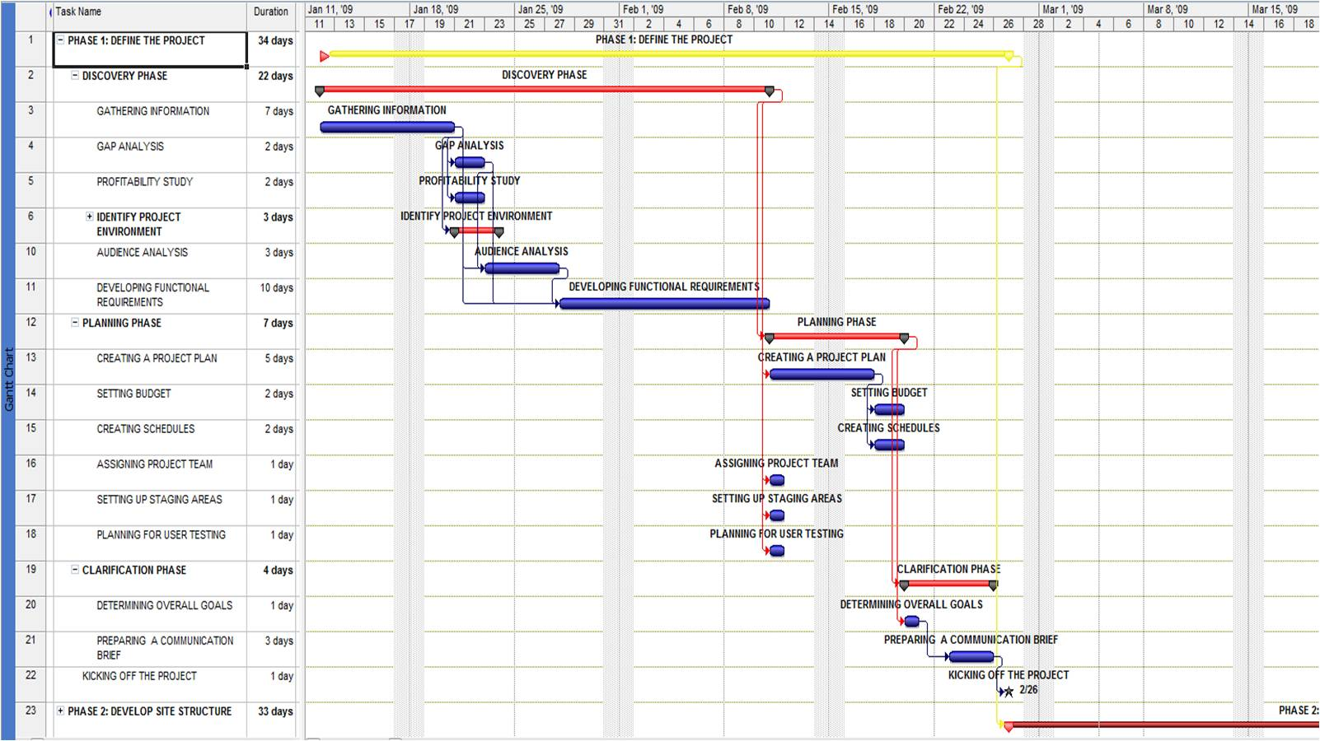

**Appendix B**: Project Gantt chart – Schedule Phase II

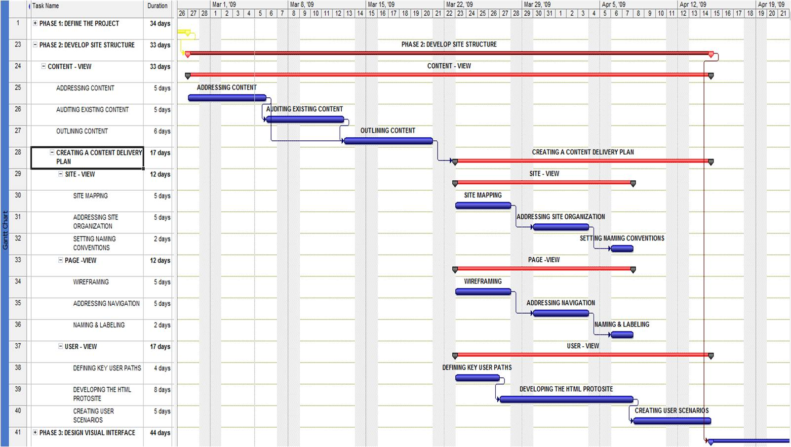

**Appendix B**: Project Gantt chart – Schedule Phase III

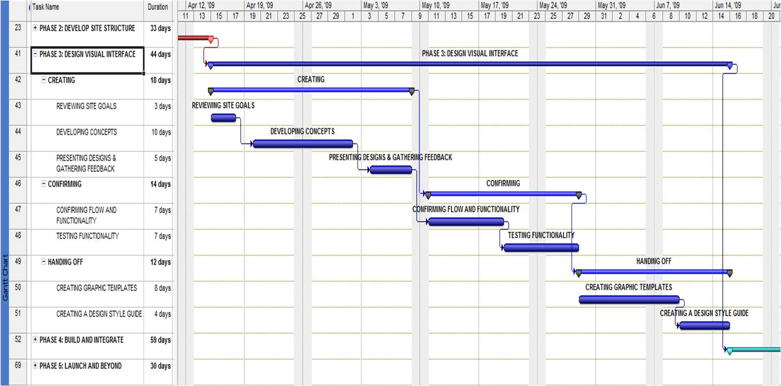

**Appendix B**: Project Gantt chart – Schedule Phase IV

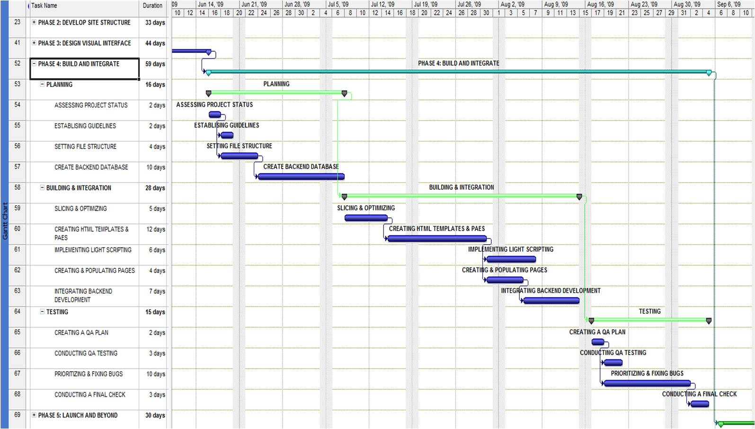

**Appendix B**: Project Gantt chart – Schedule Phase V

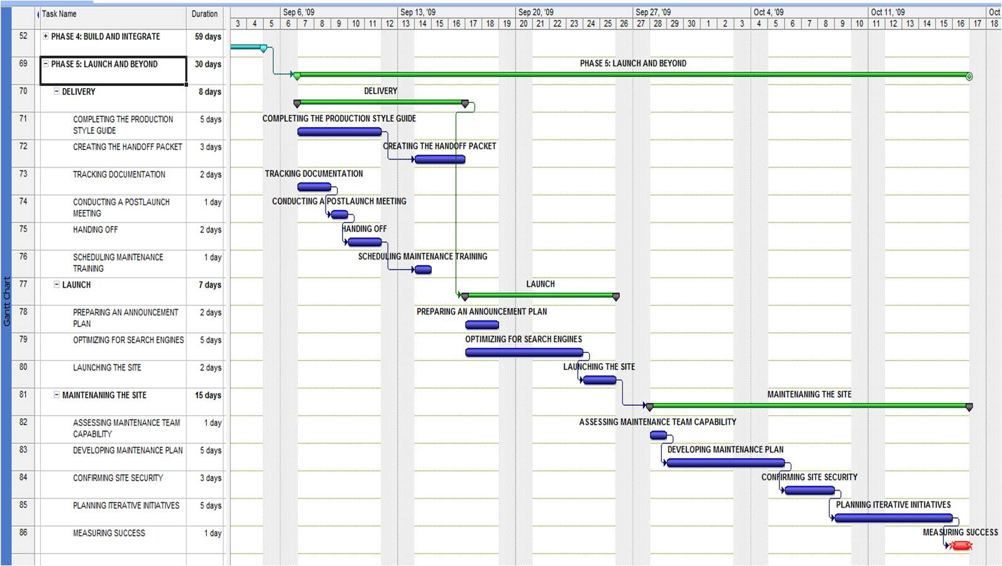

**Appendix C**: Detailed Risk Register (Risk R1 – R13: Side A)

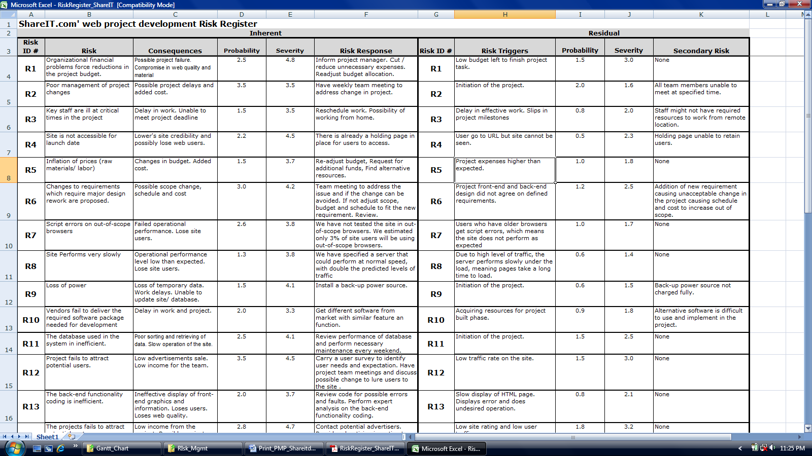

**Appendix C**: Detailed Risk Register (Risk R1 – R13: Side B)



**Appendix C**: Detailed Risk Register (Risk R13 – R24: Side A)

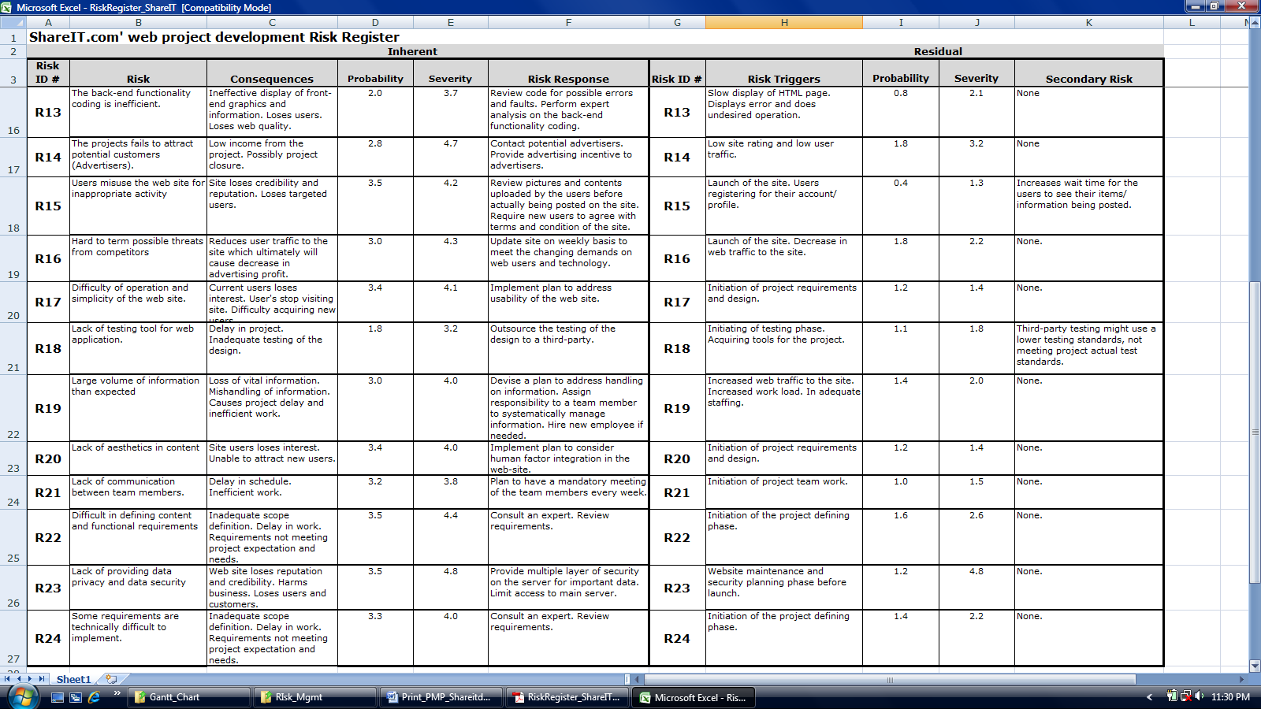

**Appendix C**: Detailed Risk Register (Risk R13 – R24: Side B)

**Appendix C**: Detailed Risk Register (Risk R13 – R24: Side B)

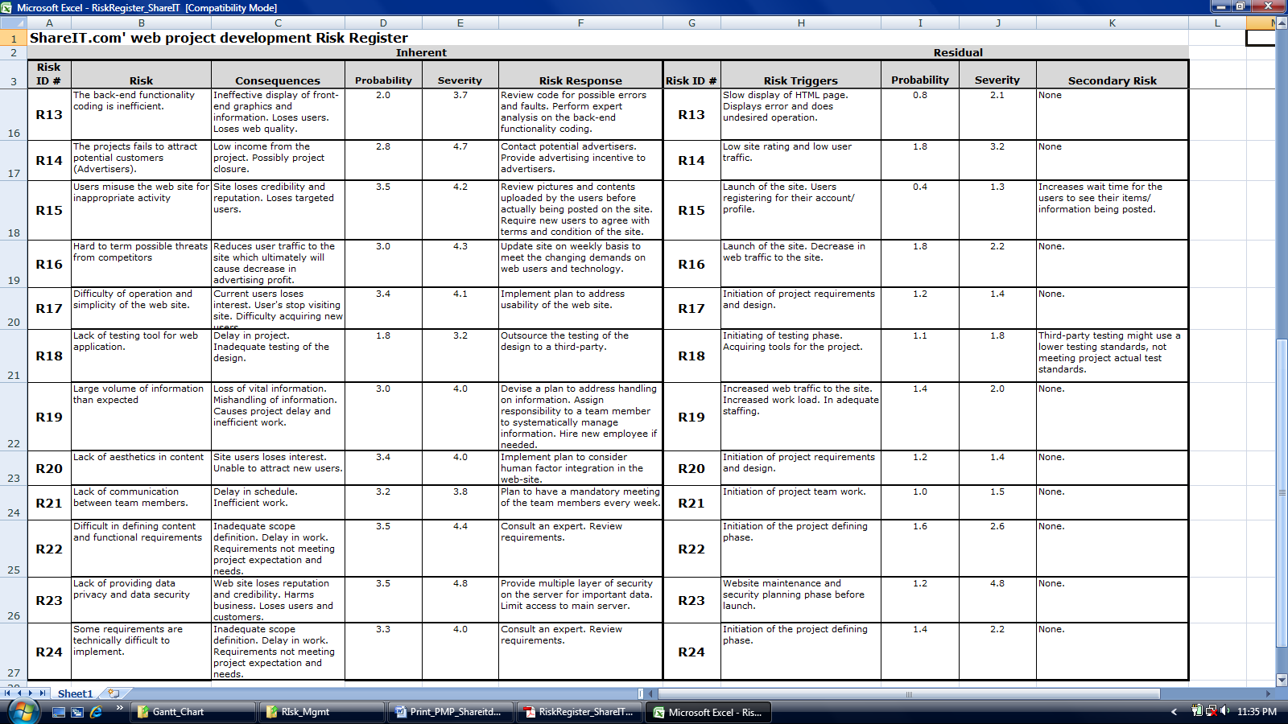

Note:

Electronic version of the PMP can be located in the project C-map can at:

[**http://users.ipfw.edu/raundb01/Project_SHAREITdotCOM.html**](http://users.ipfw.edu/raundb01/Project_SHAREITdotCOM.html)