TIPS FOR TAKING CARE OF OUR SKIN
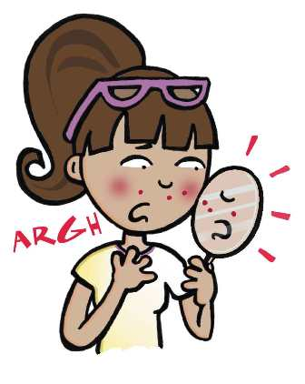
Sometimes it may seem like your skin is impossible to manage, especially when you wake up and find a huge zit on your nose or a cold sore at the corner of your mouth. The good news is that there are ways to prevent and treat common skin problems — read on for some tips.

Acne
A pimple starts when the pores in the skin become clogged with a type of oil called sebum, which normally lubricates the skin and hair. Acne is common during puberty when hormones go into overdrive, causing the skin to overproduce sebum. Because many oil-producing glands are on the forehead, nose, and chin, this area — the T-zone — is where a person is most prone to pimples.
Here are some tips to help prevent breakouts and clear them up as fast as possible:
- Wash your face twice a day (no more) with warm water and a mild soap made for people with acne. Gently massage your face with circular motions. Don't scrub. Overwashing and scrubbing can cause skin to become irritated. After cleansing, the American Academy of Dermatology (AAD) recommends applying an over-the-counter (no prescription needed) lotion containing benzoyl peroxide. This will decrease oil and bacteria.
- Don't pop pimples. It's tempting, but here's why you shouldn't: Popping pimples can push infected material further into the skin, leading to more swelling and redness, and even scarring. If you notice a pimple coming before a big event, like the prom, a dermatologist can often treat it for you with less risk of scarring or infection.
- Avoid touching your face with your fingers or leaning your face on objects that collect sebum and skin residue like your phone. Touching your face can spread the bacteria that cause pores to become inflamed and irritated. To keep bacteria at bay, wash your hands before applying anything to your face, such as treatment creams or makeup.
- If you wear glasses or sunglasses, make sure you clean them frequently to keep oil from clogging the pores around your eyes and nose.
- If you get acne on your body, try not to wear tight clothes. They don't allow skin to breathe and may cause irritation. Scarves, headbands, and caps can collect dirt and oil, too.
- Remove your makeup before you go to sleep. When buying makeup, make sure you choose brands that say "noncomedogenic" or "nonacnegenic" on the label. Throw away old makeup that smells or looks different from when you first bought it.
- Keep hair clean and out of your face to prevent additional dirt and oil from clogging your pores.
- Protect your skin from the sun. It may seem like a tan masks acne, but it's only temporary. A tan can cause the body to produce extra sebum, which may worsen your acne, not improve it. Tanning also causes damage to skin that will eventually lead to wrinkles and increase your risk of skin cancer.
If you're concerned about acne, talk to a dermatologist. Dermatologists offer a range of treatments that help to prevent and clear up acne and acne scars. A dermatologist can help you find the treatment method that's best for you and can also give you lots of useful tips for dealing with acne and caring for your skin type. Some salons and spas have trained skin specialists, called estheticians, who can offer advice and skin care treatments
Taken from: http://kidshealth.org/teen/your_body/take_care/skin_tips.html?tracking=T_RelatedArticle#

