CATHOLIC CATECHISM CONCEPT MAP (C4M) by Robert Zaar

This project seeks to create an automated concept map maker based on the catechism. There are various new technologies which when put together will fulfil the project aims. These technologies form the building blocks from which the map maker will be made. They involve the most recent developments of web, database and semantic technology. The project is then primarily a use of these new technologies and synthesysing their power for a new application

THE CONCEPT
This project is simply trying to push the Catholic Catechism through a computer to end up with a concept map.

First a look at Concept Maps, then the Catechism, followed by how a concept map of the catechism can be generated.

CONCEPT MAPS
A concept map is a graph in which the nodes represent concepts, the lines between the nodes represent relations, and the labels on the lines represent the nature of the relations.

Concept maps are also know as mind maps, topic maps and brainstorm charts. They can be as creative as the human imagination. Though the possibilities are broad the above definition will suffice for the complexities of this project. The project will limit itself to concept maps which come under this definition.
This is a typical concept map. The concepts (nodes) are in boxes and are connected by lines, which represent the relations between the concepts. The nature of the relation is described by the text in the line.
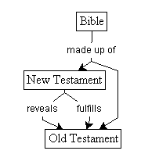
Concept maps have been around since the 60s when Prof J. Novak first developed them. Since then they have found many uses and would be familiar to most teachers particularly new teachers.

Concept maps are a subset of all visual languages. Myer’s taxonomy of visual languages specifies 14 types of visual languages. Six of these use lines to link parts and thus can be considered a concept map (see Appendix A). Myer’s taxonomy is the broadest among other taxonomies which cover concept maps. Using Myers’s taxonomy we can see where concept maps fit in, however, the many possibilities are not specific enough to clearly define the rules for concept mapping.

A more specific definition can be gained from Lambiottte, Dansereau, Cross, and Reynolds who classify "multirelational semantic maps" into four categories: the most rich is their Hybrid system that allows for nodes and relations to both contain information. This suits our above definition and the example diagram is of this type.

This definition is sufficiently rigorous though there are far more possible complexities. In fact it is possible to develop a syntax and semantic for concept map possibilities, much like a vocabulary of word types (eg noun, verb) and semantic (eg grammar, subject and object are linked by a verb). We have settled for a very simple syntax (nodes and lines) and semantic (nodes and lines can both contain information). This limits the possibilities for now but it does sufficiently define the concept map for our purposes.

We now turn our attention to the Catechism which we seek to turn into a concept map.

THE CATECHISM OF THE CATHOLIC CHURCH - WHAT IS THE CATECHISM?

The Catechism of the Catholic Church is presented: as an instrument to convey the essential and fundamental content of Catholic faith and morals (tam de fide quam de moribus), in a complete and summary way (non omnia sed totem); (Editorial Commission of the Catechism of the Catholic Church)

The Catechism is the Church’s compendium of catholic faith and thus the normative document for religious education curriculum.

The Catechism of the Catholic Church (CCC) is the official document that explains the Catholic Faith. It is the collaborative effort of all Catholic Bishops. At the 20th Anniversary Synod of Vatican II, the Synod Fathers “expressed a desire that a catechism …be composed…” John Paul II set up an ad hoc committee which first met on November 15 1986 to prepare the first draft. “The Catechism of the Catholic Church is the result of very extensive collaboration; it was prepared over six years of intense work done in a spirit of complete openness and fervent zeal.” The Catechism was finally approved on 25th June 1992. This short historical survey reflects the breadth of work that has been invested in the Catechism. It truly is a reflection of the mind and heart of the universal Church. The last universal catechism was the result of the council of Trent first published in 1566 . Since then the Church as a whole has not been to task to generate a definitive compendium of it’s teaching.

“I ask all the Church's Pastors and the Christian faithful to receive this catechism in a spirit of communion and to use it assiduously in fulfilling their mission of proclaiming the faith and calling people to the Gospel life. This catechism is given to them that it may be a sure and authentic reference text for teaching catholic doctrine and particularly for preparing local catechisms.” (John Paul II)

This document is the normative document of all Catholic teaching. It is the document from which all catechesis is derived. Thus, the content of Catholic education is based on the Catechism and must square with it. Indeed, the American Bishop’s Conference has distilled the Catechism into a set of core points which is named the Protocol. The Protocol is used for assessing the conformity of catechetical materials with the Catechism of the Catholic Church. In Melbourne, the new RE text’s doctrinal overview is based on the Catechism.

The Catechism is not just a normative document, it expresses within itself the most comprehensive articulation of the Catholic Faith. It can never be exhaustive, but must contain the core directions of Catholic thought. Theology is “Faith seeking understanding” according to the classic definition of St. Anselm. The Catechism expresses that understanding that we have come to after two millennia. With the thorough consultations, it must sufficiently express the core of Catholic belief. All beliefs would in some way be connected to an idea expressed somewhere within the Catechism. Thus the Catechism forms a grid from which any theological thought can find some degree of correlation or connection.

WHAT IS ITS STRUCTURE?

The Catechism though well organised is not in a form which is comprehensively navigated. The Catechism is organised into four parts, with sections, chapters, articles, paragraphs, headings, subheadings and finally individual points (formally known as a paragraph and referenced to by numbers, Eg CCC964). The numbered paragraphs provide an ordered system of quotation, used throughout any official Church document. There is also an index at the back. The numbered paragraphs are cross referenced to related paragraphs. The Subject index does not reference every paragraph. Coupled with the fact that many concepts are expressed in every paragraph, the Catechism is not thoroughly navigable. That is not to say that there are errors in the current index, nor that it is an adequate system for a book (47 pages just for the subject index servicing 682 pages of text). In fact it is a good system, however, to find the exact concept one is looking for requires skilled searching in some cases.

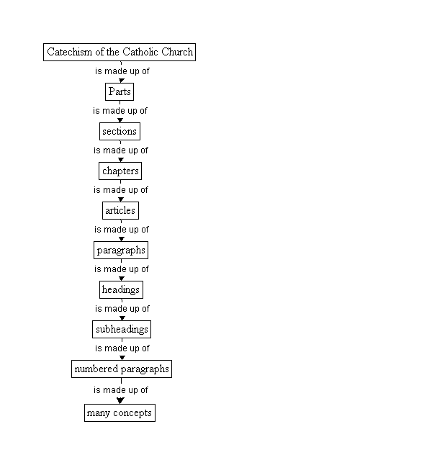
1
2865
incomplete search facility
Could be searched using a concept map of the Catechism
1
1000s
The concept level has the highest degree of resolution. It could be connected into a vast concept map, which could form the backbone of an information system.

The CD-ROM version of the Catechism, put out by St. Paul’s is far more helpful. The CD comes with a search facility which allows most words to be searched for. However, to find the place of a particular idea is still difficult. For example, “Does the Catechism comment on a Bishop’s call to give up his own life for his people?” The correct paragraph is CCC1586 “ For the Bishop… this grace impels him …not fearing to give his life for his sheep.” Using the text version, the subject index finds 1560 as the closest indexed paragraph. The CD version searched for ‘Bishop’ and ‘life’ delivers six references including 1586. This is about the limit of its search facility. A search for similar ideas could not be carried out without extensive work and use of similar words.

The Catechism conveying the Catholic faith in a complete and summary way is sufficient to form an index or structure in which to place any catholic resource in reference.

USING THE CATECHISM AS A FRAMEWORK
The Catechism has the numbered paragraph as its most basic unit, however, many concepts are expressed in one paragraph. The resolution of the Catechism cascades through parts, to sections to eventually the numbered paragraph. At this point is the Catechism referenced. I use the word ‘resolution’ in the same way your computer screen has a resolution. Usually your monitor has a resolution of 600x 800 pixels. My monitor has a resolution of 1280x1024 pixels. This means I can see far more detail on my screen. Applied to the Catechism, the resolution of the parts is only 4, since there are only four parts, the resolution at the paragraph level is 2865, having 2865 paragraphs. But what is the resolution of the actual thoughts expressed, obviously many thousands. But each thought would be unique. Some expressed over and over, such as the love of God. It is these thought or concepts that would truly have the highest resolution and be the most useful. sufficient for the usual 15” screen. But higher resolution is possible. Mine has up to But each numbered paragraph contains various ideas or concepts each may be vastly different but connected by the train of thought in the paragraph. For example, CCC964 expresses concepts such as, Mary’s role in the Church, her union with Christ, virginal conception, hour of the Passion, her pilgrimage of faith, divine plan, only begotten son, suffering, sacrifice, and loving consenting. It is the unique concept that would form the true extent the Catechism’s resolution.

Let us take an example of a catechism sentence and break it down into its concepts
1333 At the heart of the Eucharistic celebration are the bread and wine that, by the words of Christ and the invocation of the Holy Spirit, become Christ's Body and Blood.
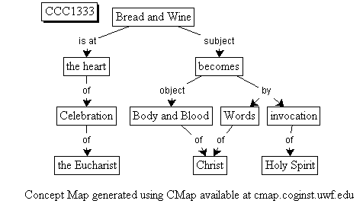
A concept map of this sentence will look like this.

Notice it is not exactly the same as the sentence. It is however sufficient for us to explore the conversion from sentence to concept map and the dynamics of concept maps.

Let us say each box is a concept strictly speaking and the lines represent relations with the unboxed information the nature of those relations. This fits in with our earlier definition. However we could group parts of this graph. This would create a new entity, which is formally called a context.

A context is a group of concepts and their relationships and operate as a single concept. By this new entity we have increased our syntax (nodes, lines and now contexts) and thus our grammar (what are the rules for contexts?)
Transubstantiation
context #1
context #2
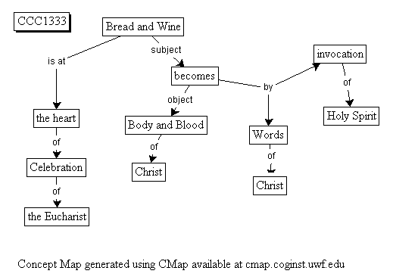

We could group parts of this sentence into contexts eg, ‘bread and wine becomes body and blood of Christ’ can be grouped into one context which we can name ‘transubstantiation’. We can form another context which we can designate context#2. Context one, ‘transubstantiation’ can be considered a concept in itself. It would turn up in other sentences as a stand alone word, a concept. We can see that all contexts are un-named concepts. Some groupings can be given names, such as transubstantiation, but others haven’t got names and it wouldn’t make sense to give them names. But as an entity in tis own right, they may occur again. This would be the case for the context of ‘words of Christ’. We would expect it to turn up many times, but there is not a single word which would represent this. ‘Words of Christ’ is sufficient.

We need to now broaden our definition of concept maps to included contexts. One such implementation of this approach is the Constraint graph specification of Dr. Robert Kremer who seeks to come up with a concept map meta-language on which specific concept map languages can be built. He has 33 requirements or rules on which concept maps are created. It covers nodes, lines and contexts and a little more. However, it is limited. Requirement 12 of his specification is “Contexts are strictly nested: they form a hierarchy”. For true flexibility, this constraint would be burdensome and ultimately untenable.

Contexts must be treated like concepts with the ability for a parent to be the child of itself. Say we have the sentence ‘Christ turns bread into his body’. ‘Bread into his body’ can be recognised as transubstantiation. However, Christ is a linked to transubstatiation, but transubstantiation contains the concept ‘Christ’ within it. If contexts were strictly hierarchical, then they couldn’t rely on themselves somewhere in the tree. This is obviously needed when it comes to the Catechism.

The following model will allow for this. The line-node relation is itself considered a concept. The concept map can then be partly redrawn as follows:
the Eucharist
of
Context #1
Celebration
Context #2

Every combination of a node and line is itself a node with a unique name. That is, any relationship of information is itself a piece of information. This is not that different from our first definition, since we still end up with nodes and lines, however, the fact that both contain information is important and really the common element, the links are what link information. The above diagram should then have another subcontext for ‘the’ and ‘Eucharist’. Each context does not have a name, but must be uniquely identified. once identified, it can be matched to any other context. Celebration will match to every other celebration, but will also match to context#2, which will lead to ‘of the Eucharist’. We then have a matching mechanism that moves up and down the tree (in the same sentence) and across to other instances of ‘celebration’. Generally the names of the contexts will be a unique identifier, but occasionally it will be a word itself such as transubstantiation. Also a context would also be generated for every two words and their combinations, eg ‘the Eucharist’, ‘of the’, ‘celebration of’, ‘of the Eucharist’, celebration of the’, and ‘celebration of the Eucharist’. This starts to generate a huge number of combinations which could be searched. These searched terms will need to be ordered. There is a limit to sentence endings and to inferred meaning. One sentence meaning carrying over to another. Thus there is a finite limit to the extent that combinations can be generated. Each combination will also be referenced to a CCC number from which it originates from. More complex meanings will be referenced to word groups, eg, ‘of the Eucharist’ will be referenced as ‘Eucharistic’ Eucharistic will be the word that defines this context and be its identifier. This process of naming context or defining them, will turn the concept map into a manageable resource, one that truly links concepts. We are then left with two questions at this point; 1) How to convert sentences into a correct tree of words? and 2) How to codify the huge complex created?

If this codification was applied to the whole Catechism, then a huge concept map would be generated. every time a word group would occur, it would use the same code. For example, ‘of the Eucharist’ would all be linked, all 35 occurrences.
901 In the celebration of the Eucharist these may most fittingly be offered to the Father along with the body of the Lord.
1055 By virtue of the "communion of saints," the Church commends the dead to God's mercy and offers her prayers, especially the holy sacrifice of the Eucharist, on their behalf.

The codification of the Catechism is firstly finding what type of word it is, eg noun. This is technically called ‘tagging’. A look up table of words would help, however this would leave words which have multiple meanings unknown. There are two approaches to dealing with ambiguous words, probabilistic (which has a higher error rate) or rules based (which leaves some ambiguous words). One of the earliest taggers which has been continuously refined is Constituent-Likelihood Automatic Word-tagging System (CLAWS), developed at the university of Lancaster. CLAWS uses statistical optimizated probabilities to assign to each word one of 133 part-of-speech tags with 96-97% success. An improved version, CLAWS4, uses 61 tags with 95-99% success. There is an online version.
If we take our example and have it tagged,
CLAWS (C5 tag set) produces
At_PRP the_AT0 heart_NN1 of_PRF the_AT0 Eucharistic_AJ0 celebration_NN1 are_VBB the_AT0 bread_NN1 and_CJC wine_NN1 that_CJT ,_, by_PRP the_AT0 words_NN2 of_PRF Christ_NP0 and_CJC the_AT0 invocation_NN1 of_PRF the_AT0 Holy_AJ0 Spirit_NN1 ,_, become_VVB Christ_NP0 's_POS Body_NN1 and_CJC Blood_NN1 ._.
KEY
PRP Preposition
AT0 Article
NN1 Noun
PRF the preposition
AJ0 Adjective
VBB The base form of the verb
CJC coordinating conjunction
CJT the conjunction THAT
NN2 plural noun
NP0 proper noun
VVB Base form of lexical verb
POS the possessive

It is as expected and has for this sentence a 100% accuracy. But it does not provide us with the necessary structure. What order should the words be grouped. It does however allow us to separate ambiguous words. What is needed is some kind of grammar analyser. There are many grammar tools developed, one of the most useful is Head-Driven Phrase Structure Grammar (HPSG). HPSG has been implemented in an online version called LinGO. Unfortunately this service is offline. However a sample analysis is given and this is sufficient for our task.

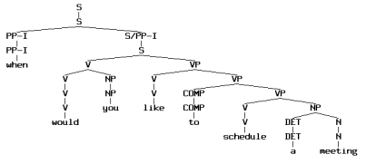
We can see from this tree generated from the sentence, “When would you like to schedule a meeting.” that LinGO correctly groups the words into the right hierarchy. This then if applied to the whole Catechism would generate our initial map of words and word connections. Coupled with CLAWS, it would give us even more information about each word and increase the accuracy of out map.

This leaves the question of how to convert the groupings into their defining word, eg ‘Eucharistic’ for ‘of the Eucharist’.

WordNet is a database of words which contain their meaning. For example the word Eucharistic generates the following information.

1 sense of eucharistic
Sense 1
Eucharistic -- (of or relating to the sacrament of the Eucharist; "the Eucharistic cup")
Pertains to noun Eucharist (Sense 1)
=>Eucharist, sacrament of the Eucharist, Holy Sacrament, Liturgy, Eucharistic liturgy, Lord's Supper -- (a Christian sacrament commemorating the Last Supper by consecrating bread and wine)
=> sacrament -- (a formal religious act conferring a specific grace on those who receive it)

It can be seen that within this information is the vital words, ‘of the Eucharist’. Obviously some work would need to be done to extract this information. However, a lot of extra information is also gained, which may also be able to be used.

If say all these technologies could be coordinated together, what would the concept map look like?
In the LinGO diagram, we can see that there are various branches that are linked up the tree. Each branch would be an entity on its own. The base entity would be every word. Linked to it would be any words further up the tree.
The semi-complete list would look like this
Words
Reference: | resource
1 | meeting
2 | a
3 | schedule
4 | to
5 | like
6 | you
7 | would
8 | when
concepts
Reference | relation | resource | Meaning
9 | 2 | 1 | a meeting
10 | 3 | 2 | schedule a
11 | 4 | 3 | to schedule
12 | 5 | 4 | like to
13 | 7 | 6 | would you
14 | 3 | 9 | schedule a meeting
15 | 4 | 10 | to schedule a
16 | 5 | 11 | like to schedule
17 | 4 | 9 | to schedule a meeting
18 | 5 | 10 | like to schedule a
19 | 5 | 9 | like to schedule a meeting
20 | 7 | 6 | would you
21 | 20 | 19 | would you like to schedule a meeting
22 | 8 | 21 | when would you like to schedule a meeting
23 | 11 | 9 | to schedule a meeting
24 | 16 | 9 | like to schedule a meeting
etc
Once a word or word group is referenced, it’s index is used from then on. There is another table that connects words to instances of Catechism quotes. Thus a connecting ability is generated. Once the complete set of word combinations is generated for the Catechism, then a sorting process is created that looks for multiples of any combinations. Combinations that score highly are counted as a concept when they turn up and form islands in the sea of connections. These then form the nodes while other words form links between these nodes. The information is also sifted for and reference that is itself a definition. eg ‘of the Eucharist’ would not just have a number, but in fact be converted to the word reference ‘Eucharistic’. So ‘of the Eucharist’ would be synonymous with ‘Eucharistic’. There is a fair amount of processing to be formulated to handle the complexity and generate something that is consistent and useful. The algorithms could only be developed in detail as the various tools used (eg CLAWS, LinGO) were used to see what the variables are. However, there is sufficient modelling expressed to start this processing. Each tool will need to be evaluated in greater detail, to see it’s usefulness and characteristics. The primary tool to do the processing will be a database engine called SQL. It allows for information to be stored in a relational database, and to be processed using stored procedures. It can import and export data.

A sketchy processing model is as follows

- convert the Catechism into a database, based around words, sentences and paragraph numbers.
- Tag the Catechism. (Use CLAWS)
- process the catechism against WordNet to differentiate similar meanings of words, this will generate a definitive set of word meanings.
- Process the Catechism through a grammar parser (eg LinGO) this will generate all the trees.
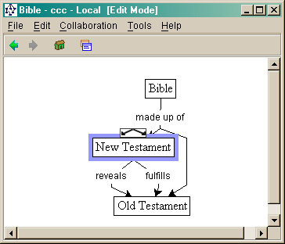
- Process the trees through WordNet to look for definitions (eg ‘Eucharistic’ is ‘of the Eucharist’) these are grouped into concepts and become normative.
- compare trees and generate frequency tables.
- Process the most frequent into unnamed concepts.
- Generate a final concept map that substitutes concepts for where ever they occur.
- This can then be navigated using concept map browser.

THE CONCEPT MAP BROWSER
There are many concept map browsers available. Cmap, thebrain and Topic Maps will be investigated, from a list of many others.

I used CMap to generate some of the concept maps in this report. It is free for non-commercial use. allows for collaboration on a map. It is however, limited to links having information. In the model proposed, links may not have information, since the linking relation could already be contained in the concept. It could be possible to adapt it though. It is open source and programmed in Java, a computer language that comes with free development tools (has to be free to compete with Microsoft). CMap has several powerful features, such as auto layout.

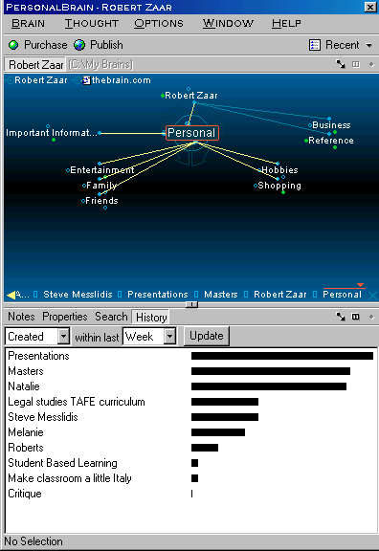
Thebrain is a commercial piece of software that has a very cool graphical interface.

Nodes are connected hierarchically. Thebrain can be viewed on line at thebrain.com. It is used for surfing the web in a concept map fashion. Its animated motion as you move from concept to concept is very sci-fi. Since the node relationships are limited, it is not ideal for this project, but it does set a standard for graphical ascetics. It also lists the contents of a node. In the case of the Catechism concept mapper, a similar list would be generated of which paragraphs contain a certain concept.

If we were to take the types of nodes and links from CMap and the listing and graphical ascetics from thebrain we would be close to the ideal for a concept map surfer. Both programs can generate maps viewed through an ordinary browser. This is also the objective of the Catechism concept mapper.

This leaves one question, how to pass concept map information from the database to the mapping ‘add in’ in the browser? Resource Description Framework (RDF)is the answer. RDF is a subset of extensible Markup Language (XML). Let me explain.

HyperText Markeup Language (HTML)
Currently the language in which information is shared on the internet is HTML. HTML is universally used across the internet in all countries. It specifies how a web page is to be presented or rendered. If part of the text is to be bold then it would be marked up with tags that clarify that the text between the tags is to appear as bold. The bold tags are before and after the text to be bolded. An internet browser such as Navigator, when it comes across the tags will take out the tags and change the text between them into bold.

Normal type | I mean what I say
HTML | I <b>mean</b> what I say

This simple example is the same for all parts of the document, and allows for the rich variety of web pages that we currently have.

What if we want to indicate who the author of the page is? This is called meta data, it is information about information. HTML allows for some metadata, but it is an add on, and not a necessary part of the document.

Libraries can access web pages, but to search for any information such as Patrick White as an author would turn up every page with Patrick White in it. The information is textually searched for a match on the words, not on the meaning. What is needed is a way to indicate Patrick White as an author. Thus it might be rendered as
<author>Patrick White</author>. Extensible Markup Language allows for this.

XML is already used widely across the internet with Netscape 5.0 and Explorer 5.0 being able to display XML documents. Many businesses are starting to use it for B2B (business to business transactions).

SPECIFICATIONS
All formal web specifications are ‘governed’ by the world wide web consortium w3.org. “The World Wide Web Consortium (W3C) develops interoperable technologies (specifications, guidelines, software, and tools) to lead the Web to its full potential as a forum for information, commerce, communication, and collective understanding.” It is this consortium that specifies the HTML and XML standards.

RDF is a subset of XML that will allow for the kind of relations concept maps are based on. RDF is part of an initiative called the Semantic web. RDF doesn’t just seek to say what information is, but to have a common vocabulary of words that have a defined meaning and can be used as part of information exhange.

Let us examine a RDF example from Resource Description Framework (RDF) Model and Syntax Specification
Consider as a simple example the sentence:
Ora Lassila is the creator of the resource http://www.w3.org/Home/Lassila.
This sentence has the following parts:
Subject (Resource) | http://www.w3.org/Home/Lassila
Predicate (Property) | Creator
Object (literal) | "Ora Lassila"
In this document we will diagram an RDF statement pictorially using directed labeled graphs (also called "nodes and arcs diagrams"). In these diagrams, the nodes (drawn as ovals) represent resources and arcs represent named properties. Nodes that represent string literals will be drawn as rectangles. The sentence above would thus be diagrammed as:
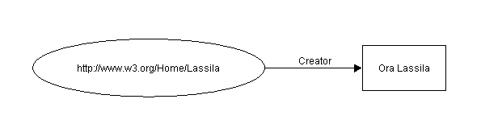D
Figure 1: Simple node and arc diagram
This looks very much like our concept map and they are using description much like our concept map definition. This map would be marked up as
<rdf:RDF>
<rdf:Description about="http://www.w3.org/Home/Lassila">
<s:Creator>Ora Lassila</s:Creator>
</rdf:Description>
</rdf:RDF>
The core point here is ‘about’, ‘creator’ and ‘Ora Lassila’. If we take our earlier example, of Eucharistic, we might have

<rdf:RDF>
<rdf:Description about="Eucharistic">
<ccc:of the>Eucharist</ccc:of the>
</rdf:Description>
</rdf:RDF>

Eucahristic is defined as ‘of the Eucharist’. ‘of the’ is part of a defined key word in the Catechism namespace, or catechism concepts. This format will allow for the tree structure to be passed around the internet. All that is needed is a graphical plug-in for the browser that will convert the RDF into a map within the browser.

CONCLUSION

How the Catechism of the Catholic Church could be converted into a concept map has been explored. A SQL database allows for the various data to be stored and manipulated. The Catechism needs to be first digitised and placed in a relational database. It can then be tagged, the word types worked out. Also the grammar structure and senses of words need to be ascertained. From this information, a concept map can be generated. To be browsed, a graphical interface needs to be added . This could be a web browser with the right plug-in. To communicate to the database a protocol needs to be developed. RDF is such a protocol that could be put to service. It is in fact the plug in that will need to be developed.

All of this is possible with emerging technology. This project is the convergence of such technology.

BIBLIOGRAPHY

CONCEPT MAPS
- <http://cmap.coginst.uwf.edu/refs.html> (SLD) Ruiz-Primo, M. A., Schultz, S. E., Li, M. and Shavelson, R. J. (1998). Comparison of the Reliability and Validity of Scores from Two Concept Mapping Techniques. Los Angeles, CA, Center for the Study of Evaluation, Standards and Student Testing.
- <http://users.edte.utwente.nl/lanzing/cm_home.htm> Concept Mapping Homepage Jan W.A. Lanzing Latest update: February 28, 1997.
- Uses of concept maps <http://www.cpsc.ucalgary.ca/~kremer/dissertation/Ch2.html#_Toc2.2> Constraint Graphs: A Concept Map Meta-Language (PhD Dissertation) Chapter 2 Background: Visual Languages and their Domains
- Lambiotte, J. G., Dansereau, D. F., Cross, D. R. & Reynolds, S. B. 1984. Multirelational Semantic Maps. Educational Psychology Review 1(4): 331-367.
- <http://www.cpsc.ucalgary.ca/~kremer/dissertation/index.html> Constraint Graphs: A Concept Map Meta-Language (PhD Dissertation) Robert Kremer (1997? no date specified evidence points to 1997)
- http://www.thebrain.com/ Thebrain concept mapping software.

CATECHISM
- <http://www.nccbuscc.org/catechism/general/history> Informative Dossier LIBRERIA EDITRICE VATICANA VATICAN CITY, JUNE 25, 1992 Editorial Commission of the Catechism of the Catholic Church
- <http://www.vatican.va/archive/catechism/aposcons.htm> APOSTOLIC CONSTITUTION
FIDEI DEPOSITUM John Paul II 11th October 1992 (introduction)
- <http://www.nccbuscc.org/catechism/general/dossier.htm#history> Catechism of The Catholic Church Course of Its Preparation Office for the Catechism National Conference of Catholic Bishops/United States Catholic Conference June 29th 1998 FIDEI DEPOSITUM, par 3.
- <http://www.nccbuscc.org/catechism/document/protocol.htm> Protocol for Assessing the Conformity of Catechetical Materials with the Catechism of the Catholic Church <http://www.nccbuscc.org/catechism/document/protocol.htm>. June 26 1998

<http://plato.stanford.edu/entries/anselm/> Stanford Encyclopedia of Philosophy Saint Anselm August 17 2000

SEMANTIC PROCESSING
- <http://www.comp.lancs.ac.uk/computing/research/ucrel/claws/> CLAWS part-of-speech tagger
- Ronald A. Cole, Editor in Chief Sponsors: National Science Foundation Directorate XIII-E of the Commission of the European Communities Center for Spoken Language Understanding, Oregon Graduate Institute November 21, 1995 p.116
- <http://lingo.stanford.edu/demo.html> LinGO Demo Nov 6 1999.
- http://cslu.cse.ogi.edu/HLTsurvey/ch3node5.html Grammar Formalisms, Hans Uszkoreit & Annie Zaenen Deutsches Forschungzentrum für Künstliche Intelligenz, Saarbrücken, Germany and Universität des Saarlandes, Saarbrücken, Germany Rank Xerox Research Centre, Grenoble, France
- http://hpsg.stanford.edu/hpsg.html Head-Driven Phrase Structure Grammar Precision Grammars for Human Languages, Ivan Sag Stanford Linguistics (Project Leader);
- http://ontoserver.aifb.uni-karlsruhe.de/texttoonto/ Ontology Learning From Text - The Text-To-Onto System, Alexander Mädche; Institute AIFB Karlsruhe University
- http://www.semanticweb.org/ The Semantic Web Community Portal Together Towards a Web Of Knowledge..., Stefan Decker
- http://www.teleport.com/~patrick/wordnetsql/ Wordnet and SQL Resources, Patrick Sullivan

INTERNET
- <http://www.w3.org/> World Wide Web Consortium.
- http://www.w3.org/2001/sw/ Semantic Web Tim Berners-Lee, James Hendler and Ora Lassila
- See also Scientific American, May 2001, Tim Berners-Lee, James Hendler and Ora Lassila
- W3C Recommendation 22 February 1999 This Version of RDF <http://www.w3.org/TR/1999/REC-rdf-syntax-19990222>
- http://www.topicmap.com/ topicmap.com Hand-crafted Machine-generated Knowledge Interchange

http://cmap.coginst.uwf.edu/refs.html (SLD) Ruiz-Primo, M. A., Schultz, S. E., Li, M. and Shavelson, R. J. (1998). Comparison of the Reliability and Validity of Scores from Two Concept Mapping Techniques. Los Angeles, CA, Center for the Study of Evaluation, Standards and Student Testing.
http://users.edte.utwente.nl/lanzing/cm_home.htm Concept Mapping Homepage Jan W.A. Lanzing Latest update: February 28, 1997.
“Concept maps have been used in education (Lambiotte et al. 1984; Novak & Gowin 1984), in management (Axelrod 1976; Hart 1977; Eden, Jones & Sims 1979; Banathy 1991), in artificial intelligence (Quillian 1968), in knowledge acquisition (McNeese et al. 1990), in linguistics (Sowa 1984; (Graesser & Clark 1985) and for many other varied purposes.” See http://www.cpsc.ucalgary.ca/~kremer/dissertation/bib.html to find the source documents. Quote from http://www.cpsc.ucalgary.ca/~kremer/dissertation/Ch2.html#_Toc2.2 Constraint Graphs: A Concept Map Meta-Language (PhD Dissertation) Chapter 2 Background: Visual Languages and their Domains
ibid. 2.1.3
Lambiotte, J. G., Dansereau, D. F., Cross, D. R. & Reynolds, S. B. 1984. Multirelational Semantic Maps. Educational Psychology Review 1(4): 331-367.
http://www.nccbuscc.org/catechism/general/history Informative Dossier LIBRERIA EDITRICE VATICANA VATICAN CITY, JUNE 25, 1992 Editorial Commission of the Catechism of the Catholic Church
http://www.vatican.va/archive/catechism/aposcons.htm APOSTOLIC CONSTITUTION FIDEI DEPOSITUM John Paul II 11th October 1992 (introduction)
ibid. par 1.
http://www.nccbuscc.org/catechism/general/dossier.htm#history Catechism of The Catholic Church Course of Its Preparation Office for the Catechism National Conference of Catholic Bishops/United States Catholic Conference June 29th 1998
FIDEI DEPOSITUM, par 3.
http://www.nccbuscc.org/catechism/document/protocol.htm Protocol for Assessing the Conformity of Catechetical Materials with the Catechism of the Catholic Church. June 26 1998
http://plato.stanford.edu/entries/anselm/ Stanford Encyclopedia of Philosophy Saint Anselm August 17 2000
CCC 964 is under the Subheading “Wholly United With Her Son…” under the heading “I. Mary’s Motherhood With Regard To The Church” under Paragraph 6. Mary – Mother Of Christ, Mother Of The Church under “Article 9: ‘I Believe In The Holy Catholic Church’” under Chapter Three I Believe In The Holy Spirit under Section Two The Profession Of The Christian Faith, under Part One The Profession Of Faith
I copied the subject index from the CD version of the Catechism to a word processor and started searching for each paragraph. 1-3 were found, but not 4. This was enough for me to see that not all paragraphs are indexed.
http://www.cpsc.ucalgary.ca/~kremer/dissertation/index.html Constraint Graphs: A Concept Map Meta-Language (PhD Dissertation) Robert Kremer (1997? no date specified evidence points to 1997)
http://www.comp.lancs.ac.uk/computing/research/ucrel/claws/ CLAWS part-of-speech tagger
“Among the most used, constraint-based grammar models are Functional Uni_cation Grammar (FUG), Head-Driven Phrase-Structure Grammar (HPSG), Lexical Functional Grammar (LFG), Categorial Uni_cation Grammar (CUG), and Tree Adjunction Grammar (TAG). Survey of the State of the Art in Human Language Technology Ronald A. Cole, Editor in Chief Sponsors: National Science Foundation Directorate XIII-E of the Commission of the European Communities Center for Spoken Language Understanding, Oregon Graduate Institute November 21, 1995 p.116
http://lingo.stanford.edu/demo.html LinGO Demo Nov 6 1999.
http://users.edte.utwente.nl/lanzing/cm_home.htm Concept Mapping Software, by Jan W.A. Lanzing Latest update: February 28, 1997.
http://www.w3.org/ Last modified: $Date: 2001/05/02 05:22:34 $
"The Semantic Web is an extension of the current web in which information is given well-defined meaning, better enabling computers and people to work in cooperation." -- Tim Berners-Lee, James Hendler, Ora Lassila, The Semantic Web http://www.w3.org/2001/sw/ See also Scientific American, May 2001, Tim Berners-Lee, James Hendler and Ora Lassila
W3C Recommendation 22 February 1999 This Version: http://www.w3.org/TR/1999/REC-rdf-syntax-19990222

