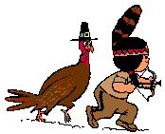

THE STORY OF THANKSGIVING

It’s the year 1620 in America …
A big ship, the Mayflower, lands.
It comes from England.
It is full of people.
People are cold and hungry.
Native Americans give them food and clothes.
The white people build houses.
The white people make a big party for the Native Americans.
They thank them for their help.
The Native Americans help them to grow corn and hunt.

