Office Supplies

- Village Office Supply is our Vendor. A file is retained for them with copies of invoices.
- When staff requests supplies, they must fill out an order request form (see example) in the Office Supply Order Book and notify the Secretary, or whoever is responsible for placing the order.
- To place an order, log onto the Village Office Supply website (or call 1-908-895-0920 or 1-908-526-0600)
  - To log on you will need to go to www.officesupply-link.com/4142/dealerstation/ this will then open this window: 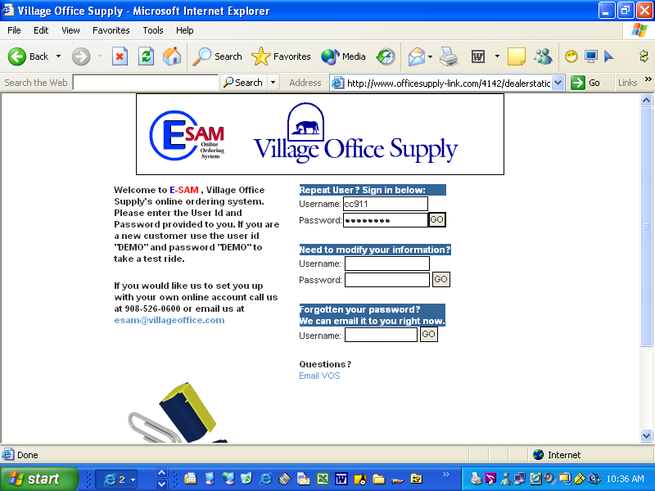
  - The Username is cc911 the password is: mypooter.*
*Note prior approval is needed by the Program Director for ordering.
  - Click GO to continue.
  - You will be brought to this screen: 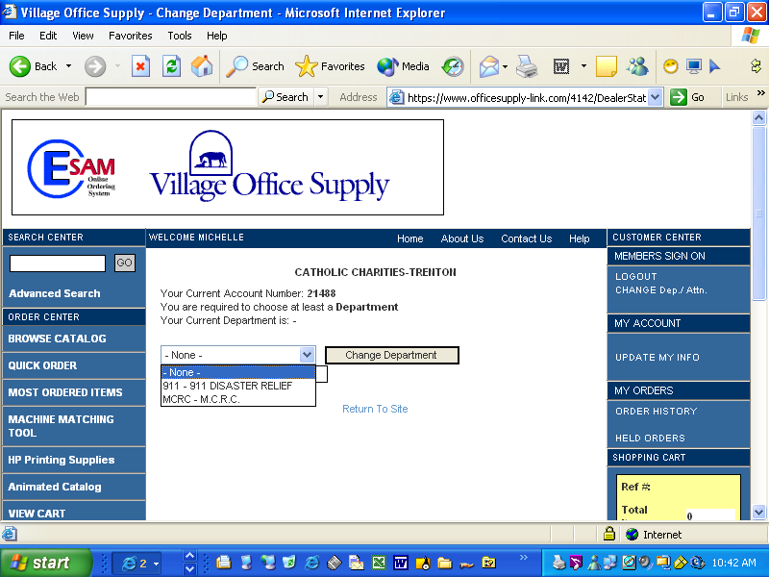
  - Choose which location you need the supplies you are ordering delivered. *Note: The 911-911 Disaster Relief is the Allentown Office location; the MCRC – MCRC is the Monmouth County Resource Center at Brookdale College location.
  - Click CHANGE DEPARTMENT to continue.
  - Now you should be at this screen: 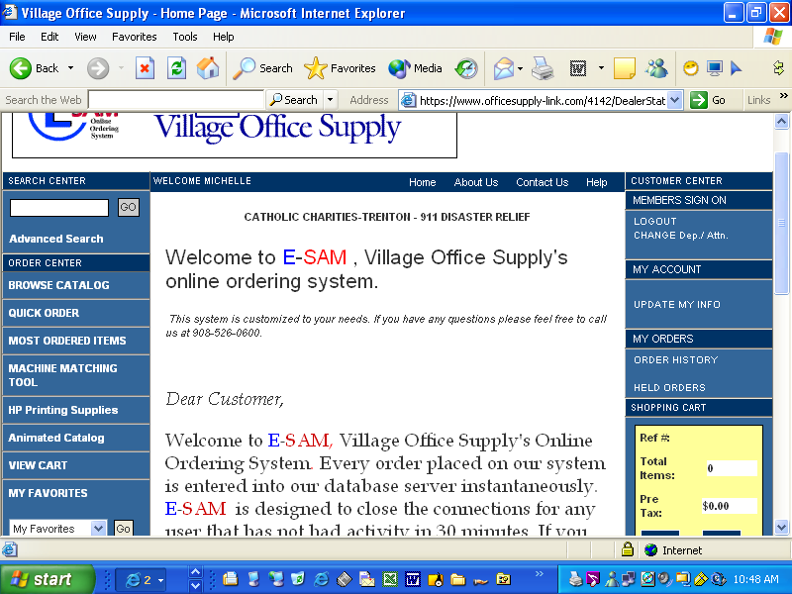
h.
  - The rest is self-explanatory…for example, if you would like to order by on-line catalog, click on BROWSE CATALOG, or you can enter an item number or keyword in the advance search.

  - When you choose your item(s), you will be brought to this screen: 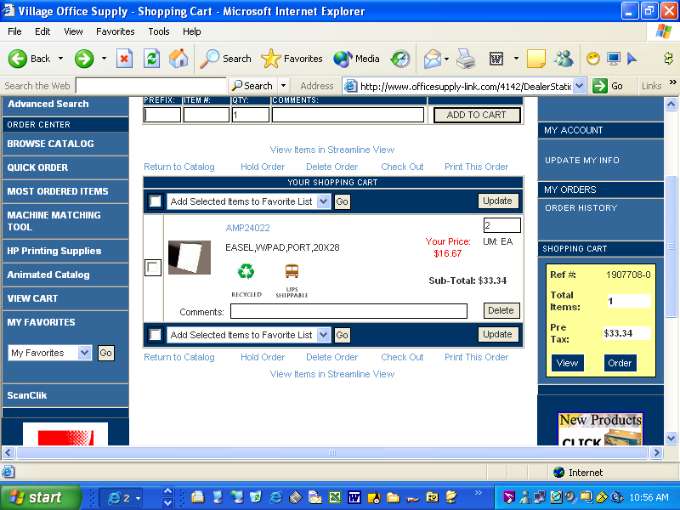
Summary of Shopping Cart
j.

  - To continue with your order you can either click on ORDER in the Summary of Shopping Cart or Check out etc…

  - When placing the order, no purchase order or PO # is necessary just the first name of the person placing the order.. Once you have completed the PO, Requisition and Attention name areas click on SUBMIT ORDER. 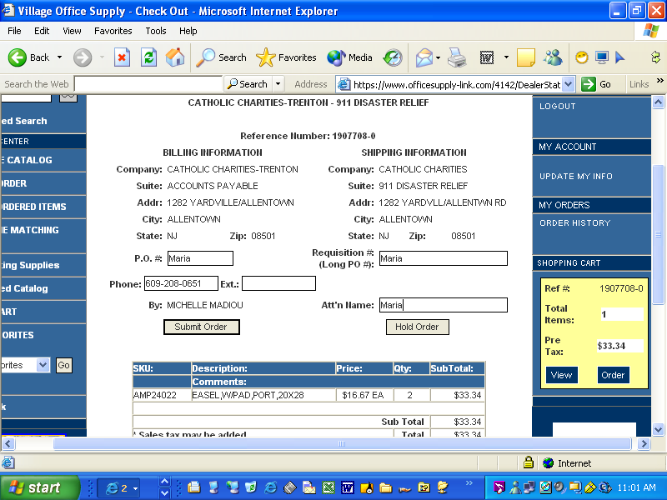

  - You will be brought to this screen: 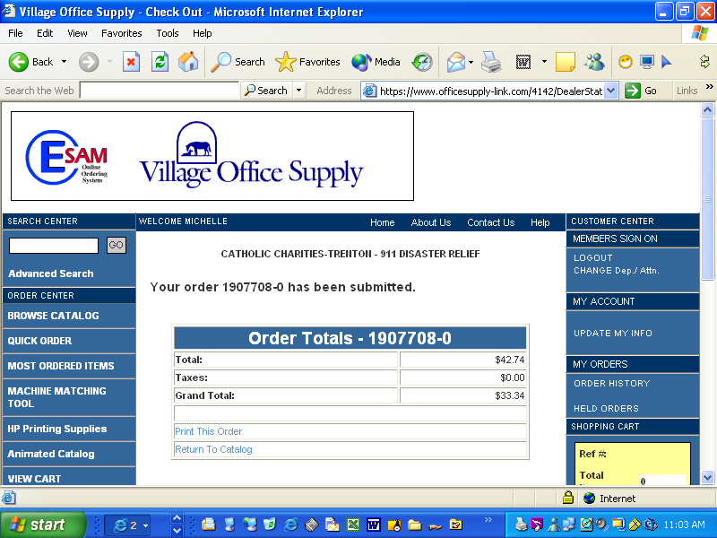 be sure to be sure to print a copy of the order for office supply order book/office records.
- When order is received (next business day), make sure to retain packing slips. The packing slips are attached to the invoice when processing.
- Original invoice with packing slips attached and the “ok to pay stamp’ must be forwarded to Betty Ann Flis, CAS.
- Retain a copy for the office files.

