Answering/Using the Phones

All telephone calls should be answered, “Catholic Charities, Disaster Response Program, __________speaking or this is ___________ how can I help you?”

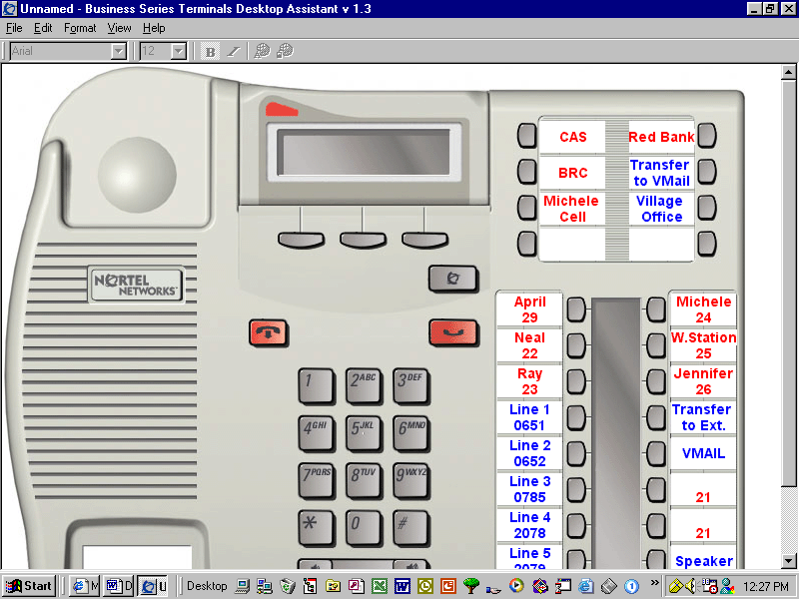
Transfer to VMail
Transfer to Ext.
Disconnect/ Hang Up
Hold
Display
To access general Mailbox

Look here for triangles

- To transfer a call:
- Always ask who is calling.
- Push Transfer to Ext. button and the extension of the person the call is for; wait until they answer and announce the call and disconnect/hang up, if they are unavailable cancel the transfer (see display on telephone and push the button under the word cancel)
- If you are unable to transfer the call as stated above, place the caller on hold and push the extension of the person the call is for, announce the call and ask if they are available to take it, let them know which line to pick up (it will be the one with the flashing triangle next to it).
If the staff member who is requested is unavailable (if a triangle is lit next to their name they are on another call) ask the caller if they wish to leave a message with you or if they would like the staff member’s V-Mail. If the caller prefers the staff members V-Mail transfer them.

- To transfer a call to voicemail:
- With the caller still on the line (do not put on hold) press the Transfer to VMail, the display screen will request a mailbox number. Type in the mailbox number using the keypad

