Summary and Analysis Paper
Part I: Evaluating CMAP Tools and Skype - Synchronous Communication in Distance Learning
Part II: Evaluating Moodle: An Open Source Online Learning Platform

For Dr. Qing Li
EDER 677 – Distributed Learning

By
Brent Beattie
Warren Kluss
Doug Sirkka

Contents:

Part I:
- CMAP Tools Evaluation Summary
- Skype Evaluation Summary

Part II:
- Moodle Evaluation Summary

The criteria used for these evaluations are given in the rubric at the end of the paper.

CMAP Tools Evaluation Summary

The ironic part about summarizing the Institute for Human and Machine Cognition concept mapping tool in text form is that summarizing is one of the main features of CMAPs. The tools website actually contains nothing but CMAPS to explain its product. In this intial summary we are giving then, we are having to take those summaries and translate them into traditional text.

CMAPS facilitates knowledge sharing and collaborative projects that need to be carried out by two or more people. It supports the shared construction of concept maps as well as peer review and critique of the concept maps when drafts are complete.

CMAPs can be completed synchronously or asynchronously. Synchronous CMAPing takes place through high speed connections and concurrent editing of a CMAP housed on a server that all parties have access to. The asynchronous collaboration occurs through non-concurrent editing, the exporting and importing of CMAPS, annotations, knowledge soups, and discussion threads.

Despite the summary just given, we felt the most effective way to summarize was to complete a CMAP on the tool itself.

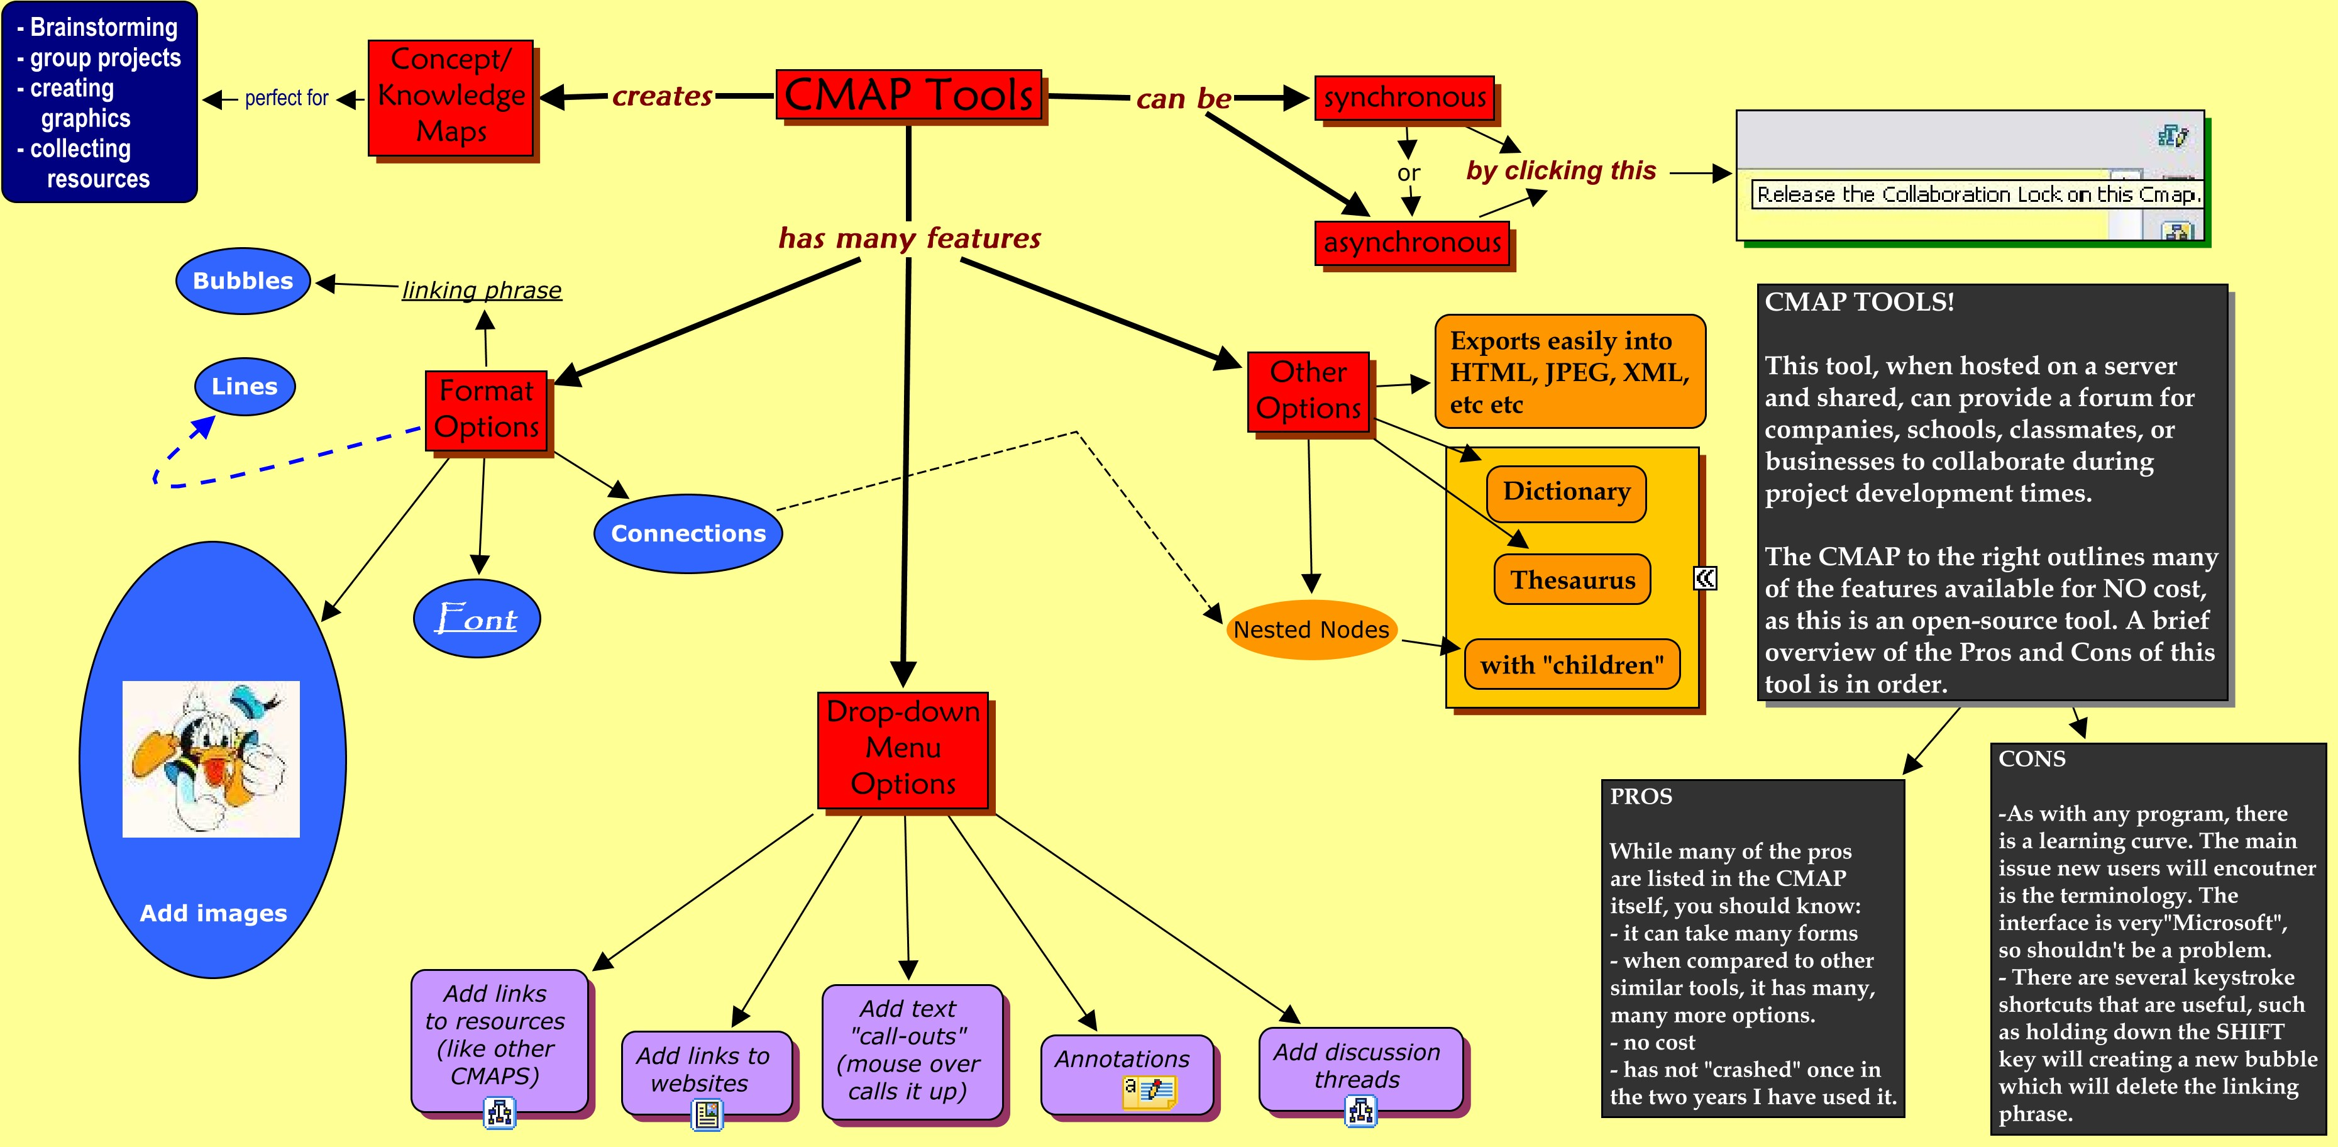

Overall Rating: 19/21 (See Rubric)

Cost to implement: 3

It is open-source so the there is no cost associated. For collaborative work, which is it’s purpose, you will need a server to host it on. School District #54 Bulkley Valley hosts a CMAP server on a “scrap-heap” computer and it works flawlessly.

Cost to maintain: 2.5

There is no online forum, but there is a mailing list and instructional videos along with the FAQ section and help sheets. After one year of usage in SD#54, there has been no server maintenance necessary.

Ease of usee: 2.5

“Non-techie” will be able to use this program after a brief in-service. Essentially, it is the program’s “vocabulary” they need to get used to, as well as the formatting box. The rest is intuitive.

Course management: N/A

Used only in the evaluation of platforms.

Content presentation: 3

Once a server is in place, created CMAPs can be stored in active directories to be released, reviewed and revamped. Varied levels of permissions can be used. CMAP’s needing to be exported to other applications can be in a variety of formats: HTML, JPEG, PDF, Postscripts, Scalable Vector Graphics, text, XML, and lifemaps.

Communication/Collaborationn: 2.5

Explained above. The only issue in collaboration is the lack of real-time discussion tools (threads are there, but no instant messaging capabilities)

Assessment of learning: N/A Instructional flexibility: N/A

Used only in the evaluation of platforms.

Upgrades/ Product longevityy: 2.5

CMAP Website outlines these issues completely.

Security: 3

Dependant upon the hosting server.

Skype Evaluation Summary
A Synchronous Communication Tool

Overall Rating: 19.5/21 (See Rubric)
Skype is a synchronous communication tool used for communication over the Internet. Skype users can chat using text, audio, or even video. As a computer-to-computer communication device, communicating with Skype is free and is the primary focus of this evaluation. Note, however, that the software can be used to telephone landlines or mobiles at a low rate. You can even apply for a local number that people can call using their telephones for a monthly fee.
Using the text-based group chat available on Skype, up to 50 learners and instructors can interact in real-time within a given chat. This chat can be bookmarked and members can return to the room for either a prearranged class meetings or for group meetings on a collaborative project. The moderator has the ability to set the access permissions so that the classroom can be somewhat secure from outside parties. As well, posting guidelines can be set for students reminding them of major outcomes, etiquette guidelines or schedules. Furthermore, once established, the teacher can easily create a link to the classroom on the Course Management Software (see Moodle Evaluation below) or students can even link to it on their MySpace accounts. Thus, a virtual classroom can be established using the chat function.
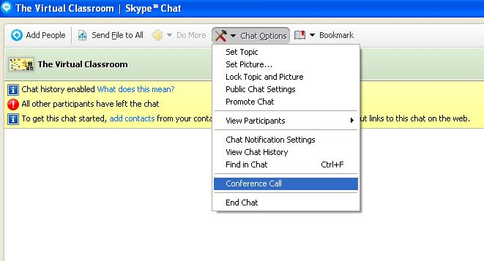
Within Skype Chat, the participants also have the ability to Conference Call with each other thus taking advantage of Skype’s main function: the Audio Call, where up to 5 users can conference together (10 with a powerful computer). Thus, Skype can be used to collaborate with others using audio.
While the basic Skype package lacks the features of other commercial web collaborating programs such as Elluminate Live, it is important to mention that using the Extras under the Do More… menu, the features of Skype can be expanded (some at a price) to include a whiteboard, application sharing, document collaboration, text-to-audio translating and even conferencing with up to 500 people with handraising and recording of the session.
Overall, Skype is a powerful synchronous communication tool with many applications in distance learning. Its basic functionality can be used to bring learners together over a distance and collaborate in realtime for projects, seminars or even shared browsing. Furthermore, its features can be enhanced to compete with that of expensive commercial applications, such as Elluminate Live, at very little expense.
Detailed Ratings:
Cost to implement – 3
Skype is free for its basic functionality and many of the Extras such as the whiteboard and application sharing are freeware.
Cost to maintain – 3
Updates are made available free of charge from the company.
Ease of use – 2.5
Skype uses an intuitive design that is easy to use. However, users unfamiliar with communication software may need some time to adjust.
Course management – N/A
Used only in the evaluation of platforms.
Skype chats can be easily linked to a Course Management System, but the software is not designed specifically for educational use so course management and content management features are lacking. File sharing, however, can be used to distribute content.
Content presentation – 2
The basic Skype application lacks the ability to present content easily. However, with the use of Extras Skype can become a powerful (synchronous) content distribution tool.
Communication/Collaboration – 3
Excellent! Audio quality, text-chat features and good video conferencing allow for collaboration at a distance. Extras are icing on the cake.
Assessment of learning – N/A
Used only in the evaluation of platforms.
Again, since Skype is not specifically designed for educational use it lacks built-in assessment tools. (Editor note: If anyone knows of any Skype Extras designed for educational use please let me know, dsirkka@hotmail.com. SkypeName:dsirkka)
Instructional flexibility – N/A
Used only in the evaluation of platforms.
With Extras, Skype can be a powerful instructional tool.
Upgrades/ Product longevity – 3
Skype is constantly being upgraded and with so many users will most likely be around a long time.
Security - 3
Skype uses digital certificates and encryption to ensure a user’s privacy and communications are relatively secure.

Moodle Evaluation Summary

Overall Rating: 24.5/30 (See Rubric)
Moodle is the best open source alternative to Blackboard and Desire2Learn and is therefore the least expensive learning management system available. Its feature set is comparable with the platforms that require licensing, and primarily personal preferences are what determines which platform is considered best.
Moodle was designed using the social constructionist pedagogy. The idea being that the instructor not just push content they feel students need to know, but lead and model learning behavior and facilitate discussions.
The current version of Moodle is 1.8 with 1.9 soon to be released. Modules are continually being added. A whiteboard module which was noticeably absent has just been released in beta form.
Student tracking and the assessment options in Moodle are good. The instructor can create quizzes with various question formats, have students peer evaluate, and collect and assess assignments. A logging feature is also useful for tracking student use and progress.
I especially like the lesson module that leads students through content at their own pace with navigation determined by their responses. This adds some structure and quick feedback that will help many high school students that will struggle with the open ended nature of distributed learning.

Detailed Ratings:
Cost to Implement – 3
Moodle is open source so there are no licensing costs. Running Moodle requires a server that has webserver software with PHP support (open source option: Apache), and a database server (open source option: MySQL or PostgresSQL). It does not require an extremely high power machine. A school can pay for a basic hosting service or implement their own within the school or district.
Cost to Maintain – 2.5
Moodle is open source so it does not come with any sort of visitation or call in support. You would need some local technical administrator and instructors to take some interest and be willing to troubleshoot. There is, however, a very strong online community and discussion forum.
Ease of Use – 2
The course structure is easy to recognize and use for instructors. From the student point of view it is easy to understand and navigate although pathways are hard to follow with linking resources to activities instead of the part of the course the resource came from.
Course Management – 2.5
Modules are present for recording grades and attendance. There is also a logging feature that enables the instructor to view the activity of all students. This is a very nice feature for keeping tabs on students that have a tendency to fall behind.
Content Presentation – 2.5
Content can be uploaded in almost any digital format. Content is easily located by students and navigation is adequate. Content is difficult for instructors to copy and reuse.
Collaboration/Communication – 2
Communication options include chat for synchronous, discussion forums for asynchronous, and wikis for document collaboration. These are decent communication options but the wiki module is pretty limited for document collaboration. It is a web page that can be updated by the group, but does not track changes, and is only in the one format. A white board module has recently been release as a beta version and should therefore be implemented as a standard feature soon.
Assessment of Learning – 3
Various methods of assessment are available. Students can peer evaluate with the workshop module, submit assignments in any format and instructors can create quizzes with various question types that can be stored in a question bank for later reuse. A grade book module is include for tracking student performance and for students to check on progress. A survey module can be used to get opinions of students on the effectiveness of the course and be used to guide future course planning.
Instructional Flexibility – 2.5
As well as adding course content of various formats, uploading assignments, and using discussion forums, I really like the lesson feature that leads students through content at their own pace checking for understanding along the way. This is a feature absent in other platforms like Blackboard. It, however, is not possible for teachers to save custom templates.
Upgrades/Product Longevity – 2.5
Moodle is the premier open source learning management system. It rivals expensive systems like Blackboard and Desire2Learn. There are over 28000 known Moodle sites with upgrades and enhancements constantly being developed. This category would have been a 3, but Blackboard was issued a US patent for e-Learning Technology in 2006. They have filed legal action against competitor Desire2Learn. We will have to wait and see the outcome and if there are any future implications for Moodle.
Security – 2
Security issues have been identified in the past with various modules, and fixes have been implemented. I would imagine that as new modules are created and updated occasional security issues will arise and require updates.

Platform/Tool Evaluation Rubric
Aspect | Developed 3 | Adequate 2 | Poor 1
Cost to implement | Benefits of ownership far out weigh the costs. Low cost licensing agreements or open source.  No special hardware or special software platforms are required. | Startup cost is affordable, but makes decision difficult when looking at other alternatives.  Benefits still out weigh the cost | Cost is almost prohibitive to implementing.  Expensive, inflexible, licensing.  Additional expensive hardware required.
Cost to maintain | Quality, timely support comes with purchase or is available with inexpensive contract.  Maintenance by local administrators is not necessary or minimal.  Online documentation is exhaustive.  Online discussion groups on the product present and active. | Local administrators will be required to do weekly or monthly maintenance.  Support from vendor is expensive or absent.  Documentation is good but not exhaustive.  There is an online presence in discussion forums. | Weekly problems for local administrators.  Vendor support is absent, ineffective or too expensive to purchase.  Documentation and online information is not adequate.
Ease of use | Non technical teachers can learn most features on their own.  Intuitive for students. little or no training is required.  Help and documentation answer most instructor and student questions. | Some training is required for most teachers.  Quick orientation for students will be necessary, but some will figure it out on their own.  Students may be confused with parts of the interface  Help and documentation are available but limited | Only “techie” teachers will touch it.  Significant time is required to train the students on how to use.  Help and documentation are absent or very limited.
Course management | Course management features for grade recording and attendance are present and easy to use. | Course management features are present and usable but not optimal. | Instructors end up using other software for management due to missing features or because the tool is too cumbersome.
Content presentation | Instructors can easily create and post course content.  Commonly reused content can be linked to.  Students can easily find and view content.  Content can be presented in multiple formats (text, audio, video). | Content can be posted but it is time consuming.  Presentation of content is not attractive or might be hard to navigate.  Multiple formats are not available | Content is extremely difficult for instructor to post. Many media formats are not supported.  Content is confusing for students to navigate.
Communication/Collaboration | Peer and instructor feedback is available.  Synchronous and asynchronous communication are both available.  Document sharing is available that tracks changes. | Collaborative tools are available but synchronous tools are missing. Document sharing is present but not full featured. | Students and instructors use outside tools most of the time for effective communication.
Assessment of learning | Tools for assessing learning are available and incorporate more than one method of assessment. | A tool for assessment is available. | No tools are available
Instructional flexibility | Tools are available for multiple teaching approaches.  Teachers can customize and save templates.  The learning environment can be structure to suit the needs of the course. | There is some flexibility for instructors, but it is limited. | Structure is such that all courses end up with exact same format.  Instructors structure courses based on platform limitations instead of the needs of the course
Upgrades/ Product longevity | Product is a standard for its purpose and will be upgraded continually. | Upgrades are currently being worked on but release dates are unclear. | No announced upgrades are forthcoming.  Product is losing its presence in the market.
Security | Software has various security levels for access to personal and system information. Personal information is safe from outside attacks. | Personal information should be secure from outside attacks.  Security issues are addressed and fixed in a timely fashion. | Outstanding security issues exist and are not being addressed.

