Management Plan: Small Whorled Pogonia  Whitney Bailey  Director of Stewardship | 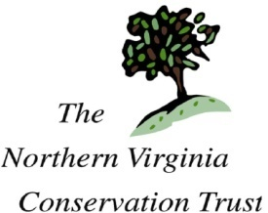

Current Condition
Natural features
This 5-acre property sits near the junction of Spriggs Rd. and VA Rt. 234. It is not contiguous with other forested land or natural area, though across the street to the south is Prince William Forest Park. The land to the northwest used to be forested but has now been developed for new roads.

The woods are composed primarily of oak and beech trees, with some tulip poplar, red maple, hickory, dogwood, and Virginia pine on the upper slopes. Understory includes some mountain laurel and viburnum spp. Groundcover includes running-cedar, new york fern, christmas fern, cucumber root, and Virginia creeper.

The eastern side of the property slopes down to a north/south drainage near the east border, and it is on the southwestern end of this drainage that most of the Small Whorled Pogonias have been found.

Invasives
Few invasives are present on this property, and are concentrated on the eastern border, on the east side of the drainage. Species observed include vinca and english ivy.

Management Goals
Maintain integrity of ecological systems on property in order to maintain population of endangered Small Whorled Pogonia.

Workplan
With the assistance of Wetland Studies & Solutions and other conservation organizations, monitor property at least once during blooming season to count for specimens, and drive by at other times of the year when possible. Look for signs of trespass or erosion and take measures immediately to mitigate. Work closely with VDOT during construction to ensure minimal impact on population. Monitor closely for invasives presence and remove immediately when sighted.

