Management Plan: Woodmont  Whitney Bailey, Director of Stewardship  Elan Margulies, Ecological Restoration Intern  14th April, 2008 | 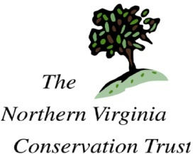

Current Condition
Natural features
This conservation easement consists of a 20-40 ft perimeter of vegetation buffer around Woodmont Development which includes trees. There is a small drainage that flows from a pipe through the north portion of the easement. The drainage way carries some sediment. The grade along the back Northwest slope is quite steep. The vegetation on the slope provides a buffer and screen from the residential properties that are adjacent to Woodmont.

There is a row of 8 Spruce trees along the North boarder of the property starting at the sidewalks edge. Other trees located on the easement consist of the following species: American Beech, Locust, Red Oak, Red Maple, Black Oak and Leyland Cypress. Many invasive species have taken hold on the easement including bamboo, black berry, English Ivy and Japanese Honeysuckle.

Management Goals
Restore native habitat to increase chances for wildlife to thrive and remove invasive species. Educate the public about NVCT, and relevant ecological issues.

Workplan
Restore native habitat conditions
- Remove invasive species and plant natives
- Conduct follow-up visits to maintain plantings and remove any reestablished invasives.
- Create interpretive signage that informs the public about NVCT management of the site, the benefits of wildlife corridors, and the positive impact of drainage buffers for water runoff.

