Management Plan: Little Falls Forest  Whitney Bailey  Director of Stewardship | 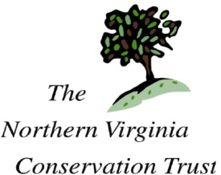

Current Condition
Natural features: Little Falls Forest is a lowland site that has medium shade and a small ephemeral pond. The area has a well established and abundant patch of Trout Lilies.
The pond was formerly about double its current size but gravel from a local construction project has been dumped in. To lighten this soil, organic matter may be needed.

Invasives: The area has plentiful populations of invasive plants including English Ivy, Vinca, Bush Honeysuckle, Bamboo, Pachysandra and Multiflora Rose.

Management Goals
- Encourage native plant growth, especially the herbaceous layer
- Encourage understory trees, shrub and groundcover to enhance wildlife value
- Replace non-native invasive species with native plants

Workplan
- Remove invasive species
  - Coordinate a work-team to remove the majority of invasive species
    - This should only be done after the Trout Lilies have finished blooming in mid-spring.
  - Have invasive removal events once or twice a year until invasives are controlled or eradicated
- Plant native understory trees, shrubs and groundcover as necessary to enhance diversity and wildlife value.
- Mix in organic matter or compost to the soil where gravel was deposited

